UNITED STATES
SECURITIES AND EXCHANGE COMMISSION
Washington, D.C. 20549

FORM 10-Q
(Mark One)
☒ |  |  | QUARTERLY REPORT PURSUANT TO SECTION 13 OR 15(d) OF THE SECURITIES EXCHANGE ACT OF 1934
For the quarterly period ended March 30, 2024
☐ |  |  | TRANSITION REPORT PURSUANT TO SECTION 13 OR 15(d) OF THE SECURITIES EXCHANGE ACT OF 1934
For the transition period from to

Commission File Number 1-6948

SPX TECHNOLOGIES, INC.
(Exact Name of registrant as specified in its charter)
Delaware |  |  |  |  |  | 88-3567996
(State or other jurisdiction of incorporation or  organization) |  |  |  |  |  | (I.R.S. Employer Identification No.)

6325 Ardrey Kell Road, Suite 400, Charlotte, North Carolina 28277
(Address of principal executive offices) (Zip Code)

(980) 474-3700
(Registrant’s telephone number, including area code)

Securities registered pursuant to Section 12(b) of the Act:
Title of each class |  |  | Trading Symbols(s) |  |  | Name of each exchange on which registered
Common Stock, par value $0.01 |  |  | SPXC |  |  | New York Stock Exchange
Indicate by check mark whether the registrant: (1) has filed all reports required to be filed by Section 13 or 15(d) of the Securities Exchange Act of 1934 during the preceding 12 months (or for such shorter period that the registrant was required to file such reports), and (2) has been subject to such filing requirements for the past 90 days. ☒ Yes ☐ No

Indicate by check mark whether the registrant has submitted electronically every Interactive Data File required to be submitted pursuant to Rule 405 of Regulation S-T (§232.405 of this chapter) during the preceding 12 months (or for such shorter period that the registrant was required to submit such files). ☒ Yes ☐ No

Indicate by check mark whether the registrant is a large accelerated filer, an accelerated filer, a non-accelerated filer, a smaller reporting company, or an emerging growth company. See definitions of “large accelerated filer,” “accelerated filer,” “smaller reporting company,” and “emerging growth company” in Rule 12b-2 of the Exchange Act.
Large accelerated filer |  |  | ☒ |  |  |  |  |  | Accelerated filer |  |  | ☐
Non-accelerated filer |  |  | ☐ |  |  |  |  |  | Smaller reporting company |  |  | ☐
 |  |  |  |  |  |  |  |  | Emerging growth company |  |  | ☐

If an emerging growth company, indicate by check mark if the registrant has elected not to use the extended transition period for complying with any new or revised financial accounting standards provided pursuant to Section 13(a) of the Exchange Act ☐

Indicate by check mark whether the registrant is a shell company (as defined in Rule 12b-2 of the Exchange Act). ☐ Yes ☒ No.
Common shares outstanding April 26, 2024, 46,230,643

SPX TECHNOLOGIES, INC. AND SUBSIDIARIES
FORM 10-Q INDEX
PART 1 – FINANCIAL INFORMATION
Item 1 – Financial Statements
Condensed Consolidated Statements of Operations and Comprehensive Income |  |  |  |  |  | 3
Condensed Consolidated Balance Sheets |  |  |  |  |  | 4
Condensed Consolidated Statements of Stockholders' Equity |  |  |  |  |  | 5
Condensed Consolidated Statements of Cash Flows |  |  |  |  |  | 6
Notes to Condensed Consolidated Financial Statements |  |  |  |  |  | 7
Item 2 – Management's Discussion and Analysis of Financial Condition and Results of Operations |  |  |  |  |  | 28
Item 3 – Quantitative and Qualitative Disclosures About Market Risk |  |  |  |  |  | 37
Item 4 – Controls and Procedures |  |  |  |  |  | 37
PART 2 – OTHER INFORMATION
Item 1 – Legal Proceedings |  |  |  |  |  | 38
Item 1A – Risk Factors |  |  |  |  |  | 38
Item 5 - Other Information |  |  |  |  |  | 38
Item 6 – Exhibits |  |  |  |  |  | 39
SIGNATURES |  |  |  |  |  | 40

PART I—FINANCIAL INFORMATION

ITEM 1. Financial Statements

SPX TECHNOLOGIES, INC. AND SUBSIDIARIES
CONDENSED CONSOLIDATED STATEMENTS OF OPERATIONS AND COMPREHENSIVE INCOME
(Unaudited; in millions, except per share amounts)
 |  |  | Three months ended
 |  |  | March 30,  2024 |  |  |  |  |  | April 1,  2023
Revenues |  |  | $ | 465.2 |  |  |  |  | $ | 399.8
Costs and expenses:
Cost of products sold |  |  | 282.3 |  |  |  |  |  | 249.9
Selling, general and administrative |  |  | 102.9 |  |  |  |  |  | 93.8
Intangible amortization |  |  | 14.8 |  |  |  |  |  | 6.3
Special charges, net |  |  | 0.6 |  |  |  |  |  | —
Operating income |  |  | 64.6 |  |  |  |  |  | 49.8
Other income (expense), net |  |  | (4.0) |  |  |  |  |  | 2.5
Interest expense |  |  | (9.8) |  |  |  |  |  | (2.4)
Interest income |  |  | 0.3 |  |  |  |  |  | 0.5
Income from continuing operations before income taxes |  |  | 51.1 |  |  |  |  |  | 50.4
Income tax provision |  |  | (1.9) |  |  |  |  |  | (11.3)
Income from continuing operations |  |  | 49.2 |  |  |  |  |  | 39.1
Income (loss) from discontinued operations, net of tax |  |  | — |  |  |  |  |  | —
Gain (loss) on disposition of discontinued operations, net of tax |  |  | (0.2) |  |  |  |  |  | 3.7
Income (loss) from discontinued operations, net of tax |  |  | (0.2) |  |  |  |  |  | 3.7
Net income |  |  | $ | 49.0 |  |  |  |  | $ | 42.8
Basic income per share of common stock:
Income from continuing operations |  |  | $ | 1.07 |  |  |  |  | $ | 0.86
Income from discontinued operations |  |  | — |  |  |  |  |  | 0.08
Net income per share |  |  | $ | 1.07 |  |  |  |  | $ | 0.94
Weighted-average number of common shares outstanding — basic |  |  | 45.828 |  |  |  |  |  | 45.382
Diluted income per share of common stock:
Income from continuing operations |  |  | $ | 1.05 |  |  |  |  | $ | 0.84
Income from discontinued operations |  |  | — |  |  |  |  |  | 0.08
Net income per share |  |  | $ | 1.05 |  |  |  |  | $ | 0.92
Weighted-average number of common shares outstanding — diluted |  |  | 46.683 |  |  |  |  |  | 46.402
Comprehensive income |  |  | $ | 38.8 |  |  |  |  | $ | 44.6

The accompanying notes are an integral part of these statements.

3

SPX TECHNOLOGIES, INC. AND SUBSIDIARIES
CONDENSED CONSOLIDATED BALANCE SHEETS
(Unaudited; in millions, except share data)
 |  |  | March 30,  2024 |  |  |  |  |  | December 31,  2023
ASSETS
Current assets:
Cash and equivalents |  |  | $ | 100.5 |  |  |  |  | $ | 99.4
Accounts receivable, net |  |  | 317.6 |  |  |  |  |  | 279.8
Contract assets |  |  | 32.0 |  |  |  |  |  | 16.6
Inventories, net |  |  | 295.1 |  |  |  |  |  | 276.7
Other current assets |  |  | 34.4 |  |  |  |  |  | 37.1
Total current assets |  |  | 779.6 |  |  |  |  |  | 709.6
Property, plant and equipment:
Land |  |  | 23.2 |  |  |  |  |  | 17.9
Buildings and leasehold improvements |  |  | 118.7 |  |  |  |  |  | 73.4
Machinery and equipment |  |  | 291.9 |  |  |  |  |  | 264.4
 |  |  | 433.8 |  |  |  |  |  | 355.7
Accumulated depreciation |  |  | (216.6) |  |  |  |  |  | (215.2)
Property, plant and equipment, net |  |  | 217.2 |  |  |  |  |  | 140.5
Goodwill |  |  | 844.5 |  |  |  |  |  | 704.8
Intangibles, net |  |  | 760.6 |  |  |  |  |  | 680.8
Other assets |  |  | 184.3 |  |  |  |  |  | 188.9
Deferred income taxes |  |  | 4.0 |  |  |  |  |  | 4.0
Assets of DBT and Heat Transfer (includes cash and equivalents of $5.0 and $5.5 at March 30, 2024 and December 31, 2023, respectively) (Note 3) |  |  | 9.4 |  |  |  |  |  | 11.1
TOTAL ASSETS |  |  | $ | 2,799.6 |  |  |  |  | $ | 2,439.7
LIABILITIES AND STOCKHOLDERS' EQUITY
Current liabilities:
Accounts payable |  |  | $ | 151.4 |  |  |  |  | $ | 118.7
Contract liabilities |  |  | 72.9 |  |  |  |  |  | 73.5
Accrued expenses |  |  | 126.2 |  |  |  |  |  | 168.5
Income taxes payable |  |  | 6.5 |  |  |  |  |  | 5.3
Short-term debt |  |  | 317.0 |  |  |  |  |  | 17.9
Current maturities of long-term debt |  |  | 20.8 |  |  |  |  |  | 17.3
Total current liabilities |  |  | 694.8 |  |  |  |  |  | 401.2
Long-term debt |  |  | 516.6 |  |  |  |  |  | 523.1
Deferred and other income taxes |  |  | 109.7 |  |  |  |  |  | 77.0
Other long-term liabilities |  |  | 202.6 |  |  |  |  |  | 204.1
Liabilities of DBT and Heat Transfer (Note 3) |  |  | 38.4 |  |  |  |  |  | 39.7
Total long-term liabilities |  |  | 867.3 |  |  |  |  |  | 843.9
Commitments and contingent liabilities (Note 15)
Stockholders' Equity:
Common stock (54,056,016 and 46,217,007 issued and outstanding at March 30, 2024, respectively, and 53,618,720 and 45,674,572 issued and outstanding at December 31, 2023, respectively) |  |  | 0.5 |  |  |  |  |  | 0.5
Paid-in capital |  |  | 1,351.6 |  |  |  |  |  | 1,353.6
Retained earnings |  |  | 87.3 |  |  |  |  |  | 38.3
Accumulated other comprehensive income |  |  | 250.9 |  |  |  |  |  | 261.1
Common stock in treasury (7,839,009 and 7,944,148 shares at March 30, 2024 and December 31, 2023, respectively) |  |  | (452.8) |  |  |  |  |  | (458.9)
Total stockholders' equity |  |  | 1,237.5 |  |  |  |  |  | 1,194.6
TOTAL LIABILITIES AND STOCKHOLDERS' EQUITY |  |  | $ | 2,799.6 |  |  |  |  | $ | 2,439.7

The accompanying notes are an integral part of these statements.

4

SPX TECHNOLOGIES, INC. AND SUBSIDIARIES
CONDENSED CONSOLIDATED STATEMENTS OF STOCKHOLDERS' EQUITY
(Unaudited; in millions)

 |  |  | Three months ended March 30, 2024
 |  |  | Common  Stock |  |  |  |  |  | Paid-In  Capital |  |  |  |  |  | Retained  Earnings |  |  |  |  |  | Accum. Other  Comprehensive  Income |  |  |  |  |  | Common  Stock In  Treasury |  |  |  |  |  | Total  Stockholders’  Equity
Balance at December 31, 2023 |  |  | $ | 0.5 |  |  |  |  | $ | 1,353.6 |  |  |  |  | $ | 38.3 |  |  |  |  | $ | 261.1 |  |  |  |  | $ | (458.9) |  |  |  |  | $ | 1,194.6
Net income |  |  | — |  |  |  |  |  | — |  |  |  |  |  | 49.0 |  |  |  |  |  | — |  |  |  |  |  | — |  |  |  |  |  | 49.0
Other comprehensive loss, net |  |  | — |  |  |  |  |  | — |  |  |  |  |  | — |  |  |  |  |  | (10.2) |  |  |  |  |  | — |  |  |  |  |  | (10.2)
Incentive plan activity |  |  | — |  |  |  |  |  | 9.8 |  |  |  |  |  | — |  |  |  |  |  | — |  |  |  |  |  | — |  |  |  |  |  | 9.8
Long-term incentive compensation expense |  |  | — |  |  |  |  |  | 3.3 |  |  |  |  |  | — |  |  |  |  |  | — |  |  |  |  |  | — |  |  |  |  |  | 3.3
Restricted stock unit vesting |  |  | — |  |  |  |  |  | (15.1) |  |  |  |  |  | — |  |  |  |  |  | — |  |  |  |  |  | 6.1 |  |  |  |  |  | (9.0)
Balance at March 30, 2024 |  |  | $ | 0.5 |  |  |  |  | $ | 1,351.6 |  |  |  |  | $ | 87.3 |  |  |  |  | $ | 250.9 |  |  |  |  | $ | (452.8) |  |  |  |  | $ | 1,237.5

 |  |  | Three months ended April 1, 2023
 |  |  | Common Stock |  |  |  |  |  | Paid-In Capital |  |  |  |  |  | Retained Deficit |  |  |  |  |  | Accum. Other Comprehensive Income |  |  |  |  |  | Common Stock In Treasury |  |  |  |  |  | Total Stockholders’ Equity
Balance at December 31, 2022 |  |  | $ | 0.5 |  |  |  |  | $ | 1,338.3 |  |  |  |  | $ | (51.6) |  |  |  |  | $ | 257.5 |  |  |  |  | $ | (465.5) |  |  |  |  | $ | 1,079.2
Net income |  |  | — |  |  |  |  |  | — |  |  |  |  |  | 42.8 |  |  |  |  |  | — |  |  |  |  |  | — |  |  |  |  |  | 42.8
Other comprehensive income, net |  |  | — |  |  |  |  |  | — |  |  |  |  |  | — |  |  |  |  |  | 1.8 |  |  |  |  |  | — |  |  |  |  |  | 1.8
Incentive plan activity |  |  | — |  |  |  |  |  | 5.2 |  |  |  |  |  | — |  |  |  |  |  | — |  |  |  |  |  | — |  |  |  |  |  | 5.2
Long-term incentive compensation expense |  |  | — |  |  |  |  |  | 3.1 |  |  |  |  |  | — |  |  |  |  |  | — |  |  |  |  |  | — |  |  |  |  |  | 3.1
Restricted stock unit vesting |  |  | — |  |  |  |  |  | (11.3) |  |  |  |  |  | — |  |  |  |  |  | — |  |  |  |  |  | 5.3 |  |  |  |  |  | (6.0)
Balance at April 1, 2023 |  |  | $ | 0.5 |  |  |  |  | $ | 1,335.3 |  |  |  |  | $ | (8.8) |  |  |  |  | $ | 259.3 |  |  |  |  | $ | (460.2) |  |  |  |  | $ | 1,126.1

The accompanying notes are an integral part of these statements.

5

SPX TECHNOLOGIES, INC. AND SUBSIDIARIES
CONDENSED CONSOLIDATED STATEMENTS OF CASH FLOWS
(Unaudited; in millions)
 |  |  | Three months ended
 |  |  | March 30,  2024 |  |  |  |  |  | April 1,  2023
Cash flows from (used in) operating activities:
Net income |  |  | $ | 49.0 |  |  |  |  | $ | 42.8
Less: Gain (loss) from discontinued operations, net of tax |  |  | (0.2) |  |  |  |  |  | 3.7
Income from continuing operations |  |  | 49.2 |  |  |  |  |  | 39.1
Adjustments to reconcile income from continuing operations to net cash from (used in) operating activities:
Special charges, net |  |  | 0.6 |  |  |  |  |  | —
(Gain) loss on change in fair value of equity security |  |  | 4.2 |  |  |  |  |  | (3.6)
Deferred and other income taxes |  |  | (3.4) |  |  |  |  |  | (3.5)
Depreciation and amortization |  |  | 21.0 |  |  |  |  |  | 10.7
Pension and other employee benefits |  |  | 4.2 |  |  |  |  |  | 3.5
Long-term incentive compensation |  |  | 3.3 |  |  |  |  |  | 3.1
Other, net |  |  | (1.6) |  |  |  |  |  | (1.5)
Changes in operating assets and liabilities, net of effects from acquisitions and divestitures:
Accounts receivable and other assets |  |  | (29.5) |  |  |  |  |  | (15.1)
Inventories |  |  | (12.0) |  |  |  |  |  | (21.2)
Accounts payable, accrued expenses and other |  |  | (24.9) |  |  |  |  |  | (10.7)
Cash spending on restructuring actions |  |  | (0.4) |  |  |  |  |  | —
Net cash from continuing operations |  |  | 10.7 |  |  |  |  |  | 0.8
Net cash used in discontinued operations |  |  | (0.2) |  |  |  |  |  | (5.2)
Net cash from (used in) operating activities |  |  | 10.5 |  |  |  |  |  | (4.4)
Cash flows from (used in) investing activities:
Proceeds related to company-owned life insurance policies, net |  |  | 0.1 |  |  |  |  |  | 0.1
Business acquisition, net of cash acquired |  |  | (294.1) |  |  |  |  |  | —
Capital expenditures |  |  | (9.9) |  |  |  |  |  | (4.0)
Net cash used in continuing operations |  |  | (303.9) |  |  |  |  |  | (3.9)
Net cash used in discontinued operations |  |  | — |  |  |  |  |  | —
Net cash used in investing activities |  |  | (303.9) |  |  |  |  |  | (3.9)
Cash flows from (used in) financing activities:
Borrowings under senior credit facilities |  |  | 557.2 |  |  |  |  |  | 20.0
Repayments under senior credit facilities |  |  | (279.2) |  |  |  |  |  | —
Borrowings under trade receivables arrangement |  |  | 65.0 |  |  |  |  |  | 47.0
Repayments under trade receivables arrangement |  |  | (47.0) |  |  |  |  |  | —
Net repayments under other financing arrangements |  |  | (0.3) |  |  |  |  |  | —
Minimum withholdings paid on behalf of employees for net share settlements, net of proceeds from the exercise of employee stock options |  |  | (3.0) |  |  |  |  |  | (4.1)
Net cash from continuing operations |  |  | 292.7 |  |  |  |  |  | 62.9
Net cash from discontinued operations |  |  | — |  |  |  |  |  | —
Net cash from financing activities |  |  | 292.7 |  |  |  |  |  | 62.9
Change in cash and equivalents due to changes in foreign currency exchange rates |  |  | 1.3 |  |  |  |  |  | 1.0
Net change in cash and equivalents |  |  | 0.6 |  |  |  |  |  | 55.6
Consolidated cash and equivalents, beginning of period |  |  | 104.9 |  |  |  |  |  | 157.1
Consolidated cash and equivalents, end of period |  |  | $ | 105.5 |  |  |  |  | $ | 212.7
 |  |  | Three months ended
 |  |  | March 30,  2024 |  |  |  |  |  | April 1,  2023
Components of cash and equivalents:
Cash and equivalents |  |  | $ | 100.5 |  |  |  |  | $ | 204.8
Cash and equivalents included in assets of DBT and Heat Transfer |  |  | 5.0 |  |  |  |  |  | 7.9
Total cash and equivalents |  |  | $ | 105.5 |  |  |  |  | $ | 212.7

The accompanying notes are an integral part of these statements.

6

SPX TECHNOLOGIES, INC. AND SUBSIDIARIES
NOTES TO CONDENSED CONSOLIDATED FINANCIAL STATEMENTS
(Unaudited; in millions, except per share data)

(1) BASIS OF PRESENTATION
Unless otherwise indicated, “we,” “us” and “our” mean SPX Technologies, Inc. and its consolidated subsidiaries (“SPX”).
We prepared the condensed consolidated financial statements pursuant to the rules and regulations of the Securities and Exchange Commission (“SEC”) for interim reporting. As permitted under those rules and regulations, certain footnotes or other financial information normally required by accounting principles generally accepted in the United States (“GAAP”) can be condensed or omitted. The financial statements represent our accounts after the elimination of intercompany transactions and, in our opinion, include the adjustments (consisting only of normal and recurring items) necessary for their presentation. Unless otherwise indicated, amounts provided in these Notes pertain to continuing operations only (see Note 3 for information on discontinued operations).
We account for investments in unconsolidated companies where we exercise significant influence but do not have control using the equity method. In determining whether we are the primary beneficiary of a variable interest entity (“VIE”), we perform a qualitative analysis that considers the design of the VIE, the nature of our involvement and the variable interests held by other parties to determine which party has the power to direct the activities of the VIE that most significantly impact the entity’s economic performance, and which party has the obligation to absorb losses or the right to receive benefits that could potentially be significant to the VIE. All of our VIE’s are immaterial, individually and in aggregate, to our condensed consolidated financial statements.
Acquisition of TAMCO

On April 3, 2023, we completed the acquisition of T. A. Morrison & Co. Inc. (“TAMCO”), a market leader in motorized and non-motorized dampers that control airflow in large-scale specialty applications in commercial, industrial, and institutional markets. We purchased TAMCO for cash consideration of $125.5, inclusive of an adjustment to the purchase price of $0.2 paid during the third quarter of 2023 related to acquired working capital, and net of cash acquired of $1.0. The post-acquisition operating results of TAMCO are reflected within our HVAC reportable segment.

Acquisition of ASPEQ

On June 2, 2023, we completed the acquisition of ASPEQ Heating Group (“ASPEQ”), a leading provider of electrical heating solutions to customers in industrial and commercial markets. We purchased ASPEQ for cash consideration of $421.5, net of (i) an adjustment to the purchase price of $0.3 received during the fourth quarter of 2023 related to acquired working capital and (ii) cash acquired of $0.9. The post-acquisition operating results of ASPEQ are reflected within our HVAC reportable segment.

Acquisition of Ingénia
On February 7, 2024, we completed the acquisition of Ingénia Technologies Inc. (“Ingénia”) which specializes in the design and manufacture of custom air handling units that demand high levels of precision and reliability in healthcare, pharmaceutical, education, food processing and industrial end markets. We purchased Ingénia for cash consideration of $294.1, net of cash acquired of $1.5. Under the terms of the purchase and sales agreement, the seller is eligible for additional cash consideration of up to Canadian Dollars (“CAD”) 3.0 (or $2.2 at the time of acquisition), with payment scheduled to be made in the event certain contingent liabilities do not materialize. The estimated fair value of such contingent consideration is $0.3, which is reflected as a liability in our condensed consolidated balance sheet as of March 30, 2024. The post-acquisition results of Ingénia are reflected within our HVAC reportable segment.
The assets acquired and liabilities assumed in the TAMCO, ASPEQ, and Ingénia transactions have been recorded at estimates of fair value as determined by management, based on information available and assumptions as to future operations and are subject to change, primarily for the final assessment and valuation of certain income tax amounts.

Other
Preparing financial statements requires us to make estimates and assumptions that affect the reported amounts of assets, liabilities, revenues and expenses. Actual results could differ from these estimates. The unaudited information included in this Quarterly Report on Form 10-Q should be read in conjunction with the consolidated financial statements contained in our Annual Report on Form 10-K for the year ended December 31, 2023 (“our 2023 Annual Report on Form 10-K”). Interim results are not necessarily indicative of full year results.
7

We establish actual interim closing dates using a fiscal calendar, which requires our businesses to close their books on the Saturday closest to the end of the first calendar quarter, with the second and third quarters being 91 days in length. Our fourth quarter ends on December 31. The interim closing dates for the first, second and third quarters of 2024 are March 30, June 29, and September 28, compared to the respective April 1, July 1, and September 30 dates of 2023. We had one less day in the first quarter of 2024 and will have two more days in the fourth quarter of 2024 than in the respective 2023 periods. It is not practicable to estimate the impact of the one less day on our consolidated operating results for the three months ended March 30, 2024, when compared to the consolidated operating results for the 2023 respective period.

(2) NEW ACCOUNTING PRONOUNCEMENTS
The following is a summary of new accounting pronouncements that apply or may apply to our business.
In November 2023, the FASB issued ASU No. 2023-07. Among other new disclosure requirements, ASU 2023-07 requires companies to disclose significant segment expenses that are regularly provided to the chief operating decision maker. ASU 2023-07 will be effective for annual periods beginning on January 1, 2024 and interim periods beginning on January 1, 2025. ASU 2023-07 must be applied retrospectively to all prior periods presented in the financial statements. We are currently evaluating the disclosure impact of ASU 2023-07; however, the standard will not have an impact on the Company’s condensed consolidated financial position, results of operations or cash flows.

In December 2023, the FASB issued ASU No. 2023-09, which requires companies to disclose, on an annual basis, specific categories in the effective tax rate reconciliation and provide additional information for reconciling items that meet a quantitative threshold. In addition, ASU 2023-09 requires companies to disclose additional information about income taxes paid. ASU 2023-09 will be effective for annual periods beginning January 1, 2025 and will be applied on a prospective basis with the option to apply the standard retrospectively. We are currently evaluating the disclosure impact of ASU 2023-09; however, the standard will not have an impact on the Company’s condensed consolidated financial position, results of operations or cash flows.

(3) ACQUISITIONS AND DISCONTINUED OPERATIONS
Acquisitions

As indicated in Note 1, on April 3, 2023, we completed the acquisition of TAMCO. The pro forma effect of this acquisition is not material to our condensed consolidated results of operations.

Acquisition of Ingénia

As indicated in Note 1, on February 7, 2024, we completed the acquisition of Ingénia, for $294.1, net of cash acquired of $1.5. We financed the acquisition with available borrowings on our revolving credit facilities under our senior credit facilities. The assets acquired and liabilities assumed have been recorded at preliminary estimates of fair value as determined by management, based on information currently available and on current assumptions as to future operations and are subject to change upon completion of the acquisition method of accounting. Final determination of the fair values of certain assets and liabilities will be completed within the measurement period of up to one year from the acquisition date, as permitted under GAAP. The excess of the purchase price over the total of the estimated fair values assigned to tangible and identifiable intangible assets acquired and liabilities assumed is recognized as goodwill. In order to determine the fair values of tangible and intangible assets acquired and liabilities assumed for Ingénia, we engaged a third-party independent valuation specialist.

8

The following is a summary of the recorded preliminary fair values of the assets acquired and liabilities assumed for Ingénia as of February 7, 2024:

Assets acquired:
Current assets, including cash and equivalents of $1.5 |  |  |  |  |  | $ | 32.6
Property, plant and equipment |  |  |  |  |  | 72.9
Goodwill |  |  |  |  |  | 141.2
Intangible assets |  |  |  |  |  | 97.9
Total assets acquired |  |  |  |  |  | 344.6
Current liabilities assumed |  |  |  |  |  | 11.1
Non-current liabilities assumed (1) |  |  |  |  |  | 37.9
Net assets acquired |  |  |  |  |  | $ | 295.6
___________________________

(1) Includes net deferred income tax liabilities and other liabilities of $37.8 and $0.1, respectively.

The identifiable intangible assets acquired consist of technology, customer relationships, trademarks, and customer backlog of $46.7, $23.5, $13.9, and $13.8, respectively, with such amounts based on a preliminary assessment of the related fair values. We expect to amortize the technology, customer relationships, trademarks, and customer backlog assets over 12.0, 7.0, 8.0, and 1.0 years, respectively.

We acquired gross receivables of $18.0, which had the same fair value at the acquisition date based on our estimates of cash flows expected to be recovered.

The qualitative factors that comprise the recorded goodwill include expected market growth for Ingénia's existing operations, increased volumes achieved by selling Ingénia’s products through existing SPX sales channels, procurement and operational savings and efficiencies, and various other factors. We expect none of the goodwill described above to be deductible for tax purposes.

We recognized revenues and net income for Ingénia of $12.5 and $0.6, respectively, for the three months ended March 30, 2024 with the net income impacted by charges during the three months ended March 30, 2024 of $3.3 associated with amortization of the various intangible assets mentioned above and $0.9 associated with the excess fair value (over historical cost) of inventory acquired which was subsequently sold.

Additionally, during the three months ended March 30, 2024, we incurred acquisition-related costs for Ingénia of $2.3, which have been recorded to “Selling, general and administrative” within our condensed consolidated statements of operations and “Corporate expense” within consolidated operating income in Note 6.

Acquisition of ASPEQ

As indicated in Note 1, on June 2, 2023, we completed the acquisition of ASPEQ for $421.5, net of (i) an adjustment to the purchase price of $0.3 received during the fourth quarter of 2023 related to acquired working capital and (ii) cash acquired of $0.9. We financed the acquisition with available cash and borrowings under our senior credit facilities. The assets acquired and liabilities assumed have been recorded at preliminary estimates of fair value as determined by management, based on information currently available and on current assumptions as to future operations and are subject to change upon completion of the acquisition method of accounting. Final determination of the fair values of certain assets and liabilities will be completed within the measurement period of up to one year from the acquisition date, as permitted under GAAP. The excess of the purchase price over the total of the estimated fair values assigned to tangible and identifiable intangible assets acquired and liabilities assumed is recognized as goodwill. In order to determine the fair values of tangible and intangible assets acquired and liabilities assumed for ASPEQ, we engaged a third-party independent valuation specialist.

9

The following is a summary of the recorded preliminary fair values of the assets acquired and liabilities assumed for ASPEQ as of June 2, 2023:

Assets acquired:
Current assets, including cash and equivalents of $0.9 |  |  |  |  |  | $ | 38.9
Property, plant and equipment |  |  |  |  |  | 10.6
Goodwill |  |  |  |  |  | 194.5
Intangible assets |  |  |  |  |  | 246.1
Other assets |  |  |  |  |  | 1.3
Total assets acquired |  |  |  |  |  | 491.4
Current liabilities assumed |  |  |  |  |  | 11.1
Non-current liabilities assumed (1) |  |  |  |  |  | 57.9
Net assets acquired |  |  |  |  |  | $ | 422.4
___________________________

(1) Includes net deferred income tax liabilities and other liabilities of $56.9 and $1.0, respectively.

The identifiable intangible assets acquired consist of customer relationships, trademarks, technology, and customer backlog of $142.3, $51.5, $47.8, and $4.5, respectively, with such amounts based on a preliminary assessment of the related fair values. We expect to amortize the ASPEQ customer relationships, technology, and customer backlog assets over 12.0, 16.0, and 1.0 years, respectively, with the trademarks acquired being indefinite-lived.

We acquired gross receivables of $18.0, which had a fair value at the acquisition date of $17.9, respectively, based on our estimates of cash flows expected to be recovered.

The qualitative factors that comprise the recorded goodwill include expected market growth for ASPEQ’s existing operations, increased volumes achieved by selling ASPEQ’s products through existing SPX sales channels, procurement and operational savings and efficiencies, and various other factors.

During the three months ended March 30, 2024, we incurred integration-related costs for ASPEQ of $0.9, which have been recorded to “Selling, general and administrative” within our condensed consolidated statements of operations and “Acquisition-related and other costs” within consolidated operating income in Note 6.

10

The following unaudited pro forma information presents our condensed consolidated results of operations for the three months ended March 30, 2024 and April 1, 2023, respectively, as if the acquisitions of Ingénia and ASPEQ had taken place on January 1, 2023 and January 1, 2022, respectively. The unaudited pro forma financial information is not intended to represent or be indicative of our condensed consolidated results of operations that would have been reported had the acquisition been completed as of the dates presented, and should not be taken as representative of our future consolidated results of operations. The pro forma results include estimates and assumptions that management believes are reasonable; however, these results do not include any anticipated cost savings or expenses of the planned integration of Ingénia and ASPEQ. These pro forma consolidated results of operations have been prepared for comparative purposes only and include additional interest expense on the borrowings required to finance the acquisitions, additional depreciation and amortization expense associated with fair value adjustments to the acquired property, plant and equipment and intangible assets, adjustments to reflect charges associated with acquisition-related costs and charges associated with the excess fair value (over historical cost) of inventory acquired and subsequently sold as if they were incurred during the first quarter of 2023 for Ingénia and first quarter of 2022 for ASPEQ, and the related income tax effects.

 |  |  | Three months ended
 |  |  | March 30, 2024 |  |  |  |  |  | April 1, 2023
Revenues |  |  | $ | 473.2 |  |  |  |  | $ | 445.7
Income from continuing operations |  |  | 50.3 |  |  |  |  |  | 29.7
Net income |  |  | 50.1 |  |  |  |  |  | 33.4
Income from continuing operations per share of common stock:
Basic |  |  | $ | 1.10 |  |  |  |  | $ | 0.65
Diluted |  |  | $ | 1.08 |  |  |  |  | $ | 0.64
Net income per share of common stock:
Basic |  |  | $ | 1.09 |  |  |  |  | $ | 0.74
Diluted |  |  | $ | 1.07 |  |  |  |  | $ | 0.72

Wind-Down of DBT Business

We completed the wind-down of our DBT Technologies (PTY) LTD (“DBT”) business after ceasing all operations, including those related to two large power projects in South Africa — Kusile and Medupi, in the fourth quarter of 2021. As a result of completing the wind-down plan, we are reporting DBT as a discontinued operation for all periods presented. As previously disclosed, DBT had asserted claims against the remaining prime contractor on the large projects, Mitsubishi Heavy Industries Power — ZAF (f.k.a. Mitsubishi-Hitachi Power Systems Africa (PTY) LTD) (“MHI”), which had also asserted claims against DBT.

As previously disclosed in our 2023 Annual Report on Form 10-K, on September 5, 2023, DBT and SPX entered into an agreement with MHI to resolve all claims between the parties with respect to the two large power projects in South Africa (the “Settlement Agreement”). The Settlement Agreement provides for full and final settlement and mutual release of all claims between the parties with respect to the projects, including any claim against SPX Technologies, Inc. as guarantor of DBT's performance on the projects. It also provides that the underlying subcontracts are terminated and all obligations of both parties under the subcontracts have been satisfied in full.

Prior to the Settlement Agreement, on February 22, 2021, a dispute adjudication panel issued a ruling in favor of DBT against MHI related to costs incurred in connection with delays on two units of the Kusile project. In connection with the ruling, DBT received South African Rand 126.6 (or $8.6 at the time of payment). This ruling was subject to final and binding arbitration in this matter. In March 2023, an arbitration tribunal upheld the decision of the dispute adjudication panel. As a result, South African Rand 126.6 (or $7.0) was recorded as income during the first quarter of 2023, with such amount recorded within “Gain (loss) on disposition of discontinued operations, net of tax.”

11

The assets and liabilities of DBT have been included within “Assets of DBT and Heat Transfer” and “Liabilities of DBT and Heat Transfer,” respectively, on the condensed consolidated balance sheets as of March 30, 2024 and December 31, 2023. The major line items constituting DBT’s assets and liabilities as of March 30, 2024 and December 31, 2023 are shown below:

 |  |  |  |  |  | March 30, 2024 |  |  |  |  |  | December 31, 2023
ASSETS
Cash and equivalents |  |  |  |  |  | $ | 5.0 |  |  |  |  | $ | 5.5
Accounts receivable, net |  |  |  |  |  | — |  |  |  |  |  | 0.4
Other current assets(1) |  |  |  |  |  | 4.0 |  |  |  |  |  | 4.7
Property, plant and equipment:
Buildings and leasehold improvements |  |  |  |  |  | 0.2 |  |  |  |  |  | 0.2
Machinery and equipment |  |  |  |  |  | 0.5 |  |  |  |  |  | 0.5
 |  |  |  |  |  | 0.7 |  |  |  |  |  | 0.7
Accumulated depreciation |  |  |  |  |  | (0.6) |  |  |  |  |  | (0.6)
Property, plant and equipment, net |  |  |  |  |  | 0.1 |  |  |  |  |  | 0.1
Total assets of DBT |  |  |  |  |  | $ | 9.1 |  |  |  |  | $ | 10.7
LIABILITIES
Accounts payable(2) |  |  |  |  |  | $ | 26.1 |  |  |  |  | $ | 26.9
Contract liabilities(1) |  |  |  |  |  | 2.1 |  |  |  |  |  | 2.1
Accrued expenses(1) |  |  |  |  |  | 5.8 |  |  |  |  |  | 6.3
Other long-term liabilities(1) |  |  |  |  |  | 4.3 |  |  |  |  |  | 4.2
Total liabilities of DBT |  |  |  |  |  | $ | 38.3 |  |  |  |  | $ | 39.5
___________________________

(1) Recorded amounts relate primarily to disputed amounts due to or from a subcontractor used by DBT during the Kusile project, that is currently in liquidation. The timing of the ultimate resolution of these matters is uncertain as they are likely to occur as part of the liquidation process.

(2) Includes DBT's remaining obligation under the Settlement Agreement to make a payment to MHI of South African Rand 480.9 (or $25.5 and $26.2 at March 30, 2024 and December 31, 2023, respectively), due in September 2024. In connection with this remaining obligation, we entered into a foreign currency forward contract which we are accounting for as a fair value hedge. Refer to Note 14 for additional details.

Wind-Down of the Heat Transfer Business

We completed the wind-down of our SPX Heat Transfer (“Heat Transfer”) business in the fourth quarter of 2020. As a result of completing the wind-down plan, we are reporting Heat Transfer as a discontinued operation for all periods presented.
The assets and liabilities of Heat Transfer have been included within “Assets of DBT and Heat Transfer” and “Liabilities of DBT and Heat Transfer,” respectively, on the condensed consolidated balance sheets as of March 30, 2024 and December 31, 2023. The major line items constituting Heat Transfer’s assets and liabilities as of March 30, 2024 and December 31, 2023 are shown below:

 |  |  |  |  |  | March 30, 2024 |  |  |  |  |  | December 31, 2023
ASSETS
Other current assets |  |  |  |  |  | $ | 0.3 |  |  |  |  | $ | 0.3
Other assets |  |  |  |  |  | — |  |  |  |  |  | 0.1
Total assets of Heat Transfer |  |  |  |  |  | $ | 0.3 |  |  |  |  | $ | 0.4
LIABILITIES
Accounts payable |  |  |  |  |  | $ | 0.1 |  |  |  |  | $ | 0.2
Total liabilities of Heat Transfer |  |  |  |  |  | $ | 0.1 |  |  |  |  | $ | 0.2
Changes in estimates associated with liabilities retained in connection with a business divestiture (e.g. income taxes) may occur. As a result, it is possible that the resulting gains/losses on these and other previous divestitures may be materially adjusted in subsequent periods.
12

For the three months ended March 30, 2024 and April 1, 2023, results of operations from our businesses reported as discontinued operations were as follows:
 |  |  | Three months ended
 |  |  | March 30, 2024 |  |  |  |  |  | April 1, 2023
DBT
Income (loss) from discontinued operations (1) |  |  | $ | (0.2) |  |  |  |  | $ | 3.0
Income tax benefit |  |  | 0.2 |  |  |  |  |  | 0.7
Income from discontinued operations, net |  |  | — |  |  |  |  |  | 3.7
All other
Loss from discontinued operations(2) |  |  | (0.2) |  |  |  |  |  | —
Income tax benefit |  |  | — |  |  |  |  |  | —
Loss from discontinued operations, net |  |  | (0.2) |  |  |  |  |  | —
Total
Income (loss) from discontinued operations |  |  | (0.4) |  |  |  |  |  | 3.0
Income tax benefit |  |  | 0.2 |  |  |  |  |  | 0.7
Income (loss) from discontinued operations, net |  |  | $ | (0.2) |  |  |  |  | $ | 3.7
___________________________
(1) Income for the three months ended April 1, 2023 resulted primarily from income recorded in connection with the dispute resolution matter mentioned above, partially offset by legal costs incurred in connection with various dispute resolution matters that existed prior to the Settlement Agreement.
(2) Loss for the three months ended March 30, 2024 resulted primarily from revisions to liabilities retained in connection with prior dispositions.

(4) REVENUES FROM CONTRACTS
Disaggregated Revenues

We disaggregate revenue from contracts with customers by major product line and based on the timing of recognition for each of our reportable segments, as we believe such disaggregation best depicts how the nature, amount, timing, and uncertainty of our revenues and cash flows are affected by economic factors, with such disaggregation presented below for the three months ended March 30, 2024 and April 1, 2023:
 |  |  |  |  |  | Three months ended March 30, 2024
Reportable Segments |  |  |  |  |  | HVAC |  |  |  |  |  | Detection and Measurement |  |  |  |  |  | Total
Major product lines
Package and process cooling equipment and services, and engineered air movement solutions |  |  |  |  |  | $ | 187.8 |  |  |  |  | $ | — |  |  |  |  | $ | 187.8
Boilers, electrical heating, and ventilation |  |  |  |  |  | 114.6 |  |  |  |  |  | — |  |  |  |  |  | 114.6
Underground locators, inspection and rehabilitation  equipment, and robotic systems |  |  |  |  |  | — |  |  |  |  |  | 61.0 |  |  |  |  |  | 61.0
Communication technologies, aids to navigation, and transportation systems |  |  |  |  |  | — |  |  |  |  |  | 101.8 |  |  |  |  |  | 101.8
 |  |  |  |  |  | $ | 302.4 |  |  |  |  | $ | 162.8 |  |  |  |  | $ | 465.2
Timing of Revenue Recognition
Revenues recognized at a point in time |  |  |  |  |  | $ | 282.4 |  |  |  |  | $ | 138.0 |  |  |  |  | $ | 420.4
Revenues recognized over time |  |  |  |  |  | 20.0 |  |  |  |  |  | 24.8 |  |  |  |  |  | 44.8
 |  |  |  |  |  | $ | 302.4 |  |  |  |  | $ | 162.8 |  |  |  |  | $ | 465.2
13

 |  |  |  |  |  | Three months ended April 1, 2023
Reportable Segments |  |  |  |  |  | HVAC |  |  |  |  |  | Detection and Measurement |  |  |  |  |  | Total
Major product lines
Package and process cooling equipment and services, and engineered air movement solutions |  |  |  |  |  | $ | 158.3 |  |  |  |  | $ | — |  |  |  |  | $ | 158.3
Boilers, electrical heating, and ventilation |  |  |  |  |  | 93.3 |  |  |  |  |  | — |  |  |  |  |  | 93.3
Underground locators, inspection and rehabilitation  equipment, and robotic systems |  |  |  |  |  | — |  |  |  |  |  | 65.9 |  |  |  |  |  | 65.9
Communication technologies, aids to navigation, and transportation systems |  |  |  |  |  | — |  |  |  |  |  | 82.3 |  |  |  |  |  | 82.3
 |  |  |  |  |  | $ | 251.6 |  |  |  |  | $ | 148.2 |  |  |  |  | $ | 399.8
Timing of Revenue Recognition
Revenues recognized at a point in time |  |  |  |  |  | $ | 228.3 |  |  |  |  | $ | 128.2 |  |  |  |  | $ | 356.5
Revenues recognized over time |  |  |  |  |  | 23.3 |  |  |  |  |  | 20.0 |  |  |  |  |  | 43.3
 |  |  |  |  |  | $ | 251.6 |  |  |  |  | $ | 148.2 |  |  |  |  | $ | 399.8

Contract Balances

Our customers are invoiced for products and services at the time of delivery or based on contractual milestones, resulting in outstanding receivables with payment terms from these customers (“Contract Accounts Receivable”). In some cases, the timing of revenue recognition, particularly for revenue recognized over time, differs from when such amounts are invoiced to customers, resulting in a contract asset (revenue recognition precedes the invoicing of the related revenue amount) or a contract liability (payment from the customer precedes recognition of the related revenue amount). Contract assets and liabilities are generally classified as current. On a contract-by-contract basis, the contract assets and contract liabilities are reported net within our condensed consolidated balance sheets. Our contract balances consisted of the following as of March 30, 2024 and December 31, 2023:

Contract Balances |  |  | March 30, 2024 |  |  |  |  |  | December 31, 2023 |  |  |  |  |  | Change
Contract Accounts Receivable(1) |  |  | $ | 310.0 |  |  |  |  | $ | 275.4 |  |  |  |  | $ | 34.6
Contract Assets |  |  | 32.0 |  |  |  |  |  | 16.6 |  |  |  |  |  | 15.4
Contract Liabilities - current |  |  | (72.9) |  |  |  |  |  | (73.5) |  |  |  |  |  | 0.6
Contract Liabilities - non-current(2) |  |  | (3.9) |  |  |  |  |  | (4.0) |  |  |  |  |  | 0.1
Net contract balance |  |  | $ | 265.2 |  |  |  |  | $ | 214.5 |  |  |  |  | $ | 50.7
___________________________
(1) Included in “Accounts receivable, net” within the accompanying condensed consolidated balance sheets.
(2) Included in “Other long-term liabilities” within the accompanying condensed consolidated balance sheets.
The timing of revenue recognition, invoicing and cash collections results in contract accounts receivable, contract assets, and customer advances and deposits (contract liabilities) on our condensed consolidated balance sheets. In general, we receive payments from customers based on a billing schedule established in our contracts. During the three months ended March 30, 2024, changes in contract balances were not materially impacted by any other factors besides the acquisition of Ingénia. At March 30, 2024, contract account receivables and current contract liabilities attributable to Ingénia were $20.7 and $0.7, respectively.
During the three months ended March 30, 2024, we recognized revenues of $26.5 related to our contract liabilities at December 31, 2023.
Performance Obligations

As of March 30, 2024, the aggregate amount allocated to remaining performance obligations was $141.4. We expect to recognize revenue on approximately 73% and 86% of remaining performance obligations over the next 12 and 24 months, respectively, with the remaining recognized thereafter.

(5) LEASES
There were no material changes to our operating and finance leases during the three months ended March 30, 2024.

14

(6) INFORMATION ON REPORTABLE SEGMENTS
We are a global supplier of highly specialized, engineered solutions with operations in 15 countries and sales in over 100 countries around the world.
We have aggregated our operating segments into the following two reportable segments: HVAC and Detection and Measurement. The factors considered in determining our aggregated segments are the economic similarity of the businesses, the nature of products sold or services provided, production processes, types of customers, distribution methods, and regulatory environment. In determining our reportable segments, we apply the threshold criteria of the Segment Reporting Topic of the Codification. Segment Income is determined before considering, if applicable, impairment and special charges, long-term incentive compensation, certain other operating income/expense, other indirect corporate expenses, intangible asset amortization expense, inventory step-up charges, and certain other acquisition-related costs. This is consistent with the way our Chief Operating Decision Maker (“CODM”) evaluates the results of each segment.
HVAC Reportable Segment
Our HVAC reportable segment engineers, designs, manufactures, installs and services package and process cooling products and engineered air movement solutions for the HVAC industrial, commercial, data center, and power generation markets, as well as boilers and electrical heating and ventilation products for the residential and commercial markets. The primary distribution channels for the segment’s products are direct to customers, independent manufacturing representatives, third-party distributors, and retailers. The segment serves a global customer base in North America, Europe, and Asia.
Detection and Measurement Reportable Segment
Our Detection and Measurement reportable segment engineers, designs, manufactures, services, and installs underground pipe and cable locators, inspection and rehabilitation equipment, robotic systems, transportation systems, communication technologies, and aids to navigation. The primary distribution channels for the segment’s products are direct to customers and third-party distributors. The segment serves a global customer base in North America, Europe, Africa, and Asia.
Corporate Expense
Corporate expense generally relates to the operating cost of our Charlotte, North Carolina corporate headquarters.
Financial data for our reportable segments for the three months ended March 30, 2024 and April 1, 2023 are presented below:
 |  |  | Three months ended
 |  |  | March 30,  2024 |  |  |  |  |  | April 1,  2023
Revenues:
HVAC reportable segment |  |  | $ | 302.4 |  |  |  |  | $ | 251.6
Detection and Measurement reportable segment |  |  | 162.8 |  |  |  |  |  | 148.2
Consolidated revenues |  |  | $ | 465.2 |  |  |  |  | $ | 399.8
Income:
HVAC reportable segment |  |  | $ | 68.4 |  |  |  |  | $ | 47.7
Detection and Measurement reportable segment |  |  | 31.4 |  |  |  |  |  | 26.7
Total income for segments |  |  | 99.8 |  |  |  |  |  | 74.4
Corporate expense |  |  | 13.9 |  |  |  |  |  | 14.6
Acquisition-related and other costs (1) |  |  | 2.6 |  |  |  |  |  | 0.6
Long-term incentive compensation expense |  |  | 3.3 |  |  |  |  |  | 3.1
Amortization of acquired intangible assets |  |  | 14.8 |  |  |  |  |  | 6.3
Special charges, net |  |  | 0.6 |  |  |  |  |  | —
Consolidated operating income |  |  | $ | 64.6 |  |  |  |  | $ | 49.8
______________________________
(1)Represents certain acquisition-related costs incurred of $2.6 and $0.6 during the three months ended March 30, 2024 and April 1, 2023, respectively, including additional “Cost of products sold” related to the step-up of inventory (to fair value) acquired in connection with the Ingénia acquisition of $0.9 during the three months ended March 30, 2024.

15

(7) SPECIAL CHARGES, NET
Special charges, net, for the three months ended March 30, 2024 and April 1, 2023 are described in more detail below:

 |  |  | Three months ended
 |  |  | March 30,  2024 |  |  |  |  |  | April 1,  2023
HVAC reportable segment |  |  | $ | 0.3 |  |  |  |  | $ | —
Detection and Measurement reportable segment |  |  | 0.3 |  |  |  |  |  | —
Total |  |  | $ | 0.6 |  |  |  |  | $ | —

HVAC — Charges for the three months ended March 30, 2024 related primarily to severance costs associated with a restructuring action at one of the segment's cooling businesses.
Detection and Measurement — Charges for the three months ended March 30, 2024 related primarily to severance costs associated with restructuring actions at the segment's inspection and rehabilitation and aids to navigation businesses.
No significant future charges are expected to be incurred under actions approved as of March 30, 2024.
The following is an analysis of our restructuring liabilities for the three months ended March 30, 2024 and April 1, 2023:
 |  |  | Three months ended
 |  |  | March 30,  2024 |  |  |  |  |  | April 1,  2023
Balance at beginning of year |  |  | $ | 0.7 |  |  |  |  | $ | —
Special charges |  |  | 0.6 |  |  |  |  |  | —
Utilization — cash |  |  | (0.4) |  |  |  |  |  | —
Currency translation adjustment and other |  |  | (0.1) |  |  |  |  |  | —
Balance at end of period |  |  | $ | 0.8 |  |  |  |  | $ | —

(8) INVENTORIES, NET
Inventories are accounted for under the first-in, first-out method and are comprised of the following at March 30, 2024 and December 31, 2023:
 |  |  | March 30,  2024 |  |  |  |  |  | December 31,  2023
Finished goods |  |  | $ | 76.9 |  |  |  |  | $ | 79.4
Work in process |  |  | 34.5 |  |  |  |  |  | 31.4
Raw materials and purchased parts |  |  | 183.7 |  |  |  |  |  | 165.9
Total inventories |  |  | $ | 295.1 |  |  |  |  | $ | 276.7

Inventories include material, labor and factory overhead costs and are reduced, when necessary, to estimated net realizable values.

16

(9) GOODWILL AND OTHER INTANGIBLE ASSETS
Goodwill
The changes in the carrying amount of goodwill for the three months ended March 30, 2024 were as follows:
 |  |  | December 31,  2023 |  |  |  |  |  |  |  | Goodwill  Resulting from  Business  Combinations (1) |  |  |  |  |  |  |  |  |  | Foreign  Currency  Translation |  |  |  |  |  | March 30,  2024
HVAC reportable segment
Gross goodwill |  |  | $ | 777.8 |  |  |  |  |  |  | $ | 144.7 |  |  |  |  |  |  |  |  | $ | (4.8) |  |  |  |  | $ | 917.7
Accumulated impairments |  |  | (331.9) |  |  |  |  |  |  |  | — |  |  |  |  |  |  |  |  |  | 2.1 |  |  |  |  |  | (329.8)
Goodwill |  |  | 445.9 |  |  |  |  |  |  |  | 144.7 |  |  |  |  |  |  |  |  |  | (2.7) |  |  |  |  |  | 587.9
Detection and Measurement reportable segment
Gross goodwill |  |  | 432.6 |  |  |  |  |  |  |  | — |  |  |  |  |  |  |  |  |  | (2.9) |  |  |  |  |  | 429.7
Accumulated impairments |  |  | (173.7) |  |  |  |  |  |  |  | — |  |  |  |  |  |  |  |  |  | 0.6 |  |  |  |  |  | (173.1)
Goodwill |  |  | 258.9 |  |  |  |  |  |  |  | — |  |  |  |  |  |  |  |  |  | (2.3) |  |  |  |  |  | 256.6
Total
Gross goodwill |  |  | 1,210.4 |  |  |  |  |  |  |  | 144.7 |  |  |  |  |  |  |  |  |  | (7.7) |  |  |  |  |  | 1,347.4
Accumulated impairments |  |  | (505.6) |  |  |  |  |  |  |  | — |  |  |  |  |  |  |  |  |  | 2.7 |  |  |  |  |  | (502.9)
Goodwill |  |  | $ | 704.8 |  |  |  |  |  |  | $ | 144.7 |  |  |  |  |  |  |  |  | $ | (5.0) |  |  |  |  | $ | 844.5
___________________________
(1)Reflects (i) goodwill acquired with the Ingénia acquisition of $141.2 and (ii) an increase in ASPEQ and TAMCO goodwill of $3.4 and $0.1, respectively, resulting from revisions to the valuation of certain assets and liabilities. As indicated in Note 1, the acquired assets, including goodwill, and liabilities assumed in the Ingénia, ASPEQ, and TAMCO acquisitions have been recorded at estimates of fair value and are subject to change upon completion of acquisition accounting.

Other Intangibles, Net
Identifiable intangible assets at March 30, 2024 and December 31, 2023 comprised the following:
 |  |  | March 30, 2024 |  |  |  |  |  |  |  |  |  |  |  |  |  |  |  |  |  | December 31, 2023
 |  |  | Gross  Carrying  Value |  |  |  |  |  | Accumulated  Amortization |  |  |  |  |  | Net  Carrying  Value |  |  |  |  |  | Gross  Carrying  Value |  |  |  |  |  | Accumulated  Amortization |  |  |  |  |  | Net  Carrying  Value
Intangible assets with determinable lives: (1)
Customer relationships |  |  | $ | 424.8 |  |  |  |  | $ | (77.2) |  |  |  |  | $ | 347.6 |  |  |  |  | $ | 403.2 |  |  |  |  | $ | (68.8) |  |  |  |  | $ | 334.4
Technology |  |  | 185.2 |  |  |  |  |  | (31.0) |  |  |  |  |  | 154.2 |  |  |  |  |  | 139.5 |  |  |  |  |  | (27.8) |  |  |  |  |  | 111.7
Patents |  |  | 4.5 |  |  |  |  |  | (4.5) |  |  |  |  |  | — |  |  |  |  |  | 4.5 |  |  |  |  |  | (4.5) |  |  |  |  |  | —
Other |  |  | 72.8 |  |  |  |  |  | (34.5) |  |  |  |  |  | 38.3 |  |  |  |  |  | 45.4 |  |  |  |  |  | (32.0) |  |  |  |  |  | 13.4
 |  |  | 687.3 |  |  |  |  |  | (147.2) |  |  |  |  |  | 540.1 |  |  |  |  |  | 592.6 |  |  |  |  |  | (133.1) |  |  |  |  |  | 459.5
Trademarks with indefinite lives |  |  | 220.5 |  |  |  |  |  | — |  |  |  |  |  | 220.5 |  |  |  |  |  | 221.3 |  |  |  |  |  | — |  |  |  |  |  | 221.3
Total |  |  | $ | 907.8 |  |  |  |  | $ | (147.2) |  |  |  |  | $ | 760.6 |  |  |  |  | $ | 813.9 |  |  |  |  | $ | (133.1) |  |  |  |  | $ | 680.8
___________________________
(1)The gross carrying value of identifiable intangible assets acquired with the Ingénia acquisition consist of technology of $46.7, customer relationships of $23.5, definite-lived trademarks of $13.9, and backlog of $13.8.

In connection with the acquisition of Ingénia, which has definite-lived intangible assets as noted above, we updated our estimated annual amortization expense related to intangible assets to approximately $66.0 for the full year 2024, $54.0 for 2025, and $53.0 for each of the three years thereafter.
At March 30, 2024, the net carrying value of intangible assets with determinable lives consisted of $422.4 in the HVAC reportable segment and $117.7 in the Detection and Measurement reportable segment. At March 30, 2024, trademarks with indefinite lives consisted of $156.6 in the HVAC reportable segment and $63.9 in the Detection and Measurement reportable segment.
We review goodwill and indefinite-lived intangible assets for impairment annually during the fourth quarter in conjunction with our annual financial planning process, with such testing based primarily on events and circumstances existing
17

as of the end of the third quarter. In addition, we test goodwill for impairment on a more frequent basis if there are indications of potential impairment. In reviewing goodwill and indefinite-lived intangible assets for impairment, we initially perform a qualitative analysis. If there is an indication of impairment, we then perform a quantitative analysis. A significant amount of judgment is involved in determining if an indication of impairment has occurred between annual testing dates. Such indication may include: a significant decline in expected future cash flows; a significant adverse change in legal factors or the business climate; unanticipated competition; and a more likely than not expectation of selling or disposing all, or a portion, of a reporting unit.
The fair value of the assets related to the ASPEQ and Ingénia acquisitions approximate their respective carrying values. If ASPEQ and Ingénia are unable to achieve their current financial forecast, we may be required to record an impairment charge in a future period related to their goodwill or indefinite-lived intangible assets. As of March 30, 2024, ASPEQ and Ingénia's goodwill totaled $194.5 and $140.2, respectively, and indefinite-lived intangible assets totaled $51.5 for ASPEQ.

We perform our annual trademarks impairment testing during the fourth quarter, or on a more frequent basis, if there are indications of potential impairment. The fair value of our trademarks is based on applying estimated royalty rates to projected revenues, with resulting cash flows discounted at a rate of return that reflects current market conditions (fair value based on unobservable inputs - Level 3, as defined in Note 17). The primary basis for these projected revenues is the annual operating plan for each of the related businesses, which is prepared in the fourth quarter of each year.

(10) WARRANTY
The following is an analysis of our product warranty accrual for the periods presented:
 |  |  | Three months ended
 |  |  | March 30,  2024 |  |  |  |  |  | April 1,  2023
Balance at beginning of year |  |  | $ | 37.9 |  |  |  |  | $ | 34.7
Acquisitions |  |  | 0.1 |  |  |  |  |  | 0.6
Provisions |  |  | 4.7 |  |  |  |  |  | 3.5
Usage |  |  | (4.2) |  |  |  |  |  | (3.1)
Balance at end of period |  |  | 38.5 |  |  |  |  |  | 35.7
Less: Current portion of warranty |  |  | 16.1 |  |  |  |  |  | 12.5
Non-current portion of warranty |  |  | $ | 22.4 |  |  |  |  | $ | 23.2

(11) EMPLOYEE BENEFIT PLANS
Net periodic benefit (income) expense for our pension and postretirement plans include the following components:

Domestic Pension Plans
 |  |  | Three months ended
 |  |  | March 30,  2024 |  |  |  |  |  | April 1,  2023
Service cost |  |  | $ | — |  |  |  |  | $ | —
Interest cost |  |  | 3.0 |  |  |  |  |  | 3.3
Expected return on plan assets |  |  | (2.2) |  |  |  |  |  | (2.2)
Net periodic pension benefit expense |  |  | $ | 0.8 |  |  |  |  | $ | 1.1

Foreign Pension Plans
 |  |  | Three months ended
 |  |  | March 30,  2024 |  |  |  |  |  | April 1,  2023
Service cost |  |  | $ | — |  |  |  |  | $ | —
Interest cost |  |  | 1.4 |  |  |  |  |  | 1.4
Expected return on plan assets |  |  | (1.3) |  |  |  |  |  | (1.6)
Net periodic pension benefit (income) expense |  |  | $ | 0.1 |  |  |  |  | $ | (0.2)
18

Postretirement Plans
 |  |  | Three months ended
 |  |  | March 30,  2024 |  |  |  |  |  | April 1,  2023
Service cost |  |  | $ | — |  |  |  |  | $ | —
Interest cost |  |  | 0.3 |  |  |  |  |  | 0.3
Amortization of unrecognized prior service credits |  |  | (0.8) |  |  |  |  |  | (1.0)
Net periodic postretirement benefit income |  |  | $ | (0.5) |  |  |  |  | $ | (0.7)

(12) INDEBTEDNESS
The following summarizes our debt activity (both current and non-current) for the three months ended March 30, 2024:
 |  |  | December 31,  2023 |  |  |  |  |  | Borrowings |  |  |  |  |  | Repayments |  |  |  |  |  | Other(5) |  |  |  |  |  | March 30,  2024
Revolving loans (1) |  |  | $ | — |  |  |  |  | $ | 557.2 |  |  |  |  | $ | (275.8) |  |  |  |  | $ | — |  |  |  |  | $ | 281.4
Term loans(2) |  |  | 539.9 |  |  |  |  |  | — |  |  |  |  |  | (3.4) |  |  |  |  |  | 0.1 |  |  |  |  |  | 536.6
Trade receivables financing arrangement(3) |  |  | 16.0 |  |  |  |  |  | 65.0 |  |  |  |  |  | (47.0) |  |  |  |  |  | — |  |  |  |  |  | 34.0
Other indebtedness(4) |  |  | 2.4 |  |  |  |  |  | — |  |  |  |  |  | (0.3) |  |  |  |  |  | 0.3 |  |  |  |  |  | 2.4
Total debt |  |  | 558.3 |  |  |  |  |  | $ | 622.2 |  |  |  |  | $ | (326.5) |  |  |  |  | $ | 0.4 |  |  |  |  | 854.4
Less: short-term debt |  |  | 17.9 |  |  |  |  |  |  |  |  |  |  |  |  |  |  |  |  |  |  |  |  |  |  |  | 317.0
Less: current maturities of long-term debt |  |  | 17.3 |  |  |  |  |  |  |  |  |  |  |  |  |  |  |  |  |  |  |  |  |  |  |  | 20.8
Total long-term debt |  |  | $ | 523.1 |  |  |  |  |  |  |  |  |  |  |  |  |  |  |  |  |  |  |  |  |  |  | $ | 516.6

__________________________
(1)While the revolving credit facility extends through August 2027 under the terms of our senior credit agreement, it is available in notes that mature, but may be reissued upon maturity, over varying terms of twelve months or less. The revolving credit facility, classified within short-term debt, is primarily used to provide liquidity for general corporate and business needs or for funding acquisitions. The revolving credit facility was utilized as the primary funding mechanism for the Ingénia acquisition.
(2)The term loans are repayable in quarterly installments equal to 0.625% of the initial term loan balances of $545.0, in each of the first three quarters of 2024, and 1.25% during the fourth quarter of 2024, all quarters of 2025 and 2026, and the first two quarters of 2027. The remaining balances are payable in full on August 12, 2027. Balances are net of unamortized debt issuance costs of $1.6 and $1.7 at March 30, 2024 and December 31, 2023, respectively.
(3)Under this arrangement, we can borrow, on a continuous basis, up to $60.0, as available. Borrowings under this arrangement are collateralized by eligible trade receivables of certain of our businesses. At March 30, 2024, we had $5.0 of available borrowing capacity under this facility after giving effect to outstanding borrowings of $34.0.
(4)Primarily includes balances under a purchase card program of $1.6 and $1.9 and finance lease obligations of $0.8 and $0.5 at March 30, 2024 and December 31, 2023, respectively. The purchase card program allows for payment beyond the normal payment terms for goods and services acquired under the program. As this arrangement extends the payment of these purchases beyond their normal payment terms through third-party lending institutions, we have classified these amounts as short-term debt.
(5)“Other” includes the impact of amortization of debt issuance costs associated with the term loans.
Senior Credit Facilities
A detailed description of our senior credit facilities is included in our 2023 Annual Report on Form 10-K.
At March 30, 2024, we had $207.8 of available borrowing capacity under our revolving credit facilities, after giving effect to borrowings under the domestic revolving loan facility of $281.4 and $10.8 reserved for outstanding letters of credit. In addition, at March 30, 2024, we had $8.6 of available issuance capacity under our foreign credit instrument facilities after giving effect to $16.4 reserved for outstanding letters of credit.
The weighted-average interest rate of outstanding borrowings under our senior credit agreement was approximately 7.0% at March 30, 2024.
At March 30, 2024, we were in compliance with all covenants of our senior credit agreement.

19

Company-owned Life Insurance
The Company has investments in company-owned life insurance (“COLI”) policies, which are recorded at their cash surrender value at each balance sheet date. Changes in the cash surrender value during the period are recorded as a gain or loss within “Other income (expense), net” within our condensed consolidated statements of operations. The cash surrender value of the company’s investments in COLI assets was $75.8 and $76.7 at March 30, 2024 and December 31, 2023, respectively, recorded in “Other assets” on the condensed consolidated balance sheets. The Company has the ability to borrow against a portion of its investment in the COLI policies as an additional source of liquidity. At March 30, 2024, the Company had not borrowed against any of its existing COLI policies’ cash surrender value.

(13) DERIVATIVE FINANCIAL INSTRUMENTS
Interest Rate Swaps
We maintain interest rate swap agreements (“Swaps”) that have a remaining notional amount of $215.6, cover the period through November 2024, and effectively convert this portion of the borrowings under our senior credit facilities to a fixed rate of 1.077%, plus the applicable margin. We have designated and are accounting for our Swaps as cash flow hedges.

As of March 30, 2024 and December 31, 2023, the unrealized gain, net of tax, recorded in accumulated other comprehensive income (“AOCI”) was $4.4 and $5.7, respectively. In addition, the fair value of our Swaps, recorded as a current asset, was $5.8 and $7.5 as of March 30, 2024 and December 31, 2023, respectively. Changes in the fair value of our Swaps are reclassified into earnings as a component of interest expense, when the forecasted transaction impacts earnings.

Currency Forward Contracts
We manufacture and sell our products in a number of countries and, as a result, are exposed to movements in foreign currency exchange rates. Our objective is to preserve the economic value of non-functional currency-denominated cash flows and to minimize the impact of changes as a result of currency fluctuations. Our principal currency exposures relate to the South African Rand, British Pound Sterling, Canadian Dollar, and Euro.

From time to time, we enter into forward contracts to manage the exposure on contracts with forecasted transactions denominated in non-functional currencies and to manage the risk of transaction gains and losses associated with assets/liabilities denominated in currencies other than the functional currency of certain subsidiaries (“FX forward contracts”).

We had FX forward contracts with an aggregate notional amount of $5.1 and $9.4 outstanding as of March 30, 2024 and December 31, 2023, respectively, with all of the $5.1 scheduled to mature within one year. The fair value of these FX forward contracts was less than $0.1 at March 30, 2024 and December 31, 2023.

In addition to the above, we entered FX forward contracts associated with the Settlement Agreement, to mitigate our exposure to fluctuations in the South African Rand, with a notional amount of South African Rand 480.9 (or $24.9 at the time of execution) and a fair value of $0.6 and $1.3 at March 30, 2024 and December 31, 2023, respectively, which are included within “Assets of DBT and Heat Transfer” on the condensed consolidated balance sheets. All of these FX forward contracts are scheduled to mature within one year. Refer to Note 3 for additional details.

(14) STOCKHOLDERS' EQUITY AND LONG-TERM INCENTIVE COMPENSATION
Income Per Share
The following table sets forth the number of weighted-average shares outstanding used in the computation of basic and diluted income per share:
 |  |  | Three months ended
 |  |  | March 30,  2024 |  |  |  |  |  | April 1,  2023
Weighted-average number of common shares used in basic income per share |  |  | 45.828 |  |  |  |  |  | 45.382
Dilutive securities — Employee stock options and restricted stock units |  |  | 0.855 |  |  |  |  |  | 1.020
Weighted-average number of common shares and dilutive securities used in diluted income per share |  |  | 46.683 |  |  |  |  |  | 46.402

20

The weighted-average number of restricted stock units and stock options excluded from the computation of diluted income per share because the assumed proceeds for these instruments exceed the average market value of the underlying common stock for the related period were 0.123 and 0.321, respectively, for the three months ended March 30, 2024, and 0.173 and 0.534, respectively, for the three months ended April 1, 2023.

Long-Term Incentive Compensation

Long-term incentive compensation awards may be granted to certain eligible employees or non-employee directors. A detailed description of the awards granted prior to 2024 is included in our 2023 Annual Report on Form 10-K.
Awards granted on February 28, 2024 to executive officers and other members of senior management were comprised of performance stock units (“PSU’s”), stock options, and time-based restricted stock units (“RSU’s”), while other eligible employees were granted PSU’s and RSU’s. The PSU’s are eligible to vest at the end of a three-year performance period, with performance based on the total return of our stock over the three-year performance period against a peer group within the combined S&P 600 Small Cap Capital Goods Index and S&P 400 Mid Cap Capital Goods Index. Stock options and RSU’s vest ratably over the three-year period subsequent to the date of grant.
Non-employee directors receive annual long-term incentive awards at the time of our annual meeting of stockholders, with the 2024 meeting scheduled for May 14, 2024.

Compensation expense related to long-term incentive awards totaled $3.3 and $3.1 for the three months ended March 30, 2024 and April 1, 2023, respectively. The related tax benefit was $0.6 and $0.5 for the three months ended March 30, 2024 and April 1, 2023, respectively.

PSU’s and RSU’s

We use the Monte Carlo simulation model valuation technique to determine the fair value of our restricted stock units that contain a market condition (i.e., the PSU’s). The Monte Carlo simulation model utilizes multiple input variables that determine the probability of satisfying the market condition stipulated in the award and calculates the fair value of each PSU.

The following table summarizes the PSU and RSU activity from December 31, 2023 through March 30, 2024:
 |  |  | Unvested PSU’s and RSU’s |  |  |  |  |  | Weighted-Average Grant-Date Fair Value Per Share
Outstanding at December 31, 2023 |  |  | 0.510 |  |  |  |  |  | $ | 58.53
Granted |  |  | 0.135 |  |  |  |  |  | 122.71
Vested |  |  | (0.187) |  |  |  |  |  | 60.64
Forfeited |  |  | (0.002) |  |  |  |  |  | 55.59
Outstanding at March 30, 2024 |  |  | 0.456 |  |  |  |  |  | $ | 76.82

As of March 30, 2024, there was $22.7 of unrecognized compensation cost related to PSU’s and RSU’s. We expect this cost to be recognized over a weighted-average period of 2.5 years.

Stock Options

On February 28, 2024, we granted 0.052 stock options, all of which were outstanding (but not exercisable) as of March 30, 2024. The exercise price per share of these options is $116.40 and the maximum contractual term of these options is 10 years.

The fair value per share of the stock options granted on February 28, 2024 was $50.84. The fair value of each option grant was estimated using the Black-Scholes option-pricing model with the following assumptions:

Annual expected stock price volatility |  |  | 37.43 |  | %
Annual expected dividend yield |  |  | — |  | %
Risk-free interest rate |  |  | 4.23 |  | %
Expected life of stock option (in years) |  |  | 6.0

Annual expected stock price volatility is based on a weighted average of SPX’s stock volatility of the most recent six-year historical volatility of a peer company group. There is no annual expected dividend yield as we discontinued dividend
21

payments in 2015 and do not expect to pay dividends for the foreseeable future. The average risk-free interest rate is based on the five-year and seven-year treasury constant maturity rates. The expected option life is based on a three-year pro-rata vesting schedule and represents the period of time that awards are expected to be outstanding.

The following table summarizes the stock option activity from December 31, 2023 through March 30, 2024:
 |  |  | Shares |  |  |  |  |  | Weighted-Average Exercise Price
Options outstanding at December 31, 2023 |  |  | 1.221 |  |  |  |  |  | $ | 30.70
Exercised |  |  | (0.404) |  |  |  |  |  | 14.86
Forfeited |  |  | — |  |  |  |  |  | —
Granted |  |  | 0.052 |  |  |  |  |  | 116.40
Options outstanding at March 30, 2024 |  |  | 0.869 |  |  |  |  |  | $ | 43.26

As of March 30, 2024, there was $3.7 of unrecognized compensation cost related to stock options. We expect this cost to be recognized over a weighted-average period of 2.6 years.

Accumulated Other Comprehensive Income

The changes in the components of accumulated other comprehensive income, net of tax, for the three months ended March 30, 2024 were as follows:
 |  |  | Foreign  Currency  Translation  Adjustment |  |  |  |  |  | Net Unrealized Gains  on Qualifying Cash  Flow Hedges(1) |  |  |  |  |  | Pension and  Postretirement  Liability  Adjustment(2) |  |  |  |  |  | Total
Balance at beginning of period |  |  | $ | 251.0 |  |  |  |  | $ | 5.7 |  |  |  |  | $ | 4.4 |  |  |  |  | $ | 261.1
Other comprehensive income (loss) before reclassifications |  |  | (8.3) |  |  |  |  |  | 0.5 |  |  |  |  |  | — |  |  |  |  |  | (7.8)
Amounts reclassified from accumulated other comprehensive income |  |  | — |  |  |  |  |  | (1.8) |  |  |  |  |  | (0.6) |  |  |  |  |  | (2.4)
Current-period other comprehensive loss |  |  | (8.3) |  |  |  |  |  | (1.3) |  |  |  |  |  | (0.6) |  |  |  |  |  | (10.2)
Balance at end of period |  |  | $ | 242.7 |  |  |  |  | $ | 4.4 |  |  |  |  | $ | 3.8 |  |  |  |  | $ | 250.9
__________________________
(1)Net of tax provision of $1.4 and $1.8 as of March 30, 2024 and December 31, 2023, respectively.
(2)Net of tax provision of $1.6 and $1.8 as of March 30, 2024 and December 31, 2023, respectively. The balances as of March 30, 2024 and December 31, 2023 include unamortized prior service credits.
The changes in the components of accumulated other comprehensive income, net of tax, for the three months ended April 1, 2023 were as follows:
 |  |  | Foreign  Currency  Translation  Adjustment |  |  |  |  |  | Net Unrealized Gains  on Qualifying Cash  Flow Hedges(1) |  |  |  |  |  | Pension and  Postretirement  Liability  Adjustment(2) |  |  |  |  |  | Total
Balance at beginning of period |  |  | $ | 239.1 |  |  |  |  | $ | 11.0 |  |  |  |  | $ | 7.4 |  |  |  |  | $ | 257.5
Other comprehensive income (loss) before reclassifications |  |  | 4.4 |  |  |  |  |  | (0.3) |  |  |  |  |  | — |  |  |  |  |  | 4.1
Amounts reclassified from accumulated other comprehensive income |  |  | — |  |  |  |  |  | (1.6) |  |  |  |  |  | (0.7) |  |  |  |  |  | (2.3)
Current-period other comprehensive income (loss) |  |  | 4.4 |  |  |  |  |  | (1.9) |  |  |  |  |  | (0.7) |  |  |  |  |  | 1.8
Balance at end of period |  |  | $ | 243.5 |  |  |  |  | $ | 9.1 |  |  |  |  | $ | 6.7 |  |  |  |  | $ | 259.3
_________________________
(1)Net of tax provision of $3.1 and $3.7 as of April 1, 2023 and December 31, 2022, respectively.
(2)Net of tax provision of $2.4 and $2.7 as of April 1, 2023 and December 31, 2022, respectively. The balances as of April 1, 2023 and December 31, 2022 include unamortized prior service credits.

22

The following summarizes amounts reclassified from each component of accumulated other comprehensive income for the three months ended March 30, 2024 and April 1, 2023:
 |  |  | Amount Reclassified from AOCI
 |  |  | Three months ended
 |  |  | March 30, 2024 |  |  |  |  |  | April 1, 2023 |  |  |  |  |  | Affected Line Item in the Condensed  Consolidated Statements of Operations
Gains on qualifying cash flow hedges:
Swaps |  |  | $ | (2.4) |  |  |  |  | $ | (2.1) |  |  |  |  | Interest expense
Pre-tax |  |  | (2.4) |  |  |  |  |  | (2.1)
Income taxes |  |  | 0.6 |  |  |  |  |  | 0.5
 |  |  | $ | (1.8) |  |  |  |  | $ | (1.6)
Gains on pension and postretirement items:
Amortization of unrecognized prior service credits - Pre-tax |  |  | $ | (0.8) |  |  |  |  | $ | (1.0) |  |  |  |  | Other income (expense), net
Income taxes |  |  | 0.2 |  |  |  |  |  | 0.3
 |  |  | $ | (0.6) |  |  |  |  | $ | (0.7)

(15) CONTINGENT LIABILITIES AND OTHER MATTERS
General
Numerous claims, complaints and proceedings arising in the ordinary course of business have been asserted or are pending against us or certain of our subsidiaries (collectively, “claims”). These claims relate to litigation matters (e.g., class actions, derivative lawsuits and contracts, intellectual property and competitive claims), environmental matters, claims for contingent consideration on prior acquisitions, product liability matters, and other risk management matters (e.g., general liability, automobile, and workers’ compensation claims). Additionally, we may become subject to other claims of which we are currently unaware, which may be significant, or the claims of which we are aware may result in our incurring significantly greater loss than we anticipate. While we (and our subsidiaries) maintain property, cargo, auto, product, general liability, environmental, and directors’ and officers’ liability insurance and have acquired rights under similar policies in connection with acquisitions that we believe cover a significant portion of these claims, this insurance may be insufficient or unavailable (e.g., in the case of insurer insolvency) to protect us against potential loss exposures. Also, while we believe we are entitled to indemnification from third parties for some of these claims, these rights may be insufficient or unavailable to protect us against potential loss exposures.
Our recorded liabilities related to these matters, primarily associated with environmental matters, totaled $38.7 and $37.9 at March 30, 2024 and December 31, 2023, respectively. Of these amounts, $29.9 and $29.4 are included in “Other long-term liabilities” within our condensed consolidated balance sheets at March 30, 2024 and December 31, 2023, respectively, with the remainder included in “Accrued expenses.” The liabilities we record for these matters are based on a number of assumptions, including historical claims and payment experience. While we base our assumptions on facts currently known to us, they entail inherently subjective judgments and uncertainties. As a result, our current assumptions for estimating these liabilities may not prove accurate, and we may be required to adjust these liabilities in the future, which could result in charges to earnings. These variances relative to current expectations could have a material impact on our financial position and results of operations.
Large Power Projects in South Africa
Overview - Since 2008, DBT had been executing on two large power projects in South Africa (Kusile and Medupi), on which it has completed its scope of work. During that time, the business environment surrounding these projects was difficult, as DBT, along with many other contractors on the projects, experienced delays, cost over-runs, and various other challenges associated with a complex set of contractual relationships among the end customer, prime contractors, various subcontractors (including DBT and its subcontractors), and various suppliers. DBT had asserted claims against the remaining prime contractor, MHI, and MHI had asserted, or issued letters of intent to claim for, alleged damages against DBT. As previously disclosed in our 2023 Annual Report on Form 10-K, and as mentioned in Note 3, on September 5, 2023, DBT and SPX entered into the Settlement Agreement to resolve all claims between the parties with respect to the two large power projects. The Settlement Agreement provides for full and final settlement and the mutual release of all claims between the parties with respect to the projects, including any claim against SPX Technologies, Inc. as guarantor of DBT’s performance on the projects. Refer to Note 3 for additional details. Prior to the Settlement Agreement, DBT had experienced success in enforcing its rights through dispute resolution processes, including a favorable arbitration ruling during the first quarter of 2023 related to awards for costs incurred
23

in connection with delays on the Kusile project of South African Rand 126.6 (or $7.0) with such amount recorded to “Gain (loss) on disposition of discontinued operations, net of tax.”

Claim against Surety - On February 5, 2021, DBT received payment of $6.7 on bonds issued in support of performance by one of DBT’s subcontractors. The subcontractor, currently in liquidation, maintains a right to seek recovery of such amount and, thus, the amount received by DBT has not been reflected in our condensed consolidated statements of operations.

Claim for Contingent Consideration Related to ULC Robotics (“ULC”) Acquisition

In connection with our acquisition of ULC in September 2020, the seller of ULC was eligible for additional cash consideration of up to $45.0 upon achievement of certain operating and financial performance milestones. At the time of the acquisition, we recorded a liability of $24.3, which represented the estimated fair value of the contingent consideration. During the third quarter of 2021, we concluded that the operational and financial performance milestones noted above were not achieved and, thus, no amount is due to the seller.

On August 23, 2022, the seller of ULC initiated a breach-of-contract lawsuit against us in the United States District Court for the Eastern District of New York claiming that it is entitled to a portion of the additional cash consideration, linked to certain operating performance milestones, totaling $15.0. If successful with their claim, the plaintiff is also eligible to recover pre-judgement interest and attorney's fees in addition to the $15.0 claimed. We have defenses against the claim and, thus, while we do not believe we have a probable loss associated with the claim, it is reasonably possible we may incur a loss associated with it.

Resolution of Dispute with Former Representative

On January 18, 2024, a jury ruled that one of our businesses within the Detection and Measurement reportable segment had breached its contract and implied duties of good faith and fair dealings in connection with an agreement entered into with a former representative. On January 26, 2024, we negotiated a settlement requiring a payment, paid during the first quarter of 2024, to the former representative of $9.0 to resolve all claims related to the matter. This amount was recorded within “Accrued Liabilities” on the condensed consolidated balance sheet as of December 31, 2023.

Litigation Matters
We are subject to other legal matters that arise in the normal course of business. We believe these matters are either without merit or of a kind that should not have a material effect, individually or in the aggregate, on our financial position, results of operations or cash flows; however, we cannot assure you that these proceedings or claims will not have a material effect on our financial position, results of operations or cash flows.
Environmental Matters
Our operations and properties are subject to federal, state, local and foreign regulatory requirements relating to environmental protection. It is our policy to comply fully with all applicable requirements. As part of our effort to comply, we have a comprehensive environmental compliance program that includes environmental audits conducted by internal and external independent professionals, as well as regular communications with our operating units regarding environmental compliance requirements and anticipated regulations. Based on current information, we believe that our operations are in substantial compliance with applicable environmental laws and regulations, and we are not aware of any violations that could have a material effect, individually or in the aggregate, on our business, financial condition, and results of operations or cash flows. We had liabilities for site investigation and/or remediation at 16 sites that we own or control, as of March 30, 2024 and December 31, 2023. In addition, while we believe that we maintain adequate accruals to cover the costs of site investigation and/or remediation, we cannot provide assurance that new matters, developments, laws and regulations, or stricter interpretations of existing laws and regulations will not materially affect our business or operations in the future.
Our environmental accruals cover anticipated costs, including investigation, remediation, and maintenance of clean-up sites. Our estimates are based primarily on investigations and remediation plans established by independent consultants, regulatory agencies and potentially responsible third parties. Accordingly, our estimates may change based on future developments, including new or changes in existing environmental laws or policies, differences in costs required to complete anticipated actions from estimates provided, future findings of investigation or remediation actions, or alteration to the expected remediation plans. It is our policy to revise an estimate once it becomes probable and the amount of change can be reasonably estimated. We generally do not discount our environmental accruals and do not reduce them by anticipated insurance recoveries. We take into account third-party indemnification from financially viable parties in determining our accruals where there is no dispute regarding the right to indemnification.
24

In the case of contamination at offsite, third-party disposal sites, as of March 30, 2024 and December 31, 2023, we have been notified that we are potentially responsible and have received other notices of potential liability pursuant to various environmental laws at 9 sites, at which the liability has not been settled, and all of which have been active in the past few years. These laws may impose liability on certain persons that are considered jointly and severally liable for the costs of investigation and remediation of hazardous substances present at these sites, regardless of fault or legality of the original disposal. These persons include the present or former owners or operators of the site and companies that generated, disposed of or arranged for the disposal of hazardous substances at the site. We are considered a “de minimis” potentially responsible party at most of the sites, and we estimate that our aggregate liability, if any, related to these sites is not material to our condensed consolidated financial statements. We conduct extensive environmental due diligence with respect to potential acquisitions, including environmental site assessments and such further testing as we may deem warranted. If an environmental matter is identified, we estimate the cost and either establish a liability, purchase insurance or obtain an indemnity from a financially sound seller; however, in connection with our acquisitions or dispositions, we may assume or retain significant environmental liabilities, some of which we may be unaware. The potential costs related to these environmental matters and the possible impact on future operations are uncertain due in part to the complexity of government laws and regulations and their interpretations, the varying costs and effectiveness of various clean-up technologies, the uncertain level of insurance or other types of recovery, and the questionable level of our responsibility. We record a liability when it is both probable and the amount can be reasonably estimated.
In our opinion, after considering accruals established for such purposes of $24.1 at March 30, 2024 and December 31, 2023, the cost of remedial actions for compliance with the present laws and regulations governing the protection of the environment are not expected to have a material impact, individually or in the aggregate, on our financial position, results of operations or cash flows.
Self-Insured Risk Management Matters
We are self-insured for certain of our workers’ compensation, automobile, product and general liability, disability and health costs, and we believe that we maintain adequate accruals to cover our retained liability. Our accruals for risk management matters are determined by us, are based on claims filed and estimates of claims incurred but not yet reported, and generally are not discounted. We consider a number of factors, including third-party actuarial valuations, when making these determinations. We maintain third-party stop-loss insurance policies to cover certain liability costs in excess of predetermined retained amounts. This insurance may be insufficient or unavailable (e.g., because of insurer insolvency) to protect us against loss exposures.

(16) INCOME AND OTHER TAXES
Uncertain Tax Benefits
As of March 30, 2024, we had gross and net unrecognized tax benefits of $2.0. All of these net unrecognized tax benefits would impact our effective tax rate from continuing operations if recognized.
We classify interest and penalties related to unrecognized tax benefits as a component of our income tax provision. As of March 30, 2024, gross and net accrued interest totaled $1.3. As of March 30, 2024, we had no accrual for penalties included in our unrecognized tax benefits.
Based on the outcome of certain examinations or as a result of the expiration of statutes of limitations for certain jurisdictions, we do not believe that within the next 12 months our previously unrecognized tax benefits will decrease by a material amount. The previously unrecognized tax benefits relate to a variety of tax matters including transfer pricing and various foreign matters.
Organization for Economic Co-operation and Development (“OECD”) Pillar Two Model Rules
In December 2021, the OECD issued model rules for a new global minimum tax framework (“Pillar Two”), and various governments around the world have issued, or are in the process of issuing, legislation to implement these rules. The Company is within the scope of the OECD Pillar Two model rules and is assessing the impact thereof. As of March 30, 2024, we believe the implementation of these rules will not have a material impact on our financial results.

25

Other Tax Matters
For the three months ended March 30, 2024, we recorded an income tax provision of $1.9 on $51.1 of pre-tax income from continuing operations, resulting in an effective rate of 3.7%. This compares to an income tax provision for the three months ended April 1, 2023 of $11.3 on $50.4 of pre-tax income from continuing operations, resulting in an effective rate of 22.4%. The most significant item impacting the income tax provision for the first quarters of 2024 and 2023 was $10.9 and $0.9, respectively, of excess tax benefits resulting from stock-based compensation awards that vested and/or were exercised during the periods.

We perform reviews of our income tax positions on a continuous basis and accrue for potential uncertain positions when we determine that an uncertain position meets the criteria of the Income Taxes Topic of the Codification. Accruals for these uncertain tax positions are recorded in “Income taxes payable” and “Deferred and other income taxes” in the accompanying condensed consolidated balance sheets based on the expectation as to the timing of when the matters will be resolved. As events change and resolutions occur, these accruals are adjusted, such as in the case of audit settlements with taxing authorities.

U.S. Federal income tax returns are subject to examination for a period of three years after filing the return. We are not currently under examination by the Internal Revenue Service and believe any contingencies in open years are adequately provided for.
State income tax returns generally are subject to examination for a period of three to five years after filing the respective tax returns. The impact on such tax returns of any federal changes remains subject to examination by various states for a period of up to one year after formal notification to the states. We regularly have various state income tax returns in the process of examination. We believe any uncertain tax positions related to these examinations have been adequately provided for.
We regularly have various foreign income tax returns under examination. We believe that any uncertain tax positions related to these examinations have been adequately provided for.
An unfavorable resolution of one or more of the above matters could have a material impact on our results of operations or cash flows in the quarter and year in which an adjustment is recorded or the tax is due or paid. As audits and examinations are still in process, the timing of the ultimate resolution and any payments that may be required for the above matters cannot be determined at this time.

(17) FAIR VALUE
Fair value is the price that would be received to sell an asset or paid to transfer a liability in an orderly transaction between market participants at the measurement date. In the absence of active markets for the identical assets or liabilities, such measurements involve developing assumptions based on market observable data and, in the absence of such data, internal information consistent with what market participants would use in a hypothetical transaction that occurs at the measurement date. Observable inputs reflect market data obtained from independent sources, while unobservable inputs reflect our market assumptions. Preference is given to observable inputs. These two types of inputs create the following fair value hierarchy:
•Level 1 — Quoted prices for identical instruments in active markets.
•Level 2 — Quoted prices for similar instruments in active markets; quoted prices for identical or similar instruments in markets that are not active; and model-derived valuations whose inputs are observable or whose significant value drivers are observable.
•Level 3 — Significant inputs to the valuation model are unobservable.
There were no changes during the periods presented to the valuation techniques we use to measure asset and liability fair values on a recurring or nonrecurring basis. There were no transfers between the three levels of the fair value hierarchy for the periods presented.
Contingent Consideration for the Ingénia Acquisition — In connection with the acquisition of Ingénia, the seller is eligible for additional cash consideration of up to CAD 3.0 (or $2.2 at the time of acquisition), with payment scheduled to be made in the event certain contingent liabilities do not materialize. The estimated fair value of such contingent consideration is $0.3, which is reflected as a liability in our condensed consolidated balance sheet as of March 30, 2024.
Goodwill, Indefinite-Lived Intangible and Other Long-Lived Assets — Certain of our non-financial assets are subject to impairment analysis, including long-lived assets, indefinite-lived intangible assets and goodwill. We review the carrying
26

amounts of such assets whenever events or changes in circumstances indicate that the carrying amounts may not be recoverable or at least annually for indefinite-lived intangible assets and goodwill. Any resulting asset impairment would require that the instrument be recorded at its fair value.
Derivative Financial Instruments — Our financial derivative assets and liabilities include interest rate swaps and FX forward contracts, valued using valuation models based on observable market inputs such as forward rates, interest rates, our own credit risk and the credit risk of our counterparties, which comprise investment-grade financial institutions. Based on these inputs, the derivative assets and liabilities are classified within Level 2 of the valuation hierarchy. We have not made any adjustments to the inputs obtained from the independent sources. Based on our continued ability to enter into interest rate swaps and FX forward contracts, we consider the markets for our fair value instruments active. We primarily use the income approach, which uses valuation techniques to convert future amounts to a single present amount.
As of March 30, 2024, there has been no significant impact to the fair value of our derivative liabilities due to our own credit risk, as the related instruments are collateralized under our senior credit facilities. Similarly, there has been no significant impact to the fair value of our derivative assets based on our evaluation of our counterparties’ credit risks.
Equity Security — We estimate the fair value of an equity security that we hold utilizing a practical expedient under existing guidance, with such estimated fair value based on our ownership percentage applied to the net asset value as provided quarterly by the investee. During the first quarter, the net asset value is updated based on the investee’s most recent audited financial statements. During the three months ended March 30, 2024 and April 1, 2023, we recorded a loss of $4.2 and a gain of $3.6, respectively, to “Other income (expense), net” to reflect the change in the estimated fair value of the equity security. As of March 30, 2024 and December 31, 2023, the equity security had an estimated fair value of $35.2 and $39.4, respectively.

Indebtedness and Other — The estimated fair value of our debt instruments as of March 30, 2024 and December 31, 2023 approximated the related carrying values due primarily to the variable market-based interest rates for such instruments. See Note 12 for further details.

27

ITEM 2. Management’s Discussion and Analysis of Financial Condition and Results of Operations (in millions)

FORWARD-LOOKING STATEMENTS

Some of the statements in this document and any documents incorporated by reference, including any statements as to operational and financial projections, constitute “forward-looking statements” within the meaning of Section 21E of the Securities Exchange Act of 1934, as amended (the “Exchange Act”). These statements relate to future events or our future financial performance and involve known and unknown risks, uncertainties and other factors that may cause our businesses’ or our industries’ actual results, levels of activity, performance or achievements to be materially different from those expressed or implied by any forward-looking statements. Such statements may address our plans, our strategies, our prospects, changes and trends in our business and the markets in which we operate under the heading “Management’s Discussion and Analysis of Financial Condition and Results of Operations” (“MD&A”) or in other sections of this document. In some cases, you can identify forward-looking statements by terminology such as “may,” “could,” “would,” “should,” “expect,” “plan,” “anticipate,” “intend,” “believe,” “estimate,” “predict,” “project,” “potential” or “continue” or the negative of those terms or other comparable terminology. Particular risks and uncertainties that could cause actual results to differ from those contained in the forward-looking statements, include the following: cyclical changes and specific industry events in the Company’s markets; changes in anticipated capital investment and maintenance expenditures by customers; availability, limitations or cost increases of raw materials and/or commodities that cannot be recovered in product pricing; the impact of competition on profit margins and the Company’s ability to maintain or increase market share; inadequate performance by third-party suppliers and subcontractors for outsourced products, components and services and other supply-chain risks; the uncertainty of claims resolution with respect to environmental and other contingent liabilities; the impact of climate change and any legal or regulatory actions taken in response thereto; cyber-security risks; risks with respect to the protection of intellectual property, including with respect to the Company’s digitalization initiatives; the impact of overruns, inflation and the incurrence of delays with respect to long-term fixed-price contracts; defects or errors in current or planned products; the impact of pandemics and governmental and other actions taken in response; domestic economic, political, legal, accounting and business developments adversely affecting the Company’s business, including regulatory changes; changes in worldwide economic conditions, including as a result of geopolitical conflicts; uncertainties with respect to the Company’s ability to identify acceptable acquisition targets; uncertainties surrounding timing and successful completion of acquisition or disposition transactions, including with respect to integrating acquisitions and achieving cost savings or other benefits from acquisitions; the impact of retained liabilities of disposed businesses; potential labor disputes; and extreme weather conditions and natural and other disasters. These statements are only predictions and actual events or results may differ materially. Accordingly, forward-looking statements should not be relied upon as a prediction of actual results. In addition, management’s estimates of future operating results are based on our current complement of businesses, which is subject to change as management selects strategic markets.

All the forward-looking statements are qualified in their entirety by reference to the factors discussed under the heading “Risk Factors” in our 2023 Annual Report on Form 10-K, in any subsequent filing with the U.S. Securities and Exchange Commission, as well as in any documents incorporated by reference that describe risks, uncertainties and other factors that could cause results to differ materially from those projected in these forward-looking statements. We caution you that these risk factors may not be exhaustive. We operate in a continually changing business environment and frequently enter into new businesses and product lines. We cannot predict these new risk factors, and we cannot assess the impact, if any, of these new risk factors on our businesses or the extent to which any factor, or combination of factors, may cause actual results to differ materially from those projected in any forward-looking statements. Accordingly, you should not rely on forward-looking statements as a prediction of actual results. We disclaim any responsibility to update or publicly revise any forward-looking statements to reflect events or circumstances that arise after the date of this document.

POTENTIAL IMPACTS OF GEOPOLITICAL CONFLICTS

Ongoing geopolitical conflicts, and governmental actions implemented in response to these conflicts, did not have a significant adverse impact on our operating results during the three months ended March 30, 2024 and April 1, 2023. We are monitoring the availability of certain raw materials that are supplied by businesses in the countries impacted by these conflicts. However, at this time, we do not expect the potential impact to be material to our operating results. These conflicts have created additional demand for certain products within our communication technologies business. Any longer-term impact of these global events on our business is currently unknown due to the uncertainty around their duration and broader impact.

28

OTHER SIGNIFICANT MATTERS

•Acquisitions

◦T. A. Morrison & Co. Inc. (“TAMCO”)
▪Acquired on April 3, 2023 for cash consideration of $125.5, inclusive of an adjustment to the purchase price of $0.2 paid during the third quarter of 2023 related to acquired working capital, and net of cash acquired of $1.0.
▪Post-acquisition operating results of TAMCO are included within our HVAC reportable segment.

◦ASPEQ Heating Group (“ASPEQ”)
▪Acquired on June 2, 2023 for cash consideration of $421.5, net of (i) an adjustment to the purchase price of $0.3 received during the fourth quarter of 2023 related to acquired working capital and (ii) cash acquired of $0.9.
▪Post-acquisition operating results of ASPEQ are included within our HVAC reportable segment.

◦Ingénia Technologies Inc. (“Ingénia”)
▪Acquired on February 7, 2024 for cash consideration of Canadian Dollars (“CAD”) 396.8 (or $294.1 at the time of payment), net of cash acquired of $1.5.
▪The purchase price is subject to adjustment based upon the final settlement of working capital and cash as of the date of acquisition.
▪Under the terms of the purchase and sales agreement, the seller is eligible for additional cash consideration of up to CAD 3.0 (or $2.2 at the time of acquisition), with payment scheduled to be made in the event certain contingent liabilities do not materialize. The estimated fair value of such contingent consideration is $0.3, which is reflected as a liability in our condensed consolidated balance sheet as of March 30, 2024.
▪Post-acquisition operating results of Ingénia are included within our HVAC reportable segment.

•Changes in Estimated Fair Value of an Equity Security
◦We recorded a loss of $4.2 and a gain of $3.6 during the three months ended March 30, 2024 and April 1, 2023, respectively.
◦See Note 17 to our condensed consolidated financial statements for additional details.

•Incremental Term Loan
◦On April 21, 2023, we amended and restated our senior credit agreement (the “Credit Agreement”).
◦The amendment provided for an additional senior secured term loan in the aggregate amount of $300.0, which was borrowed during the second quarter of 2023.
◦The funds from the additional term loan (“Incremental Term Loan”) were used to partially fund the acquisition of ASPEQ.
◦See Note 12 to our condensed consolidated financial statements for additional details.

OVERVIEW OF OPERATING RESULTS
Revenues for the three months ended March 30, 2024 totaled $465.2, compared to $399.8 during the respective period in 2023. The increase in revenues during the three months ended March 30, 2024, compared to the respective prior-year period, was due primarily to (i) inorganic revenue growth resulting from the Ingénia, ASPEQ, and TAMCO acquisitions (each within the HVAC reportable segment) and (ii) organic revenue growth within the Detection and Measurement reportable segment, partially offset by an organic revenue decline within the HVAC reportable segment. Organic revenue growth within the Detection and Measurement reportable segment was due primarily to higher large project volume within the communication technologies business. The organic revenue decline within the HVAC reportable segment was due primarily to decreased sales of heating products associated with (i) the unseasonably warm winter conditions prevalent in the relevant end markets during the first quarter of 2024 and (ii) higher volumes during the respective prior-year period that was supported by elevated backlog resulting from the effects of the COVID-19 Pandemic.

During the three months ended March 30, 2024, we generated operating income of $64.6, compared to $49.8 for the respective period in 2023. The increase in operating income during the three months ended March 30, 2024 was due primarily to higher income for both our HVAC and Detection and Measurement reportable segments of $25.4, partially offset by increases in intangible asset amortization expense of $8.5 and acquisition-related costs (primarily related to the Ingénia and ASPEQ acquisitions) of $2.9. The increase in income for our HVAC reportable segment was primarily due to (i) the inorganic revenue growth mentioned above and (ii) favorable product mix. The increase in income for our Detection and Measurement reportable segment was due primarily to the organic revenue growth mentioned above. The increase in intangible asset amortiza tion expense was driven by the acquisitions mentioned above.
29

Cash flows from operating activities associated with continuing operations totaled $10.7 for the three months ended March 30, 2024, compared to cash flows from operating activities of $0.8 during the three months ended April 1, 2023. The increase in cash flows from operating activities was due primarily to the increase in income discussed above, exclusive of the non-cash expenses incurred during the respective periods, partially offset by (i) $11.9 in additional short-term incentive compensation payments and (ii) a payment, during the three months ended March 30, 2024, related to the resolution of a dispute with a former representative at one of our businesses within the Detection and Measurement reportable segment of $9.0.

RESULTS OF CONTINUING OPERATIONS
The unaudited information included in this Quarterly Report on Form 10-Q should be read in conjunction with the consolidated financial statements contained in our 2023 Annual Report on Form 10-K. Interim results are not necessarily indicative of results for the full year. We establish actual interim closing dates using a fiscal calendar, which requires our businesses to close their books on the Saturday closest to the end of the first calendar quarter, with the second and third quarters being 91 days in length. Our fourth quarter ends on December 31. The interim closing dates for the first, second and third quarters of 2024 are March 30, June 29, and September 28, compared to the respective April 1, July 1 and September 30, 2023 dates. We had one less day in the first quarter of 2024 and will have two more days in the fourth quarter of 2024 than in the respective 2023 periods.
Cyclicality of End Markets, Seasonality and Competition — The financial results of our businesses closely follow changes in the industries in which they operate and end markets in which they serve. In addition, certain of our businesses have seasonal fluctuations. For example, our heating businesses tend to be stronger in the third and fourth quarters, as customer buying habits are driven largely by seasonal weather patterns. In aggregate, our businesses tend to be stronger in the second half of the year.
Although our businesses operate in highly competitive markets, our competitive position cannot be determined accurately in the aggregate or by segment since none of our competitors offer all the same product lines or serve all the same markets as we do. In addition, specific reliable comparative figures are not available for many of our competitors. In most product groups, competition comes from numerous concerns, both large and small. The principal methods of competition are service, product performance, technical innovation and price. These methods vary with the type of product sold. We believe we compete effectively on the basis of each of these factors.
Non-GAAP Measures — Organic revenue growth (decline) presented herein is defined as revenue growth (decline) excluding the effects of foreign currency fluctuations and acquisitions/divestitures. We believe this metric is a useful financial measure for investors in evaluating our operating performance for the periods presented as, when considered in conjunction with our revenues, it presents a useful tool to evaluate our ongoing operations and provides investors with a tool they can use to evaluate our management of assets held from period to period. In addition, organic revenue growth (decline) is one of the factors we use in internal evaluations of the overall performance of our business. This metric, however, is not a measure of financial performance under accounting principles generally accepted in the United States (“GAAP”), should not be considered a substitute for net revenue growth (decline) as determined in accordance with GAAP, and may not be comparable to similarly titled measures reported by other companies.

30

The following table provides selected financial information for the three months ended March 30, 2024 and April 1, 2023, including the reconciliation of the organic revenue increase to the net revenue increase:
 |  |  | Three months ended
 |  |  | March 30,  2024 |  |  |  |  |  | April 1,  2023 |  |  |  |  |  | % Change
Revenues |  |  | $ | 465.2 |  |  |  |  | $ | 399.8 |  |  |  |  | 16.4
Gross profit |  |  | 182.9 |  |  |  |  |  | 149.9 |  |  |  |  |  | 22.0
% of revenues |  |  | 39.3 |  | % |  |  |  | 37.5 |  | %
Selling, general and administrative expense |  |  | 102.9 |  |  |  |  |  | 93.8 |  |  |  |  |  | 9.7
% of revenues |  |  | 22.1 |  | % |  |  |  | 23.5 |  | %
Intangible amortization |  |  | 14.8 |  |  |  |  |  | 6.3 |  |  |  |  |  | 134.9
Special charges, net |  |  | 0.6 |  |  |  |  |  | — |  |  |  |  |  | *
Other income (expense), net |  |  | (4.0) |  |  |  |  |  | 2.5 |  |  |  |  |  | *
Interest expense, net |  |  | (9.5) |  |  |  |  |  | (1.9) |  |  |  |  |  | 400.0
Income from continuing operations before income taxes |  |  | 51.1 |  |  |  |  |  | 50.4 |  |  |  |  |  | 1.4
Income tax provision |  |  | (1.9) |  |  |  |  |  | (11.3) |  |  |  |  |  | (83.2)
Income from continuing operations |  |  | 49.2 |  |  |  |  |  | 39.1 |  |  |  |  |  | 25.8
Components of revenue increase:
Organic |  |  |  |  |  |  |  |  |  |  |  |  |  |  | 2.3
Foreign currency |  |  |  |  |  |  |  |  |  |  |  |  |  |  | 0.1
Acquisitions |  |  |  |  |  |  |  |  |  |  |  |  |  |  | 14.0
Net revenue increase |  |  |  |  |  |  |  |  |  |  |  |  |  |  | 16.4
_________________________________
* Not meaningful for comparison purposes.

Revenues — For the three months ended March 30, 2024, the increase in revenues, compared to the respective period in 2023, was due primarily to (i) inorganic revenue growth resulting from the Ingénia, ASPEQ, and TAMCO acquisitions (each within the HVAC reportable segment) and (ii) organic revenue growth within the Detection and Measurement reportable segment, partially offset by an organic revenue decline within the HVAC reportable segment. Organic revenue growth within the Detection and Measurement reportable segment was due primarily to higher large project volume within the communication technologies business. The organic revenue decline within the HVAC reportable segment was due primarily to decreased sales of heating products associated with (i) the unseasonably warm winter conditions prevalent in the relevant end markets during the first quarter of 2024 and (ii) higher volumes during the respective prior-year period that was supported by elevated backlog resulting from the effects of the COVID-19 Pandemic.

See “Results of Reportable Segments” for additional details.

Gross Profit — For the three months ended March 30, 2024, the increase in gross profit and gross profit as a percentage of revenues, compared to the respective period in 2023, was due primarily to (i) the revenue growth mentioned above and associated operating leverage and (ii) favorable product mix within the HVAC reportable segment.

Selling, General and Administrative (“SG&A”) Expense — For the three months ended March 30, 2024, the increase in SG&A expense, compared to the respective period in 2023, was due primarily to (i) incremental SG&A resulting from the acquisitions of Ingénia, ASPEQ, and TAMCO of $8.4, (ii) higher employee compensation expense primarily driven by merit increases and growth-related headcount additions, and (iii) higher acquisition-related costs of $2.0, partially offset by lower commissions primarily at our heating products businesses due to the lower revenues mentioned above.

Intangible Amortization — For the three months ended March 30, 2024, the increase in intangible asset amortization expense, compared to the respective period in 2023, was primarily related to incremental amortization associated with (i) backlog from the Ingénia acquisition and (ii) other intangible assets associated with the acquisitions of Ingénia, ASPEQ, and TAMCO.

Special Charges, net — Special charges, net for the three months ended March 30, 2024 related primarily to severance costs associated with restructuring actions at businesses within our HVAC and Detection and Measurement reportable segments. See Note 7 to our condensed consolidated financial statements for additional details.

31

Other Income (Expense), net — Other expense, net, for the three months ended March 30, 2024 was composed primarily of a loss of $4.2 related to a change in the estimated fair value of an equity security that we hold, environmental remediation charges of $0.8, and pension and postretirement expense of $0.4, partially offset by income of $0.9 derived from company-owned life insurance (“COLI”) policies and foreign currency transaction gains of $0.5.

Other income, net, for the three months ended April 1, 2023 was composed primarily of a gain of $3.6 related to a change in the estimated fair value of an equity security that we hold, partially offset by foreign currency transaction losses of $0.6 and pension and postretirement expense of $0.2.

Interest Expense, net — Interest expense, net, includes both interest expense and interest income. The increase in interest expense, net, during the three months ended March 30, 2024, compared to the respective period in 2023, was the result of higher average debt balances and a higher effective interest rate during the 2024 period. The higher average debt balances primarily resulted from borrowings associated with the Ingénia, ASPEQ, and TAMCO acquisitions. Refer to Note 12 to the condensed consolidated financial statements for additional details.

Income Tax Provision — For the three months ended March 30, 2024, we recorded an income tax provision of $1.9 on $51.1 of pre-tax income from continuing operations, resulting in an effective rate of 3.7%. This compares to an income tax provision for the three months ended April 1, 2023 of $11.3 on $50.4 of pre-tax income from continuing operations, resulting in an effective rate of 22.4%. The most significant item impacting the income tax provision for the first quarters of 2024 and 2023 was $10.9 and $0.9, respectively, of excess tax benefits resulting from stock-based compensation awards that vested and/or were exercised during the periods.

RESULTS OF REPORTABLE SEGMENTS
The following information should be read in conjunction with our condensed consolidated financial statements and related notes. These results exclude the operating results of discontinued operations for all periods presented. See Note 6 to our condensed consolidated financial statements for a description of our reportable segments.
Non-GAAP Measures — Throughout the following discussion of segment results, we use “organic revenue” growth (decline) to facilitate explanation of the operating performance of our segments. Organic revenue growth (decline) is a non-GAAP financial measure and is not a substitute for revenue growth (decline). Refer to the explanation of this measure and purpose of use by management under “Results of Continuing Operations—Non-GAAP Measures.”
HVAC Reportable Segment
 |  |  | Three months ended
 |  |  | March 30, 2024 |  |  |  |  |  | April 1, 2023 |  |  |  |  |  | % Change
Revenues |  |  | $ | 302.4 |  |  |  |  | $ | 251.6 |  |  |  |  | 20.2
Income |  |  | 68.4 |  |  |  |  |  | 47.7 |  |  |  |  |  | 43.4
% of revenues |  |  | 22.6 |  | % |  |  |  | 19.0 |  | %
Components of revenue increase:
Organic |  |  |  |  |  |  |  |  |  |  |  |  |  |  | (1.9)
Foreign currency |  |  |  |  |  |  |  |  |  |  |  |  |  |  | (0.1)
Acquisitions |  |  |  |  |  |  |  |  |  |  |  |  |  |  | 22.2
Net revenue increase |  |  |  |  |  |  |  |  |  |  |  |  |  |  | 20.2
Revenues — For the three months ended March 30, 2024, the increase in revenues, compared to the respective period in 2023, was due primarily to inorganic revenue growth resulting from the Ingénia, ASPEQ, and TAMCO acquisitions, partially offset by an organic revenue decline. The organic revenue decline was due primarily to decreased sales of heating products associated with (i) the unseasonably warm winter conditions prevalent in the relevant end markets during the first quarter of 2024 and (ii) higher volumes during the respective prior-year period that was supported by elevated backlog resulting from the effects of the COVID-19 Pandemic.

Income — For the three months ended March 30, 2024, the increase in income and margin, compared to the respective period in 2023, was due primarily to (i) the inorganic revenue growth mentioned above and (ii) favorable product mix.

Backlog — The segment had backlog of $461.9 and $270.3 as of March 30, 2024 and April 1, 2023, respectively. Backlog associated with the Ingénia, ASPEQ, and TAMCO acquisitions totaled $137.5 as of March 30, 2024.

32

Detection and Measurement Reportable Segment
 |  |  | Three months ended
 |  |  | March 30, 2024 |  |  |  |  |  | April 1, 2023 |  |  |  |  |  | % Change
Revenues |  |  | $ | 162.8 |  |  |  |  | $ | 148.2 |  |  |  |  | 9.9
Income |  |  | 31.4 |  |  |  |  |  | 26.7 |  |  |  |  |  | 17.6
% of revenues |  |  | 19.3 |  | % |  |  |  | 18.0 |  | %
Components of revenue increase:
Organic |  |  |  |  |  |  |  |  |  |  |  |  |  |  | 9.6
Foreign currency |  |  |  |  |  |  |  |  |  |  |  |  |  |  | 0.3
Net revenue increase |  |  |  |  |  |  |  |  |  |  |  |  |  |  | 9.9
Revenues — For the three months ended March 30, 2024, the increase in revenues, compared to the respective period in 2023, was due primarily to organic revenue growth resulting from higher large project volume within the communication technologies business.

Income — For the three months ended March 30, 2024, the increase in income and margin, compared to the respective period in 2023, was primarily due to the organic revenue growth mentioned above and associated beneficial operating leverage.

Backlog — The segment had backlog of $206.5 and $244.7 as of March 30, 2024 and April 1, 2023, respectively.

CORPORATE AND OTHER EXPENSES
 |  |  | Three months ended
 |  |  | March 30, 2024 |  |  |  |  |  | April 1, 2023 |  |  |  |  |  | % Change
Total consolidated revenues |  |  | $ | 465.2 |  |  |  |  | $ | 399.8 |  |  |  |  | 16.4
Corporate expense |  |  | 13.9 |  |  |  |  |  | 14.6 |  |  |  |  |  | (4.8)
% of revenues |  |  | 3.0 |  | % |  |  |  | 3.7 |  | %
Long-term incentive compensation expense |  |  | 3.3 |  |  |  |  |  | 3.1 |  |  |  |  |  | 6.5

Corporate Expense — Corporate expense generally relates to the operating cost associated with our Charlotte, North Carolina corporate headquarters. The decrease in corporate expense during the three months ended March 30, 2024, compared to the respective period in 2023, was due primarily to lower short-term compensation expense during the first quarter of 2024.

Long-Term Incentive Compensation Expense — Long-term incentive compensation expense represents our consolidated expense, which we do not allocate for segment reporting purposes.

LIQUIDITY AND FINANCIAL CONDITION
Listed below are the cash flows from (used in) operating, investing, and financing activities and discontinued operations, as well as the net change in cash and equivalents for the three months ended March 30, 2024 and April 1, 2023.
 |  |  | Three months ended
 |  |  | March 30, 2024 |  |  |  |  |  | April 1, 2023
Continuing operations:
Cash flows from operating activities |  |  | $ | 10.7 |  |  |  |  | $ | 0.8
Cash flows used in investing activities |  |  | (303.9) |  |  |  |  |  | (3.9)
Cash flows from financing activities |  |  | 292.7 |  |  |  |  |  | 62.9
Cash flows used in discontinued operations |  |  | (0.2) |  |  |  |  |  | (5.2)
Change in cash and equivalents due to changes in foreign currency exchange rates |  |  | 1.3 |  |  |  |  |  | 1.0
Net change in cash and equivalents |  |  | $ | 0.6 |  |  |  |  | $ | 55.6
Operating Activities — The increase in cash flows from operating activities during the three months ended March 30, 2024, compared to the respective period in 2023, was due primarily to the increase in income discussed above, exclusive of the non-cash expenses incurred during the respective periods, partially offset by (i) $11.9 in additional short-term incentive compensation payments and (ii) a payment, during the three months ended March 30, 2024, related to the resolution of a dispute with a former representative at one of our businesses within the Detection and Measurement reportable segment of $9.0.

Investing Activities — Cash flows used in investing activities for the three months ended March 30, 2024 were comprised primarily of net cash utilized in the acquisition of Ingénia of $294.1 and capital expenditures of $9.9.
33

Cash flows used in investing activities for the three months ended April 1, 2023 were comprised primarily of capital expenditures of $4.0.

Financing Activities — Cash flows from financing activities for the three months ended March 30, 2024 were comprised of net borrowings under our credit facilities and trade receivables financing arrangement of $278.0 and $18.0, respectively, primarily in connection with the Ingénia acquisition. These net borrowings were partially offset by minimum tax withholdings paid on behalf of employees related to long-term incentive awards, net of proceeds from options exercised, of $3.0 and net repayments under our other various debt instruments of $0.3.

Cash flows from financing activities for the three months ended April 1, 2023 were comprised of borrowings under our credit facilities and trade receivable financing arrangement of $20.0 and $47.0, respectively, in connection with the TAMCO acquisition, partially offset by minimum withholdings paid on behalf of employees related to long-term incentive awards, net of proceeds from options exercised, of $4.1.

Discontinued Operations — Cash used in discontinued operations for the three months ended March 30, 2024 relate primarily to disbursements for liabilities retained in connection with previous dispositions.

Cash used in discontinued operations for the three months ended April 1, 2023 relate primarily to disbursements for professional fees incurred in connection with the then-existing claim activities related to the large power projects in South Africa (see Notes 3 and 15 to the condensed consolidated financial statements for additional details).

Change in Cash and Equivalents due to Changes in Foreign Currency Exchange Rates — Changes in foreign currency exchange rates did not have a significant impact on our cash and equivalents during the first quarter of 2024 and 2023.
Borrowings and Availability
Borrowings — The following summarizes our debt activity (both current and non-current) for the three months ended March 30, 2024.
 |  |  | December 31,  2023 |  |  |  |  |  | Borrowings |  |  |  |  |  | Repayments |  |  |  |  |  | Other(5) |  |  |  |  |  | March 30,  2024
Revolving loans(1) |  |  | $ | — |  |  |  |  | $ | 557.2 |  |  |  |  | $ | (275.8) |  |  |  |  | $ | — |  |  |  |  | $ | 281.4
Term loans(2) |  |  | 539.9 |  |  |  |  |  | — |  |  |  |  |  | (3.4) |  |  |  |  |  | 0.1 |  |  |  |  |  | 536.6
Trade receivables financing arrangement(3) |  |  | 16.0 |  |  |  |  |  | 65.0 |  |  |  |  |  | (47.0) |  |  |  |  |  | — |  |  |  |  |  | 34.0
Other indebtedness(4) |  |  | 2.4 |  |  |  |  |  | — |  |  |  |  |  | (0.3) |  |  |  |  |  | 0.3 |  |  |  |  |  | 2.4
Total debt |  |  | 558.3 |  |  |  |  |  | $ | 622.2 |  |  |  |  | $ | (326.5) |  |  |  |  | $ | 0.4 |  |  |  |  | 854.4
Less: short-term debt |  |  | 17.9 |  |  |  |  |  |  |  |  |  |  |  |  |  |  |  |  |  |  |  |  |  |  |  | 317.0
Less: current maturities of long-term debt |  |  | 17.3 |  |  |  |  |  |  |  |  |  |  |  |  |  |  |  |  |  |  |  |  |  |  |  | 20.8
Total long-term debt |  |  | $ | 523.1 |  |  |  |  |  |  |  |  |  |  |  |  |  |  |  |  |  |  |  |  |  |  | $ | 516.6
__________________________
(1)While the revolving credit facility extends through August 2027 under the terms of our senior credit agreement, it is available in notes that mature, but may be reissued upon maturity, over varying terms of twelve months or less. The revolving credit facility, classified within short-term debt, is primarily used to provide liquidity for general corporate and business needs or for funding acquisitions. The revolving credit facility was utilized as the primary funding mechanism for the Ingénia acquisition.
(2)The term loans are repayable in quarterly installments equal to 0.625% of the initial term loan balances of $545.0, in each of the first three quarters of 2024, and 1.25% during the fourth quarter of 2024, all quarters of 2025 and 2026, and the first two quarters of 2027. The remaining balances are payable in full on August 12, 2027. Balances are net of unamortized debt issuance costs of $1.6 and $1.7 at March 30, 2024 and December 31, 2023, respectively.
(3)Under this arrangement, we can borrow, on a continuous basis, up to $60.0, as available. Borrowings under this arrangement are collateralized by eligible trade receivables of certain of our businesses. At March 30, 2024, we had $5.0 of available borrowing capacity under this facility after giving effect to outstanding borrowings of $34.0.
(4)Primarily includes balances under a purchase card program of $1.6 and $1.9 and finance lease obligations of $0.8 and $0.5 at March 30, 2024 and December 31, 2023, respectively. The purchase card program allows for payment beyond the normal payment terms for goods and services acquired under the program. As this arrangement extends the payment of these purchases beyond their normal payment terms through third-party lending institutions, we have classified these amounts as short-term debt.
(5)“Other” includes the impact of amortization of debt issuance costs associated with the term loans.
At March 30, 2024, we were in compliance with all covenants of our senior credit agreement.
34

Availability — At March 30, 2024, we had $207.8 of available borrowing capacity under our revolving credit facilities, after giving effect to borrowings under the domestic revolving loan facility of $281.4 and $10.8 reserved for outstanding letters of credit. In addition, at March 30, 2024, we had $8.6 of available issuance capacity under our foreign credit instrument facilities after giving effect to $16.4 reserved for outstanding letters of credit.
Financing instruments may be used from time to time including, but not limited to, public and private debt and equity offerings, operating leases, finance leases and securitizations. We expect that we will continue to access these markets as appropriate to maintain liquidity and to provide sources of funds for general corporate purposes, acquisitions or to refinance existing debt.

The Company has investments in COLI policies, which are recorded at their cash surrender value of $75.8 and $76.7 at March 30, 2024 and December 31, 2023, respectively. The Company has the ability to borrow against a portion of its investment in the COLI policies as an additional source of liquidity. At March 30, 2024, the Company had not borrowed against any of its existing COLI policies’ cash surrender value. See Note 12 to the consolidated financial statements for additional information.

Concentrations of Credit Risk
Financial instruments that potentially subject us to significant concentrations of credit risk consist of cash and equivalents, trade accounts receivable, COLI policies, and interest rate swap and foreign currency forward contracts. These financial instruments, other than trade accounts receivable, are placed with high-quality financial institutions. We periodically evaluate the credit standing of these financial institutions.
We maintain cash levels in bank accounts that, at times, may exceed federally-insured limits. We have not experienced, and believe we are not exposed to, significant risk of loss in these accounts.
We have credit loss exposure in the event of nonperformance by counterparties to the above financial instruments, but have no other off-balance-sheet credit risk of accounting loss. We anticipate, however, that counterparties will be able to fully satisfy their obligations under the contracts. We do not obtain collateral or other security to support financial instruments subject to credit risk, but we do monitor the credit standing of counterparties.
Concentrations of credit risk arising from trade accounts receivable are due to selling to customers in a particular industry. Credit risks are mitigated by performing ongoing credit evaluations of our customers’ financial conditions and obtaining collateral, advance payments, or other security when appropriate. No one customer, or group of customers that to our knowledge are under common control, accounted for more than 10% of our revenues for any period presented.
Other Matters
Contractual Obligations — Other than the borrowings under our revolving loan facility in connection with the Ingénia acquisition discussed above, there have been no material changes in the amounts of our contractual obligations from those disclosed in our 2023 Annual Report on Form 10-K. Our total net liabilities for unrecognized tax benefits including interest were $3.3 as of March 30, 2024. Based on the outcome of certain examinations or as a result of the expiration of statutes of limitations for certain jurisdictions, we believe that within the next 12 months it is reasonably possible that our previously unrecognized tax benefits could decrease by up to $0.2.
Contingencies and Other Matters — Numerous claims, complaints and proceedings arising in the ordinary course of business have been asserted or are pending against us or certain of our subsidiaries (collectively, “claims”). These claims relate to litigation matters (e.g., contracts, intellectual property, and competitive claims), environmental matters, claims for contingent consideration on prior acquisitions, product liability matters, and other risk management matters (e.g., general liability, automobile, and workers’ compensation claims). Additionally, we may become subject to other claims of which we are currently unaware, which may be significant, or the claims of which we are aware may result in our incurring significantly greater loss than we anticipate. We accrue for these contingencies when we believe a liability is probable and can be reasonably estimated. As events change and resolutions occur, these accruals may be adjusted and could differ materially from amounts originally estimated. See Note 15 to the condensed consolidated financial statements for a further discussion of contingencies and other matters.
Our Certificate of Incorporation provides that we shall indemnify our officers and directors to the fullest extent permitted by the Delaware General Corporation Law for any personal liability in connection with their employment or service with us. While we maintain insurance for this type of liability, the liability could exceed the amount of the insurance coverage.
In addition, you should read “Management’s Discussion and Analysis of Financial Condition and Results of Operations — Other Matters” herein, and “Risk Factors” in our 2023 Annual Report on Form 10-K, as well as similar sections in any future filings for an understanding of the risks, uncertainties, and trends facing our businesses.
35

Critical Accounting Policies and Use of Estimates
The preparation of financial statements in accordance with GAAP requires us to make estimates and assumptions that affect the reported amounts of assets, liabilities, revenues and expenses, and disclosure of contingent assets and liabilities. The accounting policies that we believe are most critical to the portrayal of our financial condition and results of operations, and that require our most difficult, subjective or complex judgments in estimating the effect of inherent uncertainties are discussed in our 2023 Annual Report on Form 10-K, the discussion within which is incorporated herein by reference. We have affected no material change in either our critical accounting policies or use of estimates since the filing of our 2023 Annual Report on Form 10-K.

36

ITEM 3. Quantitative and Qualitative Disclosures about Market Risk

Management does not believe our exposure to market risk has significantly changed since December 31, 2023 and does not believe that such risks will result in significant adverse impacts to our financial condition, results of operations or cash flows.

ITEM 4. Controls and Procedures

SPX management, including the Chief Executive Officer and Chief Financial Officer, conducted an evaluation of the effectiveness of disclosure controls and procedures, pursuant to Exchange Act Rule 13a-15(b), as of March 30, 2024. Based on that evaluation, the Chief Executive Officer and Chief Financial Officer concluded that our disclosure controls and procedures were effective as of March 30, 2024.

Changes in Internal Control Over Financial Reporting

In connection with the evaluation by SPX management, including the Chief Executive Officer and the Chief Financial Officer, of our internal control over financial reporting, pursuant to Exchange Act Rule 13a-15(d), no changes during the quarter ended March 30, 2024 were identified that have materially affected, or are reasonably likely to materially affect, our internal control over financial reporting.

37

PART II—OTHER INFORMATION

ITEM 1. Legal Proceedings

The information required by this Item is incorporated by reference from the footnotes to the condensed consolidated financial statements, specifically Note 15, included under Part I of this Form 10-Q.

ITEM 1A. Risk Factors

In addition to the other information set forth in this report, you should carefully consider the factors discussed in Part I, “Item 1A. Risk Factors” in our 2023 Annual Report on Form 10-K, which could materially affect our business, financial condition or future results.

ITEM 5. Other Information

Our directors and executive officers may purchase or sell shares of our common stock in the market from time to time, including pursuant to equity trading plans adopted in accordance with Rule 10b5-1(c) under the Exchange Act and in compliance with SPX’s insider trading policy. In accordance with Rule 10b5-1(c) and SPX’s insider trading policy, directors, officers and employees who, at such time, are not in possession of material non-public information about SPX are permitted to enter into written plans that pre-establish amounts, prices and dates (or formulae for determining the amounts, prices and dates) of future purchases or sales of SPX’s stock, including shares acquired pursuant to the Company’s employee and director equity plans. The use of these trading plans permits asset diversification as well as financial and tax planning. Our directors and executive officers also may buy or sell shares of SPX stock other than under a Rule 10b5-1(c) plan when they are not in possession of material nonpublic information, subject to compliance with SEC rules, as well as the terms of our insider trading policy and director and officer stock ownership guidelines. The following table lists the Rule 10b5-1(c) trading plans intended to satisfy the affirmative defense conditions of Rule 10b5-1(c) adopted or terminated by our directors and officers (as defined in Rule 16a-1(f) of the Exchange Act) during the three months ended March 30, 2024.

Name and Title |  |  | Type of Plan |  |  | Adoption Date |  |  | Duration or End Date |  |  | Aggregate Number of Securities to be Sold |  |  | Description of Trading Arrangement
J. Randall Data President, Heating and Global Operations |  |  | Rule 10b5-1(c) trading arrangement |  |  | March 21, 2024 |  |  | 12/31/2024 (or such earlier date as all shares covered by the plan are sold) |  |  | 39,412 |  |  | Sales of owned shares and exercises of vested stock options and sales of shares acquired upon option exercises

Other than as disclosed above, no other director or officer adopted, modified or terminated a “Rule 10b5-1 trading arrangement” or a “non-Rule 10b5-1 trading arrangement” (as such terms are defined in Item 408 of Regulation S-K) during the three months ended March 30, 2024.

38

ITEM 6. Exhibits

10.1 |  |  | Share Purchase Agreement dated as of February 7, 2024 among 15738393 Canada Inc., 15737338 Canada Inc., Giuseppe Racanelli Family Trust, Lise Daigle Family Trust, Giuseppe J. Racanelli, as representative of the specified Vendors, 12508991 Canada Inc., 12509008 Canada Inc., 3566382 Canada Inc., Gestion Racan Inc., Ingénia Technologies Inc., 15736854 Canada Inc., 15637406 Canada Inc. and 15708869 Canada Inc.
31.1 |  |  | Certification of Chief Executive Officer pursuant to Section 302 of the Sarbanes-Oxley Act of 2002.
31.2 |  |  | Certification of Chief Financial Officer pursuant to Section 302 of the Sarbanes-Oxley Act of 2002.
32.1 |  |  | Certification of Chief Executive Officer and Chief Financial Officer pursuant to Section 906 of the Sarbanes-Oxley Act of 2002.
101.INS* |  |  | Inline XBRL Instance Document (the instance document does not appear in the Interactive Data File because its XBRL tags are embedded within the Inline XBRL)
101.SCH* |  |  | Inline XBRL Taxonomy Extension Schema Document
101.CAL* |  |  | Inline XBRL Taxonomy Extension Calculation Linkbase Document
101.DEF* |  |  | Inline XBRL Taxonomy Extension Definitions Linkbase Document
101.LAB* |  |  | Inline XBRL Taxonomy Extension Label Linkbase Document
101.PRE* |  |  | Inline XBRL Taxonomy Extension Presentation Linkbase Document
104 |  |  | Cover Page Interactive Data File (formatted as Inline XBRL and contained in the Interactive Data Files submitted as Exhibit 101.*)

39

SIGNATURES

Pursuant to the requirements of the Securities Exchange Act of 1934, the Registrant has duly caused this report to be signed on its behalf by the undersigned thereunto duly authorized.

 |  |  |  |  |  | SPX TECHNOLOGIES, INC.
 |  |  |  |  |  | (Registrant)
Date: May 2, 2024 |  |  | By |  |  |  |  |  | /s/ Eugene J. Lowe, III
 |  |  |  |  |  |  |  |  | President and Chief Executive Officer
Date: May 2, 2024 |  |  | By |  |  |  |  |  | /s/ Mark A. Carano
 |  |  |  |  |  |  |  |  | Vice President, Chief Financial Officer and Treasurer

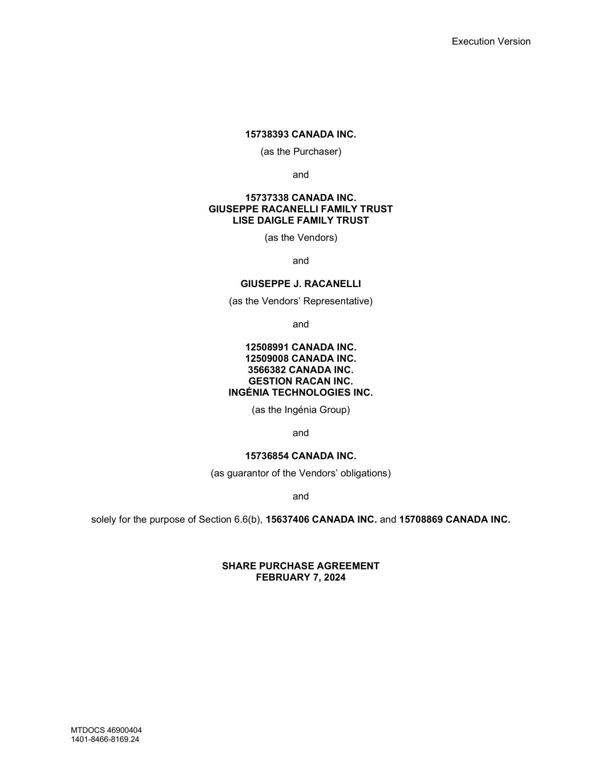
40
Execution Version MTDOCS 46900404 1401-8466-8169.24 15738393 CANADA INC. (as the Purchaser) and 15737338 CANADA INC. GIUSEPPE RACANELLI FAMILY TRUST LISE DAIGLE FAMILY TRUST (as the Vendors) and GIUSEPPE J. RACANELLI (as the Vendors’ Representative) and 12508991 CANADA INC. 12509008 CANADA INC. 3566382 CANADA INC. GESTION RACAN INC. INGÉNIA TECHNOLOGIES INC. (as the Ingénia Group) and 15736854 CANADA INC. (as guarantor of the Vendors’ obligations) and solely for the purpose of Section 6.6(b), 15637406 CANADA INC. and 15708869 CANADA INC. SHARE PURCHASE AGREEMENT FEBRUARY 7, 2024

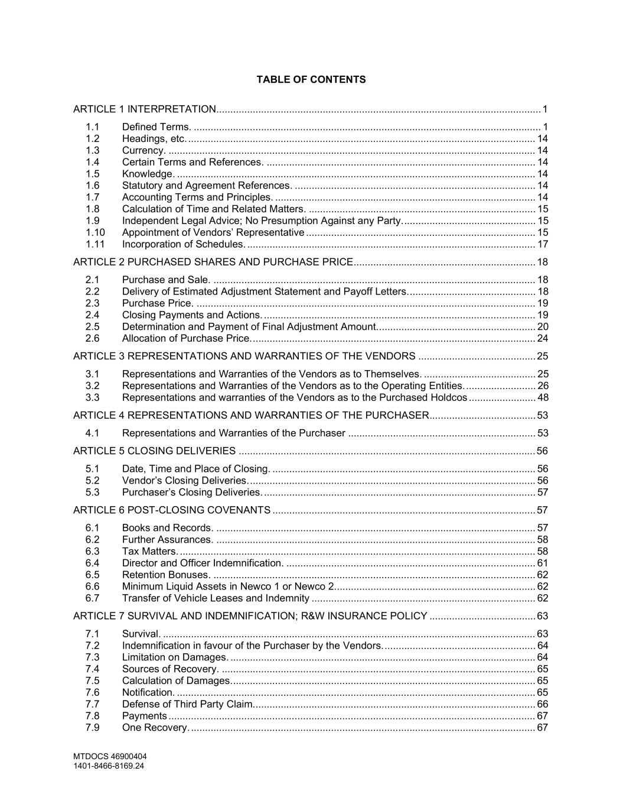
MTDOCS 46900404 1401-8466-8169.24 TABLE OF CONTENTS ARTICLE 1 INTERPRETATION....................................................................................................................1 1.1 Defined Terms. ............................................................................................................................ 1 1.2 Headings, etc............................................................................................................................. 14 1.3 Currency. ................................................................................................................................... 14 1.4 Certain Terms and References. ................................................................................................ 14 1.5 Knowledge. ................................................................................................................................ 14 1.6 Statutory and Agreement References. ...................................................................................... 14 1.7 Accounting Terms and Principles. ............................................................................................. 14 1.8 Calculation of Time and Related Matters. ................................................................................. 15 1.9 Independent Legal Advice; No Presumption Against any Party................................................ 15 1.10 Appointment of Vendors’ Representative .................................................................................. 15 1.11 Incorporation of Schedules. ....................................................................................................... 17 ARTICLE 2 PURCHASED SHARES AND PURCHASE PRICE.................................................................18 2.1 Purchase and Sale. ................................................................................................................... 18 2.2 Delivery of Estimated Adjustment Statement and Payoff Letters.............................................. 18 2.3 Purchase Price. ......................................................................................................................... 19 2.4 Closing Payments and Actions. ................................................................................................. 19 2.5 Determination and Payment of Final Adjustment Amount......................................................... 20 2.6 Allocation of Purchase Price...................................................................................................... 24 ARTICLE 3 REPRESENTATIONS AND WARRANTIES OF THE VENDORS ..........................................25 3.1 Representations and Warranties of the Vendors as to Themselves. ........................................ 25 3.2 Representations and Warranties of the Vendors as to the Operating Entities.......................... 26 3.3 Representations and warranties of the Vendors as to the Purchased Holdcos ........................ 48 ARTICLE 4 REPRESENTATIONS AND WARRANTIES OF THE PURCHASER......................................53 4.1 Representations and Warranties of the Purchaser ................................................................... 53 ARTICLE 5 CLOSING DELIVERIES ..........................................................................................................56 5.1 Date, Time and Place of Closing. .............................................................................................. 56 5.2 Vendor’s Closing Deliveries....................................................................................................... 56 5.3 Purchaser’s Closing Deliveries. ................................................................................................. 57 ARTICLE 6 POST-CLOSING COVENANTS ..............................................................................................57 6.1 Books and Records. .................................................................................................................. 57 6.2 Further Assurances. .................................................................................................................. 58 6.3 Tax Matters. ............................................................................................................................... 58 6.4 Director and Officer Indemnification. ......................................................................................... 61 6.5 Retention Bonuses. ................................................................................................................... 62 6.6 Minimum Liquid Assets in Newco 1 or Newco 2........................................................................ 62 6.7 Transfer of Vehicle Leases and Indemnity ................................................................................ 62 ARTICLE 7 SURVIVAL AND INDEMNIFICATION; R&W INSURANCE POLICY ......................................63 7.1 Survival. ..................................................................................................................................... 63 7.2 Indemnification in favour of the Purchaser by the Vendors....................................................... 64 7.3 Limitation on Damages. ............................................................................................................. 64 7.4 Sources of Recovery. ................................................................................................................ 65 7.5 Calculation of Damages............................................................................................................. 65 7.6 Notification. ................................................................................................................................ 65 7.7 Defense of Third Party Claim..................................................................................................... 66 7.8 Payments ................................................................................................................................... 67 7.9 One Recovery. ........................................................................................................................... 67

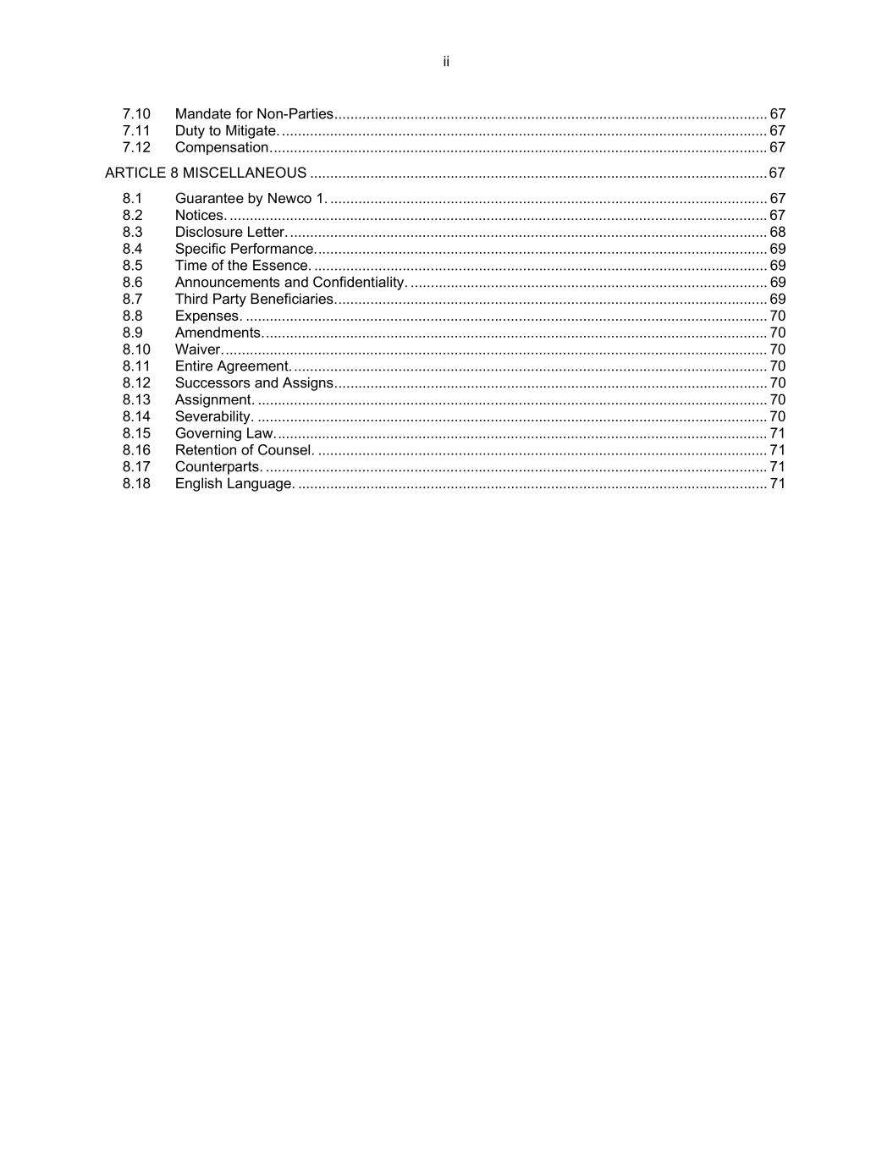
ii 7.10 Mandate for Non-Parties............................................................................................................ 67 7.11 Duty to Mitigate. ......................................................................................................................... 67 7.12 Compensation............................................................................................................................ 67 ARTICLE 8 MISCELLANEOUS ..................................................................................................................67 8.1 Guarantee by Newco 1. ............................................................................................................. 67 8.2 Notices. ...................................................................................................................................... 67 8.3 Disclosure Letter. ....................................................................................................................... 68 8.4 Specific Performance................................................................................................................. 69 8.5 Time of the Essence. ................................................................................................................. 69 8.6 Announcements and Confidentiality. ......................................................................................... 69 8.7 Third Party Beneficiaries............................................................................................................ 69 8.8 Expenses. .................................................................................................................................. 70 8.9 Amendments.............................................................................................................................. 70 8.10 Waiver........................................................................................................................................ 70 8.11 Entire Agreement. ...................................................................................................................... 70 8.12 Successors and Assigns............................................................................................................ 70 8.13 Assignment. ............................................................................................................................... 70 8.14 Severability. ............................................................................................................................... 70 8.15 Governing Law........................................................................................................................... 71 8.16 Retention of Counsel. ................................................................................................................ 71 8.17 Counterparts. ............................................................................................................................. 71 8.18 English Language. ..................................................................................................................... 71

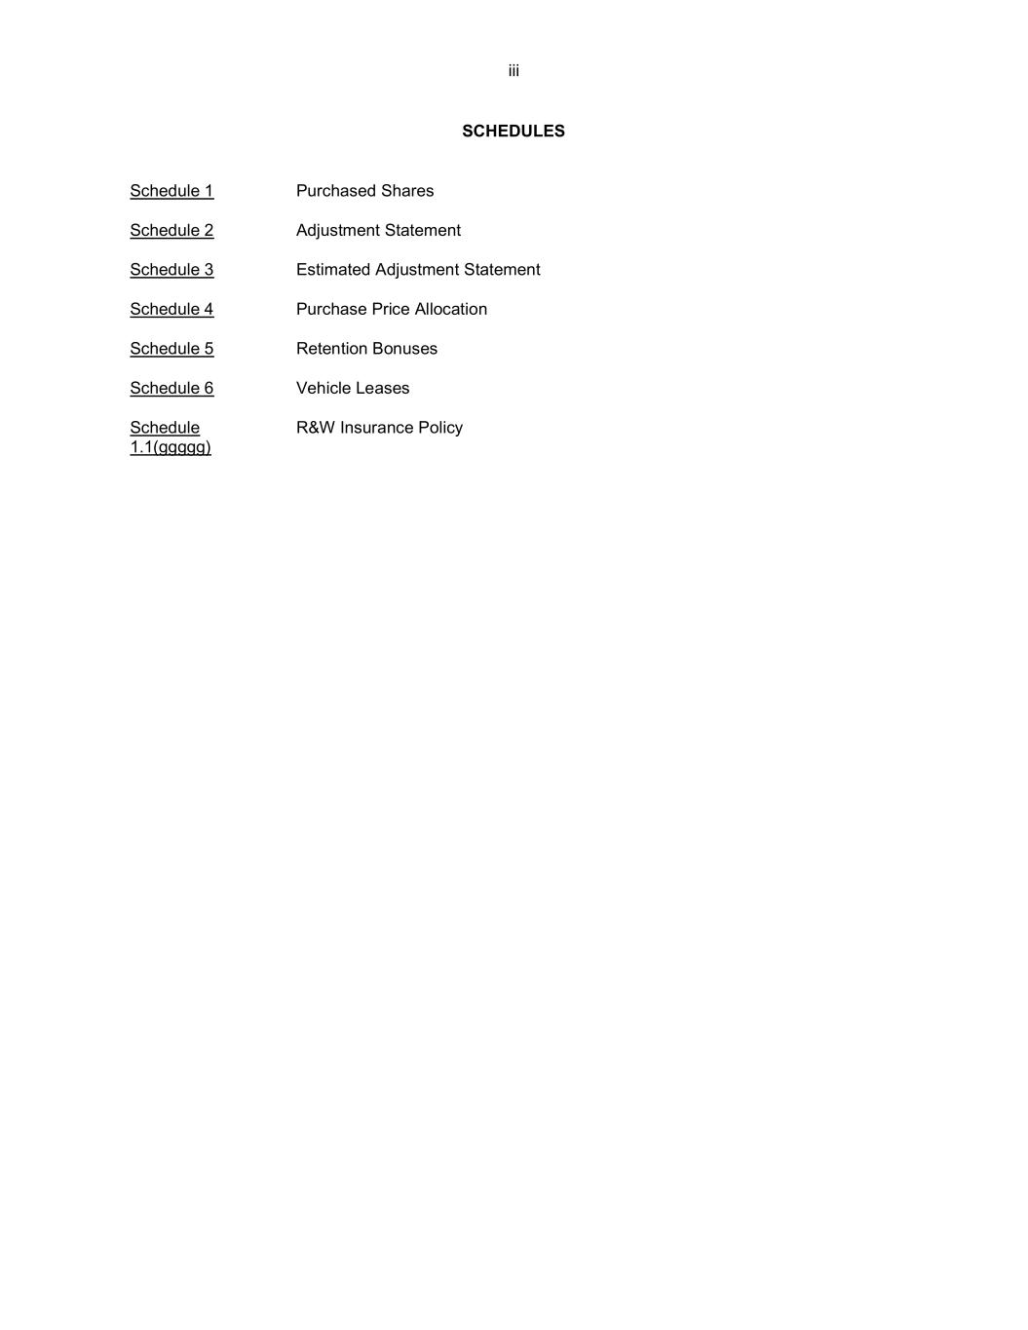
iii SCHEDULES Schedule 1 Purchased Shares Schedule 2 Adjustment Statement Schedule 3 Estimated Adjustment Statement Schedule 4 Purchase Price Allocation Schedule 5 Retention Bonuses Schedule 6 Vehicle Leases Schedule 1.1(ggggg) R&W Insurance Policy

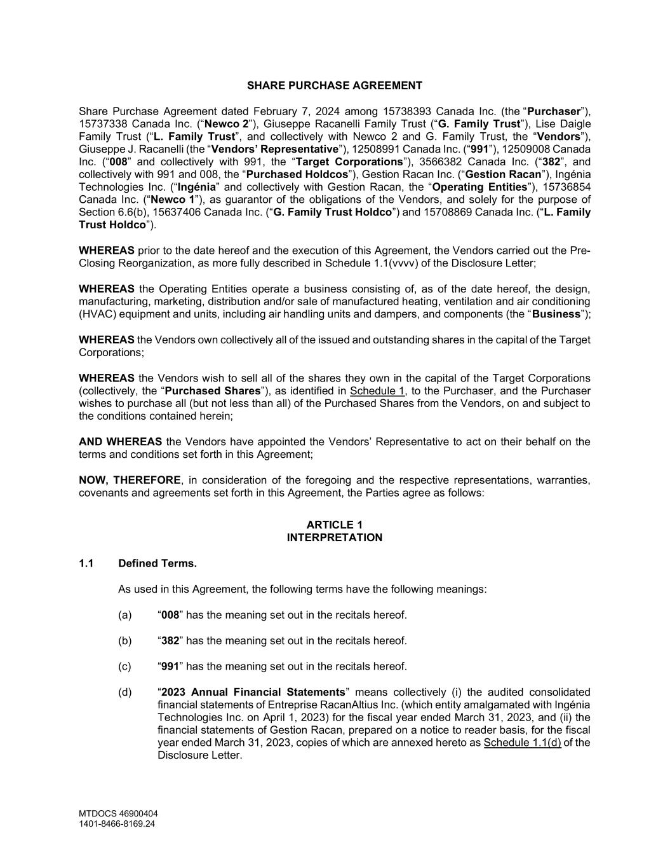
MTDOCS 46900404 1401-8466-8169.24 SHARE PURCHASE AGREEMENT Share Purchase Agreement dated February 7, 2024 among 15738393 Canada Inc. (the “Purchaser”), 15737338 Canada Inc. (“Newco 2”), Giuseppe Racanelli Family Trust (“G. Family Trust”), Lise Daigle Family Trust (“L. Family Trust”, and collectively with Newco 2 and G. Family Trust, the “Vendors”), Giuseppe J. Racanelli (the “Vendors’ Representative”), 12508991 Canada Inc. (“991”), 12509008 Canada Inc. (“008” and collectively with 991, the “Target Corporations”), 3566382 Canada Inc. (“382”, and collectively with 991 and 008, the “Purchased Holdcos”), Gestion Racan Inc. (“Gestion Racan”), Ingénia Technologies Inc. (“Ingénia” and collectively with Gestion Racan, the “Operating Entities”), 15736854 Canada Inc. (“Newco 1”), as guarantor of the obligations of the Vendors, and solely for the purpose of Section 6.6(b), 15637406 Canada Inc. (“G. Family Trust Holdco”) and 15708869 Canada Inc. (“L. Family Trust Holdco”). WHEREAS prior to the date hereof and the execution of this Agreement, the Vendors carried out the Pre- Closing Reorganization, as more fully described in Schedule 1.1(vvvv) of the Disclosure Letter; WHEREAS the Operating Entities operate a business consisting of, as of the date hereof, the design, manufacturing, marketing, distribution and/or sale of manufactured heating, ventilation and air conditioning (HVAC) equipment and units, including air handling units and dampers, and components (the “Business”); WHEREAS the Vendors own collectively all of the issued and outstanding shares in the capital of the Target Corporations; WHEREAS the Vendors wish to sell all of the shares they own in the capital of the Target Corporations (collectively, the “Purchased Shares”), as identified in Schedule 1, to the Purchaser, and the Purchaser wishes to purchase all (but not less than all) of the Purchased Shares from the Vendors, on and subject to the conditions contained herein; AND WHEREAS the Vendors have appointed the Vendors’ Representative to act on their behalf on the terms and conditions set forth in this Agreement; NOW, THEREFORE, in consideration of the foregoing and the respective representations, warranties, covenants and agreements set forth in this Agreement, the Parties agree as follows: ARTICLE 1 INTERPRETATION 1.1 Defined Terms. As used in this Agreement, the following terms have the following meanings: (a) “008” has the meaning set out in the recitals hereof. (b) “382” has the meaning set out in the recitals hereof. (c) “991” has the meaning set out in the recitals hereof. (d) “2023 Annual Financial Statements” means collectively (i) the audited consolidated financial statements of Entreprise RacanAltius Inc. (which entity amalgamated with Ingénia Technologies Inc. on April 1, 2023) for the fiscal year ended March 31, 2023, and (ii) the financial statements of Gestion Racan, prepared on a notice to reader basis, for the fiscal year ended March 31, 2023, copies of which are annexed hereto as Schedule 1.1(d) of the Disclosure Letter.

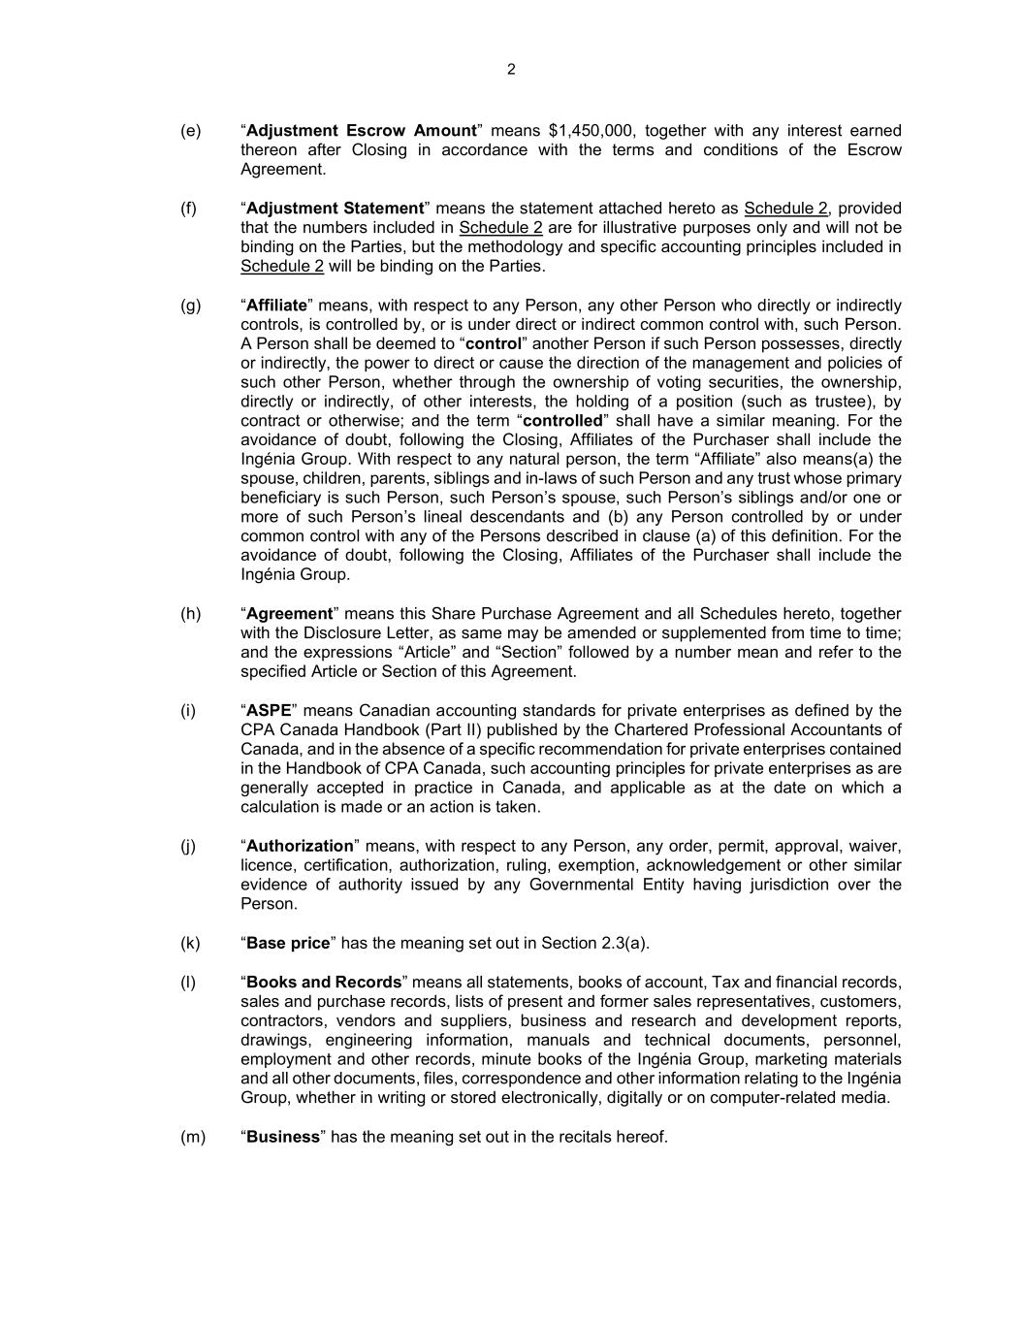
2 (e) “Adjustment Escrow Amount” means $1,450,000, together with any interest earned thereon after Closing in accordance with the terms and conditions of the Escrow Agreement. (f) “Adjustment Statement” means the statement attached hereto as Schedule 2, provided that the numbers included in Schedule 2 are for illustrative purposes only and will not be binding on the Parties, but the methodology and specific accounting principles included in Schedule 2 will be binding on the Parties. (g) “Affiliate” means, with respect to any Person, any other Person who directly or indirectly controls, is controlled by, or is under direct or indirect common control with, such Person. A Person shall be deemed to “control” another Person if such Person possesses, directly or indirectly, the power to direct or cause the direction of the management and policies of such other Person, whether through the ownership of voting securities, the ownership, directly or indirectly, of other interests, the holding of a position (such as trustee), by contract or otherwise; and the term “controlled” shall have a similar meaning. For the avoidance of doubt, following the Closing, Affiliates of the Purchaser shall include the Ingénia Group. With respect to any natural person, the term “Affiliate” also means(a) the spouse, children, parents, siblings and in-laws of such Person and any trust whose primary beneficiary is such Person, such Person’s spouse, such Person’s siblings and/or one or more of such Person’s lineal descendants and (b) any Person controlled by or under common control with any of the Persons described in clause (a) of this definition. For the avoidance of doubt, following the Closing, Affiliates of the Purchaser shall include the Ingénia Group. (h) “Agreement” means this Share Purchase Agreement and all Schedules hereto, together with the Disclosure Letter, as same may be amended or supplemented from time to time; and the expressions “Article” and “Section” followed by a number mean and refer to the specified Article or Section of this Agreement. (i) “ASPE” means Canadian accounting standards for private enterprises as defined by the CPA Canada Handbook (Part II) published by the Chartered Professional Accountants of Canada, and in the absence of a specific recommendation for private enterprises contained in the Handbook of CPA Canada, such accounting principles for private enterprises as are generally accepted in practice in Canada, and applicable as at the date on which a calculation is made or an action is taken. (j) “Authorization” means, with respect to any Person, any order, permit, approval, waiver, licence, certification, authorization, ruling, exemption, acknowledgement or other similar evidence of authority issued by any Governmental Entity having jurisdiction over the Person. (k) “Base price” has the meaning set out in Section 2.3(a). (l) “Books and Records” means all statements, books of account, Tax and financial records, sales and purchase records, lists of present and former sales representatives, customers, contractors, vendors and suppliers, business and research and development reports, drawings, engineering information, manuals and technical documents, personnel, employment and other records, minute books of the Ingénia Group, marketing materials and all other documents, files, correspondence and other information relating to the Ingénia Group, whether in writing or stored electronically, digitally or on computer-related media. (m) “Business” has the meaning set out in the recitals hereof.

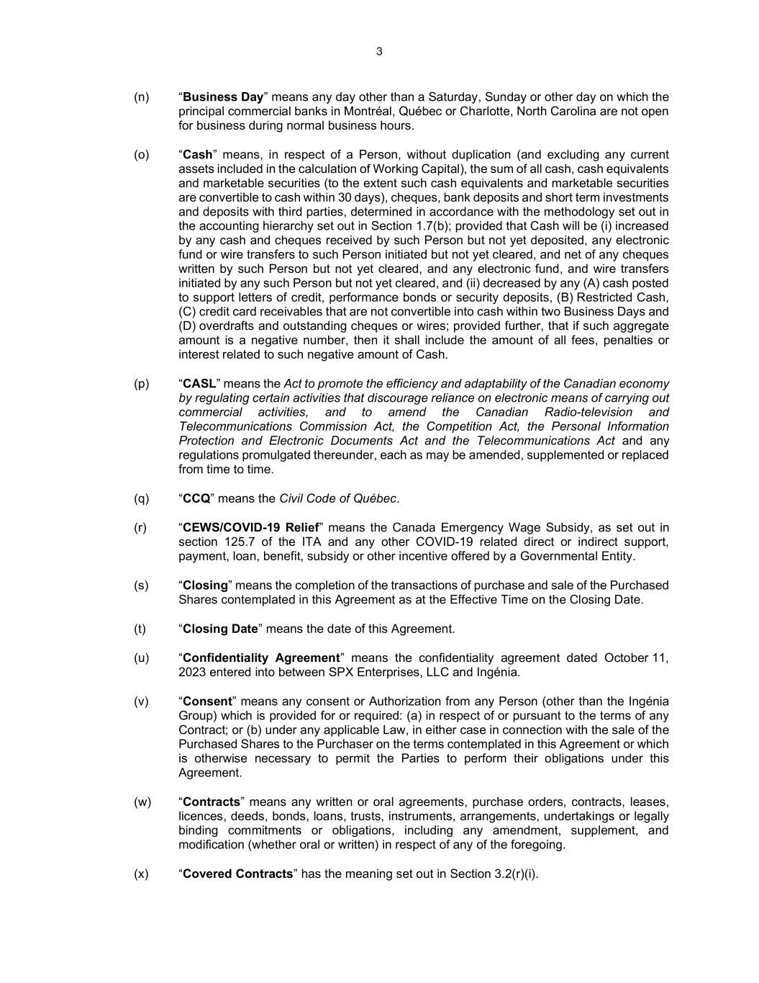
3 (n) “Business Day” means any day other than a Saturday, Sunday or other day on which the principal commercial banks in Montréal, Québec or Charlotte, North Carolina are not open for business during normal business hours. (o) “Cash” means, in respect of a Person, without duplication (and excluding any current assets included in the calculation of Working Capital), the sum of all cash, cash equivalents and marketable securities (to the extent such cash equivalents and marketable securities are convertible to cash within 30 days), cheques, bank deposits and short term investments and deposits with third parties, determined in accordance with the methodology set out in the accounting hierarchy set out in Section 1.7(b); provided that Cash will be (i) increased by any cash and cheques received by such Person but not yet deposited, any electronic fund or wire transfers to such Person initiated but not yet cleared, and net of any cheques written by such Person but not yet cleared, and any electronic fund, and wire transfers initiated by any such Person but not yet cleared, and (ii) decreased by any (A) cash posted to support letters of credit, performance bonds or security deposits, (B) Restricted Cash, (C) credit card receivables that are not convertible into cash within two Business Days and (D) overdrafts and outstanding cheques or wires; provided further, that if such aggregate amount is a negative number, then it shall include the amount of all fees, penalties or interest related to such negative amount of Cash. (p) “CASL” means the Act to promote the efficiency and adaptability of the Canadian economy by regulating certain activities that discourage reliance on electronic means of carrying out commercial activities, and to amend the Canadian Radio-television and Telecommunications Commission Act, the Competition Act, the Personal Information Protection and Electronic Documents Act and the Telecommunications Act and any regulations promulgated thereunder, each as may be amended, supplemented or replaced from time to time. (q) “CCQ” means the Civil Code of Québec. (r) “CEWS/COVID-19 Relief” means the Canada Emergency Wage Subsidy, as set out in section 125.7 of the ITA and any other COVID-19 related direct or indirect support, payment, loan, benefit, subsidy or other incentive offered by a Governmental Entity. (s) “Closing” means the completion of the transactions of purchase and sale of the Purchased Shares contemplated in this Agreement as at the Effective Time on the Closing Date. (t) “Closing Date” means the date of this Agreement. (u) “Confidentiality Agreement” means the confidentiality agreement dated October 11, 2023 entered into between SPX Enterprises, LLC and Ingénia. (v) “Consent” means any consent or Authorization from any Person (other than the Ingénia Group) which is provided for or required: (a) in respect of or pursuant to the terms of any Contract; or (b) under any applicable Law, in either case in connection with the sale of the Purchased Shares to the Purchaser on the terms contemplated in this Agreement or which is otherwise necessary to permit the Parties to perform their obligations under this Agreement. (w) “Contracts” means any written or oral agreements, purchase orders, contracts, leases, licences, deeds, bonds, loans, trusts, instruments, arrangements, undertakings or legally binding commitments or obligations, including any amendment, supplement, and modification (whether oral or written) in respect of any of the foregoing. (x) “Covered Contracts” has the meaning set out in Section 3.2(r)(i).

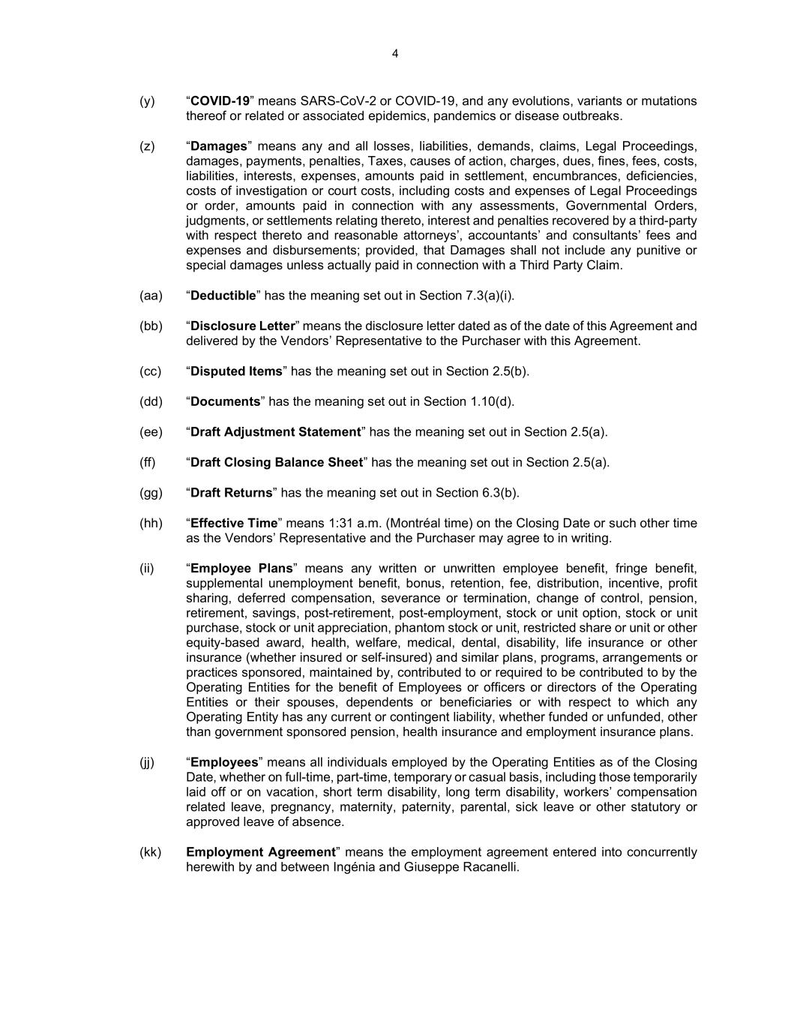
4 (y) “COVID-19” means SARS-CoV-2 or COVID-19, and any evolutions, variants or mutations thereof or related or associated epidemics, pandemics or disease outbreaks. (z) “Damages” means any and all losses, liabilities, demands, claims, Legal Proceedings, damages, payments, penalties, Taxes, causes of action, charges, dues, fines, fees, costs, liabilities, interests, expenses, amounts paid in settlement, encumbrances, deficiencies, costs of investigation or court costs, including costs and expenses of Legal Proceedings or order, amounts paid in connection with any assessments, Governmental Orders, judgments, or settlements relating thereto, interest and penalties recovered by a third-party with respect thereto and reasonable attorneys’, accountants’ and consultants’ fees and expenses and disbursements; provided, that Damages shall not include any punitive or special damages unless actually paid in connection with a Third Party Claim. (aa) “Deductible” has the meaning set out in Section 7.3(a)(i). (bb) “Disclosure Letter” means the disclosure letter dated as of the date of this Agreement and delivered by the Vendors’ Representative to the Purchaser with this Agreement. (cc) “Disputed Items” has the meaning set out in Section 2.5(b). (dd) “Documents” has the meaning set out in Section 1.10(d). (ee) “Draft Adjustment Statement” has the meaning set out in Section 2.5(a). (ff) “Draft Closing Balance Sheet” has the meaning set out in Section 2.5(a). (gg) “Draft Returns” has the meaning set out in Section 6.3(b). (hh) “Effective Time” means 1:31 a.m. (Montréal time) on the Closing Date or such other time as the Vendors’ Representative and the Purchaser may agree to in writing. (ii) “Employee Plans” means any written or unwritten employee benefit, fringe benefit, supplemental unemployment benefit, bonus, retention, fee, distribution, incentive, profit sharing, deferred compensation, severance or termination, change of control, pension, retirement, savings, post-retirement, post-employment, stock or unit option, stock or unit purchase, stock or unit appreciation, phantom stock or unit, restricted share or unit or other equity-based award, health, welfare, medical, dental, disability, life insurance or other insurance (whether insured or self-insured) and similar plans, programs, arrangements or practices sponsored, maintained by, contributed to or required to be contributed to by the Operating Entities for the benefit of Employees or officers or directors of the Operating Entities or their spouses, dependents or beneficiaries or with respect to which any Operating Entity has any current or contingent liability, whether funded or unfunded, other than government sponsored pension, health insurance and employment insurance plans. (jj) “Employees” means all individuals employed by the Operating Entities as of the Closing Date, whether on full-time, part-time, temporary or casual basis, including those temporarily laid off or on vacation, short term disability, long term disability, workers’ compensation related leave, pregnancy, maternity, paternity, parental, sick leave or other statutory or approved leave of absence. (kk) Employment Agreement” means the employment agreement entered into concurrently herewith by and between Ingénia and Giuseppe Racanelli.

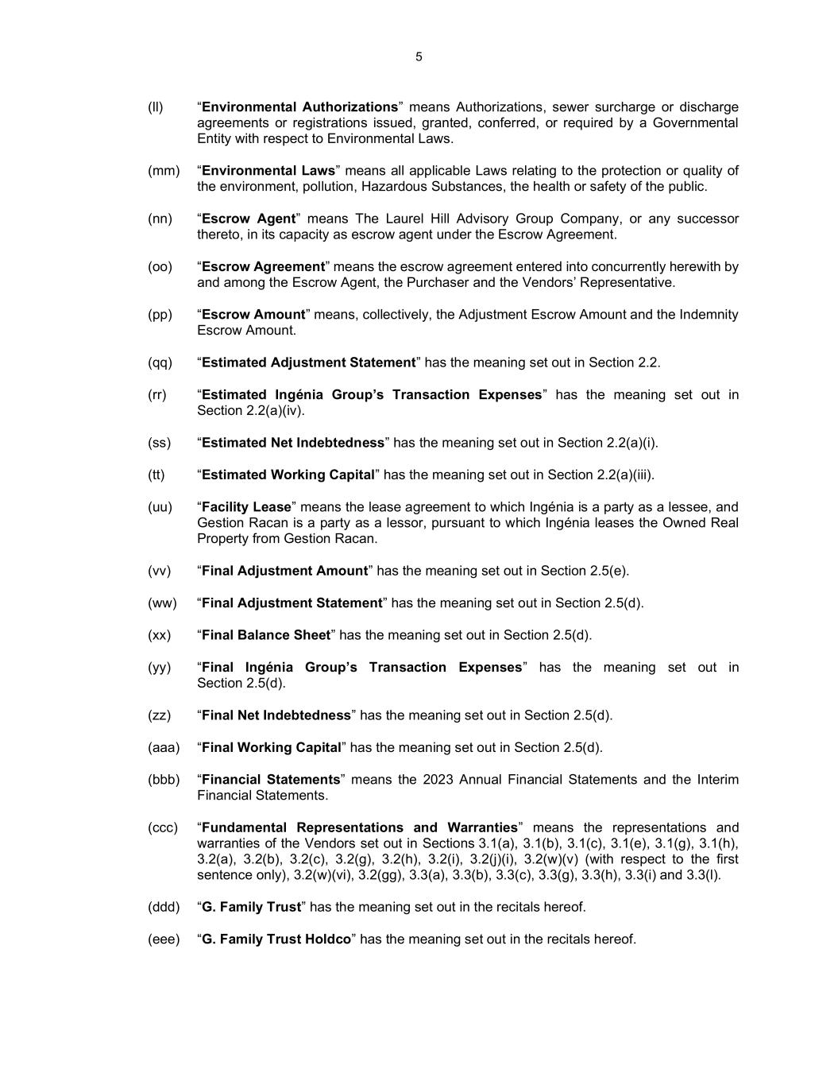
5 (ll) “Environmental Authorizations” means Authorizations, sewer surcharge or discharge agreements or registrations issued, granted, conferred, or required by a Governmental Entity with respect to Environmental Laws. (mm) “Environmental Laws” means all applicable Laws relating to the protection or quality of the environment, pollution, Hazardous Substances, the health or safety of the public. (nn) “Escrow Agent” means The Laurel Hill Advisory Group Company, or any successor thereto, in its capacity as escrow agent under the Escrow Agreement. (oo) “Escrow Agreement” means the escrow agreement entered into concurrently herewith by and among the Escrow Agent, the Purchaser and the Vendors’ Representative. (pp) “Escrow Amount” means, collectively, the Adjustment Escrow Amount and the Indemnity Escrow Amount. (qq) “Estimated Adjustment Statement” has the meaning set out in Section 2.2. (rr) “Estimated Ingénia Group’s Transaction Expenses” has the meaning set out in Section 2.2(a)(iv). (ss) “Estimated Net Indebtedness” has the meaning set out in Section 2.2(a)(i). (tt) “Estimated Working Capital” has the meaning set out in Section 2.2(a)(iii). (uu) “Facility Lease” means the lease agreement to which Ingénia is a party as a lessee, and Gestion Racan is a party as a lessor, pursuant to which Ingénia leases the Owned Real Property from Gestion Racan. (vv) “Final Adjustment Amount” has the meaning set out in Section 2.5(e). (ww) “Final Adjustment Statement” has the meaning set out in Section 2.5(d). (xx) “Final Balance Sheet” has the meaning set out in Section 2.5(d). (yy) “Final Ingénia Group’s Transaction Expenses” has the meaning set out in Section 2.5(d). (zz) “Final Net Indebtedness” has the meaning set out in Section 2.5(d). (aaa) “Final Working Capital” has the meaning set out in Section 2.5(d). (bbb) “Financial Statements” means the 2023 Annual Financial Statements and the Interim Financial Statements. (ccc) “Fundamental Representations and Warranties” means the representations and warranties of the Vendors set out in Sections 3.1(a), 3.1(b), 3.1(c), 3.1(e), 3.1(g), 3.1(h), 3.2(a), 3.2(b), 3.2(c), 3.2(g), 3.2(h), 3.2(i), 3.2(j)(i), 3.2(w)(v) (with respect to the first sentence only), 3.2(w)(vi), 3.2(gg), 3.3(a), 3.3(b), 3.3(c), 3.3(g), 3.3(h), 3.3(i) and 3.3(l). (ddd) “G. Family Trust” has the meaning set out in the recitals hereof. (eee) “G. Family Trust Holdco” has the meaning set out in the recitals hereof.

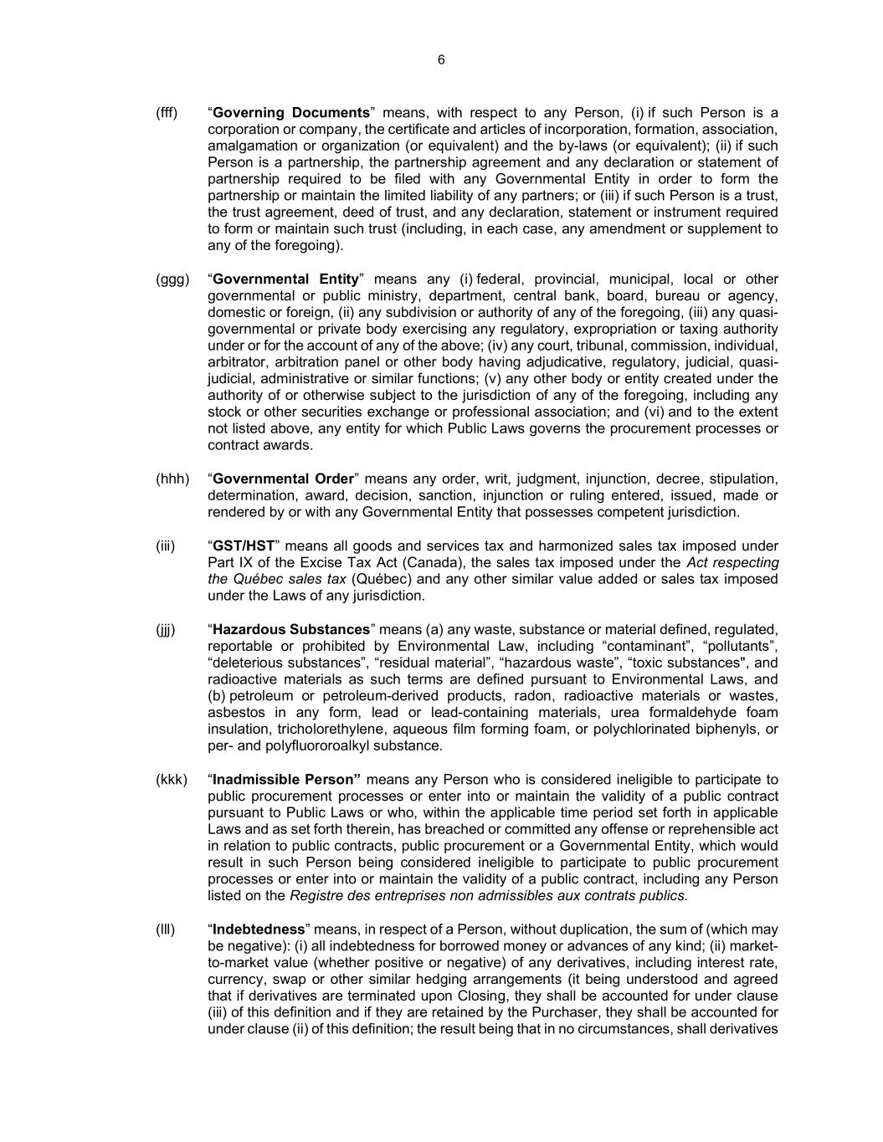
6 (fff) “Governing Documents” means, with respect to any Person, (i) if such Person is a corporation or company, the certificate and articles of incorporation, formation, association, amalgamation or organization (or equivalent) and the by-laws (or equivalent); (ii) if such Person is a partnership, the partnership agreement and any declaration or statement of partnership required to be filed with any Governmental Entity in order to form the partnership or maintain the limited liability of any partners; or (iii) if such Person is a trust, the trust agreement, deed of trust, and any declaration, statement or instrument required to form or maintain such trust (including, in each case, any amendment or supplement to any of the foregoing). (ggg) “Governmental Entity” means any (i) federal, provincial, municipal, local or other governmental or public ministry, department, central bank, board, bureau or agency, domestic or foreign, (ii) any subdivision or authority of any of the foregoing, (iii) any quasi- governmental or private body exercising any regulatory, expropriation or taxing authority under or for the account of any of the above; (iv) any court, tribunal, commission, individual, arbitrator, arbitration panel or other body having adjudicative, regulatory, judicial, quasi- judicial, administrative or similar functions; (v) any other body or entity created under the authority of or otherwise subject to the jurisdiction of any of the foregoing, including any stock or other securities exchange or professional association; and (vi) and to the extent not listed above, any entity for which Public Laws governs the procurement processes or contract awards. (hhh) “Governmental Order” means any order, writ, judgment, injunction, decree, stipulation, determination, award, decision, sanction, injunction or ruling entered, issued, made or rendered by or with any Governmental Entity that possesses competent jurisdiction. (iii) “GST/HST” means all goods and services tax and harmonized sales tax imposed under Part IX of the Excise Tax Act (Canada), the sales tax imposed under the Act respecting the Québec sales tax (Québec) and any other similar value added or sales tax imposed under the Laws of any jurisdiction. (jjj) “Hazardous Substances” means (a) any waste, substance or material defined, regulated, reportable or prohibited by Environmental Law, including “contaminant”, “pollutants”, “deleterious substances”, “residual material”, “hazardous waste”, “toxic substances", and radioactive materials as such terms are defined pursuant to Environmental Laws, and (b) petroleum or petroleum-derived products, radon, radioactive materials or wastes, asbestos in any form, lead or lead-containing materials, urea formaldehyde foam insulation, tricholorethylene, aqueous film forming foam, or polychlorinated biphenyls, or per- and polyfluororoalkyl substance. (kkk) “Inadmissible Person” means any Person who is considered ineligible to participate to public procurement processes or enter into or maintain the validity of a public contract pursuant to Public Laws or who, within the applicable time period set forth in applicable Laws and as set forth therein, has breached or committed any offense or reprehensible act in relation to public contracts, public procurement or a Governmental Entity, which would result in such Person being considered ineligible to participate to public procurement processes or enter into or maintain the validity of a public contract, including any Person listed on the Registre des entreprises non admissibles aux contrats publics. (lll) “Indebtedness” means, in respect of a Person, without duplication, the sum of (which may be negative): (i) all indebtedness for borrowed money or advances of any kind; (ii) market- to-market value (whether positive or negative) of any derivatives, including interest rate, currency, swap or other similar hedging arrangements (it being understood and agreed that if derivatives are terminated upon Closing, they shall be accounted for under clause (iii) of this definition and if they are retained by the Purchaser, they shall be accounted for under clause (ii) of this definition; the result being that in no circumstances, shall derivatives

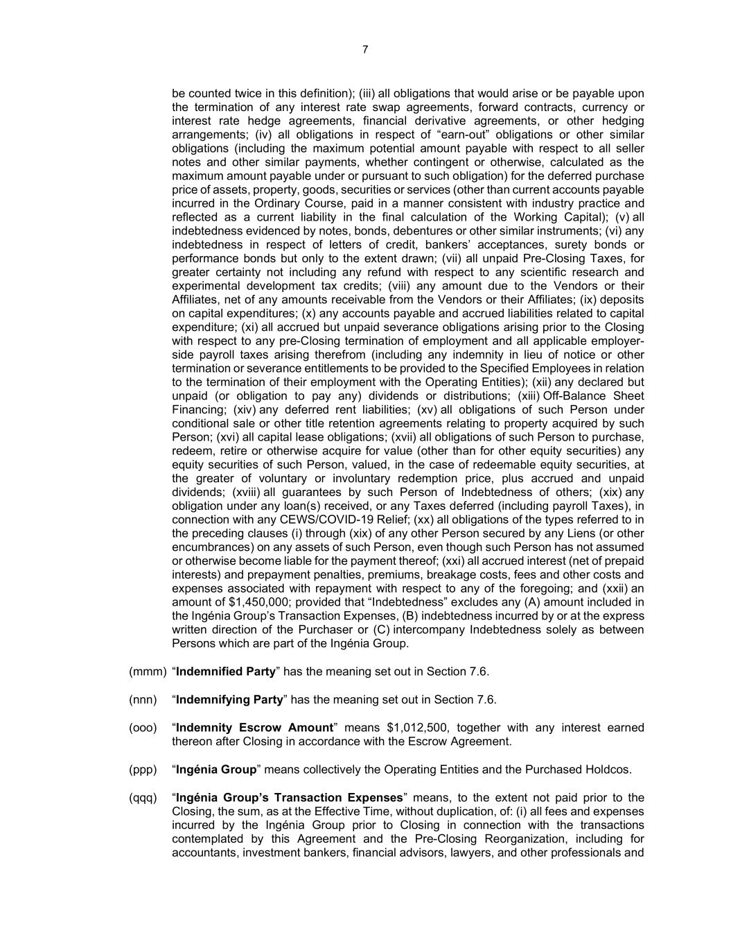
7 be counted twice in this definition); (iii) all obligations that would arise or be payable upon the termination of any interest rate swap agreements, forward contracts, currency or interest rate hedge agreements, financial derivative agreements, or other hedging arrangements; (iv) all obligations in respect of “earn-out” obligations or other similar obligations (including the maximum potential amount payable with respect to all seller notes and other similar payments, whether contingent or otherwise, calculated as the maximum amount payable under or pursuant to such obligation) for the deferred purchase price of assets, property, goods, securities or services (other than current accounts payable incurred in the Ordinary Course, paid in a manner consistent with industry practice and reflected as a current liability in the final calculation of the Working Capital); (v) all indebtedness evidenced by notes, bonds, debentures or other similar instruments; (vi) any indebtedness in respect of letters of credit, bankers’ acceptances, surety bonds or performance bonds but only to the extent drawn; (vii) all unpaid Pre-Closing Taxes, for greater certainty not including any refund with respect to any scientific research and experimental development tax credits; (viii) any amount due to the Vendors or their Affiliates, net of any amounts receivable from the Vendors or their Affiliates; (ix) deposits on capital expenditures; (x) any accounts payable and accrued liabilities related to capital expenditure; (xi) all accrued but unpaid severance obligations arising prior to the Closing with respect to any pre-Closing termination of employment and all applicable employer- side payroll taxes arising therefrom (including any indemnity in lieu of notice or other termination or severance entitlements to be provided to the Specified Employees in relation to the termination of their employment with the Operating Entities); (xii) any declared but unpaid (or obligation to pay any) dividends or distributions; (xiii) Off-Balance Sheet Financing; (xiv) any deferred rent liabilities; (xv) all obligations of such Person under conditional sale or other title retention agreements relating to property acquired by such Person; (xvi) all capital lease obligations; (xvii) all obligations of such Person to purchase, redeem, retire or otherwise acquire for value (other than for other equity securities) any equity securities of such Person, valued, in the case of redeemable equity securities, at the greater of voluntary or involuntary redemption price, plus accrued and unpaid dividends; (xviii) all guarantees by such Person of Indebtedness of others; (xix) any obligation under any loan(s) received, or any Taxes deferred (including payroll Taxes), in connection with any CEWS/COVID-19 Relief; (xx) all obligations of the types referred to in the preceding clauses (i) through (xix) of any other Person secured by any Liens (or other encumbrances) on any assets of such Person, even though such Person has not assumed or otherwise become liable for the payment thereof; (xxi) all accrued interest (net of prepaid interests) and prepayment penalties, premiums, breakage costs, fees and other costs and expenses associated with repayment with respect to any of the foregoing; and (xxii) an amount of $1,450,000; provided that “Indebtedness” excludes any (A) amount included in the Ingénia Group’s Transaction Expenses, (B) indebtedness incurred by or at the express written direction of the Purchaser or (C) intercompany Indebtedness solely as between Persons which are part of the Ingénia Group. (mmm) “Indemnified Party” has the meaning set out in Section 7.6. (nnn) “Indemnifying Party” has the meaning set out in Section 7.6. (ooo) “Indemnity Escrow Amount” means $1,012,500, together with any interest earned thereon after Closing in accordance with the Escrow Agreement. (ppp) “Ingénia Group” means collectively the Operating Entities and the Purchased Holdcos. (qqq) “Ingénia Group’s Transaction Expenses” means, to the extent not paid prior to the Closing, the sum, as at the Effective Time, without duplication, of: (i) all fees and expenses incurred by the Ingénia Group prior to Closing in connection with the transactions contemplated by this Agreement and the Pre-Closing Reorganization, including for accountants, investment bankers, financial advisors, lawyers, and other professionals and

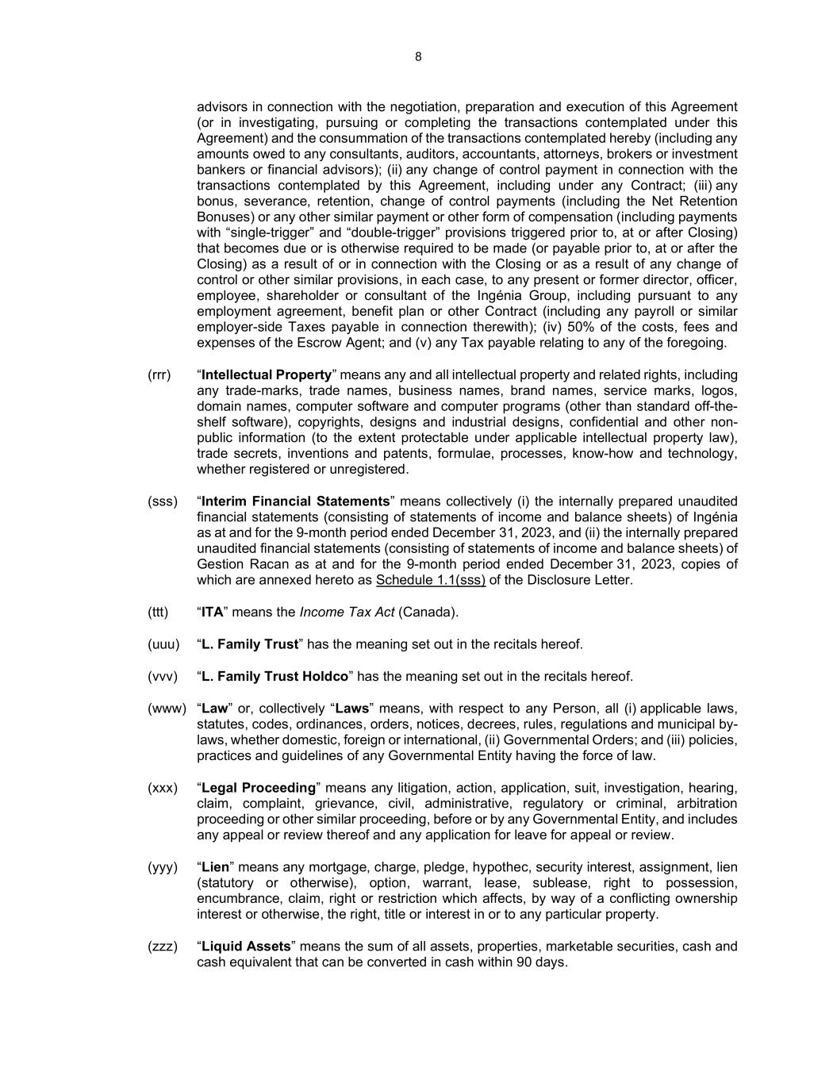
8 advisors in connection with the negotiation, preparation and execution of this Agreement (or in investigating, pursuing or completing the transactions contemplated under this Agreement) and the consummation of the transactions contemplated hereby (including any amounts owed to any consultants, auditors, accountants, attorneys, brokers or investment bankers or financial advisors); (ii) any change of control payment in connection with the transactions contemplated by this Agreement, including under any Contract; (iii) any bonus, severance, retention, change of control payments (including the Net Retention Bonuses) or any other similar payment or other form of compensation (including payments with “single-trigger” and “double-trigger” provisions triggered prior to, at or after Closing) that becomes due or is otherwise required to be made (or payable prior to, at or after the Closing) as a result of or in connection with the Closing or as a result of any change of control or other similar provisions, in each case, to any present or former director, officer, employee, shareholder or consultant of the Ingénia Group, including pursuant to any employment agreement, benefit plan or other Contract (including any payroll or similar employer-side Taxes payable in connection therewith); (iv) 50% of the costs, fees and expenses of the Escrow Agent; and (v) any Tax payable relating to any of the foregoing. (rrr) “Intellectual Property” means any and all intellectual property and related rights, including any trade-marks, trade names, business names, brand names, service marks, logos, domain names, computer software and computer programs (other than standard off-the- shelf software), copyrights, designs and industrial designs, confidential and other non- public information (to the extent protectable under applicable intellectual property law), trade secrets, inventions and patents, formulae, processes, know-how and technology, whether registered or unregistered. (sss) “Interim Financial Statements” means collectively (i) the internally prepared unaudited financial statements (consisting of statements of income and balance sheets) of Ingénia as at and for the 9-month period ended December 31, 2023, and (ii) the internally prepared unaudited financial statements (consisting of statements of income and balance sheets) of Gestion Racan as at and for the 9-month period ended December 31, 2023, copies of which are annexed hereto as Schedule 1.1(sss) of the Disclosure Letter. (ttt) “ITA” means the Income Tax Act (Canada). (uuu) “L. Family Trust” has the meaning set out in the recitals hereof. (vvv) “L. Family Trust Holdco” has the meaning set out in the recitals hereof. (www) “Law” or, collectively “Laws” means, with respect to any Person, all (i) applicable laws, statutes, codes, ordinances, orders, notices, decrees, rules, regulations and municipal by- laws, whether domestic, foreign or international, (ii) Governmental Orders; and (iii) policies, practices and guidelines of any Governmental Entity having the force of law. (xxx) “Legal Proceeding” means any litigation, action, application, suit, investigation, hearing, claim, complaint, grievance, civil, administrative, regulatory or criminal, arbitration proceeding or other similar proceeding, before or by any Governmental Entity, and includes any appeal or review thereof and any application for leave for appeal or review. (yyy) “Lien” means any mortgage, charge, pledge, hypothec, security interest, assignment, lien (statutory or otherwise), option, warrant, lease, sublease, right to possession, encumbrance, claim, right or restriction which affects, by way of a conflicting ownership interest or otherwise, the right, title or interest in or to any particular property. (zzz) “Liquid Assets” means the sum of all assets, properties, marketable securities, cash and cash equivalent that can be converted in cash within 90 days.

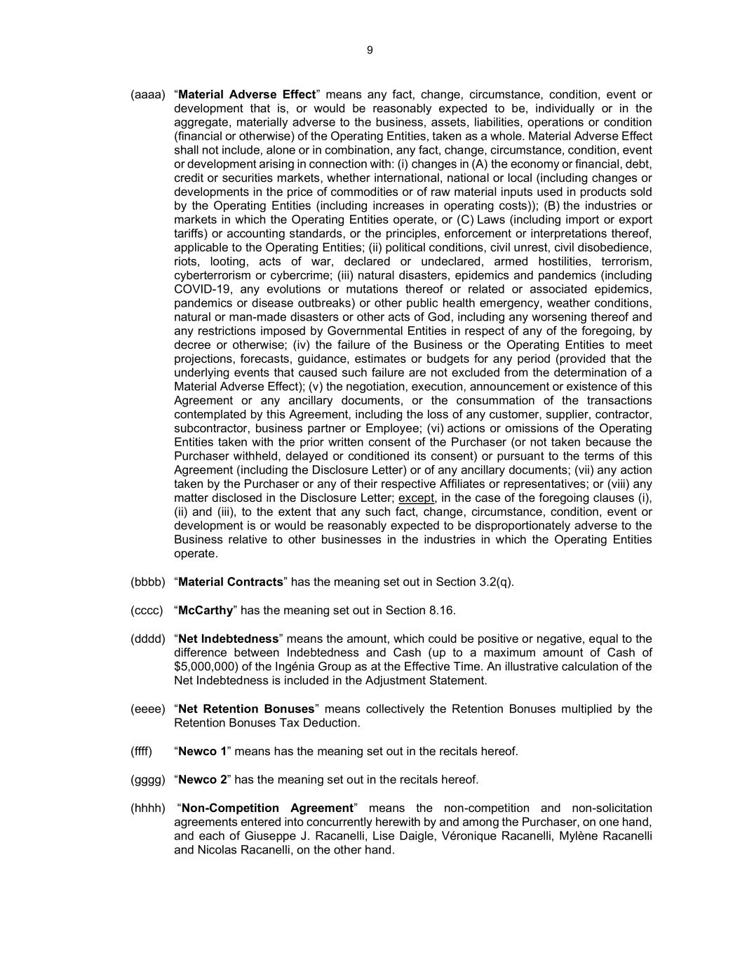
9 (aaaa) “Material Adverse Effect” means any fact, change, circumstance, condition, event or development that is, or would be reasonably expected to be, individually or in the aggregate, materially adverse to the business, assets, liabilities, operations or condition (financial or otherwise) of the Operating Entities, taken as a whole. Material Adverse Effect shall not include, alone or in combination, any fact, change, circumstance, condition, event or development arising in connection with: (i) changes in (A) the economy or financial, debt, credit or securities markets, whether international, national or local (including changes or developments in the price of commodities or of raw material inputs used in products sold by the Operating Entities (including increases in operating costs)); (B) the industries or markets in which the Operating Entities operate, or (C) Laws (including import or export tariffs) or accounting standards, or the principles, enforcement or interpretations thereof, applicable to the Operating Entities; (ii) political conditions, civil unrest, civil disobedience, riots, looting, acts of war, declared or undeclared, armed hostilities, terrorism, cyberterrorism or cybercrime; (iii) natural disasters, epidemics and pandemics (including COVID-19, any evolutions or mutations thereof or related or associated epidemics, pandemics or disease outbreaks) or other public health emergency, weather conditions, natural or man-made disasters or other acts of God, including any worsening thereof and any restrictions imposed by Governmental Entities in respect of any of the foregoing, by decree or otherwise; (iv) the failure of the Business or the Operating Entities to meet projections, forecasts, guidance, estimates or budgets for any period (provided that the underlying events that caused such failure are not excluded from the determination of a Material Adverse Effect); (v) the negotiation, execution, announcement or existence of this Agreement or any ancillary documents, or the consummation of the transactions contemplated by this Agreement, including the loss of any customer, supplier, contractor, subcontractor, business partner or Employee; (vi) actions or omissions of the Operating Entities taken with the prior written consent of the Purchaser (or not taken because the Purchaser withheld, delayed or conditioned its consent) or pursuant to the terms of this Agreement (including the Disclosure Letter) or of any ancillary documents; (vii) any action taken by the Purchaser or any of their respective Affiliates or representatives; or (viii) any matter disclosed in the Disclosure Letter; except, in the case of the foregoing clauses (i), (ii) and (iii), to the extent that any such fact, change, circumstance, condition, event or development is or would be reasonably expected to be disproportionately adverse to the Business relative to other businesses in the industries in which the Operating Entities operate. (bbbb) “Material Contracts” has the meaning set out in Section 3.2(q). (cccc) “McCarthy” has the meaning set out in Section 8.16. (dddd) “Net Indebtedness” means the amount, which could be positive or negative, equal to the difference between Indebtedness and Cash (up to a maximum amount of Cash of $5,000,000) of the Ingénia Group as at the Effective Time. An illustrative calculation of the Net Indebtedness is included in the Adjustment Statement. (eeee) “Net Retention Bonuses” means collectively the Retention Bonuses multiplied by the Retention Bonuses Tax Deduction. (ffff) “Newco 1” means has the meaning set out in the recitals hereof. (gggg) “Newco 2” has the meaning set out in the recitals hereof. (hhhh) “Non-Competition Agreement” means the non-competition and non-solicitation agreements entered into concurrently herewith by and among the Purchaser, on one hand, and each of Giuseppe J. Racanelli, Lise Daigle, Véronique Racanelli, Mylène Racanelli and Nicolas Racanelli, on the other hand.

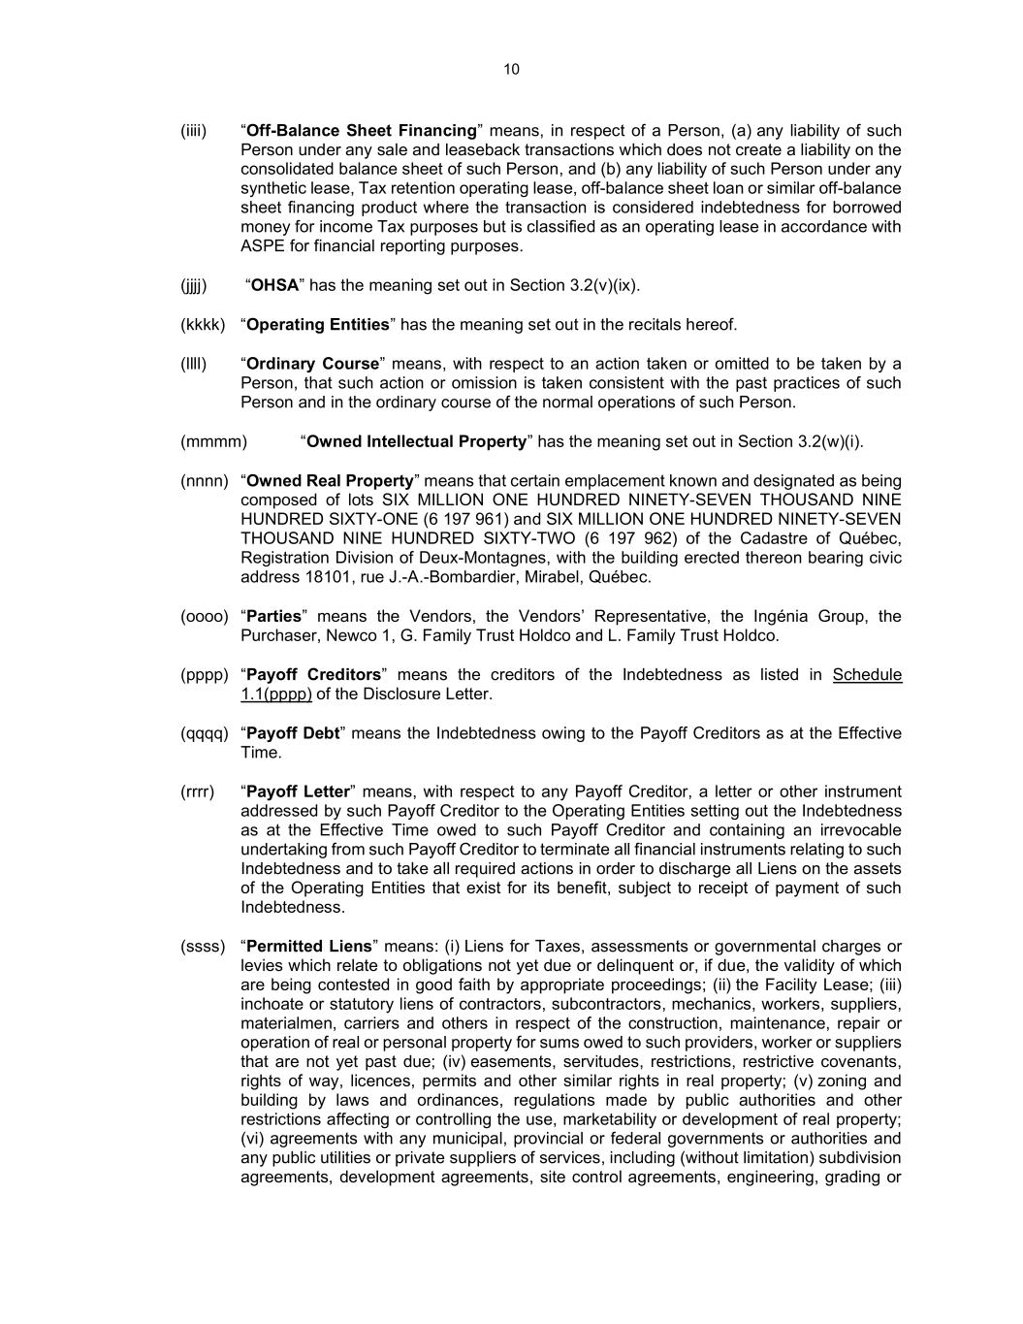
10 (iiii) “Off-Balance Sheet Financing” means, in respect of a Person, (a) any liability of such Person under any sale and leaseback transactions which does not create a liability on the consolidated balance sheet of such Person, and (b) any liability of such Person under any synthetic lease, Tax retention operating lease, off-balance sheet loan or similar off-balance sheet financing product where the transaction is considered indebtedness for borrowed money for income Tax purposes but is classified as an operating lease in accordance with ASPE for financial reporting purposes. (jjjj) “OHSA” has the meaning set out in Section 3.2(v)(ix). (kkkk) “Operating Entities” has the meaning set out in the recitals hereof. (llll) “Ordinary Course” means, with respect to an action taken or omitted to be taken by a Person, that such action or omission is taken consistent with the past practices of such Person and in the ordinary course of the normal operations of such Person. (mmmm) “Owned Intellectual Property” has the meaning set out in Section 3.2(w)(i). (nnnn) “Owned Real Property” means that certain emplacement known and designated as being composed of lots SIX MILLION ONE HUNDRED NINETY-SEVEN THOUSAND NINE HUNDRED SIXTY-ONE (6 197 961) and SIX MILLION ONE HUNDRED NINETY-SEVEN THOUSAND NINE HUNDRED SIXTY-TWO (6 197 962) of the Cadastre of Québec, Registration Division of Deux-Montagnes, with the building erected thereon bearing civic address 18101, rue J.-A.-Bombardier, Mirabel, Québec. (oooo) “Parties” means the Vendors, the Vendors’ Representative, the Ingénia Group, the Purchaser, Newco 1, G. Family Trust Holdco and L. Family Trust Holdco. (pppp) “Payoff Creditors” means the creditors of the Indebtedness as listed in Schedule 1.1(pppp) of the Disclosure Letter. (qqqq) “Payoff Debt” means the Indebtedness owing to the Payoff Creditors as at the Effective Time. (rrrr) “Payoff Letter” means, with respect to any Payoff Creditor, a letter or other instrument addressed by such Payoff Creditor to the Operating Entities setting out the Indebtedness as at the Effective Time owed to such Payoff Creditor and containing an irrevocable undertaking from such Payoff Creditor to terminate all financial instruments relating to such Indebtedness and to take all required actions in order to discharge all Liens on the assets of the Operating Entities that exist for its benefit, subject to receipt of payment of such Indebtedness. (ssss) “Permitted Liens” means: (i) Liens for Taxes, assessments or governmental charges or levies which relate to obligations not yet due or delinquent or, if due, the validity of which are being contested in good faith by appropriate proceedings; (ii) the Facility Lease; (iii) inchoate or statutory liens of contractors, subcontractors, mechanics, workers, suppliers, materialmen, carriers and others in respect of the construction, maintenance, repair or operation of real or personal property for sums owed to such providers, worker or suppliers that are not yet past due; (iv) easements, servitudes, restrictions, restrictive covenants, rights of way, licences, permits and other similar rights in real property; (v) zoning and building by laws and ordinances, regulations made by public authorities and other restrictions affecting or controlling the use, marketability or development of real property; (vi) agreements with any municipal, provincial or federal governments or authorities and any public utilities or private suppliers of services, including (without limitation) subdivision agreements, development agreements, site control agreements, engineering, grading or

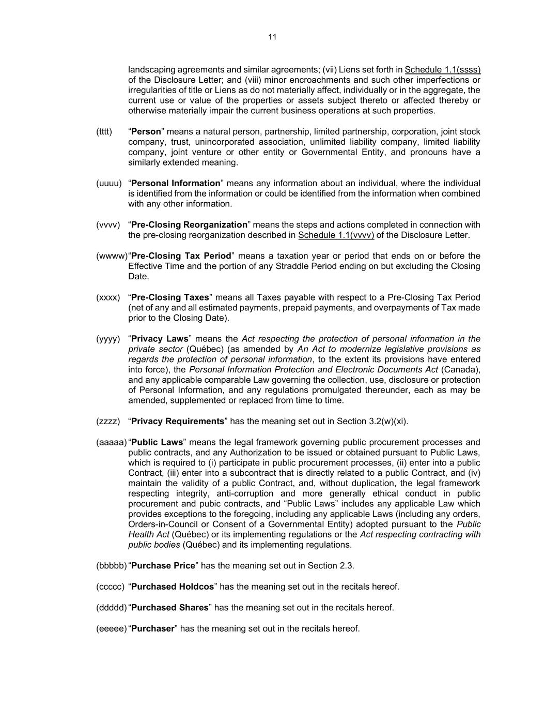
11 landscaping agreements and similar agreements; (vii) Liens set forth in Schedule 1.1(ssss) of the Disclosure Letter; and (viii) minor encroachments and such other imperfections or irregularities of title or Liens as do not materially affect, individually or in the aggregate, the current use or value of the properties or assets subject thereto or affected thereby or otherwise materially impair the current business operations at such properties. (tttt) “Person” means a natural person, partnership, limited partnership, corporation, joint stock company, trust, unincorporated association, unlimited liability company, limited liability company, joint venture or other entity or Governmental Entity, and pronouns have a similarly extended meaning. (uuuu) “Personal Information” means any information about an individual, where the individual is identified from the information or could be identified from the information when combined with any other information. (vvvv) “Pre-Closing Reorganization” means the steps and actions completed in connection with the pre-closing reorganization described in Schedule 1.1(vvvv) of the Disclosure Letter. (wwww)“Pre-Closing Tax Period” means a taxation year or period that ends on or before the Effective Time and the portion of any Straddle Period ending on but excluding the Closing Date. (xxxx) “Pre-Closing Taxes” means all Taxes payable with respect to a Pre-Closing Tax Period (net of any and all estimated payments, prepaid payments, and overpayments of Tax made prior to the Closing Date). (yyyy) “Privacy Laws” means the Act respecting the protection of personal information in the private sector (Québec) (as amended by An Act to modernize legislative provisions as regards the protection of personal information, to the extent its provisions have entered into force), the Personal Information Protection and Electronic Documents Act (Canada), and any applicable comparable Law governing the collection, use, disclosure or protection of Personal Information, and any regulations promulgated thereunder, each as may be amended, supplemented or replaced from time to time. (zzzz) “Privacy Requirements” has the meaning set out in Section 3.2(w)(xi). (aaaaa) “Public Laws” means the legal framework governing public procurement processes and public contracts, and any Authorization to be issued or obtained pursuant to Public Laws, which is required to (i) participate in public procurement processes, (ii) enter into a public Contract, (iii) enter into a subcontract that is directly related to a public Contract, and (iv) maintain the validity of a public Contract, and, without duplication, the legal framework respecting integrity, anti-corruption and more generally ethical conduct in public procurement and pubic contracts, and “Public Laws” includes any applicable Law which provides exceptions to the foregoing, including any applicable Laws (including any orders, Orders-in-Council or Consent of a Governmental Entity) adopted pursuant to the Public Health Act (Québec) or its implementing regulations or the Act respecting contracting with public bodies (Québec) and its implementing regulations. (bbbbb) “Purchase Price” has the meaning set out in Section 2.3. (ccccc) “Purchased Holdcos” has the meaning set out in the recitals hereof. (ddddd) “Purchased Shares” has the meaning set out in the recitals hereof. (eeeee) “Purchaser” has the meaning set out in the recitals hereof.

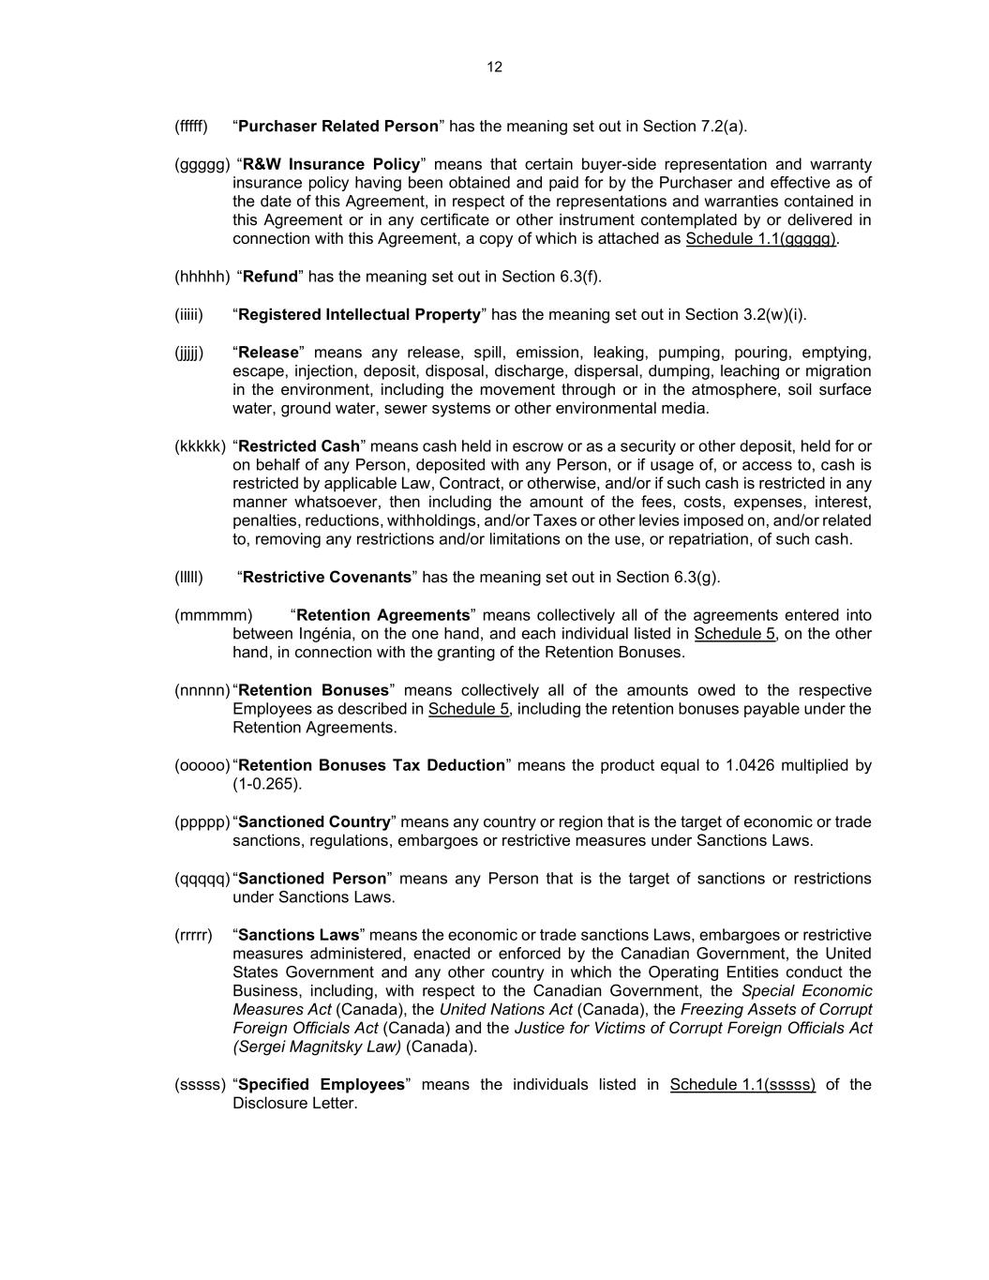
12 (fffff) “Purchaser Related Person” has the meaning set out in Section 7.2(a). (ggggg) “R&W Insurance Policy” means that certain buyer-side representation and warranty insurance policy having been obtained and paid for by the Purchaser and effective as of the date of this Agreement, in respect of the representations and warranties contained in this Agreement or in any certificate or other instrument contemplated by or delivered in connection with this Agreement, a copy of which is attached as Schedule 1.1(ggggg). (hhhhh) “Refund” has the meaning set out in Section 6.3(f). (iiiii) “Registered Intellectual Property” has the meaning set out in Section 3.2(w)(i). (jjjjj) “Release” means any release, spill, emission, leaking, pumping, pouring, emptying, escape, injection, deposit, disposal, discharge, dispersal, dumping, leaching or migration in the environment, including the movement through or in the atmosphere, soil surface water, ground water, sewer systems or other environmental media. (kkkkk) “Restricted Cash” means cash held in escrow or as a security or other deposit, held for or on behalf of any Person, deposited with any Person, or if usage of, or access to, cash is restricted by applicable Law, Contract, or otherwise, and/or if such cash is restricted in any manner whatsoever, then including the amount of the fees, costs, expenses, interest, penalties, reductions, withholdings, and/or Taxes or other levies imposed on, and/or related to, removing any restrictions and/or limitations on the use, or repatriation, of such cash. (lllll) “Restrictive Covenants” has the meaning set out in Section 6.3(g). (mmmmm) “Retention Agreements” means collectively all of the agreements entered into between Ingénia, on the one hand, and each individual listed in Schedule 5, on the other hand, in connection with the granting of the Retention Bonuses. (nnnnn) “Retention Bonuses” means collectively all of the amounts owed to the respective Employees as described in Schedule 5, including the retention bonuses payable under the Retention Agreements. (ooooo) “Retention Bonuses Tax Deduction” means the product equal to 1.0426 multiplied by (1-0.265). (ppppp) “Sanctioned Country” means any country or region that is the target of economic or trade sanctions, regulations, embargoes or restrictive measures under Sanctions Laws. (qqqqq) “Sanctioned Person” means any Person that is the target of sanctions or restrictions under Sanctions Laws. (rrrrr) “Sanctions Laws” means the economic or trade sanctions Laws, embargoes or restrictive measures administered, enacted or enforced by the Canadian Government, the United States Government and any other country in which the Operating Entities conduct the Business, including, with respect to the Canadian Government, the Special Economic Measures Act (Canada), the United Nations Act (Canada), the Freezing Assets of Corrupt Foreign Officials Act (Canada) and the Justice for Victims of Corrupt Foreign Officials Act (Sergei Magnitsky Law) (Canada). (sssss) “Specified Employees” means the individuals listed in Schedule 1.1(sssss) of the Disclosure Letter.

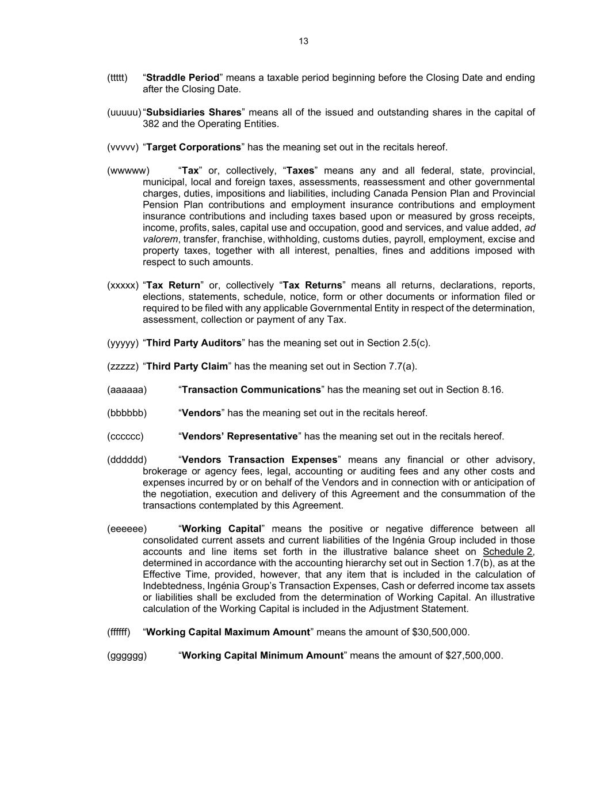
13 (ttttt) “Straddle Period” means a taxable period beginning before the Closing Date and ending after the Closing Date. (uuuuu) “Subsidiaries Shares” means all of the issued and outstanding shares in the capital of 382 and the Operating Entities. (vvvvv) “Target Corporations” has the meaning set out in the recitals hereof. (wwwww) “Tax” or, collectively, “Taxes” means any and all federal, state, provincial, municipal, local and foreign taxes, assessments, reassessment and other governmental charges, duties, impositions and liabilities, including Canada Pension Plan and Provincial Pension Plan contributions and employment insurance contributions and employment insurance contributions and including taxes based upon or measured by gross receipts, income, profits, sales, capital use and occupation, good and services, and value added, ad valorem, transfer, franchise, withholding, customs duties, payroll, employment, excise and property taxes, together with all interest, penalties, fines and additions imposed with respect to such amounts. (xxxxx) “Tax Return” or, collectively “Tax Returns” means all returns, declarations, reports, elections, statements, schedule, notice, form or other documents or information filed or required to be filed with any applicable Governmental Entity in respect of the determination, assessment, collection or payment of any Tax. (yyyyy) “Third Party Auditors” has the meaning set out in Section 2.5(c). (zzzzz) “Third Party Claim” has the meaning set out in Section 7.7(a). (aaaaaa) “Transaction Communications” has the meaning set out in Section 8.16. (bbbbbb) “Vendors” has the meaning set out in the recitals hereof. (cccccc) “Vendors’ Representative” has the meaning set out in the recitals hereof. (dddddd) “Vendors Transaction Expenses” means any financial or other advisory, brokerage or agency fees, legal, accounting or auditing fees and any other costs and expenses incurred by or on behalf of the Vendors and in connection with or anticipation of the negotiation, execution and delivery of this Agreement and the consummation of the transactions contemplated by this Agreement. (eeeeee) “Working Capital” means the positive or negative difference between all consolidated current assets and current liabilities of the Ingénia Group included in those accounts and line items set forth in the illustrative balance sheet on Schedule 2, determined in accordance with the accounting hierarchy set out in Section 1.7(b), as at the Effective Time, provided, however, that any item that is included in the calculation of Indebtedness, Ingénia Group’s Transaction Expenses, Cash or deferred income tax assets or liabilities shall be excluded from the determination of Working Capital. An illustrative calculation of the Working Capital is included in the Adjustment Statement. (ffffff) “Working Capital Maximum Amount” means the amount of $30,500,000. (gggggg) “Working Capital Minimum Amount” means the amount of $27,500,000.

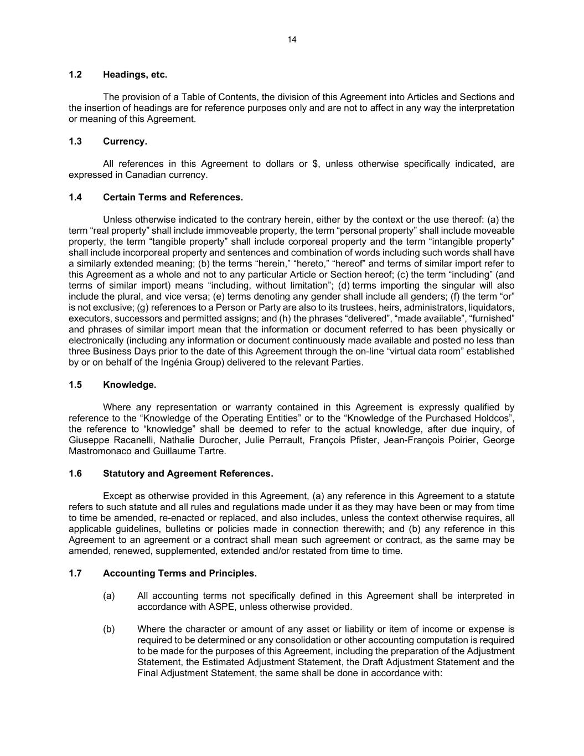
14 1.2 Headings, etc. The provision of a Table of Contents, the division of this Agreement into Articles and Sections and the insertion of headings are for reference purposes only and are not to affect in any way the interpretation or meaning of this Agreement. 1.3 Currency. All references in this Agreement to dollars or $, unless otherwise specifically indicated, are expressed in Canadian currency. 1.4 Certain Terms and References. Unless otherwise indicated to the contrary herein, either by the context or the use thereof: (a) the term “real property” shall include immoveable property, the term “personal property” shall include moveable property, the term “tangible property” shall include corporeal property and the term “intangible property” shall include incorporeal property and sentences and combination of words including such words shall have a similarly extended meaning; (b) the terms “herein,” “hereto,” “hereof” and terms of similar import refer to this Agreement as a whole and not to any particular Article or Section hereof; (c) the term “including” (and terms of similar import) means “including, without limitation”; (d) terms importing the singular will also include the plural, and vice versa; (e) terms denoting any gender shall include all genders; (f) the term “or” is not exclusive; (g) references to a Person or Party are also to its trustees, heirs, administrators, liquidators, executors, successors and permitted assigns; and (h) the phrases “delivered”, “made available”, “furnished” and phrases of similar import mean that the information or document referred to has been physically or electronically (including any information or document continuously made available and posted no less than three Business Days prior to the date of this Agreement through the on-line “virtual data room” established by or on behalf of the Ingénia Group) delivered to the relevant Parties. 1.5 Knowledge. Where any representation or warranty contained in this Agreement is expressly qualified by reference to the “Knowledge of the Operating Entities” or to the “Knowledge of the Purchased Holdcos”, the reference to “knowledge” shall be deemed to refer to the actual knowledge, after due inquiry, of Giuseppe Racanelli, Nathalie Durocher, Julie Perrault, François Pfister, Jean-François Poirier, George Mastromonaco and Guillaume Tartre. 1.6 Statutory and Agreement References. Except as otherwise provided in this Agreement, (a) any reference in this Agreement to a statute refers to such statute and all rules and regulations made under it as they may have been or may from time to time be amended, re-enacted or replaced, and also includes, unless the context otherwise requires, all applicable guidelines, bulletins or policies made in connection therewith; and (b) any reference in this Agreement to an agreement or a contract shall mean such agreement or contract, as the same may be amended, renewed, supplemented, extended and/or restated from time to time. 1.7 Accounting Terms and Principles. (a) All accounting terms not specifically defined in this Agreement shall be interpreted in accordance with ASPE, unless otherwise provided. (b) Where the character or amount of any asset or liability or item of income or expense is required to be determined or any consolidation or other accounting computation is required to be made for the purposes of this Agreement, including the preparation of the Adjustment Statement, the Estimated Adjustment Statement, the Draft Adjustment Statement and the Final Adjustment Statement, the same shall be done in accordance with:

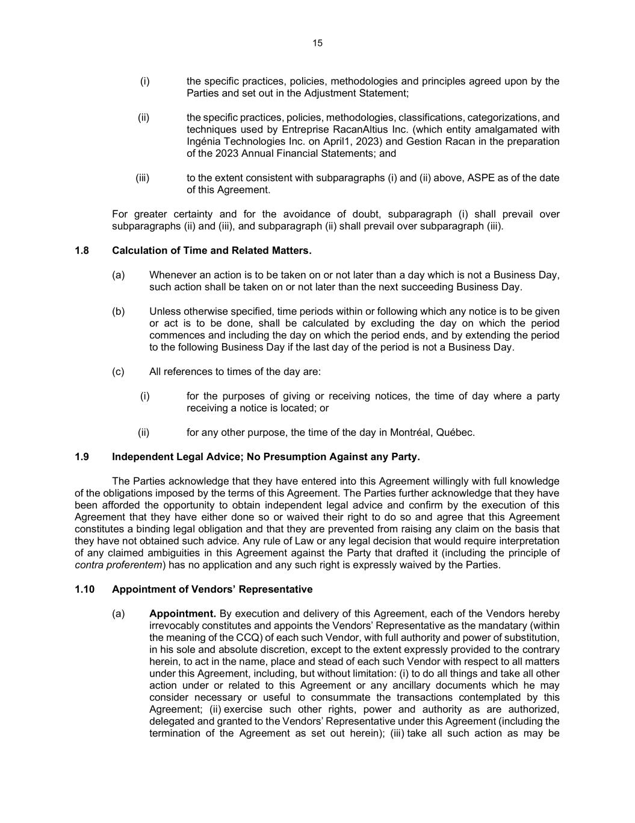
15 (i) the specific practices, policies, methodologies and principles agreed upon by the Parties and set out in the Adjustment Statement; (ii) the specific practices, policies, methodologies, classifications, categorizations, and techniques used by Entreprise RacanAltius Inc. (which entity amalgamated with Ingénia Technologies Inc. on April1, 2023) and Gestion Racan in the preparation of the 2023 Annual Financial Statements; and (iii) to the extent consistent with subparagraphs (i) and (ii) above, ASPE as of the date of this Agreement. For greater certainty and for the avoidance of doubt, subparagraph (i) shall prevail over subparagraphs (ii) and (iii), and subparagraph (ii) shall prevail over subparagraph (iii). 1.8 Calculation of Time and Related Matters. (a) Whenever an action is to be taken on or not later than a day which is not a Business Day, such action shall be taken on or not later than the next succeeding Business Day. (b) Unless otherwise specified, time periods within or following which any notice is to be given or act is to be done, shall be calculated by excluding the day on which the period commences and including the day on which the period ends, and by extending the period to the following Business Day if the last day of the period is not a Business Day. (c) All references to times of the day are: (i) for the purposes of giving or receiving notices, the time of day where a party receiving a notice is located; or (ii) for any other purpose, the time of the day in Montréal, Québec. 1.9 Independent Legal Advice; No Presumption Against any Party. The Parties acknowledge that they have entered into this Agreement willingly with full knowledge of the obligations imposed by the terms of this Agreement. The Parties further acknowledge that they have been afforded the opportunity to obtain independent legal advice and confirm by the execution of this Agreement that they have either done so or waived their right to do so and agree that this Agreement constitutes a binding legal obligation and that they are prevented from raising any claim on the basis that they have not obtained such advice. Any rule of Law or any legal decision that would require interpretation of any claimed ambiguities in this Agreement against the Party that drafted it (including the principle of contra proferentem) has no application and any such right is expressly waived by the Parties. 1.10 Appointment of Vendors’ Representative (a) Appointment. By execution and delivery of this Agreement, each of the Vendors hereby irrevocably constitutes and appoints the Vendors’ Representative as the mandatary (within the meaning of the CCQ) of each such Vendor, with full authority and power of substitution, in his sole and absolute discretion, except to the extent expressly provided to the contrary herein, to act in the name, place and stead of each such Vendor with respect to all matters under this Agreement, including, but without limitation: (i) to do all things and take all other action under or related to this Agreement or any ancillary documents which he may consider necessary or useful to consummate the transactions contemplated by this Agreement; (ii) exercise such other rights, power and authority as are authorized, delegated and granted to the Vendors’ Representative under this Agreement (including the termination of the Agreement as set out herein); (iii) take all such action as may be

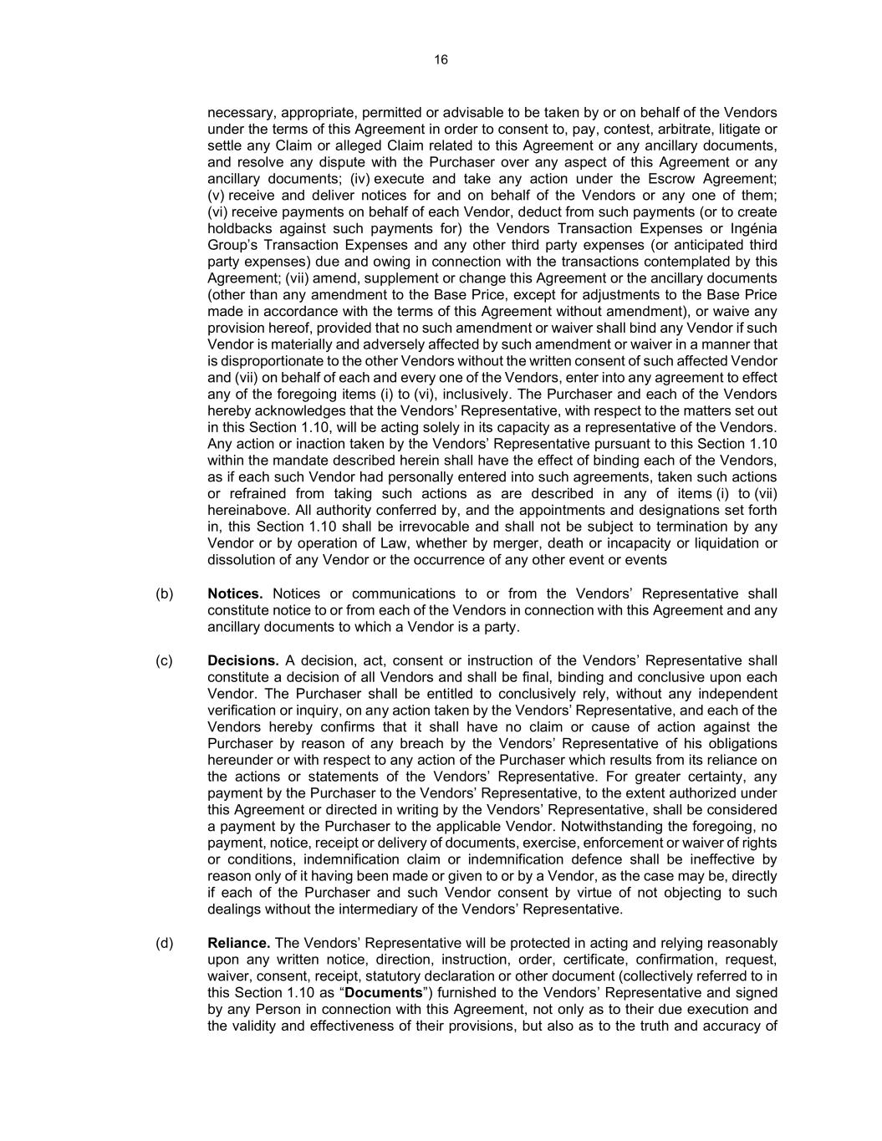
16 necessary, appropriate, permitted or advisable to be taken by or on behalf of the Vendors under the terms of this Agreement in order to consent to, pay, contest, arbitrate, litigate or settle any Claim or alleged Claim related to this Agreement or any ancillary documents, and resolve any dispute with the Purchaser over any aspect of this Agreement or any ancillary documents; (iv) execute and take any action under the Escrow Agreement; (v) receive and deliver notices for and on behalf of the Vendors or any one of them; (vi) receive payments on behalf of each Vendor, deduct from such payments (or to create holdbacks against such payments for) the Vendors Transaction Expenses or Ingénia Group’s Transaction Expenses and any other third party expenses (or anticipated third party expenses) due and owing in connection with the transactions contemplated by this Agreement; (vii) amend, supplement or change this Agreement or the ancillary documents (other than any amendment to the Base Price, except for adjustments to the Base Price made in accordance with the terms of this Agreement without amendment), or waive any provision hereof, provided that no such amendment or waiver shall bind any Vendor if such Vendor is materially and adversely affected by such amendment or waiver in a manner that is disproportionate to the other Vendors without the written consent of such affected Vendor and (vii) on behalf of each and every one of the Vendors, enter into any agreement to effect any of the foregoing items (i) to (vi), inclusively. The Purchaser and each of the Vendors hereby acknowledges that the Vendors’ Representative, with respect to the matters set out in this Section 1.10, will be acting solely in its capacity as a representative of the Vendors. Any action or inaction taken by the Vendors’ Representative pursuant to this Section 1.10 within the mandate described herein shall have the effect of binding each of the Vendors, as if each such Vendor had personally entered into such agreements, taken such actions or refrained from taking such actions as are described in any of items (i) to (vii) hereinabove. All authority conferred by, and the appointments and designations set forth in, this Section 1.10 shall be irrevocable and shall not be subject to termination by any Vendor or by operation of Law, whether by merger, death or incapacity or liquidation or dissolution of any Vendor or the occurrence of any other event or events (b) Notices. Notices or communications to or from the Vendors’ Representative shall constitute notice to or from each of the Vendors in connection with this Agreement and any ancillary documents to which a Vendor is a party. (c) Decisions. A decision, act, consent or instruction of the Vendors’ Representative shall constitute a decision of all Vendors and shall be final, binding and conclusive upon each Vendor. The Purchaser shall be entitled to conclusively rely, without any independent verification or inquiry, on any action taken by the Vendors’ Representative, and each of the Vendors hereby confirms that it shall have no claim or cause of action against the Purchaser by reason of any breach by the Vendors’ Representative of his obligations hereunder or with respect to any action of the Purchaser which results from its reliance on the actions or statements of the Vendors’ Representative. For greater certainty, any payment by the Purchaser to the Vendors’ Representative, to the extent authorized under this Agreement or directed in writing by the Vendors’ Representative, shall be considered a payment by the Purchaser to the applicable Vendor. Notwithstanding the foregoing, no payment, notice, receipt or delivery of documents, exercise, enforcement or waiver of rights or conditions, indemnification claim or indemnification defence shall be ineffective by reason only of it having been made or given to or by a Vendor, as the case may be, directly if each of the Purchaser and such Vendor consent by virtue of not objecting to such dealings without the intermediary of the Vendors’ Representative. (d) Reliance. The Vendors’ Representative will be protected in acting and relying reasonably upon any written notice, direction, instruction, order, certificate, confirmation, request, waiver, consent, receipt, statutory declaration or other document (collectively referred to in this Section 1.10 as “Documents”) furnished to the Vendors’ Representative and signed by any Person in connection with this Agreement, not only as to their due execution and the validity and effectiveness of their provisions, but also as to the truth and accuracy of

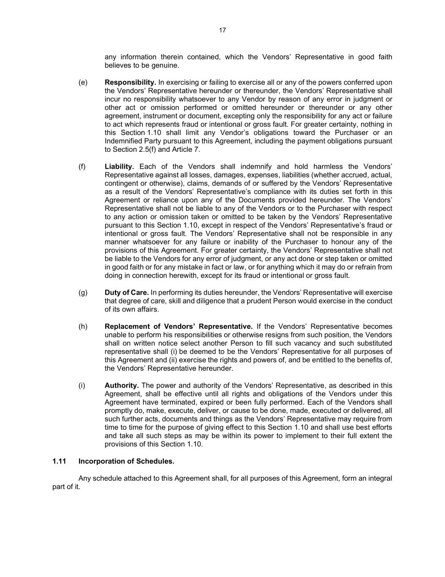
17 any information therein contained, which the Vendors’ Representative in good faith believes to be genuine. (e) Responsibility. In exercising or failing to exercise all or any of the powers conferred upon the Vendors’ Representative hereunder or thereunder, the Vendors’ Representative shall incur no responsibility whatsoever to any Vendor by reason of any error in judgment or other act or omission performed or omitted hereunder or thereunder or any other agreement, instrument or document, excepting only the responsibility for any act or failure to act which represents fraud or intentional or gross fault. For greater certainty, nothing in this Section 1.10 shall limit any Vendor’s obligations toward the Purchaser or an Indemnified Party pursuant to this Agreement, including the payment obligations pursuant to Section 2.5(f) and Article 7. (f) Liability. Each of the Vendors shall indemnify and hold harmless the Vendors’ Representative against all losses, damages, expenses, liabilities (whether accrued, actual, contingent or otherwise), claims, demands of or suffered by the Vendors’ Representative as a result of the Vendors’ Representative’s compliance with its duties set forth in this Agreement or reliance upon any of the Documents provided hereunder. The Vendors’ Representative shall not be liable to any of the Vendors or to the Purchaser with respect to any action or omission taken or omitted to be taken by the Vendors’ Representative pursuant to this Section 1.10, except in respect of the Vendors’ Representative’s fraud or intentional or gross fault. The Vendors’ Representative shall not be responsible in any manner whatsoever for any failure or inability of the Purchaser to honour any of the provisions of this Agreement. For greater certainty, the Vendors’ Representative shall not be liable to the Vendors for any error of judgment, or any act done or step taken or omitted in good faith or for any mistake in fact or law, or for anything which it may do or refrain from doing in connection herewith, except for its fraud or intentional or gross fault. (g) Duty of Care. In performing its duties hereunder, the Vendors’ Representative will exercise that degree of care, skill and diligence that a prudent Person would exercise in the conduct of its own affairs. (h) Replacement of Vendors’ Representative. If the Vendors’ Representative becomes unable to perform his responsibilities or otherwise resigns from such position, the Vendors shall on written notice select another Person to fill such vacancy and such substituted representative shall (i) be deemed to be the Vendors’ Representative for all purposes of this Agreement and (ii) exercise the rights and powers of, and be entitled to the benefits of, the Vendors’ Representative hereunder. (i) Authority. The power and authority of the Vendors’ Representative, as described in this Agreement, shall be effective until all rights and obligations of the Vendors under this Agreement have terminated, expired or been fully performed. Each of the Vendors shall promptly do, make, execute, deliver, or cause to be done, made, executed or delivered, all such further acts, documents and things as the Vendors’ Representative may require from time to time for the purpose of giving effect to this Section 1.10 and shall use best efforts and take all such steps as may be within its power to implement to their full extent the provisions of this Section 1.10. 1.11 Incorporation of Schedules. Any schedule attached to this Agreement shall, for all purposes of this Agreement, form an integral part of it.

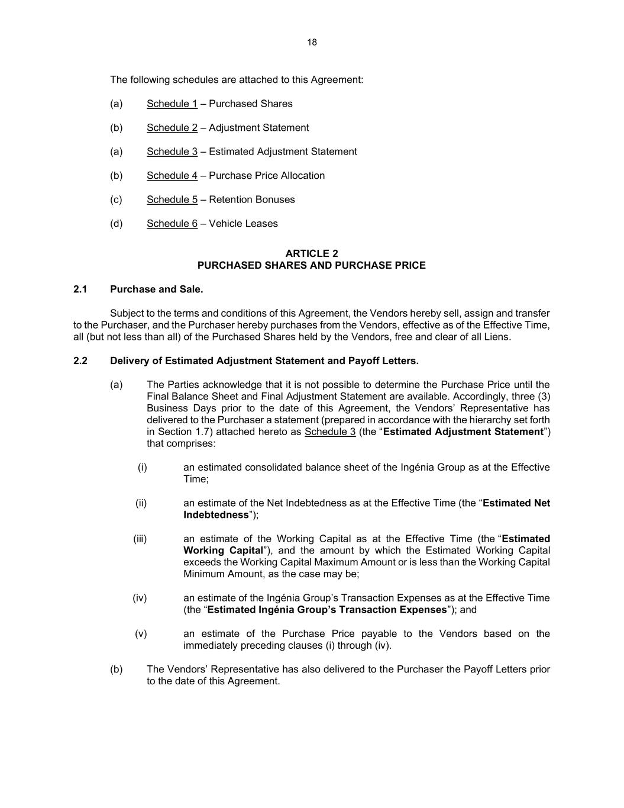
18 The following schedules are attached to this Agreement: (a) Schedule 1 – Purchased Shares (b) Schedule 2 – Adjustment Statement (a) Schedule 3 – Estimated Adjustment Statement (b) Schedule 4 – Purchase Price Allocation (c) Schedule 5 – Retention Bonuses (d) Schedule 6 – Vehicle Leases ARTICLE 2 PURCHASED SHARES AND PURCHASE PRICE 2.1 Purchase and Sale. Subject to the terms and conditions of this Agreement, the Vendors hereby sell, assign and transfer to the Purchaser, and the Purchaser hereby purchases from the Vendors, effective as of the Effective Time, all (but not less than all) of the Purchased Shares held by the Vendors, free and clear of all Liens. 2.2 Delivery of Estimated Adjustment Statement and Payoff Letters. (a) The Parties acknowledge that it is not possible to determine the Purchase Price until the Final Balance Sheet and Final Adjustment Statement are available. Accordingly, three (3) Business Days prior to the date of this Agreement, the Vendors’ Representative has delivered to the Purchaser a statement (prepared in accordance with the hierarchy set forth in Section 1.7) attached hereto as Schedule 3 (the “Estimated Adjustment Statement”) that comprises: (i) an estimated consolidated balance sheet of the Ingénia Group as at the Effective Time; (ii) an estimate of the Net Indebtedness as at the Effective Time (the “Estimated Net Indebtedness”); (iii) an estimate of the Working Capital as at the Effective Time (the “Estimated Working Capital”), and the amount by which the Estimated Working Capital exceeds the Working Capital Maximum Amount or is less than the Working Capital Minimum Amount, as the case may be; (iv) an estimate of the Ingénia Group’s Transaction Expenses as at the Effective Time (the “Estimated Ingénia Group’s Transaction Expenses”); and (v) an estimate of the Purchase Price payable to the Vendors based on the immediately preceding clauses (i) through (iv). (b) The Vendors’ Representative has also delivered to the Purchaser the Payoff Letters prior to the date of this Agreement.

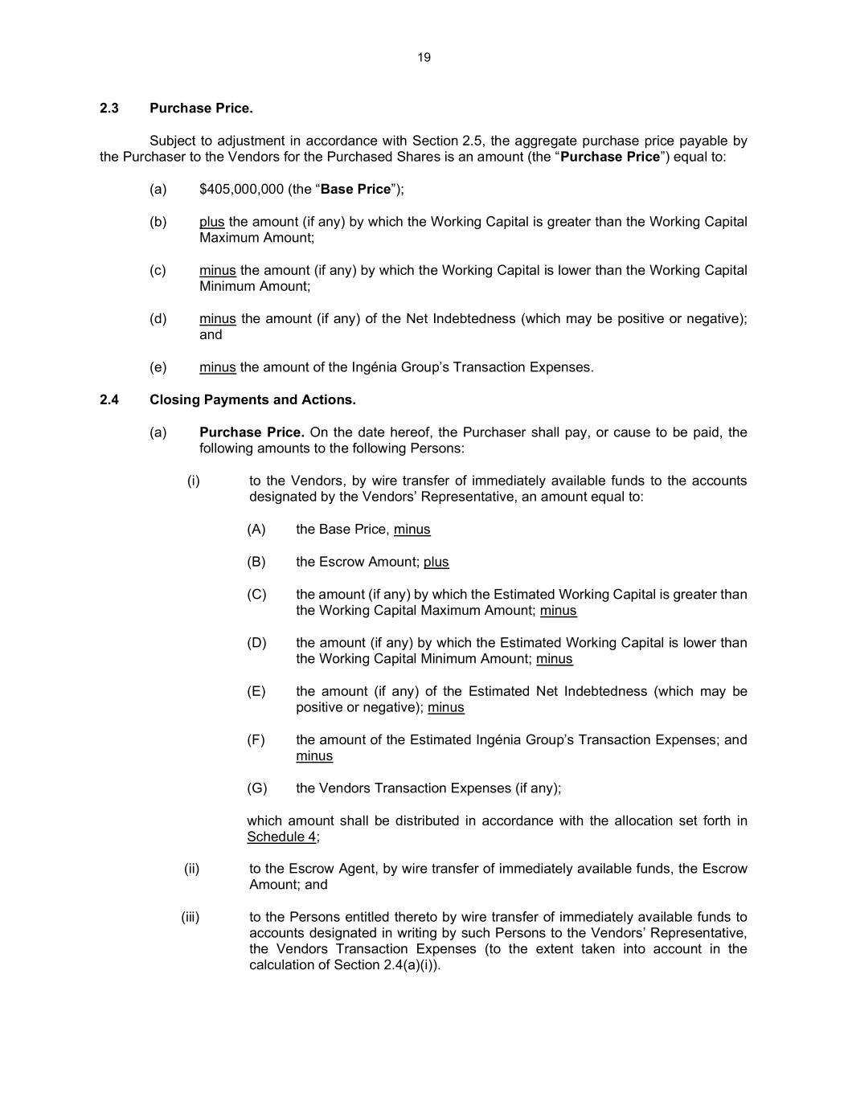
19 2.3 Purchase Price. Subject to adjustment in accordance with Section 2.5, the aggregate purchase price payable by the Purchaser to the Vendors for the Purchased Shares is an amount (the “Purchase Price”) equal to: (a) $405,000,000 (the “Base Price”); (b) plus the amount (if any) by which the Working Capital is greater than the Working Capital Maximum Amount; (c) minus the amount (if any) by which the Working Capital is lower than the Working Capital Minimum Amount; (d) minus the amount (if any) of the Net Indebtedness (which may be positive or negative); and (e) minus the amount of the Ingénia Group’s Transaction Expenses. 2.4 Closing Payments and Actions. (a) Purchase Price. On the date hereof, the Purchaser shall pay, or cause to be paid, the following amounts to the following Persons: (i) to the Vendors, by wire transfer of immediately available funds to the accounts designated by the Vendors’ Representative, an amount equal to: (A) the Base Price, minus (B) the Escrow Amount; plus (C) the amount (if any) by which the Estimated Working Capital is greater than the Working Capital Maximum Amount; minus (D) the amount (if any) by which the Estimated Working Capital is lower than the Working Capital Minimum Amount; minus (E) the amount (if any) of the Estimated Net Indebtedness (which may be positive or negative); minus (F) the amount of the Estimated Ingénia Group’s Transaction Expenses; and minus (G) the Vendors Transaction Expenses (if any); which amount shall be distributed in accordance with the allocation set forth in Schedule 4; (ii) to the Escrow Agent, by wire transfer of immediately available funds, the Escrow Amount; and (iii) to the Persons entitled thereto by wire transfer of immediately available funds to accounts designated in writing by such Persons to the Vendors’ Representative, the Vendors Transaction Expenses (to the extent taken into account in the calculation of Section 2.4(a)(i)).

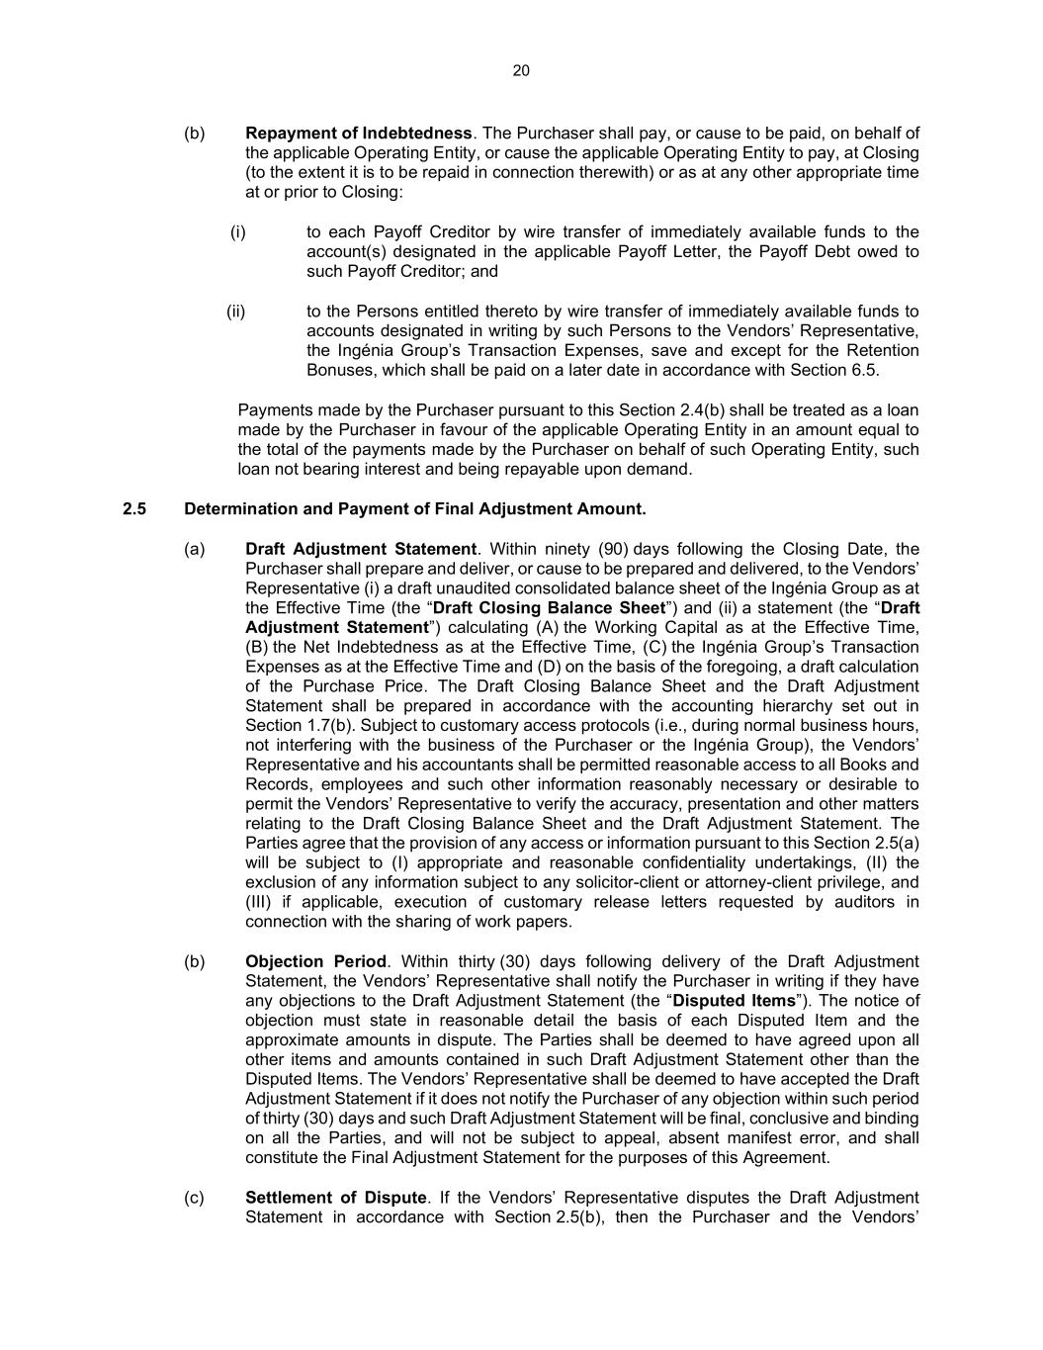
20 (b) Repayment of Indebtedness. The Purchaser shall pay, or cause to be paid, on behalf of the applicable Operating Entity, or cause the applicable Operating Entity to pay, at Closing (to the extent it is to be repaid in connection therewith) or as at any other appropriate time at or prior to Closing: (i) to each Payoff Creditor by wire transfer of immediately available funds to the account(s) designated in the applicable Payoff Letter, the Payoff Debt owed to such Payoff Creditor; and (ii) to the Persons entitled thereto by wire transfer of immediately available funds to accounts designated in writing by such Persons to the Vendors’ Representative, the Ingénia Group’s Transaction Expenses, save and except for the Retention Bonuses, which shall be paid on a later date in accordance with Section 6.5. Payments made by the Purchaser pursuant to this Section 2.4(b) shall be treated as a loan made by the Purchaser in favour of the applicable Operating Entity in an amount equal to the total of the payments made by the Purchaser on behalf of such Operating Entity, such loan not bearing interest and being repayable upon demand. 2.5 Determination and Payment of Final Adjustment Amount. (a) Draft Adjustment Statement. Within ninety (90) days following the Closing Date, the Purchaser shall prepare and deliver, or cause to be prepared and delivered, to the Vendors’ Representative (i) a draft unaudited consolidated balance sheet of the Ingénia Group as at the Effective Time (the “Draft Closing Balance Sheet”) and (ii) a statement (the “Draft Adjustment Statement”) calculating (A) the Working Capital as at the Effective Time, (B) the Net Indebtedness as at the Effective Time, (C) the Ingénia Group’s Transaction Expenses as at the Effective Time and (D) on the basis of the foregoing, a draft calculation of the Purchase Price. The Draft Closing Balance Sheet and the Draft Adjustment Statement shall be prepared in accordance with the accounting hierarchy set out in Section 1.7(b). Subject to customary access protocols (i.e., during normal business hours, not interfering with the business of the Purchaser or the Ingénia Group), the Vendors’ Representative and his accountants shall be permitted reasonable access to all Books and Records, employees and such other information reasonably necessary or desirable to permit the Vendors’ Representative to verify the accuracy, presentation and other matters relating to the Draft Closing Balance Sheet and the Draft Adjustment Statement. The Parties agree that the provision of any access or information pursuant to this Section 2.5(a) will be subject to (I) appropriate and reasonable confidentiality undertakings, (II) the exclusion of any information subject to any solicitor-client or attorney-client privilege, and (III) if applicable, execution of customary release letters requested by auditors in connection with the sharing of work papers. (b) Objection Period. Within thirty (30) days following delivery of the Draft Adjustment Statement, the Vendors’ Representative shall notify the Purchaser in writing if they have any objections to the Draft Adjustment Statement (the “Disputed Items”). The notice of objection must state in reasonable detail the basis of each Disputed Item and the approximate amounts in dispute. The Parties shall be deemed to have agreed upon all other items and amounts contained in such Draft Adjustment Statement other than the Disputed Items. The Vendors’ Representative shall be deemed to have accepted the Draft Adjustment Statement if it does not notify the Purchaser of any objection within such period of thirty (30) days and such Draft Adjustment Statement will be final, conclusive and binding on all the Parties, and will not be subject to appeal, absent manifest error, and shall constitute the Final Adjustment Statement for the purposes of this Agreement. (c) Settlement of Dispute. If the Vendors’ Representative disputes the Draft Adjustment Statement in accordance with Section 2.5(b), then the Purchaser and the Vendors’

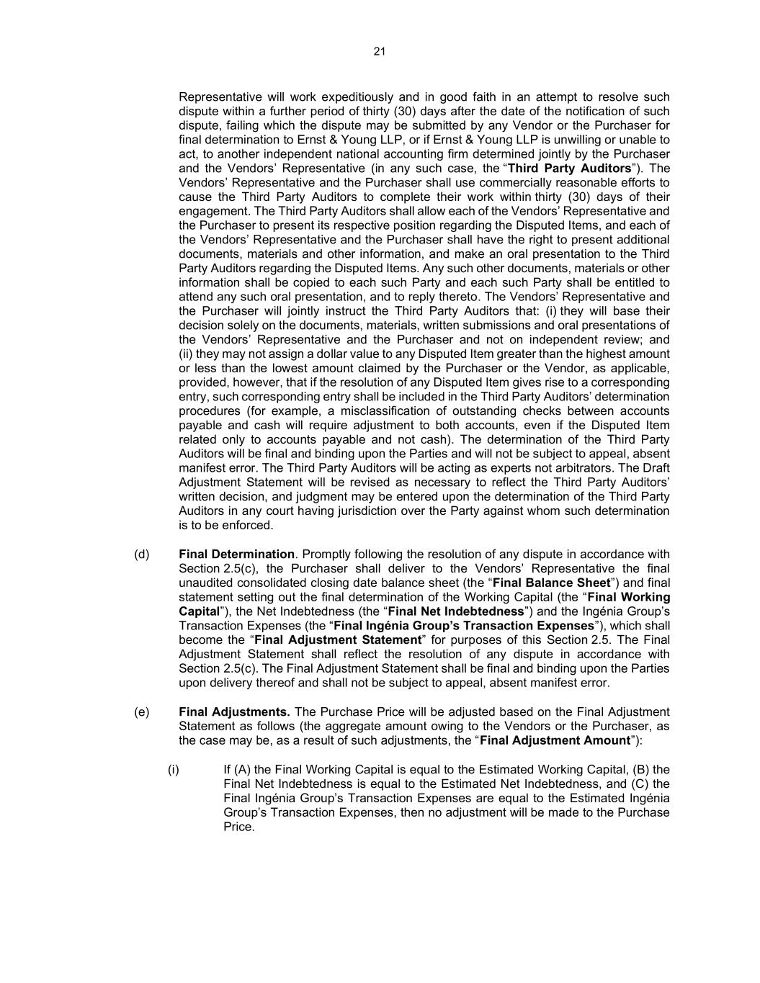
21 Representative will work expeditiously and in good faith in an attempt to resolve such dispute within a further period of thirty (30) days after the date of the notification of such dispute, failing which the dispute may be submitted by any Vendor or the Purchaser for final determination to Ernst & Young LLP, or if Ernst & Young LLP is unwilling or unable to act, to another independent national accounting firm determined jointly by the Purchaser and the Vendors’ Representative (in any such case, the “Third Party Auditors”). The Vendors’ Representative and the Purchaser shall use commercially reasonable efforts to cause the Third Party Auditors to complete their work within thirty (30) days of their engagement. The Third Party Auditors shall allow each of the Vendors’ Representative and the Purchaser to present its respective position regarding the Disputed Items, and each of the Vendors’ Representative and the Purchaser shall have the right to present additional documents, materials and other information, and make an oral presentation to the Third Party Auditors regarding the Disputed Items. Any such other documents, materials or other information shall be copied to each such Party and each such Party shall be entitled to attend any such oral presentation, and to reply thereto. The Vendors’ Representative and the Purchaser will jointly instruct the Third Party Auditors that: (i) they will base their decision solely on the documents, materials, written submissions and oral presentations of the Vendors’ Representative and the Purchaser and not on independent review; and (ii) they may not assign a dollar value to any Disputed Item greater than the highest amount or less than the lowest amount claimed by the Purchaser or the Vendor, as applicable, provided, however, that if the resolution of any Disputed Item gives rise to a corresponding entry, such corresponding entry shall be included in the Third Party Auditors’ determination procedures (for example, a misclassification of outstanding checks between accounts payable and cash will require adjustment to both accounts, even if the Disputed Item related only to accounts payable and not cash). The determination of the Third Party Auditors will be final and binding upon the Parties and will not be subject to appeal, absent manifest error. The Third Party Auditors will be acting as experts not arbitrators. The Draft Adjustment Statement will be revised as necessary to reflect the Third Party Auditors’ written decision, and judgment may be entered upon the determination of the Third Party Auditors in any court having jurisdiction over the Party against whom such determination is to be enforced. (d) Final Determination. Promptly following the resolution of any dispute in accordance with Section 2.5(c), the Purchaser shall deliver to the Vendors’ Representative the final unaudited consolidated closing date balance sheet (the “Final Balance Sheet”) and final statement setting out the final determination of the Working Capital (the “Final Working Capital”), the Net Indebtedness (the “Final Net Indebtedness”) and the Ingénia Group’s Transaction Expenses (the “Final Ingénia Group’s Transaction Expenses”), which shall become the “Final Adjustment Statement” for purposes of this Section 2.5. The Final Adjustment Statement shall reflect the resolution of any dispute in accordance with Section 2.5(c). The Final Adjustment Statement shall be final and binding upon the Parties upon delivery thereof and shall not be subject to appeal, absent manifest error. (e) Final Adjustments. The Purchase Price will be adjusted based on the Final Adjustment Statement as follows (the aggregate amount owing to the Vendors or the Purchaser, as the case may be, as a result of such adjustments, the “Final Adjustment Amount”): (i) If (A) the Final Working Capital is equal to the Estimated Working Capital, (B) the Final Net Indebtedness is equal to the Estimated Net Indebtedness, and (C) the Final Ingénia Group’s Transaction Expenses are equal to the Estimated Ingénia Group’s Transaction Expenses, then no adjustment will be made to the Purchase Price.

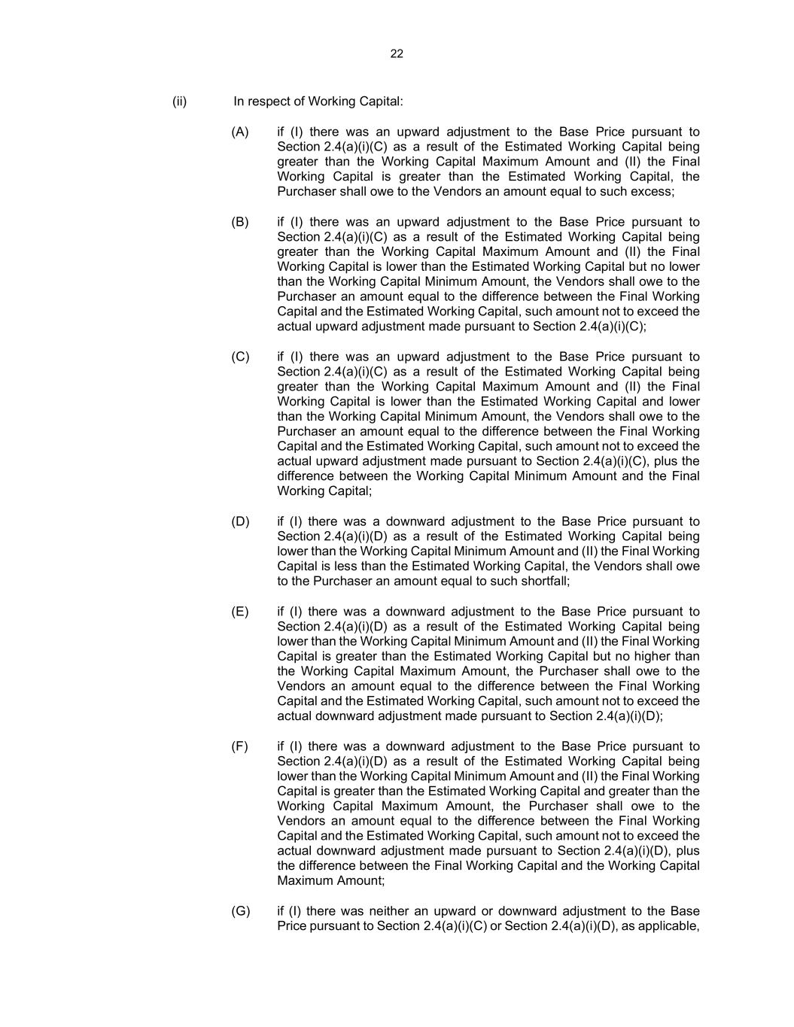
22 (ii) In respect of Working Capital: (A) if (I) there was an upward adjustment to the Base Price pursuant to Section 2.4(a)(i)(C) as a result of the Estimated Working Capital being greater than the Working Capital Maximum Amount and (II) the Final Working Capital is greater than the Estimated Working Capital, the Purchaser shall owe to the Vendors an amount equal to such excess; (B) if (I) there was an upward adjustment to the Base Price pursuant to Section 2.4(a)(i)(C) as a result of the Estimated Working Capital being greater than the Working Capital Maximum Amount and (II) the Final Working Capital is lower than the Estimated Working Capital but no lower than the Working Capital Minimum Amount, the Vendors shall owe to the Purchaser an amount equal to the difference between the Final Working Capital and the Estimated Working Capital, such amount not to exceed the actual upward adjustment made pursuant to Section 2.4(a)(i)(C); (C) if (I) there was an upward adjustment to the Base Price pursuant to Section 2.4(a)(i)(C) as a result of the Estimated Working Capital being greater than the Working Capital Maximum Amount and (II) the Final Working Capital is lower than the Estimated Working Capital and lower than the Working Capital Minimum Amount, the Vendors shall owe to the Purchaser an amount equal to the difference between the Final Working Capital and the Estimated Working Capital, such amount not to exceed the actual upward adjustment made pursuant to Section 2.4(a)(i)(C), plus the difference between the Working Capital Minimum Amount and the Final Working Capital; (D) if (I) there was a downward adjustment to the Base Price pursuant to Section 2.4(a)(i)(D) as a result of the Estimated Working Capital being lower than the Working Capital Minimum Amount and (II) the Final Working Capital is less than the Estimated Working Capital, the Vendors shall owe to the Purchaser an amount equal to such shortfall; (E) if (I) there was a downward adjustment to the Base Price pursuant to Section 2.4(a)(i)(D) as a result of the Estimated Working Capital being lower than the Working Capital Minimum Amount and (II) the Final Working Capital is greater than the Estimated Working Capital but no higher than the Working Capital Maximum Amount, the Purchaser shall owe to the Vendors an amount equal to the difference between the Final Working Capital and the Estimated Working Capital, such amount not to exceed the actual downward adjustment made pursuant to Section 2.4(a)(i)(D); (F) if (I) there was a downward adjustment to the Base Price pursuant to Section 2.4(a)(i)(D) as a result of the Estimated Working Capital being lower than the Working Capital Minimum Amount and (II) the Final Working Capital is greater than the Estimated Working Capital and greater than the Working Capital Maximum Amount, the Purchaser shall owe to the Vendors an amount equal to the difference between the Final Working Capital and the Estimated Working Capital, such amount not to exceed the actual downward adjustment made pursuant to Section 2.4(a)(i)(D), plus the difference between the Final Working Capital and the Working Capital Maximum Amount; (G) if (I) there was neither an upward or downward adjustment to the Base Price pursuant to Section 2.4(a)(i)(C) or Section 2.4(a)(i)(D), as applicable,

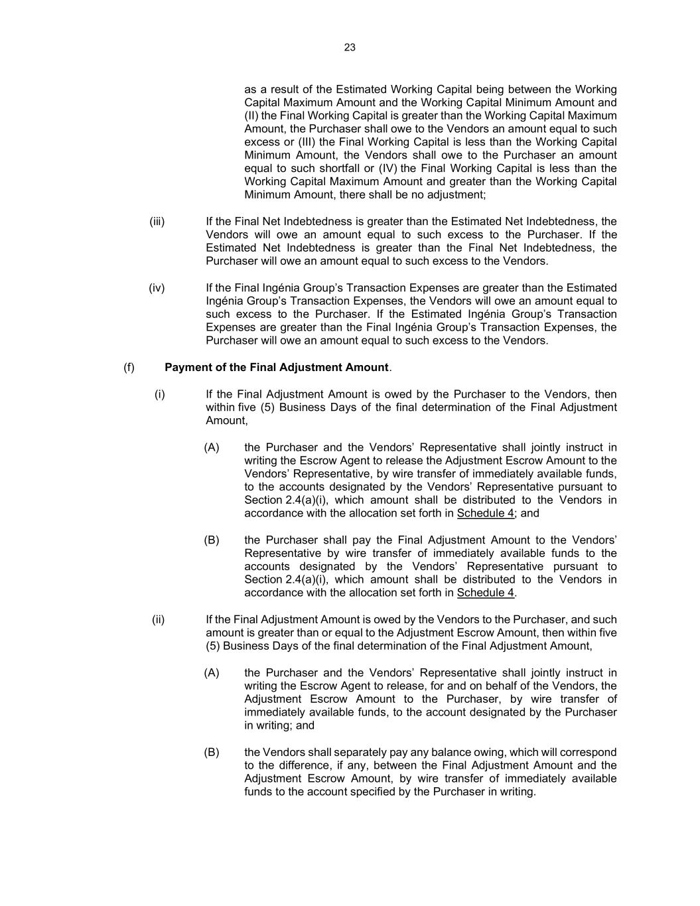
23 as a result of the Estimated Working Capital being between the Working Capital Maximum Amount and the Working Capital Minimum Amount and (II) the Final Working Capital is greater than the Working Capital Maximum Amount, the Purchaser shall owe to the Vendors an amount equal to such excess or (III) the Final Working Capital is less than the Working Capital Minimum Amount, the Vendors shall owe to the Purchaser an amount equal to such shortfall or (IV) the Final Working Capital is less than the Working Capital Maximum Amount and greater than the Working Capital Minimum Amount, there shall be no adjustment; (iii) If the Final Net Indebtedness is greater than the Estimated Net Indebtedness, the Vendors will owe an amount equal to such excess to the Purchaser. If the Estimated Net Indebtedness is greater than the Final Net Indebtedness, the Purchaser will owe an amount equal to such excess to the Vendors. (iv) If the Final Ingénia Group’s Transaction Expenses are greater than the Estimated Ingénia Group’s Transaction Expenses, the Vendors will owe an amount equal to such excess to the Purchaser. If the Estimated Ingénia Group’s Transaction Expenses are greater than the Final Ingénia Group’s Transaction Expenses, the Purchaser will owe an amount equal to such excess to the Vendors. (f) Payment of the Final Adjustment Amount. (i) If the Final Adjustment Amount is owed by the Purchaser to the Vendors, then within five (5) Business Days of the final determination of the Final Adjustment Amount, (A) the Purchaser and the Vendors’ Representative shall jointly instruct in writing the Escrow Agent to release the Adjustment Escrow Amount to the Vendors’ Representative, by wire transfer of immediately available funds, to the accounts designated by the Vendors’ Representative pursuant to Section 2.4(a)(i), which amount shall be distributed to the Vendors in accordance with the allocation set forth in Schedule 4; and (B) the Purchaser shall pay the Final Adjustment Amount to the Vendors’ Representative by wire transfer of immediately available funds to the accounts designated by the Vendors’ Representative pursuant to Section 2.4(a)(i), which amount shall be distributed to the Vendors in accordance with the allocation set forth in Schedule 4. (ii) If the Final Adjustment Amount is owed by the Vendors to the Purchaser, and such amount is greater than or equal to the Adjustment Escrow Amount, then within five (5) Business Days of the final determination of the Final Adjustment Amount, (A) the Purchaser and the Vendors’ Representative shall jointly instruct in writing the Escrow Agent to release, for and on behalf of the Vendors, the Adjustment Escrow Amount to the Purchaser, by wire transfer of immediately available funds, to the account designated by the Purchaser in writing; and (B) the Vendors shall separately pay any balance owing, which will correspond to the difference, if any, between the Final Adjustment Amount and the Adjustment Escrow Amount, by wire transfer of immediately available funds to the account specified by the Purchaser in writing.

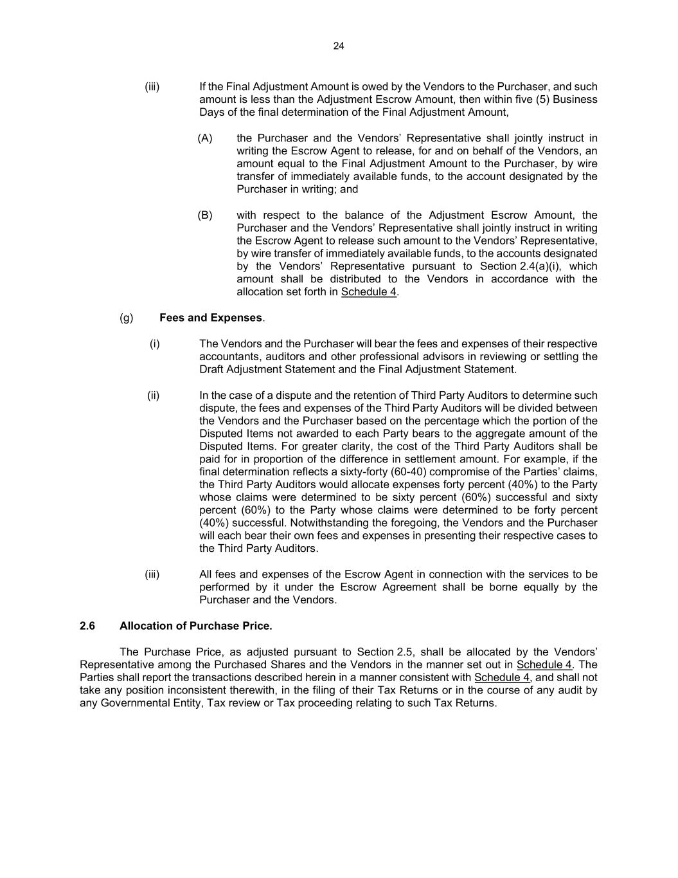
24 (iii) If the Final Adjustment Amount is owed by the Vendors to the Purchaser, and such amount is less than the Adjustment Escrow Amount, then within five (5) Business Days of the final determination of the Final Adjustment Amount, (A) the Purchaser and the Vendors’ Representative shall jointly instruct in writing the Escrow Agent to release, for and on behalf of the Vendors, an amount equal to the Final Adjustment Amount to the Purchaser, by wire transfer of immediately available funds, to the account designated by the Purchaser in writing; and (B) with respect to the balance of the Adjustment Escrow Amount, the Purchaser and the Vendors’ Representative shall jointly instruct in writing the Escrow Agent to release such amount to the Vendors’ Representative, by wire transfer of immediately available funds, to the accounts designated by the Vendors’ Representative pursuant to Section 2.4(a)(i), which amount shall be distributed to the Vendors in accordance with the allocation set forth in Schedule 4. (g) Fees and Expenses. (i) The Vendors and the Purchaser will bear the fees and expenses of their respective accountants, auditors and other professional advisors in reviewing or settling the Draft Adjustment Statement and the Final Adjustment Statement. (ii) In the case of a dispute and the retention of Third Party Auditors to determine such dispute, the fees and expenses of the Third Party Auditors will be divided between the Vendors and the Purchaser based on the percentage which the portion of the Disputed Items not awarded to each Party bears to the aggregate amount of the Disputed Items. For greater clarity, the cost of the Third Party Auditors shall be paid for in proportion of the difference in settlement amount. For example, if the final determination reflects a sixty-forty (60-40) compromise of the Parties’ claims, the Third Party Auditors would allocate expenses forty percent (40%) to the Party whose claims were determined to be sixty percent (60%) successful and sixty percent (60%) to the Party whose claims were determined to be forty percent (40%) successful. Notwithstanding the foregoing, the Vendors and the Purchaser will each bear their own fees and expenses in presenting their respective cases to the Third Party Auditors. (iii) All fees and expenses of the Escrow Agent in connection with the services to be performed by it under the Escrow Agreement shall be borne equally by the Purchaser and the Vendors. 2.6 Allocation of Purchase Price. The Purchase Price, as adjusted pursuant to Section 2.5, shall be allocated by the Vendors’ Representative among the Purchased Shares and the Vendors in the manner set out in Schedule 4. The Parties shall report the transactions described herein in a manner consistent with Schedule 4, and shall not take any position inconsistent therewith, in the filing of their Tax Returns or in the course of any audit by any Governmental Entity, Tax review or Tax proceeding relating to such Tax Returns.

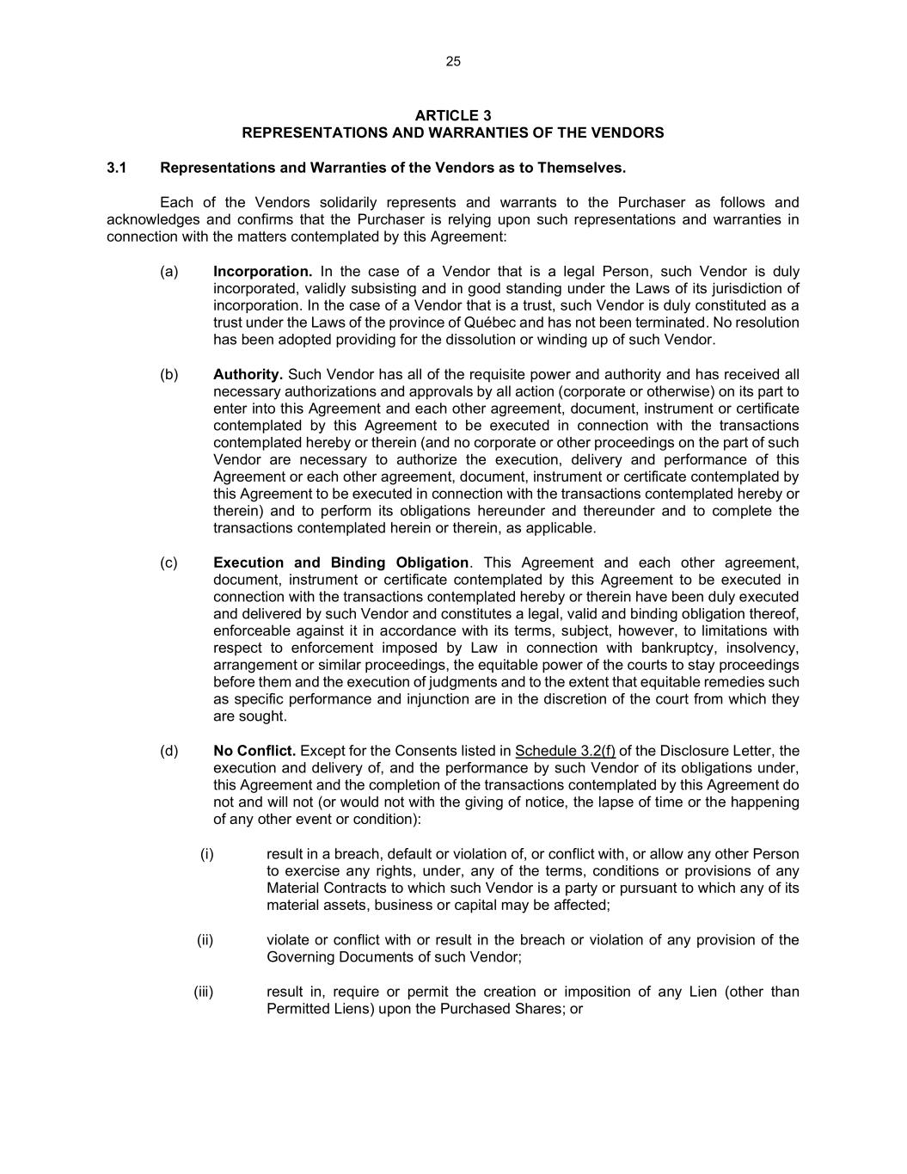
25 ARTICLE 3 REPRESENTATIONS AND WARRANTIES OF THE VENDORS 3.1 Representations and Warranties of the Vendors as to Themselves. Each of the Vendors solidarily represents and warrants to the Purchaser as follows and acknowledges and confirms that the Purchaser is relying upon such representations and warranties in connection with the matters contemplated by this Agreement: (a) Incorporation. In the case of a Vendor that is a legal Person, such Vendor is duly incorporated, validly subsisting and in good standing under the Laws of its jurisdiction of incorporation. In the case of a Vendor that is a trust, such Vendor is duly constituted as a trust under the Laws of the province of Québec and has not been terminated. No resolution has been adopted providing for the dissolution or winding up of such Vendor. (b) Authority. Such Vendor has all of the requisite power and authority and has received all necessary authorizations and approvals by all action (corporate or otherwise) on its part to enter into this Agreement and each other agreement, document, instrument or certificate contemplated by this Agreement to be executed in connection with the transactions contemplated hereby or therein (and no corporate or other proceedings on the part of such Vendor are necessary to authorize the execution, delivery and performance of this Agreement or each other agreement, document, instrument or certificate contemplated by this Agreement to be executed in connection with the transactions contemplated hereby or therein) and to perform its obligations hereunder and thereunder and to complete the transactions contemplated herein or therein, as applicable. (c) Execution and Binding Obligation. This Agreement and each other agreement, document, instrument or certificate contemplated by this Agreement to be executed in connection with the transactions contemplated hereby or therein have been duly executed and delivered by such Vendor and constitutes a legal, valid and binding obligation thereof, enforceable against it in accordance with its terms, subject, however, to limitations with respect to enforcement imposed by Law in connection with bankruptcy, insolvency, arrangement or similar proceedings, the equitable power of the courts to stay proceedings before them and the execution of judgments and to the extent that equitable remedies such as specific performance and injunction are in the discretion of the court from which they are sought. (d) No Conflict. Except for the Consents listed in Schedule 3.2(f) of the Disclosure Letter, the execution and delivery of, and the performance by such Vendor of its obligations under, this Agreement and the completion of the transactions contemplated by this Agreement do not and will not (or would not with the giving of notice, the lapse of time or the happening of any other event or condition): (i) result in a breach, default or violation of, or conflict with, or allow any other Person to exercise any rights, under, any of the terms, conditions or provisions of any Material Contracts to which such Vendor is a party or pursuant to which any of its material assets, business or capital may be affected; (ii) violate or conflict with or result in the breach or violation of any provision of the Governing Documents of such Vendor; (iii) result in, require or permit the creation or imposition of any Lien (other than Permitted Liens) upon the Purchased Shares; or

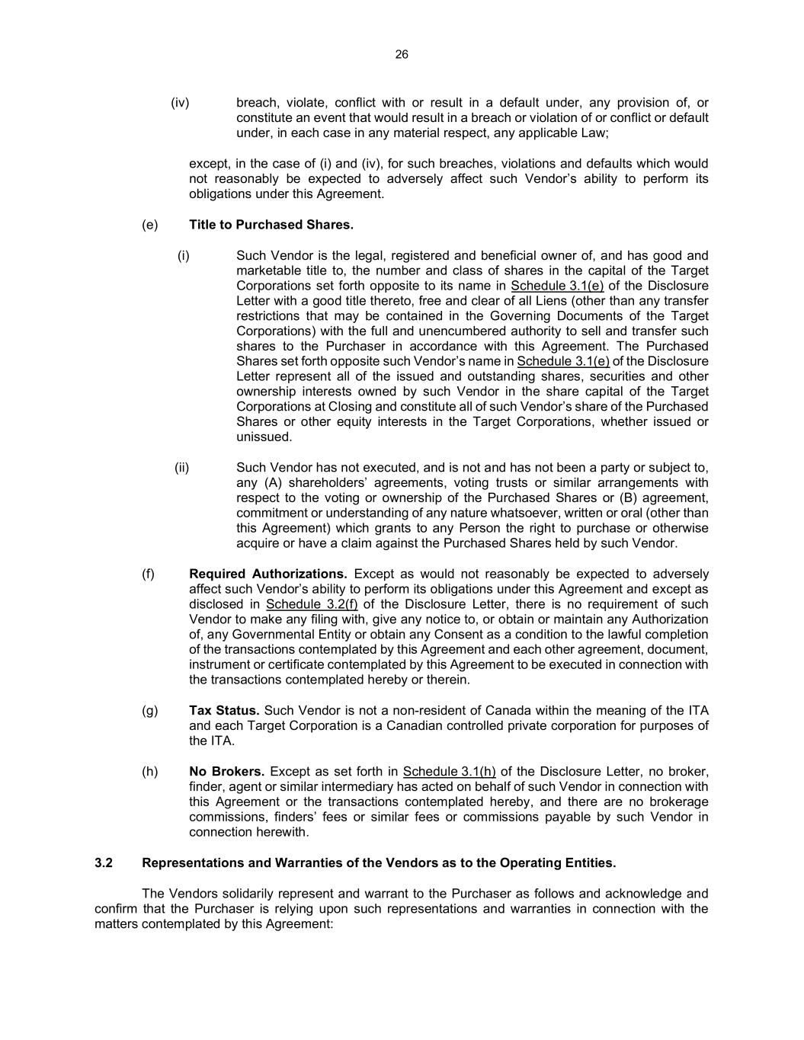
26 (iv) breach, violate, conflict with or result in a default under, any provision of, or constitute an event that would result in a breach or violation of or conflict or default under, in each case in any material respect, any applicable Law; except, in the case of (i) and (iv), for such breaches, violations and defaults which would not reasonably be expected to adversely affect such Vendor’s ability to perform its obligations under this Agreement. (e) Title to Purchased Shares. (i) Such Vendor is the legal, registered and beneficial owner of, and has good and marketable title to, the number and class of shares in the capital of the Target Corporations set forth opposite to its name in Schedule 3.1(e) of the Disclosure Letter with a good title thereto, free and clear of all Liens (other than any transfer restrictions that may be contained in the Governing Documents of the Target Corporations) with the full and unencumbered authority to sell and transfer such shares to the Purchaser in accordance with this Agreement. The Purchased Shares set forth opposite such Vendor’s name in Schedule 3.1(e) of the Disclosure Letter represent all of the issued and outstanding shares, securities and other ownership interests owned by such Vendor in the share capital of the Target Corporations at Closing and constitute all of such Vendor’s share of the Purchased Shares or other equity interests in the Target Corporations, whether issued or unissued. (ii) Such Vendor has not executed, and is not and has not been a party or subject to, any (A) shareholders’ agreements, voting trusts or similar arrangements with respect to the voting or ownership of the Purchased Shares or (B) agreement, commitment or understanding of any nature whatsoever, written or oral (other than this Agreement) which grants to any Person the right to purchase or otherwise acquire or have a claim against the Purchased Shares held by such Vendor. (f) Required Authorizations. Except as would not reasonably be expected to adversely affect such Vendor’s ability to perform its obligations under this Agreement and except as disclosed in Schedule 3.2(f) of the Disclosure Letter, there is no requirement of such Vendor to make any filing with, give any notice to, or obtain or maintain any Authorization of, any Governmental Entity or obtain any Consent as a condition to the lawful completion of the transactions contemplated by this Agreement and each other agreement, document, instrument or certificate contemplated by this Agreement to be executed in connection with the transactions contemplated hereby or therein. (g) Tax Status. Such Vendor is not a non-resident of Canada within the meaning of the ITA and each Target Corporation is a Canadian controlled private corporation for purposes of the ITA. (h) No Brokers. Except as set forth in Schedule 3.1(h) of the Disclosure Letter, no broker, finder, agent or similar intermediary has acted on behalf of such Vendor in connection with this Agreement or the transactions contemplated hereby, and there are no brokerage commissions, finders’ fees or similar fees or commissions payable by such Vendor in connection herewith. 3.2 Representations and Warranties of the Vendors as to the Operating Entities. The Vendors solidarily represent and warrant to the Purchaser as follows and acknowledge and confirm that the Purchaser is relying upon such representations and warranties in connection with the matters contemplated by this Agreement:

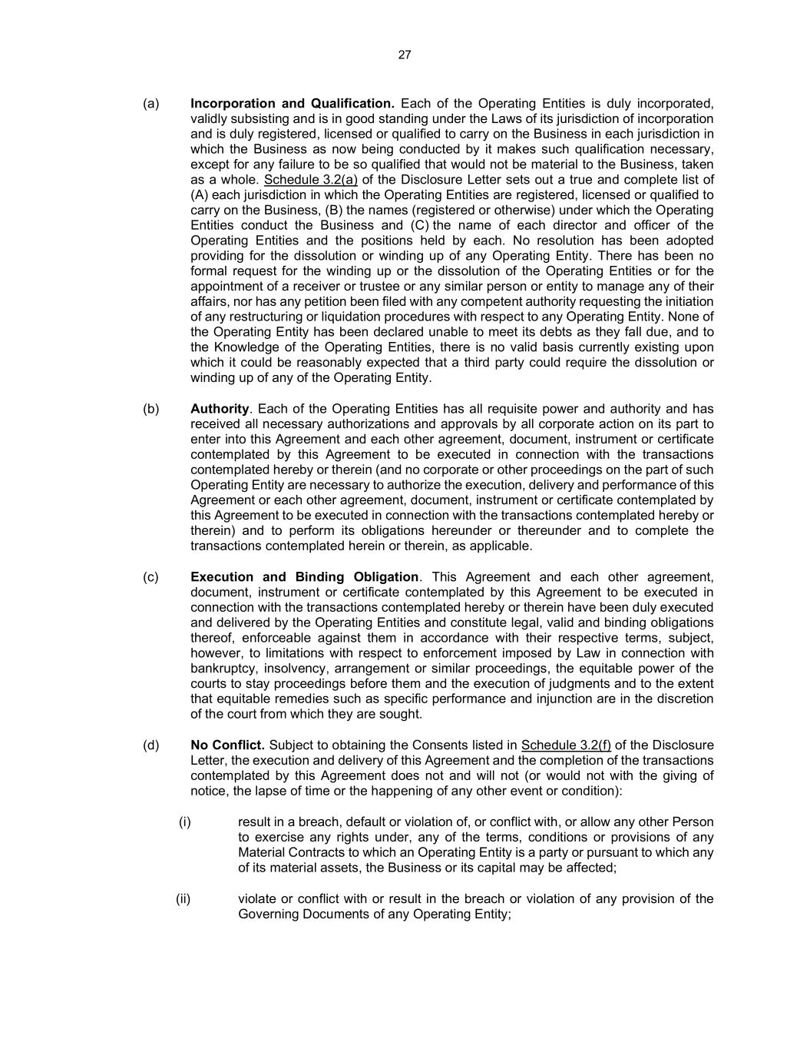
27 (a) Incorporation and Qualification. Each of the Operating Entities is duly incorporated, validly subsisting and is in good standing under the Laws of its jurisdiction of incorporation and is duly registered, licensed or qualified to carry on the Business in each jurisdiction in which the Business as now being conducted by it makes such qualification necessary, except for any failure to be so qualified that would not be material to the Business, taken as a whole. Schedule 3.2(a) of the Disclosure Letter sets out a true and complete list of (A) each jurisdiction in which the Operating Entities are registered, licensed or qualified to carry on the Business, (B) the names (registered or otherwise) under which the Operating Entities conduct the Business and (C) the name of each director and officer of the Operating Entities and the positions held by each. No resolution has been adopted providing for the dissolution or winding up of any Operating Entity. There has been no formal request for the winding up or the dissolution of the Operating Entities or for the appointment of a receiver or trustee or any similar person or entity to manage any of their affairs, nor has any petition been filed with any competent authority requesting the initiation of any restructuring or liquidation procedures with respect to any Operating Entity. None of the Operating Entity has been declared unable to meet its debts as they fall due, and to the Knowledge of the Operating Entities, there is no valid basis currently existing upon which it could be reasonably expected that a third party could require the dissolution or winding up of any of the Operating Entity. (b) Authority. Each of the Operating Entities has all requisite power and authority and has received all necessary authorizations and approvals by all corporate action on its part to enter into this Agreement and each other agreement, document, instrument or certificate contemplated by this Agreement to be executed in connection with the transactions contemplated hereby or therein (and no corporate or other proceedings on the part of such Operating Entity are necessary to authorize the execution, delivery and performance of this Agreement or each other agreement, document, instrument or certificate contemplated by this Agreement to be executed in connection with the transactions contemplated hereby or therein) and to perform its obligations hereunder or thereunder and to complete the transactions contemplated herein or therein, as applicable. (c) Execution and Binding Obligation. This Agreement and each other agreement, document, instrument or certificate contemplated by this Agreement to be executed in connection with the transactions contemplated hereby or therein have been duly executed and delivered by the Operating Entities and constitute legal, valid and binding obligations thereof, enforceable against them in accordance with their respective terms, subject, however, to limitations with respect to enforcement imposed by Law in connection with bankruptcy, insolvency, arrangement or similar proceedings, the equitable power of the courts to stay proceedings before them and the execution of judgments and to the extent that equitable remedies such as specific performance and injunction are in the discretion of the court from which they are sought. (d) No Conflict. Subject to obtaining the Consents listed in Schedule 3.2(f) of the Disclosure Letter, the execution and delivery of this Agreement and the completion of the transactions contemplated by this Agreement does not and will not (or would not with the giving of notice, the lapse of time or the happening of any other event or condition): (i) result in a breach, default or violation of, or conflict with, or allow any other Person to exercise any rights under, any of the terms, conditions or provisions of any Material Contracts to which an Operating Entity is a party or pursuant to which any of its material assets, the Business or its capital may be affected; (ii) violate or conflict with or result in the breach or violation of any provision of the Governing Documents of any Operating Entity;

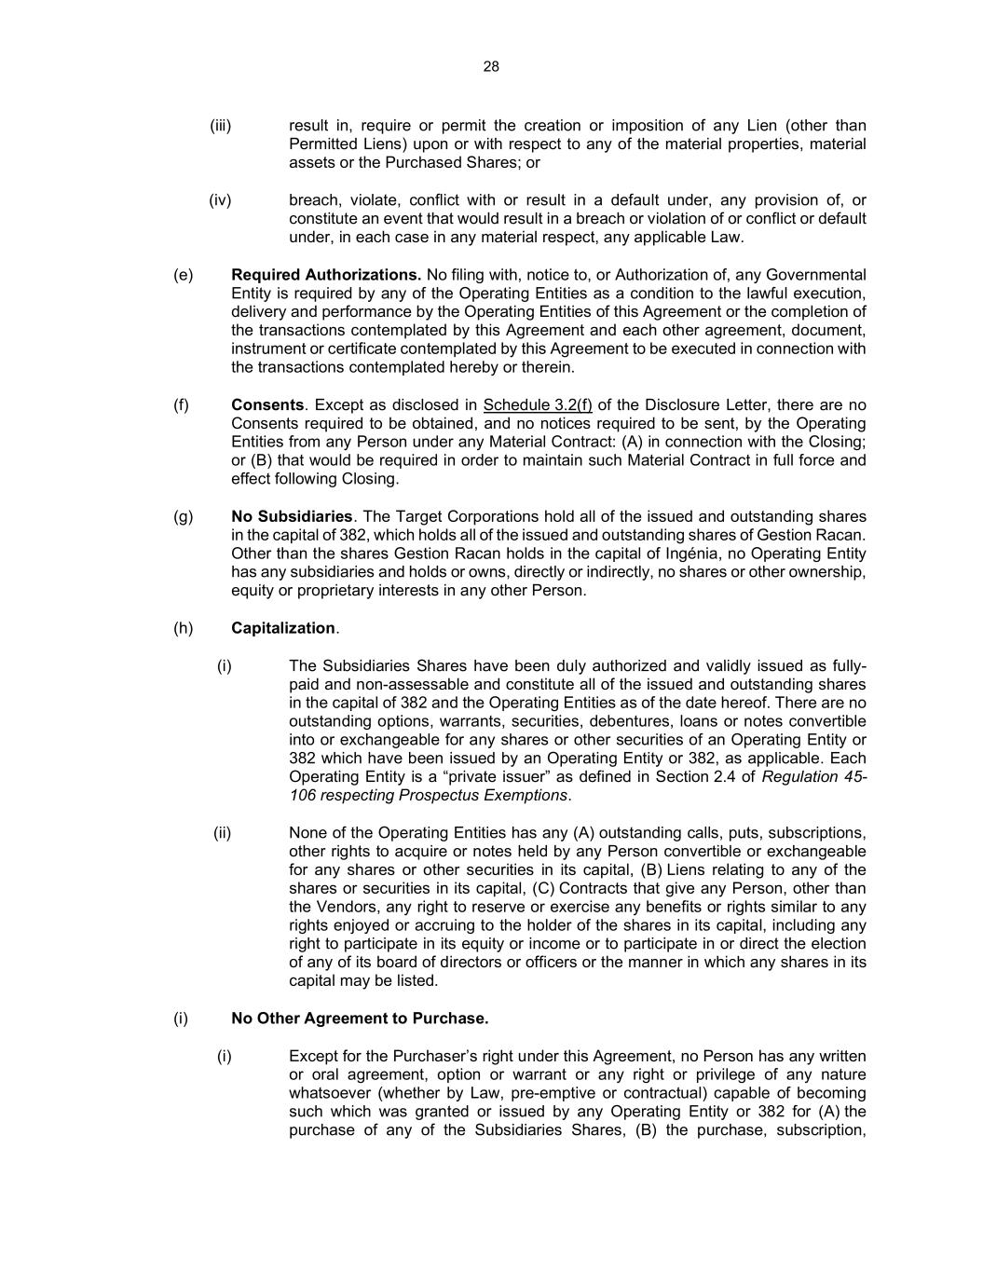
28 (iii) result in, require or permit the creation or imposition of any Lien (other than Permitted Liens) upon or with respect to any of the material properties, material assets or the Purchased Shares; or (iv) breach, violate, conflict with or result in a default under, any provision of, or constitute an event that would result in a breach or violation of or conflict or default under, in each case in any material respect, any applicable Law. (e) Required Authorizations. No filing with, notice to, or Authorization of, any Governmental Entity is required by any of the Operating Entities as a condition to the lawful execution, delivery and performance by the Operating Entities of this Agreement or the completion of the transactions contemplated by this Agreement and each other agreement, document, instrument or certificate contemplated by this Agreement to be executed in connection with the transactions contemplated hereby or therein. (f) Consents. Except as disclosed in Schedule 3.2(f) of the Disclosure Letter, there are no Consents required to be obtained, and no notices required to be sent, by the Operating Entities from any Person under any Material Contract: (A) in connection with the Closing; or (B) that would be required in order to maintain such Material Contract in full force and effect following Closing. (g) No Subsidiaries. The Target Corporations hold all of the issued and outstanding shares in the capital of 382, which holds all of the issued and outstanding shares of Gestion Racan. Other than the shares Gestion Racan holds in the capital of Ingénia, no Operating Entity has any subsidiaries and holds or owns, directly or indirectly, no shares or other ownership, equity or proprietary interests in any other Person. (h) Capitalization. (i) The Subsidiaries Shares have been duly authorized and validly issued as fully- paid and non-assessable and constitute all of the issued and outstanding shares in the capital of 382 and the Operating Entities as of the date hereof. There are no outstanding options, warrants, securities, debentures, loans or notes convertible into or exchangeable for any shares or other securities of an Operating Entity or 382 which have been issued by an Operating Entity or 382, as applicable. Each Operating Entity is a “private issuer” as defined in Section 2.4 of Regulation 45- 106 respecting Prospectus Exemptions. (ii) None of the Operating Entities has any (A) outstanding calls, puts, subscriptions, other rights to acquire or notes held by any Person convertible or exchangeable for any shares or other securities in its capital, (B) Liens relating to any of the shares or securities in its capital, (C) Contracts that give any Person, other than the Vendors, any right to reserve or exercise any benefits or rights similar to any rights enjoyed or accruing to the holder of the shares in its capital, including any right to participate in its equity or income or to participate in or direct the election of any of its board of directors or officers or the manner in which any shares in its capital may be listed. (i) No Other Agreement to Purchase. (i) Except for the Purchaser’s right under this Agreement, no Person has any written or oral agreement, option or warrant or any right or privilege of any nature whatsoever (whether by Law, pre-emptive or contractual) capable of becoming such which was granted or issued by any Operating Entity or 382 for (A) the purchase of any of the Subsidiaries Shares, (B) the purchase, subscription,

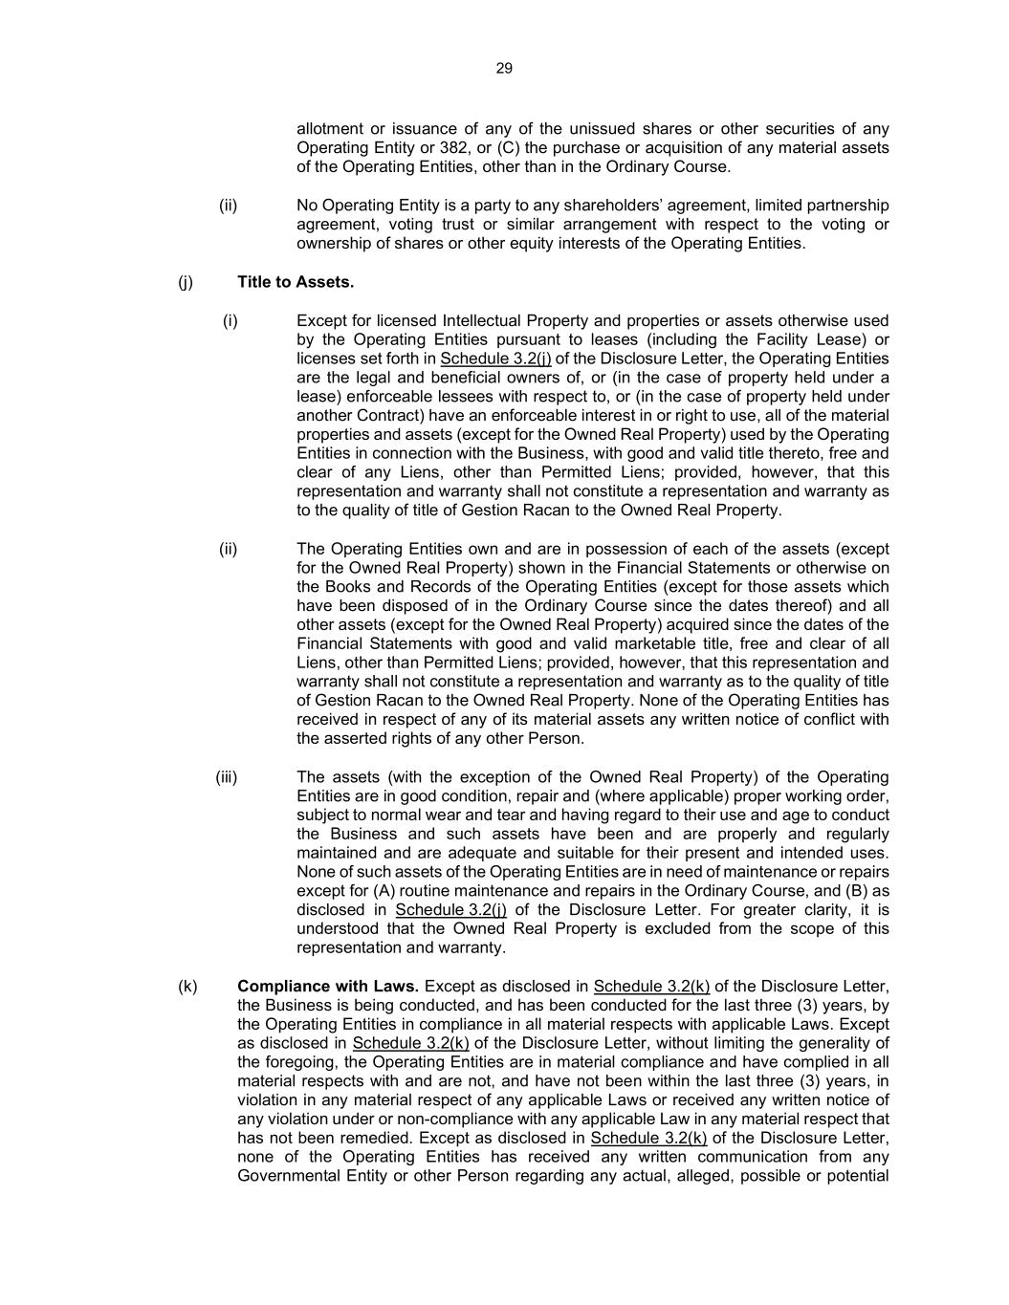
29 allotment or issuance of any of the unissued shares or other securities of any Operating Entity or 382, or (C) the purchase or acquisition of any material assets of the Operating Entities, other than in the Ordinary Course. (ii) No Operating Entity is a party to any shareholders’ agreement, limited partnership agreement, voting trust or similar arrangement with respect to the voting or ownership of shares or other equity interests of the Operating Entities. (j) Title to Assets. (i) Except for licensed Intellectual Property and properties or assets otherwise used by the Operating Entities pursuant to leases (including the Facility Lease) or licenses set forth in Schedule 3.2(j) of the Disclosure Letter, the Operating Entities are the legal and beneficial owners of, or (in the case of property held under a lease) enforceable lessees with respect to, or (in the case of property held under another Contract) have an enforceable interest in or right to use, all of the material properties and assets (except for the Owned Real Property) used by the Operating Entities in connection with the Business, with good and valid title thereto, free and clear of any Liens, other than Permitted Liens; provided, however, that this representation and warranty shall not constitute a representation and warranty as to the quality of title of Gestion Racan to the Owned Real Property. (ii) The Operating Entities own and are in possession of each of the assets (except for the Owned Real Property) shown in the Financial Statements or otherwise on the Books and Records of the Operating Entities (except for those assets which have been disposed of in the Ordinary Course since the dates thereof) and all other assets (except for the Owned Real Property) acquired since the dates of the Financial Statements with good and valid marketable title, free and clear of all Liens, other than Permitted Liens; provided, however, that this representation and warranty shall not constitute a representation and warranty as to the quality of title of Gestion Racan to the Owned Real Property. None of the Operating Entities has received in respect of any of its material assets any written notice of conflict with the asserted rights of any other Person. (iii) The assets (with the exception of the Owned Real Property) of the Operating Entities are in good condition, repair and (where applicable) proper working order, subject to normal wear and tear and having regard to their use and age to conduct the Business and such assets have been and are properly and regularly maintained and are adequate and suitable for their present and intended uses. None of such assets of the Operating Entities are in need of maintenance or repairs except for (A) routine maintenance and repairs in the Ordinary Course, and (B) as disclosed in Schedule 3.2(j) of the Disclosure Letter. For greater clarity, it is understood that the Owned Real Property is excluded from the scope of this representation and warranty. (k) Compliance with Laws. Except as disclosed in Schedule 3.2(k) of the Disclosure Letter, the Business is being conducted, and has been conducted for the last three (3) years, by the Operating Entities in compliance in all material respects with applicable Laws. Except as disclosed in Schedule 3.2(k) of the Disclosure Letter, without limiting the generality of the foregoing, the Operating Entities are in material compliance and have complied in all material respects with and are not, and have not been within the last three (3) years, in violation in any material respect of any applicable Laws or received any written notice of any violation under or non-compliance with any applicable Law in any material respect that has not been remedied. Except as disclosed in Schedule 3.2(k) of the Disclosure Letter, none of the Operating Entities has received any written communication from any Governmental Entity or other Person regarding any actual, alleged, possible or potential

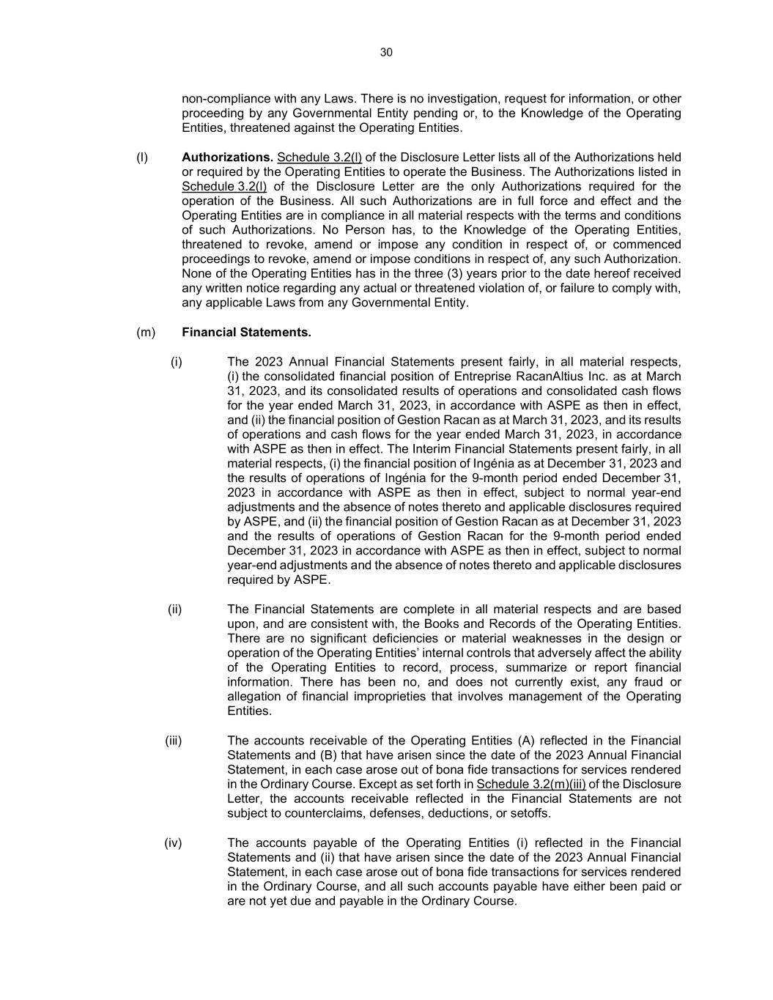
30 non-compliance with any Laws. There is no investigation, request for information, or other proceeding by any Governmental Entity pending or, to the Knowledge of the Operating Entities, threatened against the Operating Entities. (l) Authorizations. Schedule 3.2(l) of the Disclosure Letter lists all of the Authorizations held or required by the Operating Entities to operate the Business. The Authorizations listed in Schedule 3.2(l) of the Disclosure Letter are the only Authorizations required for the operation of the Business. All such Authorizations are in full force and effect and the Operating Entities are in compliance in all material respects with the terms and conditions of such Authorizations. No Person has, to the Knowledge of the Operating Entities, threatened to revoke, amend or impose any condition in respect of, or commenced proceedings to revoke, amend or impose conditions in respect of, any such Authorization. None of the Operating Entities has in the three (3) years prior to the date hereof received any written notice regarding any actual or threatened violation of, or failure to comply with, any applicable Laws from any Governmental Entity. (m) Financial Statements. (i) The 2023 Annual Financial Statements present fairly, in all material respects, (i) the consolidated financial position of Entreprise RacanAltius Inc. as at March 31, 2023, and its consolidated results of operations and consolidated cash flows for the year ended March 31, 2023, in accordance with ASPE as then in effect, and (ii) the financial position of Gestion Racan as at March 31, 2023, and its results of operations and cash flows for the year ended March 31, 2023, in accordance with ASPE as then in effect. The Interim Financial Statements present fairly, in all material respects, (i) the financial position of Ingénia as at December 31, 2023 and the results of operations of Ingénia for the 9-month period ended December 31, 2023 in accordance with ASPE as then in effect, subject to normal year-end adjustments and the absence of notes thereto and applicable disclosures required by ASPE, and (ii) the financial position of Gestion Racan as at December 31, 2023 and the results of operations of Gestion Racan for the 9-month period ended December 31, 2023 in accordance with ASPE as then in effect, subject to normal year-end adjustments and the absence of notes thereto and applicable disclosures required by ASPE. (ii) The Financial Statements are complete in all material respects and are based upon, and are consistent with, the Books and Records of the Operating Entities. There are no significant deficiencies or material weaknesses in the design or operation of the Operating Entities’ internal controls that adversely affect the ability of the Operating Entities to record, process, summarize or report financial information. There has been no, and does not currently exist, any fraud or allegation of financial improprieties that involves management of the Operating Entities. (iii) The accounts receivable of the Operating Entities (A) reflected in the Financial Statements and (B) that have arisen since the date of the 2023 Annual Financial Statement, in each case arose out of bona fide transactions for services rendered in the Ordinary Course. Except as set forth in Schedule 3.2(m)(iii) of the Disclosure Letter, the accounts receivable reflected in the Financial Statements are not subject to counterclaims, defenses, deductions, or setoffs. (iv) The accounts payable of the Operating Entities (i) reflected in the Financial Statements and (ii) that have arisen since the date of the 2023 Annual Financial Statement, in each case arose out of bona fide transactions for services rendered in the Ordinary Course, and all such accounts payable have either been paid or are not yet due and payable in the Ordinary Course.

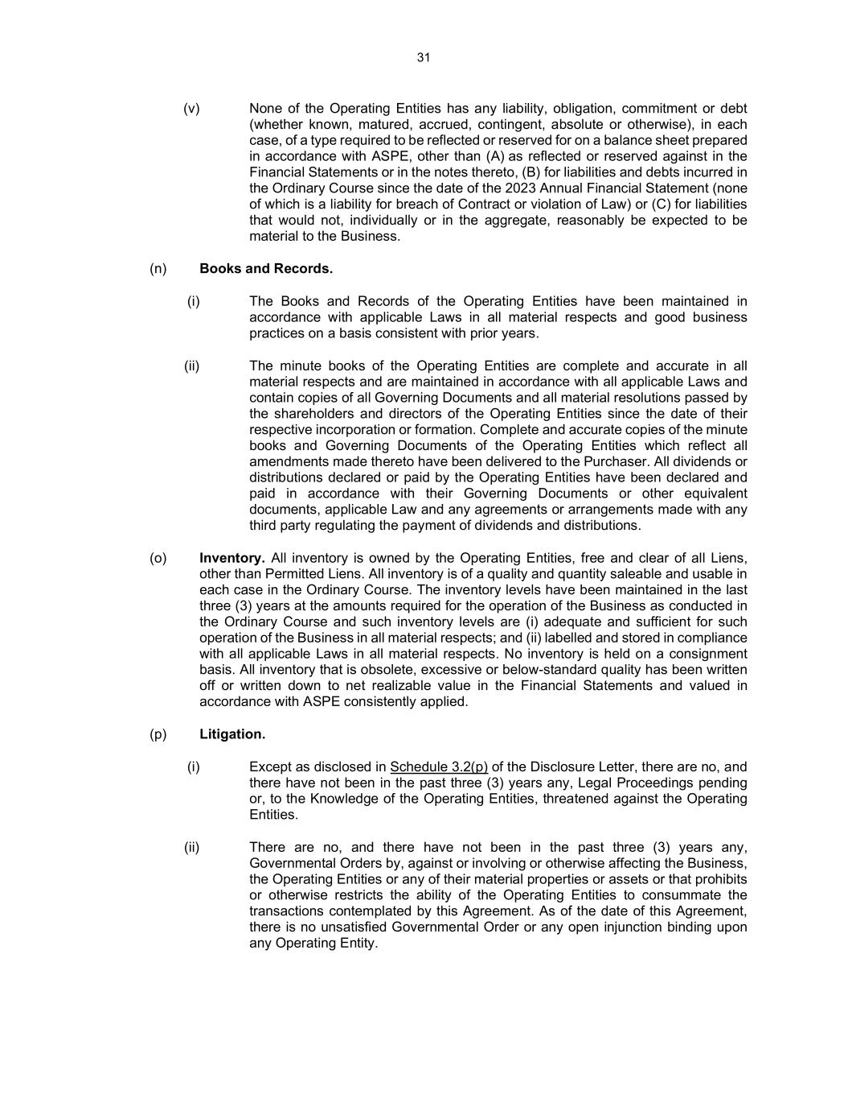
31 (v) None of the Operating Entities has any liability, obligation, commitment or debt (whether known, matured, accrued, contingent, absolute or otherwise), in each case, of a type required to be reflected or reserved for on a balance sheet prepared in accordance with ASPE, other than (A) as reflected or reserved against in the Financial Statements or in the notes thereto, (B) for liabilities and debts incurred in the Ordinary Course since the date of the 2023 Annual Financial Statement (none of which is a liability for breach of Contract or violation of Law) or (C) for liabilities that would not, individually or in the aggregate, reasonably be expected to be material to the Business. (n) Books and Records. (i) The Books and Records of the Operating Entities have been maintained in accordance with applicable Laws in all material respects and good business practices on a basis consistent with prior years. (ii) The minute books of the Operating Entities are complete and accurate in all material respects and are maintained in accordance with all applicable Laws and contain copies of all Governing Documents and all material resolutions passed by the shareholders and directors of the Operating Entities since the date of their respective incorporation or formation. Complete and accurate copies of the minute books and Governing Documents of the Operating Entities which reflect all amendments made thereto have been delivered to the Purchaser. All dividends or distributions declared or paid by the Operating Entities have been declared and paid in accordance with their Governing Documents or other equivalent documents, applicable Law and any agreements or arrangements made with any third party regulating the payment of dividends and distributions. (o) Inventory. All inventory is owned by the Operating Entities, free and clear of all Liens, other than Permitted Liens. All inventory is of a quality and quantity saleable and usable in each case in the Ordinary Course. The inventory levels have been maintained in the last three (3) years at the amounts required for the operation of the Business as conducted in the Ordinary Course and such inventory levels are (i) adequate and sufficient for such operation of the Business in all material respects; and (ii) labelled and stored in compliance with all applicable Laws in all material respects. No inventory is held on a consignment basis. All inventory that is obsolete, excessive or below-standard quality has been written off or written down to net realizable value in the Financial Statements and valued in accordance with ASPE consistently applied. (p) Litigation. (i) Except as disclosed in Schedule 3.2(p) of the Disclosure Letter, there are no, and there have not been in the past three (3) years any, Legal Proceedings pending or, to the Knowledge of the Operating Entities, threatened against the Operating Entities. (ii) There are no, and there have not been in the past three (3) years any, Governmental Orders by, against or involving or otherwise affecting the Business, the Operating Entities or any of their material properties or assets or that prohibits or otherwise restricts the ability of the Operating Entities to consummate the transactions contemplated by this Agreement. As of the date of this Agreement, there is no unsatisfied Governmental Order or any open injunction binding upon any Operating Entity.

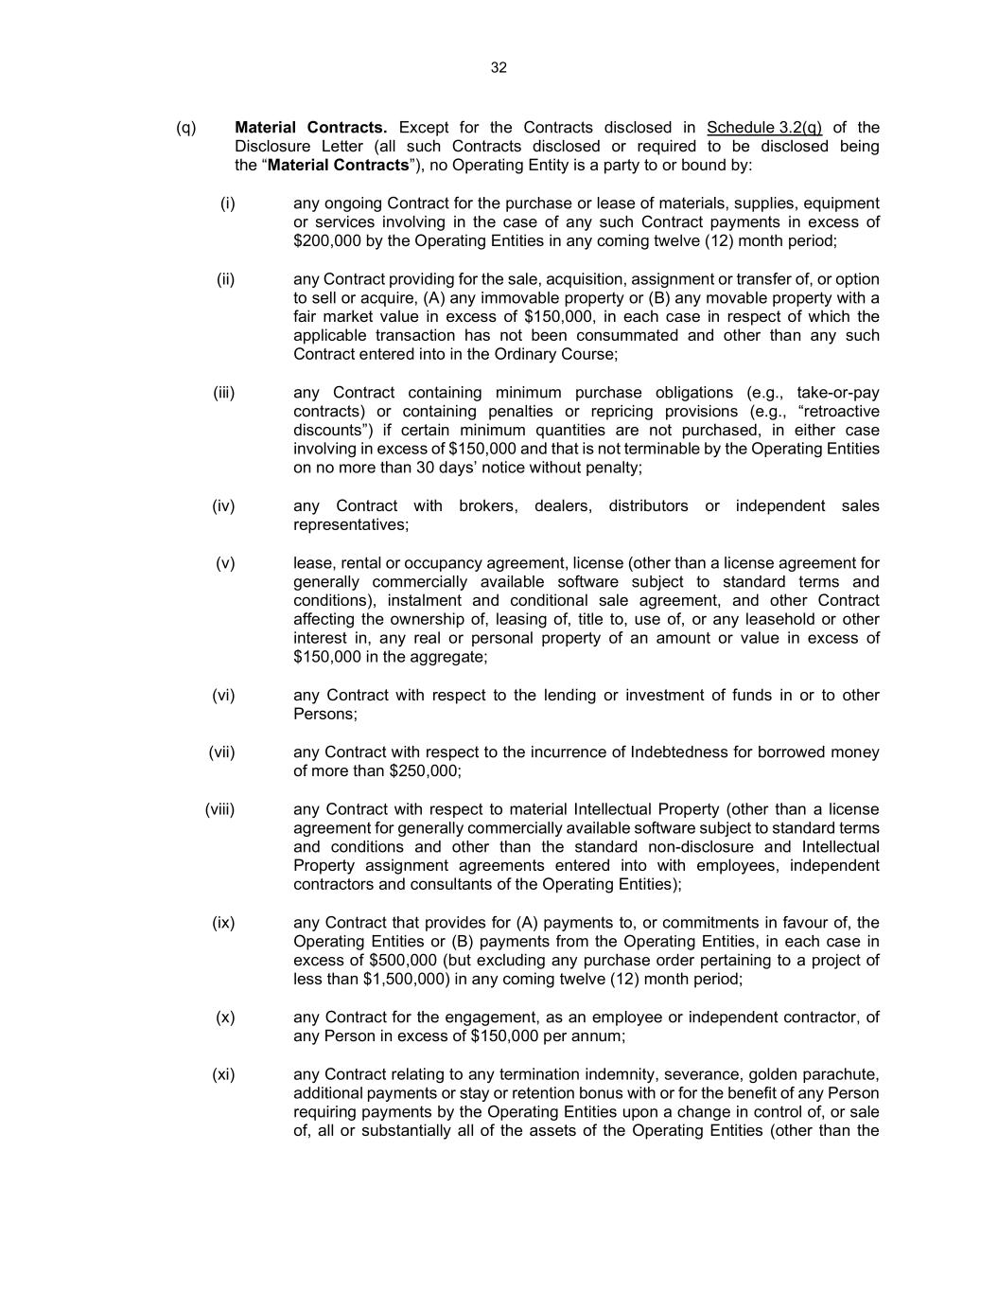
32 (q) Material Contracts. Except for the Contracts disclosed in Schedule 3.2(q) of the Disclosure Letter (all such Contracts disclosed or required to be disclosed being the “Material Contracts”), no Operating Entity is a party to or bound by: (i) any ongoing Contract for the purchase or lease of materials, supplies, equipment or services involving in the case of any such Contract payments in excess of $200,000 by the Operating Entities in any coming twelve (12) month period; (ii) any Contract providing for the sale, acquisition, assignment or transfer of, or option to sell or acquire, (A) any immovable property or (B) any movable property with a fair market value in excess of $150,000, in each case in respect of which the applicable transaction has not been consummated and other than any such Contract entered into in the Ordinary Course; (iii) any Contract containing minimum purchase obligations (e.g., take-or-pay contracts) or containing penalties or repricing provisions (e.g., “retroactive discounts”) if certain minimum quantities are not purchased, in either case involving in excess of $150,000 and that is not terminable by the Operating Entities on no more than 30 days’ notice without penalty; (iv) any Contract with brokers, dealers, distributors or independent sales representatives; (v) lease, rental or occupancy agreement, license (other than a license agreement for generally commercially available software subject to standard terms and conditions), instalment and conditional sale agreement, and other Contract affecting the ownership of, leasing of, title to, use of, or any leasehold or other interest in, any real or personal property of an amount or value in excess of $150,000 in the aggregate; (vi) any Contract with respect to the lending or investment of funds in or to other Persons; (vii) any Contract with respect to the incurrence of Indebtedness for borrowed money of more than $250,000; (viii) any Contract with respect to material Intellectual Property (other than a license agreement for generally commercially available software subject to standard terms and conditions and other than the standard non-disclosure and Intellectual Property assignment agreements entered into with employees, independent contractors and consultants of the Operating Entities); (ix) any Contract that provides for (A) payments to, or commitments in favour of, the Operating Entities or (B) payments from the Operating Entities, in each case in excess of $500,000 (but excluding any purchase order pertaining to a project of less than $1,500,000) in any coming twelve (12) month period; (x) any Contract for the engagement, as an employee or independent contractor, of any Person in excess of $150,000 per annum; (xi) any Contract relating to any termination indemnity, severance, golden parachute, additional payments or stay or retention bonus with or for the benefit of any Person requiring payments by the Operating Entities upon a change in control of, or sale of, all or substantially all of the assets of the Operating Entities (other than the

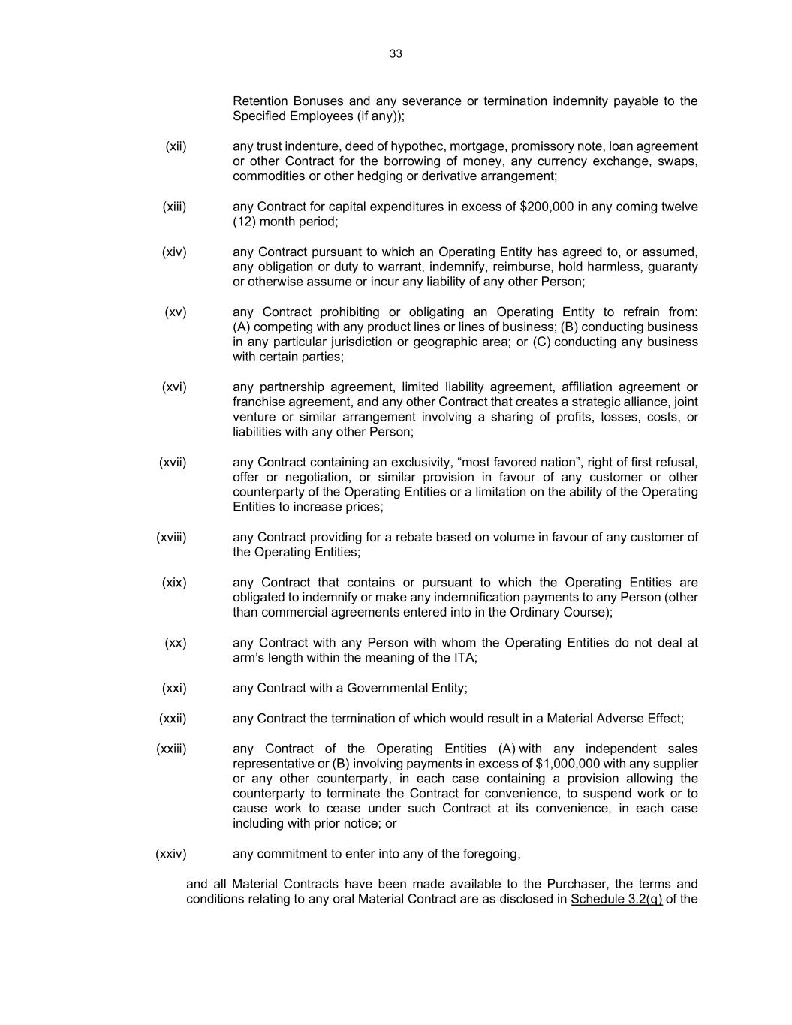
33 Retention Bonuses and any severance or termination indemnity payable to the Specified Employees (if any)); (xii) any trust indenture, deed of hypothec, mortgage, promissory note, loan agreement or other Contract for the borrowing of money, any currency exchange, swaps, commodities or other hedging or derivative arrangement; (xiii) any Contract for capital expenditures in excess of $200,000 in any coming twelve (12) month period; (xiv) any Contract pursuant to which an Operating Entity has agreed to, or assumed, any obligation or duty to warrant, indemnify, reimburse, hold harmless, guaranty or otherwise assume or incur any liability of any other Person; (xv) any Contract prohibiting or obligating an Operating Entity to refrain from: (A) competing with any product lines or lines of business; (B) conducting business in any particular jurisdiction or geographic area; or (C) conducting any business with certain parties; (xvi) any partnership agreement, limited liability agreement, affiliation agreement or franchise agreement, and any other Contract that creates a strategic alliance, joint venture or similar arrangement involving a sharing of profits, losses, costs, or liabilities with any other Person; (xvii) any Contract containing an exclusivity, “most favored nation”, right of first refusal, offer or negotiation, or similar provision in favour of any customer or other counterparty of the Operating Entities or a limitation on the ability of the Operating Entities to increase prices; (xviii) any Contract providing for a rebate based on volume in favour of any customer of the Operating Entities; (xix) any Contract that contains or pursuant to which the Operating Entities are obligated to indemnify or make any indemnification payments to any Person (other than commercial agreements entered into in the Ordinary Course); (xx) any Contract with any Person with whom the Operating Entities do not deal at arm’s length within the meaning of the ITA; (xxi) any Contract with a Governmental Entity; (xxii) any Contract the termination of which would result in a Material Adverse Effect; (xxiii) any Contract of the Operating Entities (A) with any independent sales representative or (B) involving payments in excess of $1,000,000 with any supplier or any other counterparty, in each case containing a provision allowing the counterparty to terminate the Contract for convenience, to suspend work or to cause work to cease under such Contract at its convenience, in each case including with prior notice; or (xxiv) any commitment to enter into any of the foregoing, and all Material Contracts have been made available to the Purchaser, the terms and conditions relating to any oral Material Contract are as disclosed in Schedule 3.2(q) of the

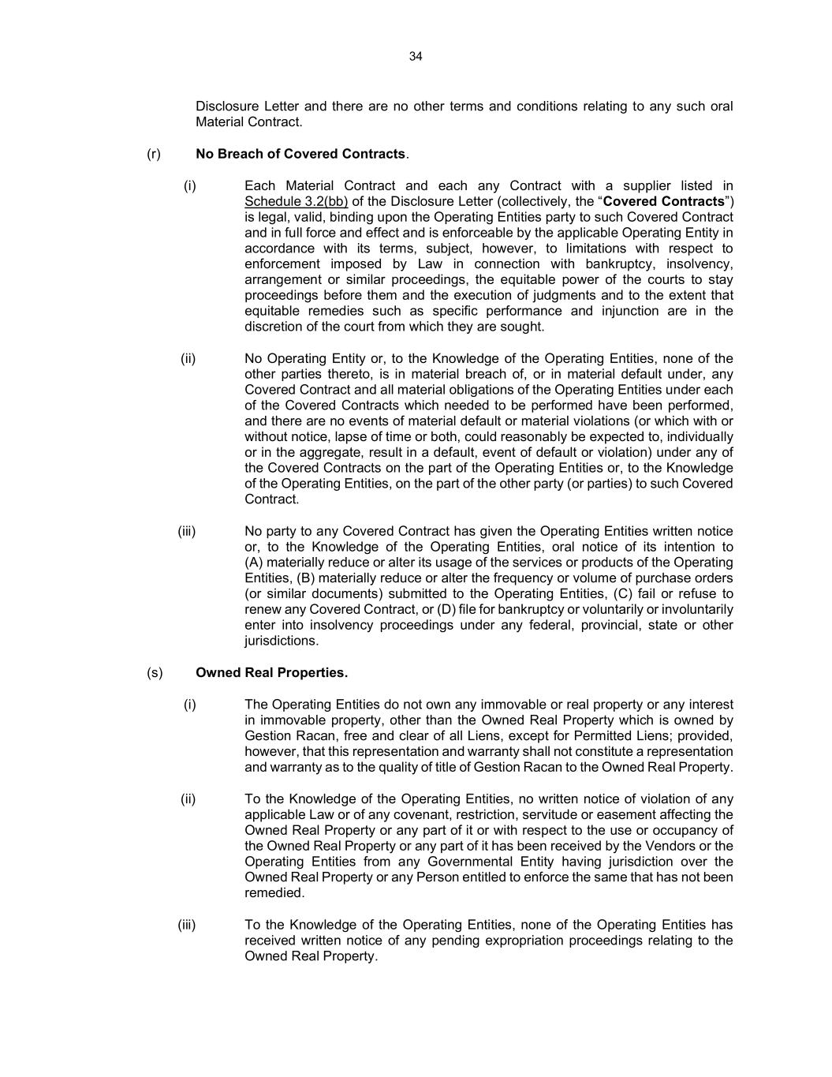
34 Disclosure Letter and there are no other terms and conditions relating to any such oral Material Contract. (r) No Breach of Covered Contracts. (i) Each Material Contract and each any Contract with a supplier listed in Schedule 3.2(bb) of the Disclosure Letter (collectively, the “Covered Contracts”) is legal, valid, binding upon the Operating Entities party to such Covered Contract and in full force and effect and is enforceable by the applicable Operating Entity in accordance with its terms, subject, however, to limitations with respect to enforcement imposed by Law in connection with bankruptcy, insolvency, arrangement or similar proceedings, the equitable power of the courts to stay proceedings before them and the execution of judgments and to the extent that equitable remedies such as specific performance and injunction are in the discretion of the court from which they are sought. (ii) No Operating Entity or, to the Knowledge of the Operating Entities, none of the other parties thereto, is in material breach of, or in material default under, any Covered Contract and all material obligations of the Operating Entities under each of the Covered Contracts which needed to be performed have been performed, and there are no events of material default or material violations (or which with or without notice, lapse of time or both, could reasonably be expected to, individually or in the aggregate, result in a default, event of default or violation) under any of the Covered Contracts on the part of the Operating Entities or, to the Knowledge of the Operating Entities, on the part of the other party (or parties) to such Covered Contract. (iii) No party to any Covered Contract has given the Operating Entities written notice or, to the Knowledge of the Operating Entities, oral notice of its intention to (A) materially reduce or alter its usage of the services or products of the Operating Entities, (B) materially reduce or alter the frequency or volume of purchase orders (or similar documents) submitted to the Operating Entities, (C) fail or refuse to renew any Covered Contract, or (D) file for bankruptcy or voluntarily or involuntarily enter into insolvency proceedings under any federal, provincial, state or other jurisdictions. (s) Owned Real Properties. (i) The Operating Entities do not own any immovable or real property or any interest in immovable property, other than the Owned Real Property which is owned by Gestion Racan, free and clear of all Liens, except for Permitted Liens; provided, however, that this representation and warranty shall not constitute a representation and warranty as to the quality of title of Gestion Racan to the Owned Real Property. (ii) To the Knowledge of the Operating Entities, no written notice of violation of any applicable Law or of any covenant, restriction, servitude or easement affecting the Owned Real Property or any part of it or with respect to the use or occupancy of the Owned Real Property or any part of it has been received by the Vendors or the Operating Entities from any Governmental Entity having jurisdiction over the Owned Real Property or any Person entitled to enforce the same that has not been remedied. (iii) To the Knowledge of the Operating Entities, none of the Operating Entities has received written notice of any pending expropriation proceedings relating to the Owned Real Property.

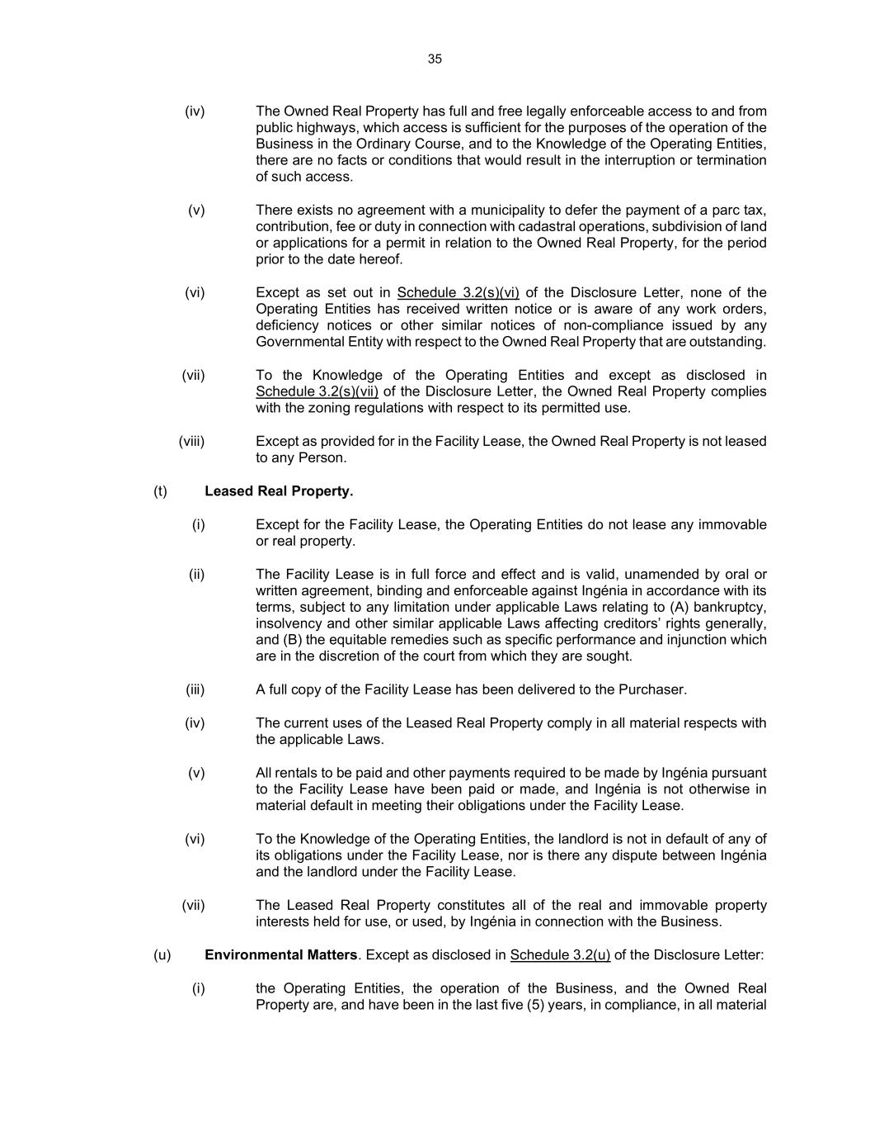
35 (iv) The Owned Real Property has full and free legally enforceable access to and from public highways, which access is sufficient for the purposes of the operation of the Business in the Ordinary Course, and to the Knowledge of the Operating Entities, there are no facts or conditions that would result in the interruption or termination of such access. (v) There exists no agreement with a municipality to defer the payment of a parc tax, contribution, fee or duty in connection with cadastral operations, subdivision of land or applications for a permit in relation to the Owned Real Property, for the period prior to the date hereof. (vi) Except as set out in Schedule 3.2(s)(vi) of the Disclosure Letter, none of the Operating Entities has received written notice or is aware of any work orders, deficiency notices or other similar notices of non-compliance issued by any Governmental Entity with respect to the Owned Real Property that are outstanding. (vii) To the Knowledge of the Operating Entities and except as disclosed in Schedule 3.2(s)(vii) of the Disclosure Letter, the Owned Real Property complies with the zoning regulations with respect to its permitted use. (viii) Except as provided for in the Facility Lease, the Owned Real Property is not leased to any Person. (t) Leased Real Property. (i) Except for the Facility Lease, the Operating Entities do not lease any immovable or real property. (ii) The Facility Lease is in full force and effect and is valid, unamended by oral or written agreement, binding and enforceable against Ingénia in accordance with its terms, subject to any limitation under applicable Laws relating to (A) bankruptcy, insolvency and other similar applicable Laws affecting creditors’ rights generally, and (B) the equitable remedies such as specific performance and injunction which are in the discretion of the court from which they are sought. (iii) A full copy of the Facility Lease has been delivered to the Purchaser. (iv) The current uses of the Leased Real Property comply in all material respects with the applicable Laws. (v) All rentals to be paid and other payments required to be made by Ingénia pursuant to the Facility Lease have been paid or made, and Ingénia is not otherwise in material default in meeting their obligations under the Facility Lease. (vi) To the Knowledge of the Operating Entities, the landlord is not in default of any of its obligations under the Facility Lease, nor is there any dispute between Ingénia and the landlord under the Facility Lease. (vii) The Leased Real Property constitutes all of the real and immovable property interests held for use, or used, by Ingénia in connection with the Business. (u) Environmental Matters. Except as disclosed in Schedule 3.2(u) of the Disclosure Letter: (i) the Operating Entities, the operation of the Business, and the Owned Real Property are, and have been in the last five (5) years, in compliance, in all material

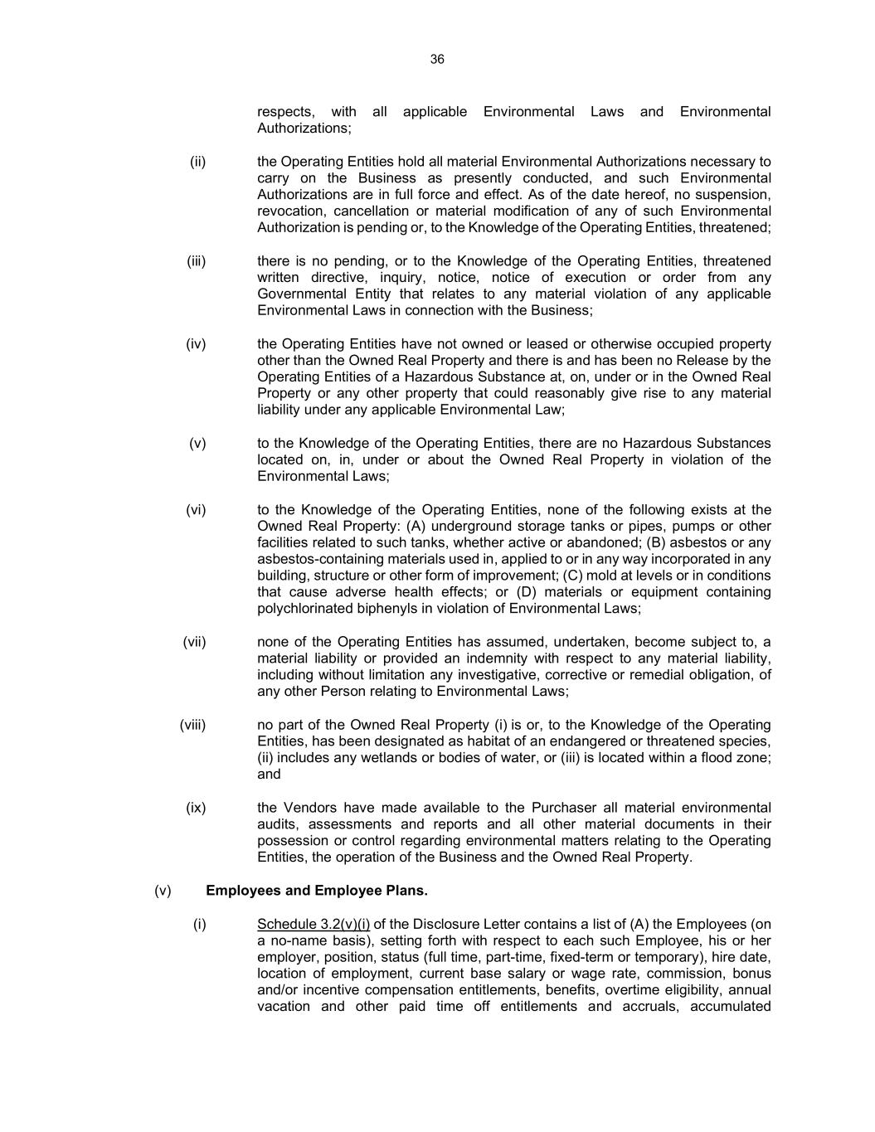
36 respects, with all applicable Environmental Laws and Environmental Authorizations; (ii) the Operating Entities hold all material Environmental Authorizations necessary to carry on the Business as presently conducted, and such Environmental Authorizations are in full force and effect. As of the date hereof, no suspension, revocation, cancellation or material modification of any of such Environmental Authorization is pending or, to the Knowledge of the Operating Entities, threatened; (iii) there is no pending, or to the Knowledge of the Operating Entities, threatened written directive, inquiry, notice, notice of execution or order from any Governmental Entity that relates to any material violation of any applicable Environmental Laws in connection with the Business; (iv) the Operating Entities have not owned or leased or otherwise occupied property other than the Owned Real Property and there is and has been no Release by the Operating Entities of a Hazardous Substance at, on, under or in the Owned Real Property or any other property that could reasonably give rise to any material liability under any applicable Environmental Law; (v) to the Knowledge of the Operating Entities, there are no Hazardous Substances located on, in, under or about the Owned Real Property in violation of the Environmental Laws; (vi) to the Knowledge of the Operating Entities, none of the following exists at the Owned Real Property: (A) underground storage tanks or pipes, pumps or other facilities related to such tanks, whether active or abandoned; (B) asbestos or any asbestos-containing materials used in, applied to or in any way incorporated in any building, structure or other form of improvement; (C) mold at levels or in conditions that cause adverse health effects; or (D) materials or equipment containing polychlorinated biphenyls in violation of Environmental Laws; (vii) none of the Operating Entities has assumed, undertaken, become subject to, a material liability or provided an indemnity with respect to any material liability, including without limitation any investigative, corrective or remedial obligation, of any other Person relating to Environmental Laws; (viii) no part of the Owned Real Property (i) is or, to the Knowledge of the Operating Entities, has been designated as habitat of an endangered or threatened species, (ii) includes any wetlands or bodies of water, or (iii) is located within a flood zone; and (ix) the Vendors have made available to the Purchaser all material environmental audits, assessments and reports and all other material documents in their possession or control regarding environmental matters relating to the Operating Entities, the operation of the Business and the Owned Real Property. (v) Employees and Employee Plans. (i) Schedule 3.2(v)(i) of the Disclosure Letter contains a list of (A) the Employees (on a no-name basis), setting forth with respect to each such Employee, his or her employer, position, status (full time, part-time, fixed-term or temporary), hire date, location of employment, current base salary or wage rate, commission, bonus and/or incentive compensation entitlements, benefits, overtime eligibility, annual vacation and other paid time off entitlements and accruals, accumulated

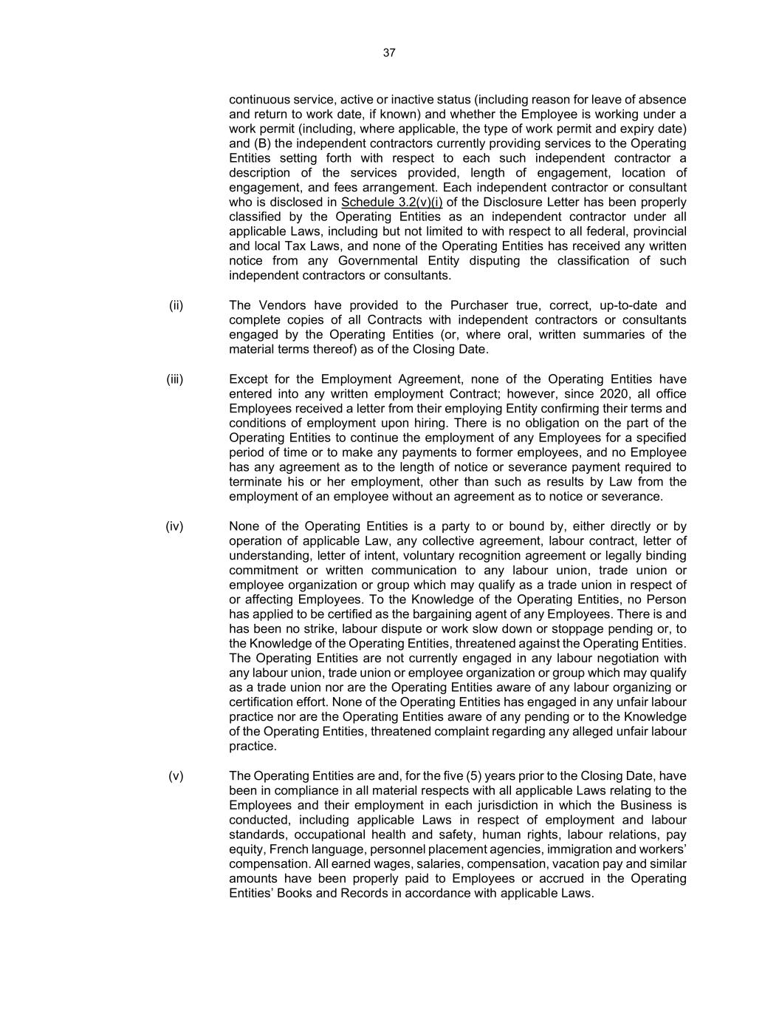
37 continuous service, active or inactive status (including reason for leave of absence and return to work date, if known) and whether the Employee is working under a work permit (including, where applicable, the type of work permit and expiry date) and (B) the independent contractors currently providing services to the Operating Entities setting forth with respect to each such independent contractor a description of the services provided, length of engagement, location of engagement, and fees arrangement. Each independent contractor or consultant who is disclosed in Schedule 3.2(v)(i) of the Disclosure Letter has been properly classified by the Operating Entities as an independent contractor under all applicable Laws, including but not limited to with respect to all federal, provincial and local Tax Laws, and none of the Operating Entities has received any written notice from any Governmental Entity disputing the classification of such independent contractors or consultants. (ii) The Vendors have provided to the Purchaser true, correct, up-to-date and complete copies of all Contracts with independent contractors or consultants engaged by the Operating Entities (or, where oral, written summaries of the material terms thereof) as of the Closing Date. (iii) Except for the Employment Agreement, none of the Operating Entities have entered into any written employment Contract; however, since 2020, all office Employees received a letter from their employing Entity confirming their terms and conditions of employment upon hiring. There is no obligation on the part of the Operating Entities to continue the employment of any Employees for a specified period of time or to make any payments to former employees, and no Employee has any agreement as to the length of notice or severance payment required to terminate his or her employment, other than such as results by Law from the employment of an employee without an agreement as to notice or severance. (iv) None of the Operating Entities is a party to or bound by, either directly or by operation of applicable Law, any collective agreement, labour contract, letter of understanding, letter of intent, voluntary recognition agreement or legally binding commitment or written communication to any labour union, trade union or employee organization or group which may qualify as a trade union in respect of or affecting Employees. To the Knowledge of the Operating Entities, no Person has applied to be certified as the bargaining agent of any Employees. There is and has been no strike, labour dispute or work slow down or stoppage pending or, to the Knowledge of the Operating Entities, threatened against the Operating Entities. The Operating Entities are not currently engaged in any labour negotiation with any labour union, trade union or employee organization or group which may qualify as a trade union nor are the Operating Entities aware of any labour organizing or certification effort. None of the Operating Entities has engaged in any unfair labour practice nor are the Operating Entities aware of any pending or to the Knowledge of the Operating Entities, threatened complaint regarding any alleged unfair labour practice. (v) The Operating Entities are and, for the five (5) years prior to the Closing Date, have been in compliance in all material respects with all applicable Laws relating to the Employees and their employment in each jurisdiction in which the Business is conducted, including applicable Laws in respect of employment and labour standards, occupational health and safety, human rights, labour relations, pay equity, French language, personnel placement agencies, immigration and workers’ compensation. All earned wages, salaries, compensation, vacation pay and similar amounts have been properly paid to Employees or accrued in the Operating Entities’ Books and Records in accordance with applicable Laws.

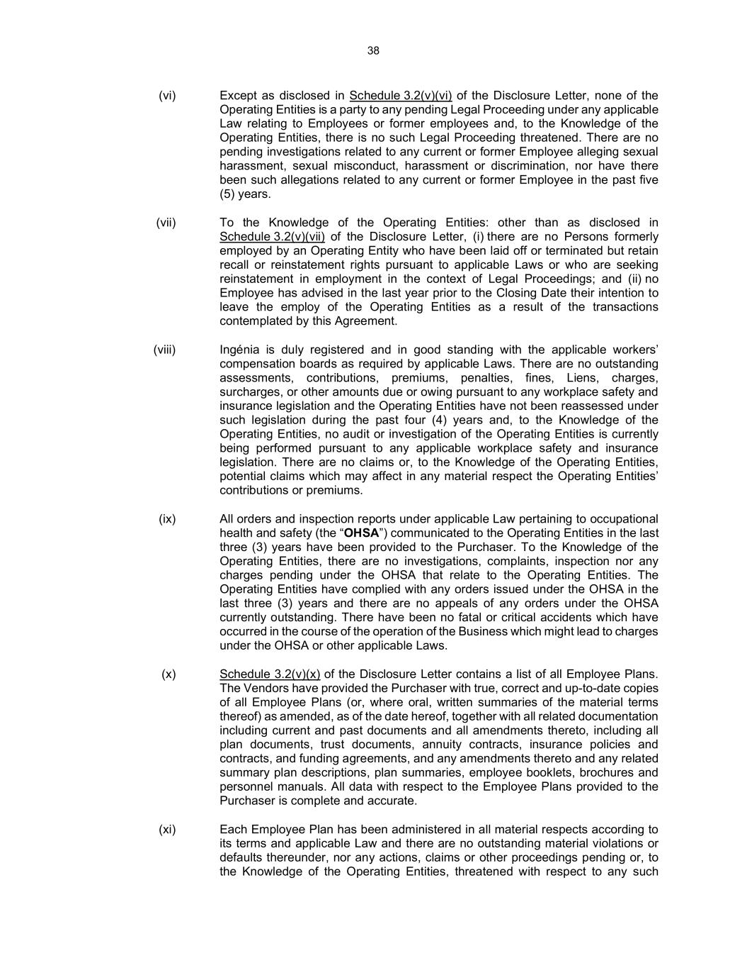
38 (vi) Except as disclosed in Schedule 3.2(v)(vi) of the Disclosure Letter, none of the Operating Entities is a party to any pending Legal Proceeding under any applicable Law relating to Employees or former employees and, to the Knowledge of the Operating Entities, there is no such Legal Proceeding threatened. There are no pending investigations related to any current or former Employee alleging sexual harassment, sexual misconduct, harassment or discrimination, nor have there been such allegations related to any current or former Employee in the past five (5) years. (vii) To the Knowledge of the Operating Entities: other than as disclosed in Schedule 3.2(v)(vii) of the Disclosure Letter, (i) there are no Persons formerly employed by an Operating Entity who have been laid off or terminated but retain recall or reinstatement rights pursuant to applicable Laws or who are seeking reinstatement in employment in the context of Legal Proceedings; and (ii) no Employee has advised in the last year prior to the Closing Date their intention to leave the employ of the Operating Entities as a result of the transactions contemplated by this Agreement. (viii) Ingénia is duly registered and in good standing with the applicable workers’ compensation boards as required by applicable Laws. There are no outstanding assessments, contributions, premiums, penalties, fines, Liens, charges, surcharges, or other amounts due or owing pursuant to any workplace safety and insurance legislation and the Operating Entities have not been reassessed under such legislation during the past four (4) years and, to the Knowledge of the Operating Entities, no audit or investigation of the Operating Entities is currently being performed pursuant to any applicable workplace safety and insurance legislation. There are no claims or, to the Knowledge of the Operating Entities, potential claims which may affect in any material respect the Operating Entities’ contributions or premiums. (ix) All orders and inspection reports under applicable Law pertaining to occupational health and safety (the “OHSA”) communicated to the Operating Entities in the last three (3) years have been provided to the Purchaser. To the Knowledge of the Operating Entities, there are no investigations, complaints, inspection nor any charges pending under the OHSA that relate to the Operating Entities. The Operating Entities have complied with any orders issued under the OHSA in the last three (3) years and there are no appeals of any orders under the OHSA currently outstanding. There have been no fatal or critical accidents which have occurred in the course of the operation of the Business which might lead to charges under the OHSA or other applicable Laws. (x) Schedule 3.2(v)(x) of the Disclosure Letter contains a list of all Employee Plans. The Vendors have provided the Purchaser with true, correct and up-to-date copies of all Employee Plans (or, where oral, written summaries of the material terms thereof) as amended, as of the date hereof, together with all related documentation including current and past documents and all amendments thereto, including all plan documents, trust documents, annuity contracts, insurance policies and contracts, and funding agreements, and any amendments thereto and any related summary plan descriptions, plan summaries, employee booklets, brochures and personnel manuals. All data with respect to the Employee Plans provided to the Purchaser is complete and accurate. (xi) Each Employee Plan has been administered in all material respects according to its terms and applicable Law and there are no outstanding material violations or defaults thereunder, nor any actions, claims or other proceedings pending or, to the Knowledge of the Operating Entities, threatened with respect to any such

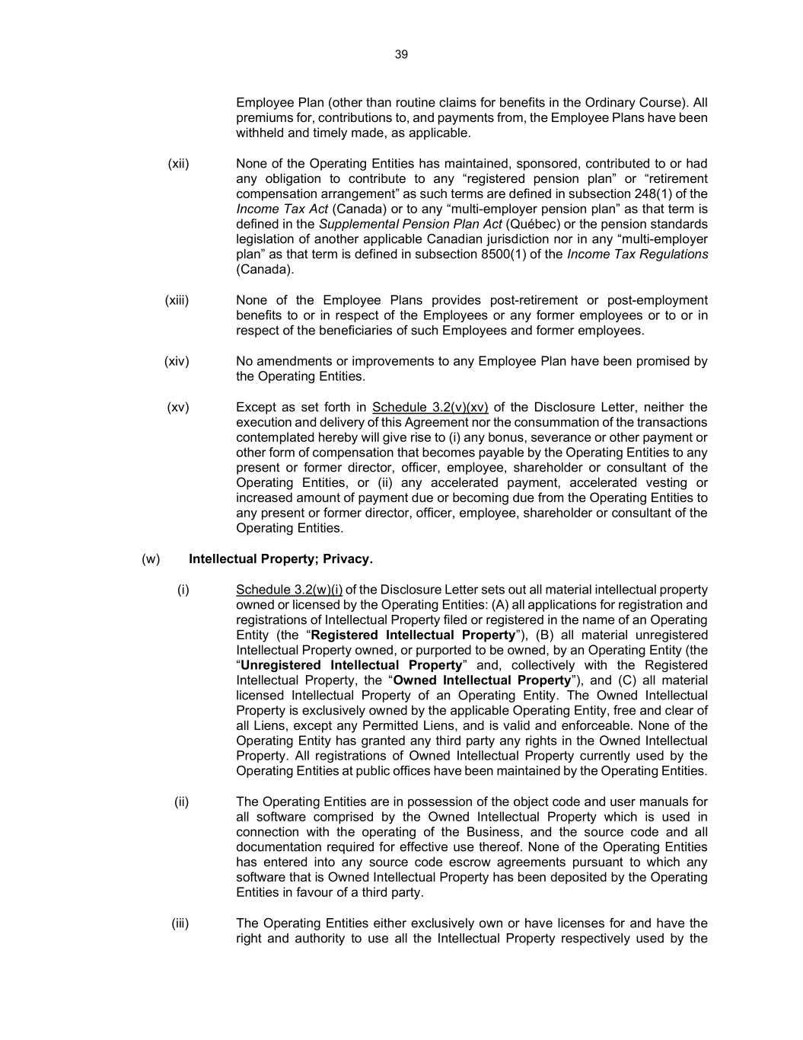
39 Employee Plan (other than routine claims for benefits in the Ordinary Course). All premiums for, contributions to, and payments from, the Employee Plans have been withheld and timely made, as applicable. (xii) None of the Operating Entities has maintained, sponsored, contributed to or had any obligation to contribute to any “registered pension plan” or “retirement compensation arrangement” as such terms are defined in subsection 248(1) of the Income Tax Act (Canada) or to any “multi-employer pension plan” as that term is defined in the Supplemental Pension Plan Act (Québec) or the pension standards legislation of another applicable Canadian jurisdiction nor in any “multi-employer plan” as that term is defined in subsection 8500(1) of the Income Tax Regulations (Canada). (xiii) None of the Employee Plans provides post-retirement or post-employment benefits to or in respect of the Employees or any former employees or to or in respect of the beneficiaries of such Employees and former employees. (xiv) No amendments or improvements to any Employee Plan have been promised by the Operating Entities. (xv) Except as set forth in Schedule 3.2(v)(xv) of the Disclosure Letter, neither the execution and delivery of this Agreement nor the consummation of the transactions contemplated hereby will give rise to (i) any bonus, severance or other payment or other form of compensation that becomes payable by the Operating Entities to any present or former director, officer, employee, shareholder or consultant of the Operating Entities, or (ii) any accelerated payment, accelerated vesting or increased amount of payment due or becoming due from the Operating Entities to any present or former director, officer, employee, shareholder or consultant of the Operating Entities. (w) Intellectual Property; Privacy. (i) Schedule 3.2(w)(i) of the Disclosure Letter sets out all material intellectual property owned or licensed by the Operating Entities: (A) all applications for registration and registrations of Intellectual Property filed or registered in the name of an Operating Entity (the “Registered Intellectual Property”), (B) all material unregistered Intellectual Property owned, or purported to be owned, by an Operating Entity (the “Unregistered Intellectual Property” and, collectively with the Registered Intellectual Property, the “Owned Intellectual Property”), and (C) all material licensed Intellectual Property of an Operating Entity. The Owned Intellectual Property is exclusively owned by the applicable Operating Entity, free and clear of all Liens, except any Permitted Liens, and is valid and enforceable. None of the Operating Entity has granted any third party any rights in the Owned Intellectual Property. All registrations of Owned Intellectual Property currently used by the Operating Entities at public offices have been maintained by the Operating Entities. (ii) The Operating Entities are in possession of the object code and user manuals for all software comprised by the Owned Intellectual Property which is used in connection with the operating of the Business, and the source code and all documentation required for effective use thereof. None of the Operating Entities has entered into any source code escrow agreements pursuant to which any software that is Owned Intellectual Property has been deposited by the Operating Entities in favour of a third party. (iii) The Operating Entities either exclusively own or have licenses for and have the right and authority to use all the Intellectual Property respectively used by the

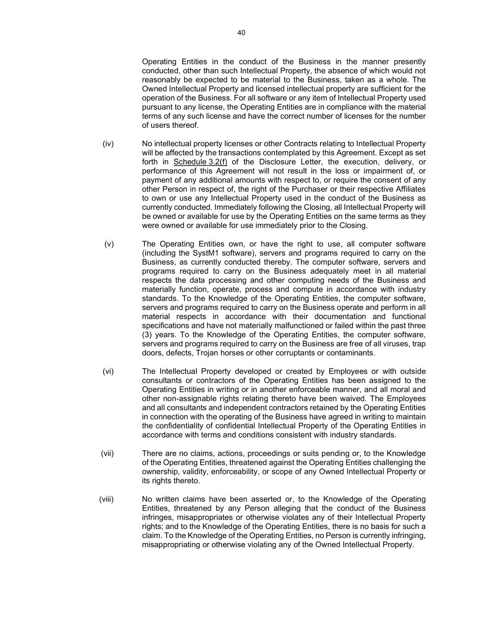
40 Operating Entities in the conduct of the Business in the manner presently conducted, other than such Intellectual Property, the absence of which would not reasonably be expected to be material to the Business, taken as a whole. The Owned Intellectual Property and licensed intellectual property are sufficient for the operation of the Business. For all software or any item of Intellectual Property used pursuant to any license, the Operating Entities are in compliance with the material terms of any such license and have the correct number of licenses for the number of users thereof. (iv) No intellectual property licenses or other Contracts relating to Intellectual Property will be affected by the transactions contemplated by this Agreement. Except as set forth in Schedule 3.2(f) of the Disclosure Letter, the execution, delivery, or performance of this Agreement will not result in the loss or impairment of, or payment of any additional amounts with respect to, or require the consent of any other Person in respect of, the right of the Purchaser or their respective Affiliates to own or use any Intellectual Property used in the conduct of the Business as currently conducted. Immediately following the Closing, all Intellectual Property will be owned or available for use by the Operating Entities on the same terms as they were owned or available for use immediately prior to the Closing. (v) The Operating Entities own, or have the right to use, all computer software (including the SystM1 software), servers and programs required to carry on the Business, as currently conducted thereby. The computer software, servers and programs required to carry on the Business adequately meet in all material respects the data processing and other computing needs of the Business and materially function, operate, process and compute in accordance with industry standards. To the Knowledge of the Operating Entities, the computer software, servers and programs required to carry on the Business operate and perform in all material respects in accordance with their documentation and functional specifications and have not materially malfunctioned or failed within the past three (3) years. To the Knowledge of the Operating Entities, the computer software, servers and programs required to carry on the Business are free of all viruses, trap doors, defects, Trojan horses or other corruptants or contaminants. (vi) The Intellectual Property developed or created by Employees or with outside consultants or contractors of the Operating Entities has been assigned to the Operating Entities in writing or in another enforceable manner, and all moral and other non-assignable rights relating thereto have been waived. The Employees and all consultants and independent contractors retained by the Operating Entities in connection with the operating of the Business have agreed in writing to maintain the confidentiality of confidential Intellectual Property of the Operating Entities in accordance with terms and conditions consistent with industry standards. (vii) There are no claims, actions, proceedings or suits pending or, to the Knowledge of the Operating Entities, threatened against the Operating Entities challenging the ownership, validity, enforceability, or scope of any Owned Intellectual Property or its rights thereto. (viii) No written claims have been asserted or, to the Knowledge of the Operating Entities, threatened by any Person alleging that the conduct of the Business infringes, misappropriates or otherwise violates any of their Intellectual Property rights; and to the Knowledge of the Operating Entities, there is no basis for such a claim. To the Knowledge of the Operating Entities, no Person is currently infringing, misappropriating or otherwise violating any of the Owned Intellectual Property.

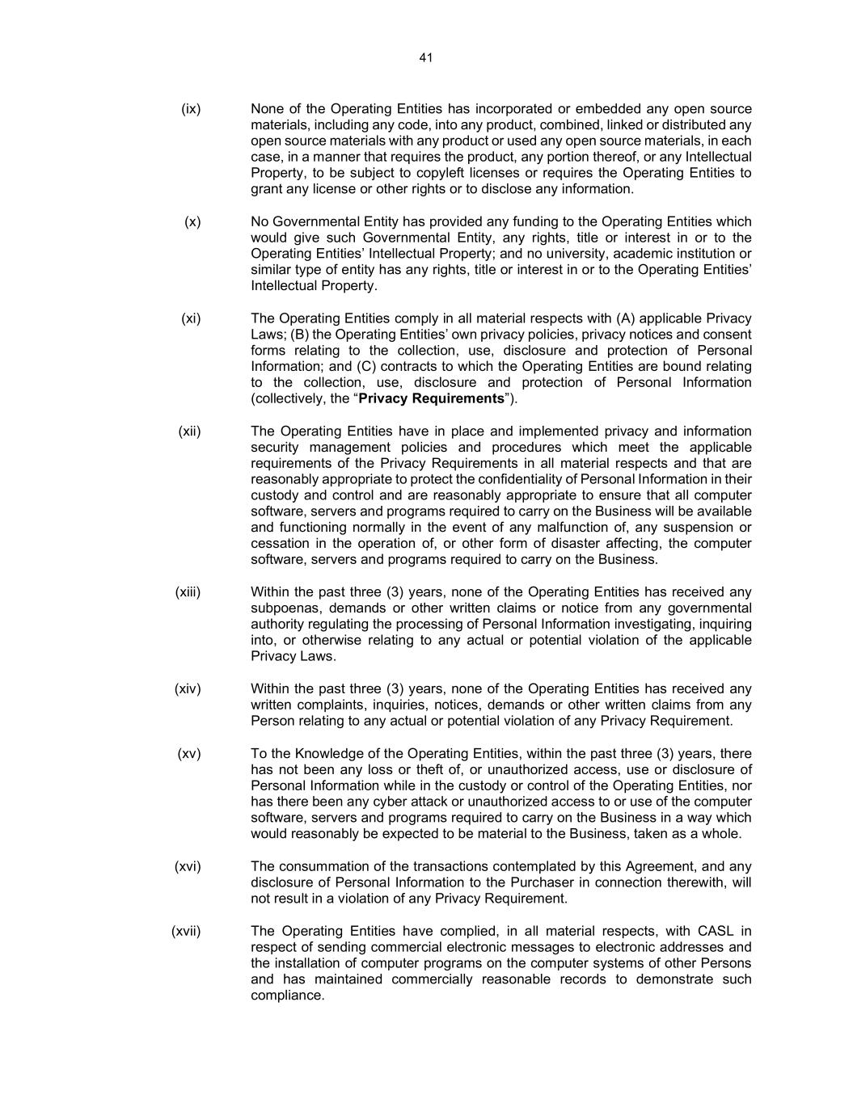
41 (ix) None of the Operating Entities has incorporated or embedded any open source materials, including any code, into any product, combined, linked or distributed any open source materials with any product or used any open source materials, in each case, in a manner that requires the product, any portion thereof, or any Intellectual Property, to be subject to copyleft licenses or requires the Operating Entities to grant any license or other rights or to disclose any information. (x) No Governmental Entity has provided any funding to the Operating Entities which would give such Governmental Entity, any rights, title or interest in or to the Operating Entities’ Intellectual Property; and no university, academic institution or similar type of entity has any rights, title or interest in or to the Operating Entities’ Intellectual Property. (xi) The Operating Entities comply in all material respects with (A) applicable Privacy Laws; (B) the Operating Entities’ own privacy policies, privacy notices and consent forms relating to the collection, use, disclosure and protection of Personal Information; and (C) contracts to which the Operating Entities are bound relating to the collection, use, disclosure and protection of Personal Information (collectively, the “Privacy Requirements”). (xii) The Operating Entities have in place and implemented privacy and information security management policies and procedures which meet the applicable requirements of the Privacy Requirements in all material respects and that are reasonably appropriate to protect the confidentiality of Personal Information in their custody and control and are reasonably appropriate to ensure that all computer software, servers and programs required to carry on the Business will be available and functioning normally in the event of any malfunction of, any suspension or cessation in the operation of, or other form of disaster affecting, the computer software, servers and programs required to carry on the Business. (xiii) Within the past three (3) years, none of the Operating Entities has received any subpoenas, demands or other written claims or notice from any governmental authority regulating the processing of Personal Information investigating, inquiring into, or otherwise relating to any actual or potential violation of the applicable Privacy Laws. (xiv) Within the past three (3) years, none of the Operating Entities has received any written complaints, inquiries, notices, demands or other written claims from any Person relating to any actual or potential violation of any Privacy Requirement. (xv) To the Knowledge of the Operating Entities, within the past three (3) years, there has not been any loss or theft of, or unauthorized access, use or disclosure of Personal Information while in the custody or control of the Operating Entities, nor has there been any cyber attack or unauthorized access to or use of the computer software, servers and programs required to carry on the Business in a way which would reasonably be expected to be material to the Business, taken as a whole. (xvi) The consummation of the transactions contemplated by this Agreement, and any disclosure of Personal Information to the Purchaser in connection therewith, will not result in a violation of any Privacy Requirement. (xvii) The Operating Entities have complied, in all material respects, with CASL in respect of sending commercial electronic messages to electronic addresses and the installation of computer programs on the computer systems of other Persons and has maintained commercially reasonable records to demonstrate such compliance.

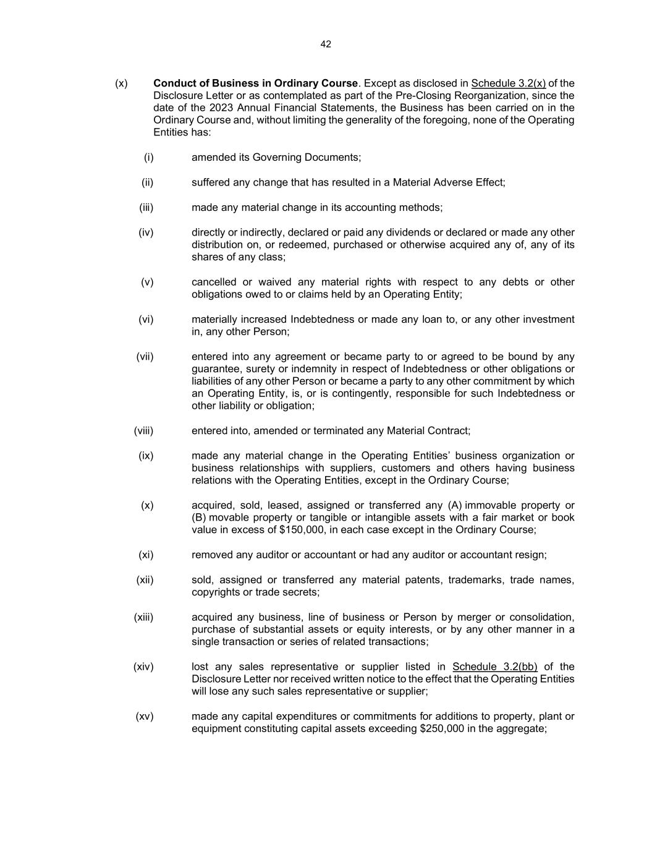
42 (x) Conduct of Business in Ordinary Course. Except as disclosed in Schedule 3.2(x) of the Disclosure Letter or as contemplated as part of the Pre-Closing Reorganization, since the date of the 2023 Annual Financial Statements, the Business has been carried on in the Ordinary Course and, without limiting the generality of the foregoing, none of the Operating Entities has: (i) amended its Governing Documents; (ii) suffered any change that has resulted in a Material Adverse Effect; (iii) made any material change in its accounting methods; (iv) directly or indirectly, declared or paid any dividends or declared or made any other distribution on, or redeemed, purchased or otherwise acquired any of, any of its shares of any class; (v) cancelled or waived any material rights with respect to any debts or other obligations owed to or claims held by an Operating Entity; (vi) materially increased Indebtedness or made any loan to, or any other investment in, any other Person; (vii) entered into any agreement or became party to or agreed to be bound by any guarantee, surety or indemnity in respect of Indebtedness or other obligations or liabilities of any other Person or became a party to any other commitment by which an Operating Entity, is, or is contingently, responsible for such Indebtedness or other liability or obligation; (viii) entered into, amended or terminated any Material Contract; (ix) made any material change in the Operating Entities’ business organization or business relationships with suppliers, customers and others having business relations with the Operating Entities, except in the Ordinary Course; (x) acquired, sold, leased, assigned or transferred any (A) immovable property or (B) movable property or tangible or intangible assets with a fair market or book value in excess of $150,000, in each case except in the Ordinary Course; (xi) removed any auditor or accountant or had any auditor or accountant resign; (xii) sold, assigned or transferred any material patents, trademarks, trade names, copyrights or trade secrets; (xiii) acquired any business, line of business or Person by merger or consolidation, purchase of substantial assets or equity interests, or by any other manner in a single transaction or series of related transactions; (xiv) lost any sales representative or supplier listed in Schedule 3.2(bb) of the Disclosure Letter nor received written notice to the effect that the Operating Entities will lose any such sales representative or supplier; (xv) made any capital expenditures or commitments for additions to property, plant or equipment constituting capital assets exceeding $250,000 in the aggregate;

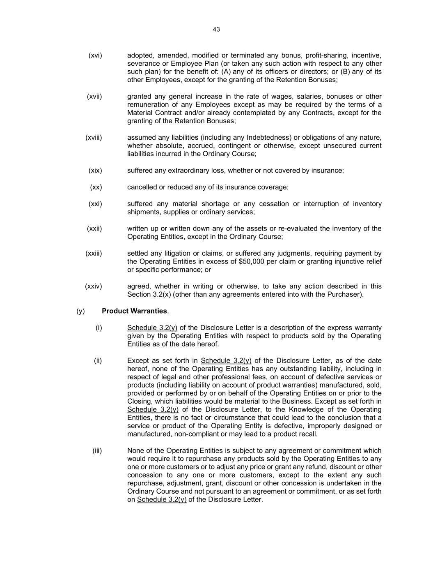
43 (xvi) adopted, amended, modified or terminated any bonus, profit-sharing, incentive, severance or Employee Plan (or taken any such action with respect to any other such plan) for the benefit of: (A) any of its officers or directors; or (B) any of its other Employees, except for the granting of the Retention Bonuses; (xvii) granted any general increase in the rate of wages, salaries, bonuses or other remuneration of any Employees except as may be required by the terms of a Material Contract and/or already contemplated by any Contracts, except for the granting of the Retention Bonuses; (xviii) assumed any liabilities (including any Indebtedness) or obligations of any nature, whether absolute, accrued, contingent or otherwise, except unsecured current liabilities incurred in the Ordinary Course; (xix) suffered any extraordinary loss, whether or not covered by insurance; (xx) cancelled or reduced any of its insurance coverage; (xxi) suffered any material shortage or any cessation or interruption of inventory shipments, supplies or ordinary services; (xxii) written up or written down any of the assets or re-evaluated the inventory of the Operating Entities, except in the Ordinary Course; (xxiii) settled any litigation or claims, or suffered any judgments, requiring payment by the Operating Entities in excess of $50,000 per claim or granting injunctive relief or specific performance; or (xxiv) agreed, whether in writing or otherwise, to take any action described in this Section 3.2(x) (other than any agreements entered into with the Purchaser). (y) Product Warranties. (i) Schedule 3.2(y) of the Disclosure Letter is a description of the express warranty given by the Operating Entities with respect to products sold by the Operating Entities as of the date hereof. (ii) Except as set forth in Schedule 3.2(y) of the Disclosure Letter, as of the date hereof, none of the Operating Entities has any outstanding liability, including in respect of legal and other professional fees, on account of defective services or products (including liability on account of product warranties) manufactured, sold, provided or performed by or on behalf of the Operating Entities on or prior to the Closing, which liabilities would be material to the Business. Except as set forth in Schedule 3.2(y) of the Disclosure Letter, to the Knowledge of the Operating Entities, there is no fact or circumstance that could lead to the conclusion that a service or product of the Operating Entity is defective, improperly designed or manufactured, non-compliant or may lead to a product recall. (iii) None of the Operating Entities is subject to any agreement or commitment which would require it to repurchase any products sold by the Operating Entities to any one or more customers or to adjust any price or grant any refund, discount or other concession to any one or more customers, except to the extent any such repurchase, adjustment, grant, discount or other concession is undertaken in the Ordinary Course and not pursuant to an agreement or commitment, or as set forth on Schedule 3.2(y) of the Disclosure Letter.

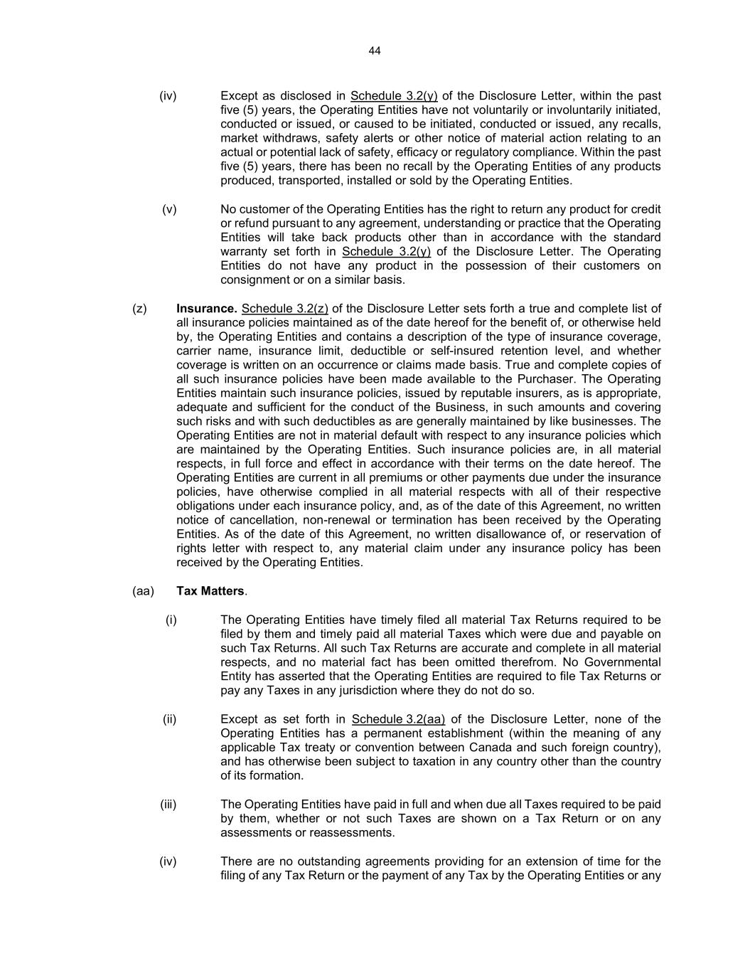
44 (iv) Except as disclosed in Schedule 3.2(y) of the Disclosure Letter, within the past five (5) years, the Operating Entities have not voluntarily or involuntarily initiated, conducted or issued, or caused to be initiated, conducted or issued, any recalls, market withdraws, safety alerts or other notice of material action relating to an actual or potential lack of safety, efficacy or regulatory compliance. Within the past five (5) years, there has been no recall by the Operating Entities of any products produced, transported, installed or sold by the Operating Entities. (v) No customer of the Operating Entities has the right to return any product for credit or refund pursuant to any agreement, understanding or practice that the Operating Entities will take back products other than in accordance with the standard warranty set forth in Schedule 3.2(y) of the Disclosure Letter. The Operating Entities do not have any product in the possession of their customers on consignment or on a similar basis. (z) Insurance. Schedule 3.2(z) of the Disclosure Letter sets forth a true and complete list of all insurance policies maintained as of the date hereof for the benefit of, or otherwise held by, the Operating Entities and contains a description of the type of insurance coverage, carrier name, insurance limit, deductible or self-insured retention level, and whether coverage is written on an occurrence or claims made basis. True and complete copies of all such insurance policies have been made available to the Purchaser. The Operating Entities maintain such insurance policies, issued by reputable insurers, as is appropriate, adequate and sufficient for the conduct of the Business, in such amounts and covering such risks and with such deductibles as are generally maintained by like businesses. The Operating Entities are not in material default with respect to any insurance policies which are maintained by the Operating Entities. Such insurance policies are, in all material respects, in full force and effect in accordance with their terms on the date hereof. The Operating Entities are current in all premiums or other payments due under the insurance policies, have otherwise complied in all material respects with all of their respective obligations under each insurance policy, and, as of the date of this Agreement, no written notice of cancellation, non-renewal or termination has been received by the Operating Entities. As of the date of this Agreement, no written disallowance of, or reservation of rights letter with respect to, any material claim under any insurance policy has been received by the Operating Entities. (aa) Tax Matters. (i) The Operating Entities have timely filed all material Tax Returns required to be filed by them and timely paid all material Taxes which were due and payable on such Tax Returns. All such Tax Returns are accurate and complete in all material respects, and no material fact has been omitted therefrom. No Governmental Entity has asserted that the Operating Entities are required to file Tax Returns or pay any Taxes in any jurisdiction where they do not do so. (ii) Except as set forth in Schedule 3.2(aa) of the Disclosure Letter, none of the Operating Entities has a permanent establishment (within the meaning of any applicable Tax treaty or convention between Canada and such foreign country), and has otherwise been subject to taxation in any country other than the country of its formation. (iii) The Operating Entities have paid in full and when due all Taxes required to be paid by them, whether or not such Taxes are shown on a Tax Return or on any assessments or reassessments. (iv) There are no outstanding agreements providing for an extension of time for the filing of any Tax Return or the payment of any Tax by the Operating Entities or any

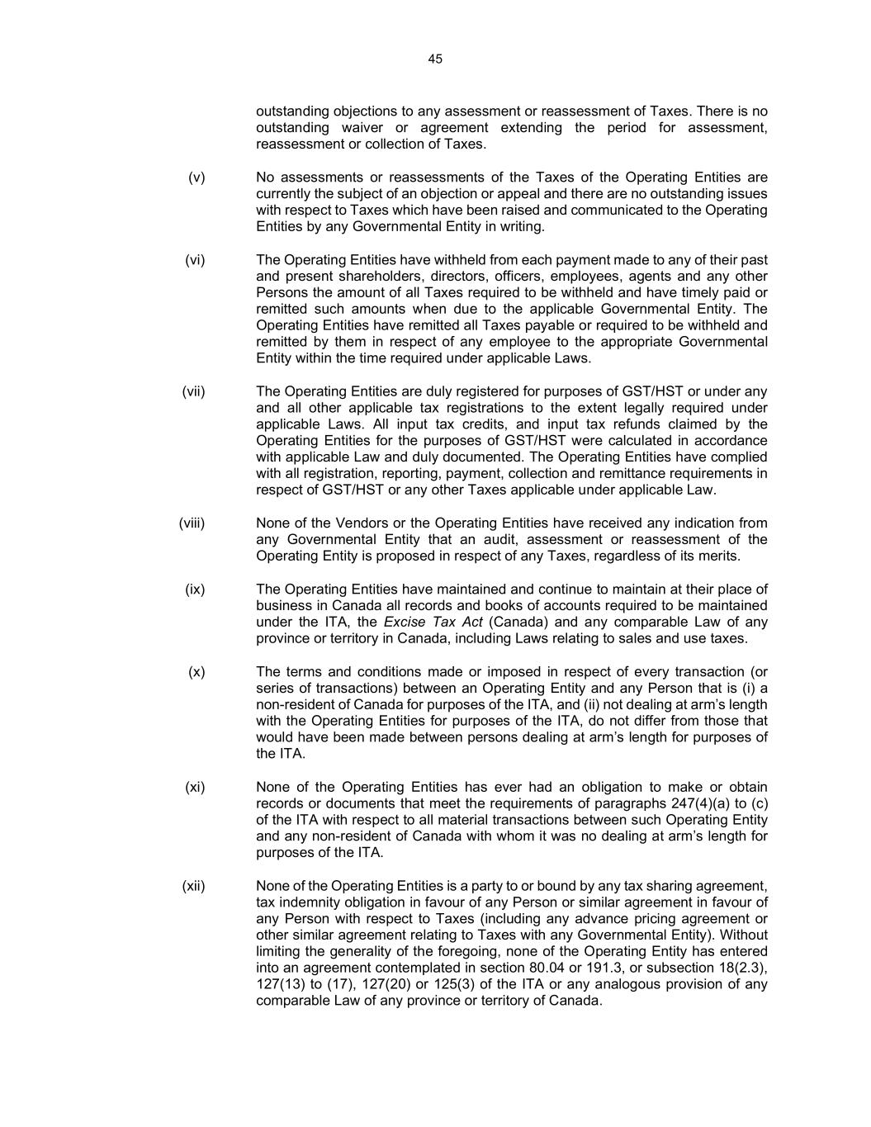
45 outstanding objections to any assessment or reassessment of Taxes. There is no outstanding waiver or agreement extending the period for assessment, reassessment or collection of Taxes. (v) No assessments or reassessments of the Taxes of the Operating Entities are currently the subject of an objection or appeal and there are no outstanding issues with respect to Taxes which have been raised and communicated to the Operating Entities by any Governmental Entity in writing. (vi) The Operating Entities have withheld from each payment made to any of their past and present shareholders, directors, officers, employees, agents and any other Persons the amount of all Taxes required to be withheld and have timely paid or remitted such amounts when due to the applicable Governmental Entity. The Operating Entities have remitted all Taxes payable or required to be withheld and remitted by them in respect of any employee to the appropriate Governmental Entity within the time required under applicable Laws. (vii) The Operating Entities are duly registered for purposes of GST/HST or under any and all other applicable tax registrations to the extent legally required under applicable Laws. All input tax credits, and input tax refunds claimed by the Operating Entities for the purposes of GST/HST were calculated in accordance with applicable Law and duly documented. The Operating Entities have complied with all registration, reporting, payment, collection and remittance requirements in respect of GST/HST or any other Taxes applicable under applicable Law. (viii) None of the Vendors or the Operating Entities have received any indication from any Governmental Entity that an audit, assessment or reassessment of the Operating Entity is proposed in respect of any Taxes, regardless of its merits. (ix) The Operating Entities have maintained and continue to maintain at their place of business in Canada all records and books of accounts required to be maintained under the ITA, the Excise Tax Act (Canada) and any comparable Law of any province or territory in Canada, including Laws relating to sales and use taxes. (x) The terms and conditions made or imposed in respect of every transaction (or series of transactions) between an Operating Entity and any Person that is (i) a non-resident of Canada for purposes of the ITA, and (ii) not dealing at arm’s length with the Operating Entities for purposes of the ITA, do not differ from those that would have been made between persons dealing at arm’s length for purposes of the ITA. (xi) None of the Operating Entities has ever had an obligation to make or obtain records or documents that meet the requirements of paragraphs 247(4)(a) to (c) of the ITA with respect to all material transactions between such Operating Entity and any non-resident of Canada with whom it was no dealing at arm’s length for purposes of the ITA. (xii) None of the Operating Entities is a party to or bound by any tax sharing agreement, tax indemnity obligation in favour of any Person or similar agreement in favour of any Person with respect to Taxes (including any advance pricing agreement or other similar agreement relating to Taxes with any Governmental Entity). Without limiting the generality of the foregoing, none of the Operating Entity has entered into an agreement contemplated in section 80.04 or 191.3, or subsection 18(2.3), 127(13) to (17), 127(20) or 125(3) of the ITA or any analogous provision of any comparable Law of any province or territory of Canada.

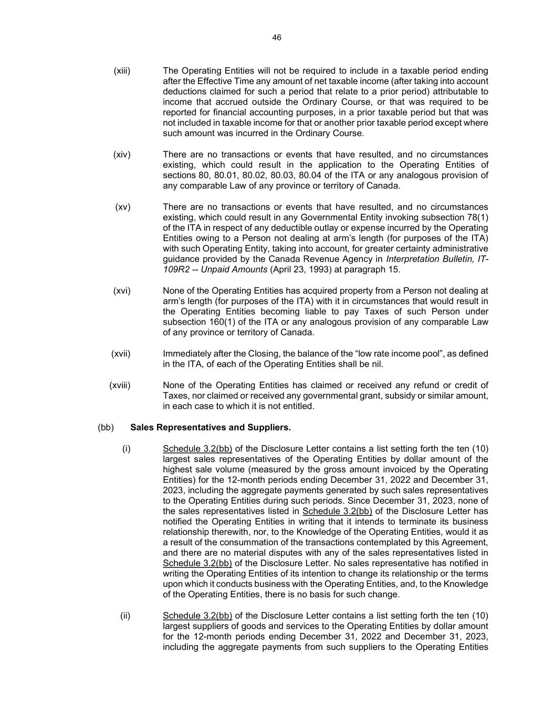
46 (xiii) The Operating Entities will not be required to include in a taxable period ending after the Effective Time any amount of net taxable income (after taking into account deductions claimed for such a period that relate to a prior period) attributable to income that accrued outside the Ordinary Course, or that was required to be reported for financial accounting purposes, in a prior taxable period but that was not included in taxable income for that or another prior taxable period except where such amount was incurred in the Ordinary Course. (xiv) There are no transactions or events that have resulted, and no circumstances existing, which could result in the application to the Operating Entities of sections 80, 80.01, 80.02, 80.03, 80.04 of the ITA or any analogous provision of any comparable Law of any province or territory of Canada. (xv) There are no transactions or events that have resulted, and no circumstances existing, which could result in any Governmental Entity invoking subsection 78(1) of the ITA in respect of any deductible outlay or expense incurred by the Operating Entities owing to a Person not dealing at arm’s length (for purposes of the ITA) with such Operating Entity, taking into account, for greater certainty administrative guidance provided by the Canada Revenue Agency in Interpretation Bulletin, IT- 109R2 -- Unpaid Amounts (April 23, 1993) at paragraph 15. (xvi) None of the Operating Entities has acquired property from a Person not dealing at arm’s length (for purposes of the ITA) with it in circumstances that would result in the Operating Entities becoming liable to pay Taxes of such Person under subsection 160(1) of the ITA or any analogous provision of any comparable Law of any province or territory of Canada. (xvii) Immediately after the Closing, the balance of the “low rate income pool”, as defined in the ITA, of each of the Operating Entities shall be nil. (xviii) None of the Operating Entities has claimed or received any refund or credit of Taxes, nor claimed or received any governmental grant, subsidy or similar amount, in each case to which it is not entitled. (bb) Sales Representatives and Suppliers. (i) Schedule 3.2(bb) of the Disclosure Letter contains a list setting forth the ten (10) largest sales representatives of the Operating Entities by dollar amount of the highest sale volume (measured by the gross amount invoiced by the Operating Entities) for the 12-month periods ending December 31, 2022 and December 31, 2023, including the aggregate payments generated by such sales representatives to the Operating Entities during such periods. Since December 31, 2023, none of the sales representatives listed in Schedule 3.2(bb) of the Disclosure Letter has notified the Operating Entities in writing that it intends to terminate its business relationship therewith, nor, to the Knowledge of the Operating Entities, would it as a result of the consummation of the transactions contemplated by this Agreement, and there are no material disputes with any of the sales representatives listed in Schedule 3.2(bb) of the Disclosure Letter. No sales representative has notified in writing the Operating Entities of its intention to change its relationship or the terms upon which it conducts business with the Operating Entities, and, to the Knowledge of the Operating Entities, there is no basis for such change. (ii) Schedule 3.2(bb) of the Disclosure Letter contains a list setting forth the ten (10) largest suppliers of goods and services to the Operating Entities by dollar amount for the 12-month periods ending December 31, 2022 and December 31, 2023, including the aggregate payments from such suppliers to the Operating Entities

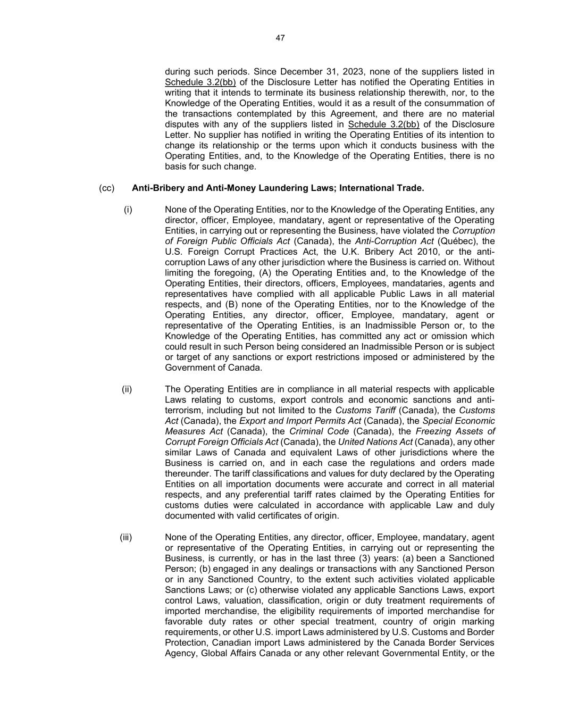
47 during such periods. Since December 31, 2023, none of the suppliers listed in Schedule 3.2(bb) of the Disclosure Letter has notified the Operating Entities in writing that it intends to terminate its business relationship therewith, nor, to the Knowledge of the Operating Entities, would it as a result of the consummation of the transactions contemplated by this Agreement, and there are no material disputes with any of the suppliers listed in Schedule 3.2(bb) of the Disclosure Letter. No supplier has notified in writing the Operating Entities of its intention to change its relationship or the terms upon which it conducts business with the Operating Entities, and, to the Knowledge of the Operating Entities, there is no basis for such change. (cc) Anti-Bribery and Anti-Money Laundering Laws; International Trade. (i) None of the Operating Entities, nor to the Knowledge of the Operating Entities, any director, officer, Employee, mandatary, agent or representative of the Operating Entities, in carrying out or representing the Business, have violated the Corruption of Foreign Public Officials Act (Canada), the Anti-Corruption Act (Québec), the U.S. Foreign Corrupt Practices Act, the U.K. Bribery Act 2010, or the anti- corruption Laws of any other jurisdiction where the Business is carried on. Without limiting the foregoing, (A) the Operating Entities and, to the Knowledge of the Operating Entities, their directors, officers, Employees, mandataries, agents and representatives have complied with all applicable Public Laws in all material respects, and (B) none of the Operating Entities, nor to the Knowledge of the Operating Entities, any director, officer, Employee, mandatary, agent or representative of the Operating Entities, is an Inadmissible Person or, to the Knowledge of the Operating Entities, has committed any act or omission which could result in such Person being considered an Inadmissible Person or is subject or target of any sanctions or export restrictions imposed or administered by the Government of Canada. (ii) The Operating Entities are in compliance in all material respects with applicable Laws relating to customs, export controls and economic sanctions and anti- terrorism, including but not limited to the Customs Tariff (Canada), the Customs Act (Canada), the Export and Import Permits Act (Canada), the Special Economic Measures Act (Canada), the Criminal Code (Canada), the Freezing Assets of Corrupt Foreign Officials Act (Canada), the United Nations Act (Canada), any other similar Laws of Canada and equivalent Laws of other jurisdictions where the Business is carried on, and in each case the regulations and orders made thereunder. The tariff classifications and values for duty declared by the Operating Entities on all importation documents were accurate and correct in all material respects, and any preferential tariff rates claimed by the Operating Entities for customs duties were calculated in accordance with applicable Law and duly documented with valid certificates of origin. (iii) None of the Operating Entities, any director, officer, Employee, mandatary, agent or representative of the Operating Entities, in carrying out or representing the Business, is currently, or has in the last three (3) years: (a) been a Sanctioned Person; (b) engaged in any dealings or transactions with any Sanctioned Person or in any Sanctioned Country, to the extent such activities violated applicable Sanctions Laws; or (c) otherwise violated any applicable Sanctions Laws, export control Laws, valuation, classification, origin or duty treatment requirements of imported merchandise, the eligibility requirements of imported merchandise for favorable duty rates or other special treatment, country of origin marking requirements, or other U.S. import Laws administered by U.S. Customs and Border Protection, Canadian import Laws administered by the Canada Border Services Agency, Global Affairs Canada or any other relevant Governmental Entity, or the

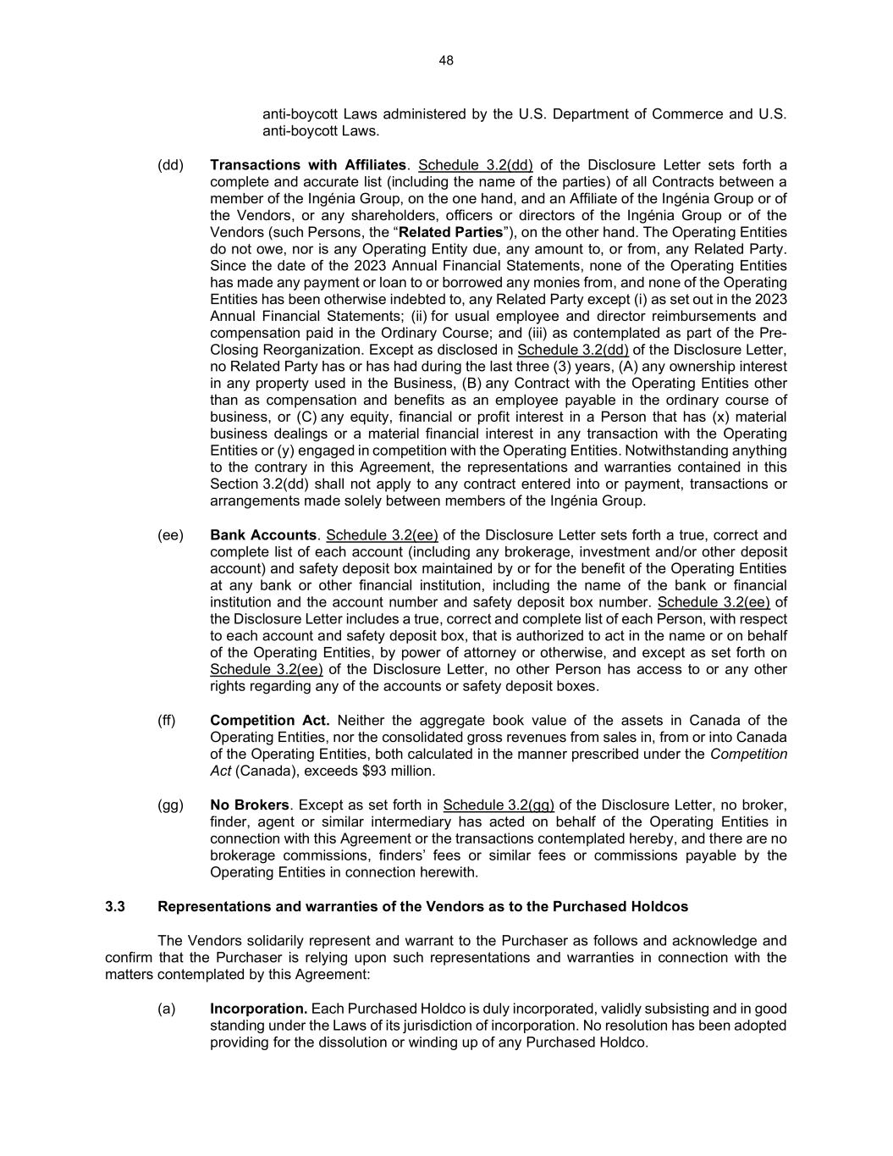
48 anti-boycott Laws administered by the U.S. Department of Commerce and U.S. anti-boycott Laws. (dd) Transactions with Affiliates. Schedule 3.2(dd) of the Disclosure Letter sets forth a complete and accurate list (including the name of the parties) of all Contracts between a member of the Ingénia Group, on the one hand, and an Affiliate of the Ingénia Group or of the Vendors, or any shareholders, officers or directors of the Ingénia Group or of the Vendors (such Persons, the “Related Parties”), on the other hand. The Operating Entities do not owe, nor is any Operating Entity due, any amount to, or from, any Related Party. Since the date of the 2023 Annual Financial Statements, none of the Operating Entities has made any payment or loan to or borrowed any monies from, and none of the Operating Entities has been otherwise indebted to, any Related Party except (i) as set out in the 2023 Annual Financial Statements; (ii) for usual employee and director reimbursements and compensation paid in the Ordinary Course; and (iii) as contemplated as part of the Pre- Closing Reorganization. Except as disclosed in Schedule 3.2(dd) of the Disclosure Letter, no Related Party has or has had during the last three (3) years, (A) any ownership interest in any property used in the Business, (B) any Contract with the Operating Entities other than as compensation and benefits as an employee payable in the ordinary course of business, or (C) any equity, financial or profit interest in a Person that has (x) material business dealings or a material financial interest in any transaction with the Operating Entities or (y) engaged in competition with the Operating Entities. Notwithstanding anything to the contrary in this Agreement, the representations and warranties contained in this Section 3.2(dd) shall not apply to any contract entered into or payment, transactions or arrangements made solely between members of the Ingénia Group. (ee) Bank Accounts. Schedule 3.2(ee) of the Disclosure Letter sets forth a true, correct and complete list of each account (including any brokerage, investment and/or other deposit account) and safety deposit box maintained by or for the benefit of the Operating Entities at any bank or other financial institution, including the name of the bank or financial institution and the account number and safety deposit box number. Schedule 3.2(ee) of the Disclosure Letter includes a true, correct and complete list of each Person, with respect to each account and safety deposit box, that is authorized to act in the name or on behalf of the Operating Entities, by power of attorney or otherwise, and except as set forth on Schedule 3.2(ee) of the Disclosure Letter, no other Person has access to or any other rights regarding any of the accounts or safety deposit boxes. (ff) Competition Act. Neither the aggregate book value of the assets in Canada of the Operating Entities, nor the consolidated gross revenues from sales in, from or into Canada of the Operating Entities, both calculated in the manner prescribed under the Competition Act (Canada), exceeds $93 million. (gg) No Brokers. Except as set forth in Schedule 3.2(gg) of the Disclosure Letter, no broker, finder, agent or similar intermediary has acted on behalf of the Operating Entities in connection with this Agreement or the transactions contemplated hereby, and there are no brokerage commissions, finders’ fees or similar fees or commissions payable by the Operating Entities in connection herewith. 3.3 Representations and warranties of the Vendors as to the Purchased Holdcos The Vendors solidarily represent and warrant to the Purchaser as follows and acknowledge and confirm that the Purchaser is relying upon such representations and warranties in connection with the matters contemplated by this Agreement: (a) Incorporation. Each Purchased Holdco is duly incorporated, validly subsisting and in good standing under the Laws of its jurisdiction of incorporation. No resolution has been adopted providing for the dissolution or winding up of any Purchased Holdco.

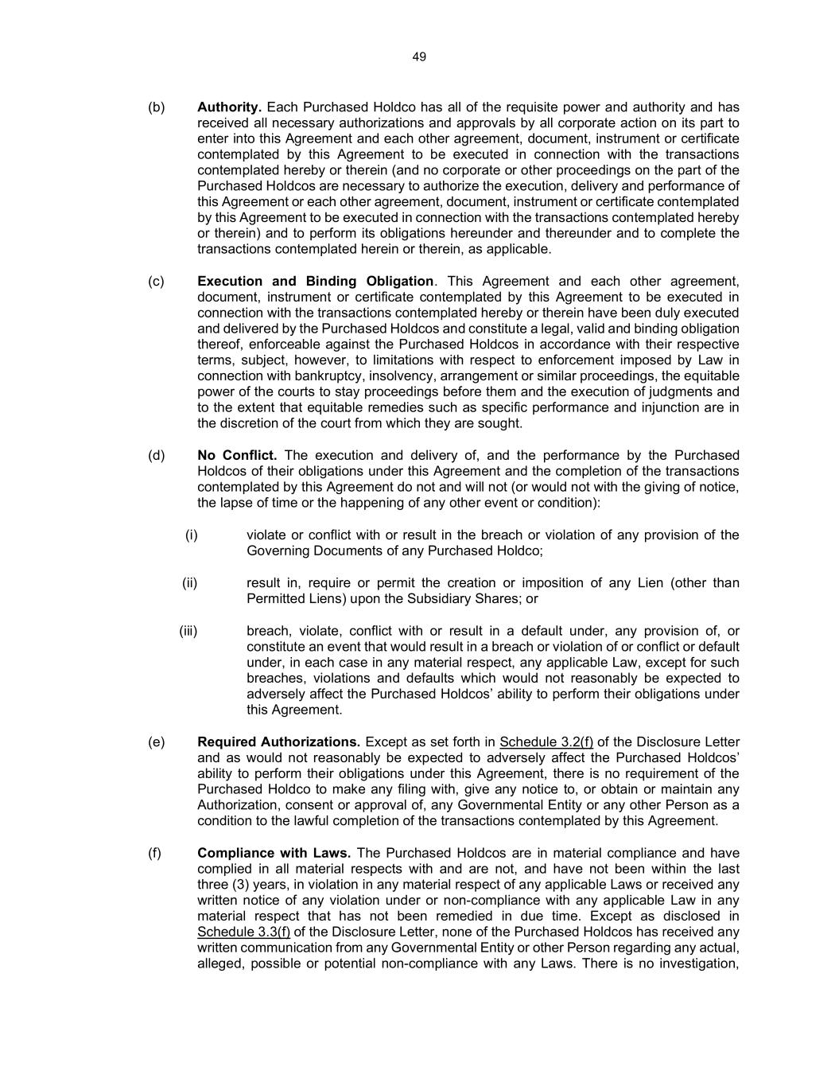
49 (b) Authority. Each Purchased Holdco has all of the requisite power and authority and has received all necessary authorizations and approvals by all corporate action on its part to enter into this Agreement and each other agreement, document, instrument or certificate contemplated by this Agreement to be executed in connection with the transactions contemplated hereby or therein (and no corporate or other proceedings on the part of the Purchased Holdcos are necessary to authorize the execution, delivery and performance of this Agreement or each other agreement, document, instrument or certificate contemplated by this Agreement to be executed in connection with the transactions contemplated hereby or therein) and to perform its obligations hereunder and thereunder and to complete the transactions contemplated herein or therein, as applicable. (c) Execution and Binding Obligation. This Agreement and each other agreement, document, instrument or certificate contemplated by this Agreement to be executed in connection with the transactions contemplated hereby or therein have been duly executed and delivered by the Purchased Holdcos and constitute a legal, valid and binding obligation thereof, enforceable against the Purchased Holdcos in accordance with their respective terms, subject, however, to limitations with respect to enforcement imposed by Law in connection with bankruptcy, insolvency, arrangement or similar proceedings, the equitable power of the courts to stay proceedings before them and the execution of judgments and to the extent that equitable remedies such as specific performance and injunction are in the discretion of the court from which they are sought. (d) No Conflict. The execution and delivery of, and the performance by the Purchased Holdcos of their obligations under this Agreement and the completion of the transactions contemplated by this Agreement do not and will not (or would not with the giving of notice, the lapse of time or the happening of any other event or condition): (i) violate or conflict with or result in the breach or violation of any provision of the Governing Documents of any Purchased Holdco; (ii) result in, require or permit the creation or imposition of any Lien (other than Permitted Liens) upon the Subsidiary Shares; or (iii) breach, violate, conflict with or result in a default under, any provision of, or constitute an event that would result in a breach or violation of or conflict or default under, in each case in any material respect, any applicable Law, except for such breaches, violations and defaults which would not reasonably be expected to adversely affect the Purchased Holdcos’ ability to perform their obligations under this Agreement. (e) Required Authorizations. Except as set forth in Schedule 3.2(f) of the Disclosure Letter and as would not reasonably be expected to adversely affect the Purchased Holdcos’ ability to perform their obligations under this Agreement, there is no requirement of the Purchased Holdco to make any filing with, give any notice to, or obtain or maintain any Authorization, consent or approval of, any Governmental Entity or any other Person as a condition to the lawful completion of the transactions contemplated by this Agreement. (f) Compliance with Laws. The Purchased Holdcos are in material compliance and have complied in all material respects with and are not, and have not been within the last three (3) years, in violation in any material respect of any applicable Laws or received any written notice of any violation under or non-compliance with any applicable Law in any material respect that has not been remedied in due time. Except as disclosed in Schedule 3.3(f) of the Disclosure Letter, none of the Purchased Holdcos has received any written communication from any Governmental Entity or other Person regarding any actual, alleged, possible or potential non-compliance with any Laws. There is no investigation,

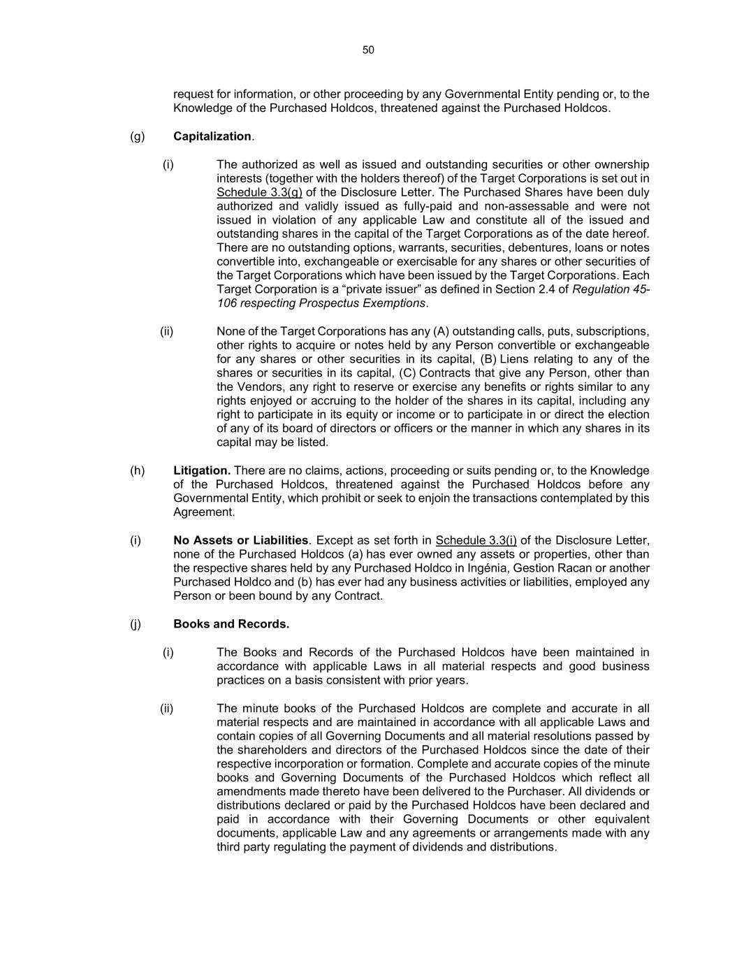
50 request for information, or other proceeding by any Governmental Entity pending or, to the Knowledge of the Purchased Holdcos, threatened against the Purchased Holdcos. (g) Capitalization. (i) The authorized as well as issued and outstanding securities or other ownership interests (together with the holders thereof) of the Target Corporations is set out in Schedule 3.3(g) of the Disclosure Letter. The Purchased Shares have been duly authorized and validly issued as fully-paid and non-assessable and were not issued in violation of any applicable Law and constitute all of the issued and outstanding shares in the capital of the Target Corporations as of the date hereof. There are no outstanding options, warrants, securities, debentures, loans or notes convertible into, exchangeable or exercisable for any shares or other securities of the Target Corporations which have been issued by the Target Corporations. Each Target Corporation is a “private issuer” as defined in Section 2.4 of Regulation 45- 106 respecting Prospectus Exemptions. (ii) None of the Target Corporations has any (A) outstanding calls, puts, subscriptions, other rights to acquire or notes held by any Person convertible or exchangeable for any shares or other securities in its capital, (B) Liens relating to any of the shares or securities in its capital, (C) Contracts that give any Person, other than the Vendors, any right to reserve or exercise any benefits or rights similar to any rights enjoyed or accruing to the holder of the shares in its capital, including any right to participate in its equity or income or to participate in or direct the election of any of its board of directors or officers or the manner in which any shares in its capital may be listed. (h) Litigation. There are no claims, actions, proceeding or suits pending or, to the Knowledge of the Purchased Holdcos, threatened against the Purchased Holdcos before any Governmental Entity, which prohibit or seek to enjoin the transactions contemplated by this Agreement. (i) No Assets or Liabilities. Except as set forth in Schedule 3.3(i) of the Disclosure Letter, none of the Purchased Holdcos (a) has ever owned any assets or properties, other than the respective shares held by any Purchased Holdco in Ingénia, Gestion Racan or another Purchased Holdco and (b) has ever had any business activities or liabilities, employed any Person or been bound by any Contract. (j) Books and Records. (i) The Books and Records of the Purchased Holdcos have been maintained in accordance with applicable Laws in all material respects and good business practices on a basis consistent with prior years. (ii) The minute books of the Purchased Holdcos are complete and accurate in all material respects and are maintained in accordance with all applicable Laws and contain copies of all Governing Documents and all material resolutions passed by the shareholders and directors of the Purchased Holdcos since the date of their respective incorporation or formation. Complete and accurate copies of the minute books and Governing Documents of the Purchased Holdcos which reflect all amendments made thereto have been delivered to the Purchaser. All dividends or distributions declared or paid by the Purchased Holdcos have been declared and paid in accordance with their Governing Documents or other equivalent documents, applicable Law and any agreements or arrangements made with any third party regulating the payment of dividends and distributions.

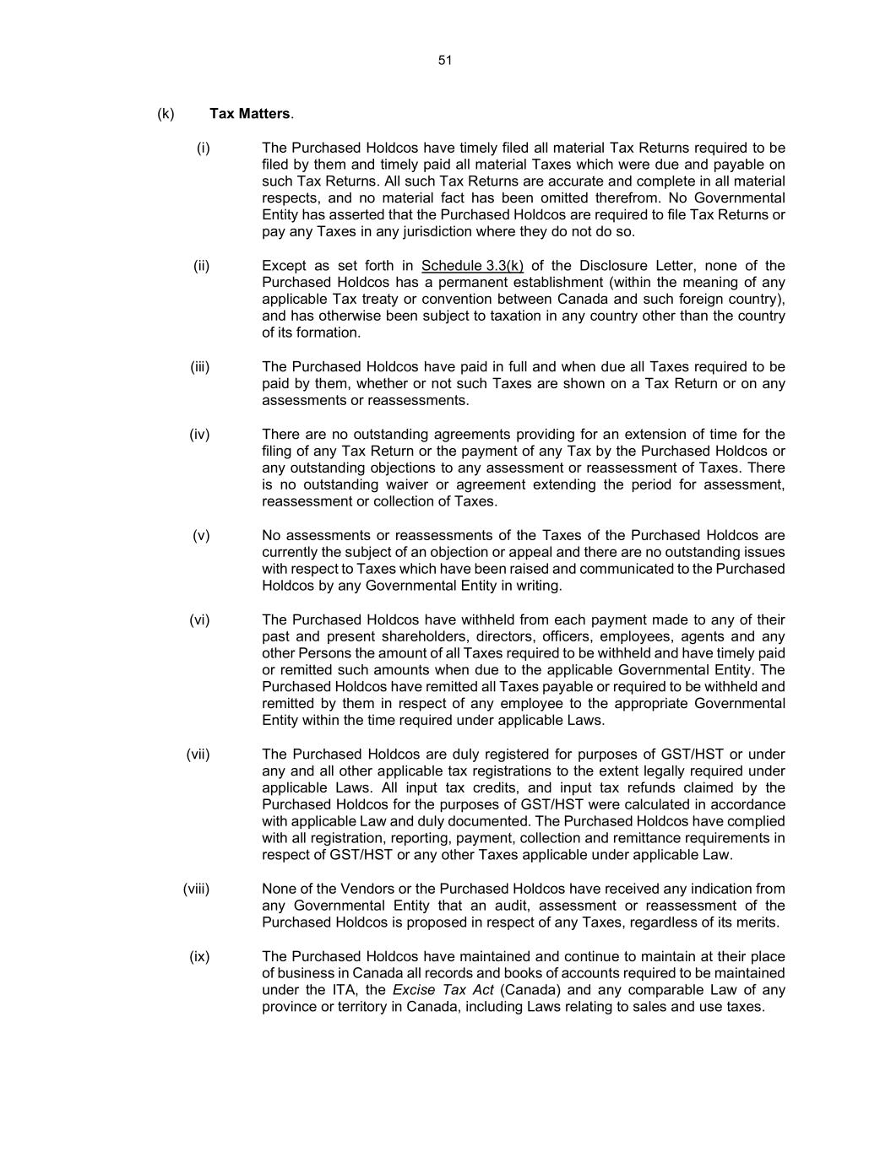
51 (k) Tax Matters. (i) The Purchased Holdcos have timely filed all material Tax Returns required to be filed by them and timely paid all material Taxes which were due and payable on such Tax Returns. All such Tax Returns are accurate and complete in all material respects, and no material fact has been omitted therefrom. No Governmental Entity has asserted that the Purchased Holdcos are required to file Tax Returns or pay any Taxes in any jurisdiction where they do not do so. (ii) Except as set forth in Schedule 3.3(k) of the Disclosure Letter, none of the Purchased Holdcos has a permanent establishment (within the meaning of any applicable Tax treaty or convention between Canada and such foreign country), and has otherwise been subject to taxation in any country other than the country of its formation. (iii) The Purchased Holdcos have paid in full and when due all Taxes required to be paid by them, whether or not such Taxes are shown on a Tax Return or on any assessments or reassessments. (iv) There are no outstanding agreements providing for an extension of time for the filing of any Tax Return or the payment of any Tax by the Purchased Holdcos or any outstanding objections to any assessment or reassessment of Taxes. There is no outstanding waiver or agreement extending the period for assessment, reassessment or collection of Taxes. (v) No assessments or reassessments of the Taxes of the Purchased Holdcos are currently the subject of an objection or appeal and there are no outstanding issues with respect to Taxes which have been raised and communicated to the Purchased Holdcos by any Governmental Entity in writing. (vi) The Purchased Holdcos have withheld from each payment made to any of their past and present shareholders, directors, officers, employees, agents and any other Persons the amount of all Taxes required to be withheld and have timely paid or remitted such amounts when due to the applicable Governmental Entity. The Purchased Holdcos have remitted all Taxes payable or required to be withheld and remitted by them in respect of any employee to the appropriate Governmental Entity within the time required under applicable Laws. (vii) The Purchased Holdcos are duly registered for purposes of GST/HST or under any and all other applicable tax registrations to the extent legally required under applicable Laws. All input tax credits, and input tax refunds claimed by the Purchased Holdcos for the purposes of GST/HST were calculated in accordance with applicable Law and duly documented. The Purchased Holdcos have complied with all registration, reporting, payment, collection and remittance requirements in respect of GST/HST or any other Taxes applicable under applicable Law. (viii) None of the Vendors or the Purchased Holdcos have received any indication from any Governmental Entity that an audit, assessment or reassessment of the Purchased Holdcos is proposed in respect of any Taxes, regardless of its merits. (ix) The Purchased Holdcos have maintained and continue to maintain at their place of business in Canada all records and books of accounts required to be maintained under the ITA, the Excise Tax Act (Canada) and any comparable Law of any province or territory in Canada, including Laws relating to sales and use taxes.

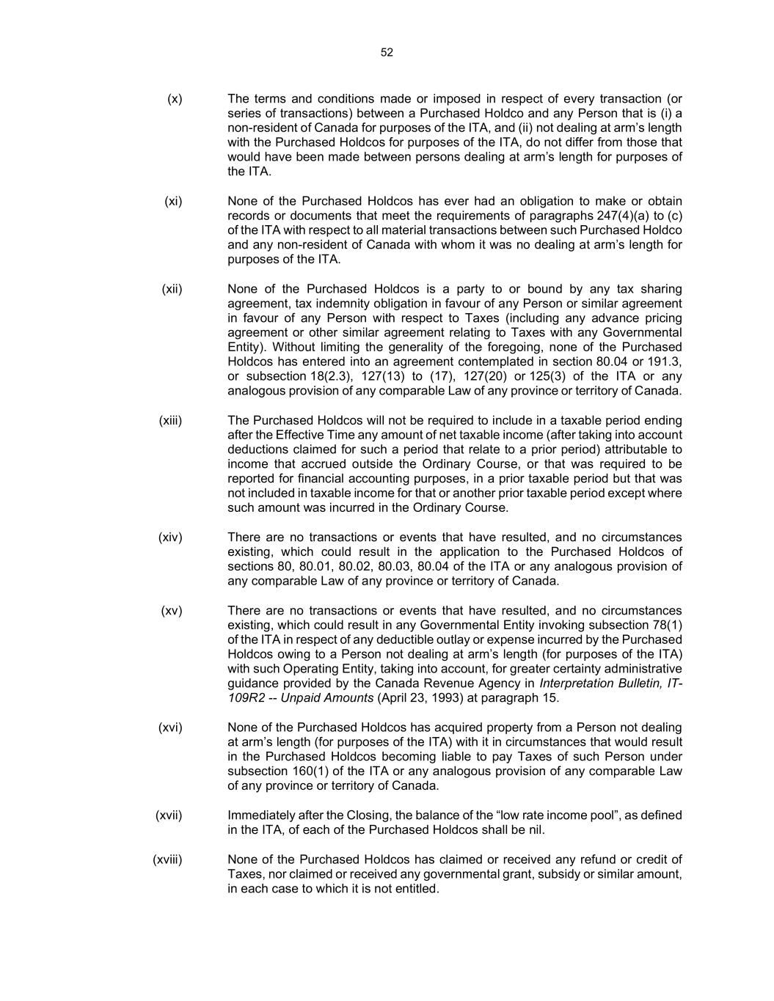
52 (x) The terms and conditions made or imposed in respect of every transaction (or series of transactions) between a Purchased Holdco and any Person that is (i) a non-resident of Canada for purposes of the ITA, and (ii) not dealing at arm’s length with the Purchased Holdcos for purposes of the ITA, do not differ from those that would have been made between persons dealing at arm’s length for purposes of the ITA. (xi) None of the Purchased Holdcos has ever had an obligation to make or obtain records or documents that meet the requirements of paragraphs 247(4)(a) to (c) of the ITA with respect to all material transactions between such Purchased Holdco and any non-resident of Canada with whom it was no dealing at arm’s length for purposes of the ITA. (xii) None of the Purchased Holdcos is a party to or bound by any tax sharing agreement, tax indemnity obligation in favour of any Person or similar agreement in favour of any Person with respect to Taxes (including any advance pricing agreement or other similar agreement relating to Taxes with any Governmental Entity). Without limiting the generality of the foregoing, none of the Purchased Holdcos has entered into an agreement contemplated in section 80.04 or 191.3, or subsection 18(2.3), 127(13) to (17), 127(20) or 125(3) of the ITA or any analogous provision of any comparable Law of any province or territory of Canada. (xiii) The Purchased Holdcos will not be required to include in a taxable period ending after the Effective Time any amount of net taxable income (after taking into account deductions claimed for such a period that relate to a prior period) attributable to income that accrued outside the Ordinary Course, or that was required to be reported for financial accounting purposes, in a prior taxable period but that was not included in taxable income for that or another prior taxable period except where such amount was incurred in the Ordinary Course. (xiv) There are no transactions or events that have resulted, and no circumstances existing, which could result in the application to the Purchased Holdcos of sections 80, 80.01, 80.02, 80.03, 80.04 of the ITA or any analogous provision of any comparable Law of any province or territory of Canada. (xv) There are no transactions or events that have resulted, and no circumstances existing, which could result in any Governmental Entity invoking subsection 78(1) of the ITA in respect of any deductible outlay or expense incurred by the Purchased Holdcos owing to a Person not dealing at arm’s length (for purposes of the ITA) with such Operating Entity, taking into account, for greater certainty administrative guidance provided by the Canada Revenue Agency in Interpretation Bulletin, IT- 109R2 -- Unpaid Amounts (April 23, 1993) at paragraph 15. (xvi) None of the Purchased Holdcos has acquired property from a Person not dealing at arm’s length (for purposes of the ITA) with it in circumstances that would result in the Purchased Holdcos becoming liable to pay Taxes of such Person under subsection 160(1) of the ITA or any analogous provision of any comparable Law of any province or territory of Canada. (xvii) Immediately after the Closing, the balance of the “low rate income pool”, as defined in the ITA, of each of the Purchased Holdcos shall be nil. (xviii) None of the Purchased Holdcos has claimed or received any refund or credit of Taxes, nor claimed or received any governmental grant, subsidy or similar amount, in each case to which it is not entitled.

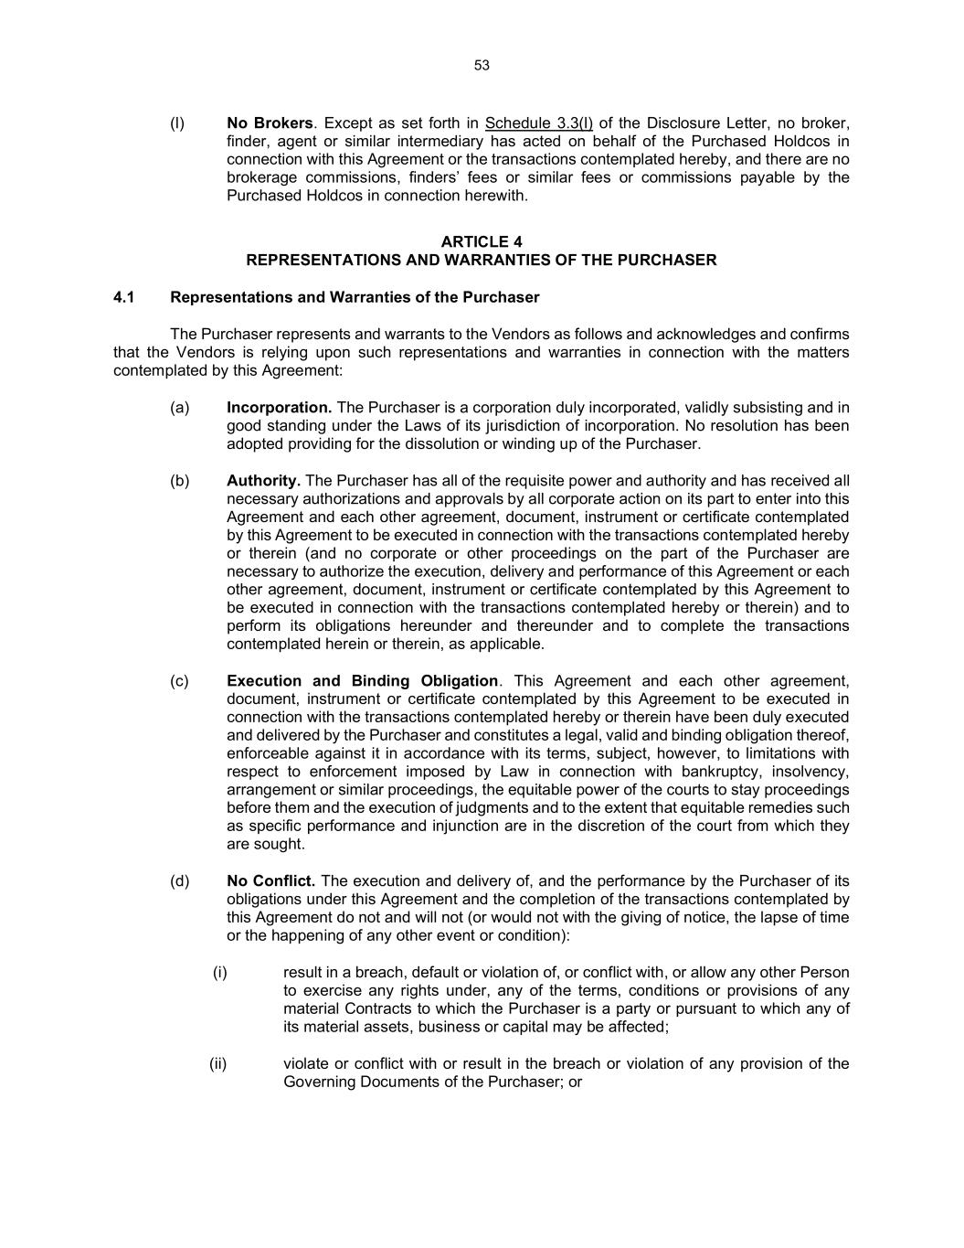
53 (l) No Brokers. Except as set forth in Schedule 3.3(l) of the Disclosure Letter, no broker, finder, agent or similar intermediary has acted on behalf of the Purchased Holdcos in connection with this Agreement or the transactions contemplated hereby, and there are no brokerage commissions, finders’ fees or similar fees or commissions payable by the Purchased Holdcos in connection herewith. ARTICLE 4 REPRESENTATIONS AND WARRANTIES OF THE PURCHASER 4.1 Representations and Warranties of the Purchaser The Purchaser represents and warrants to the Vendors as follows and acknowledges and confirms that the Vendors is relying upon such representations and warranties in connection with the matters contemplated by this Agreement: (a) Incorporation. The Purchaser is a corporation duly incorporated, validly subsisting and in good standing under the Laws of its jurisdiction of incorporation. No resolution has been adopted providing for the dissolution or winding up of the Purchaser. (b) Authority. The Purchaser has all of the requisite power and authority and has received all necessary authorizations and approvals by all corporate action on its part to enter into this Agreement and each other agreement, document, instrument or certificate contemplated by this Agreement to be executed in connection with the transactions contemplated hereby or therein (and no corporate or other proceedings on the part of the Purchaser are necessary to authorize the execution, delivery and performance of this Agreement or each other agreement, document, instrument or certificate contemplated by this Agreement to be executed in connection with the transactions contemplated hereby or therein) and to perform its obligations hereunder and thereunder and to complete the transactions contemplated herein or therein, as applicable. (c) Execution and Binding Obligation. This Agreement and each other agreement, document, instrument or certificate contemplated by this Agreement to be executed in connection with the transactions contemplated hereby or therein have been duly executed and delivered by the Purchaser and constitutes a legal, valid and binding obligation thereof, enforceable against it in accordance with its terms, subject, however, to limitations with respect to enforcement imposed by Law in connection with bankruptcy, insolvency, arrangement or similar proceedings, the equitable power of the courts to stay proceedings before them and the execution of judgments and to the extent that equitable remedies such as specific performance and injunction are in the discretion of the court from which they are sought. (d) No Conflict. The execution and delivery of, and the performance by the Purchaser of its obligations under this Agreement and the completion of the transactions contemplated by this Agreement do not and will not (or would not with the giving of notice, the lapse of time or the happening of any other event or condition): (i) result in a breach, default or violation of, or conflict with, or allow any other Person to exercise any rights under, any of the terms, conditions or provisions of any material Contracts to which the Purchaser is a party or pursuant to which any of its material assets, business or capital may be affected; (ii) violate or conflict with or result in the breach or violation of any provision of the Governing Documents of the Purchaser; or

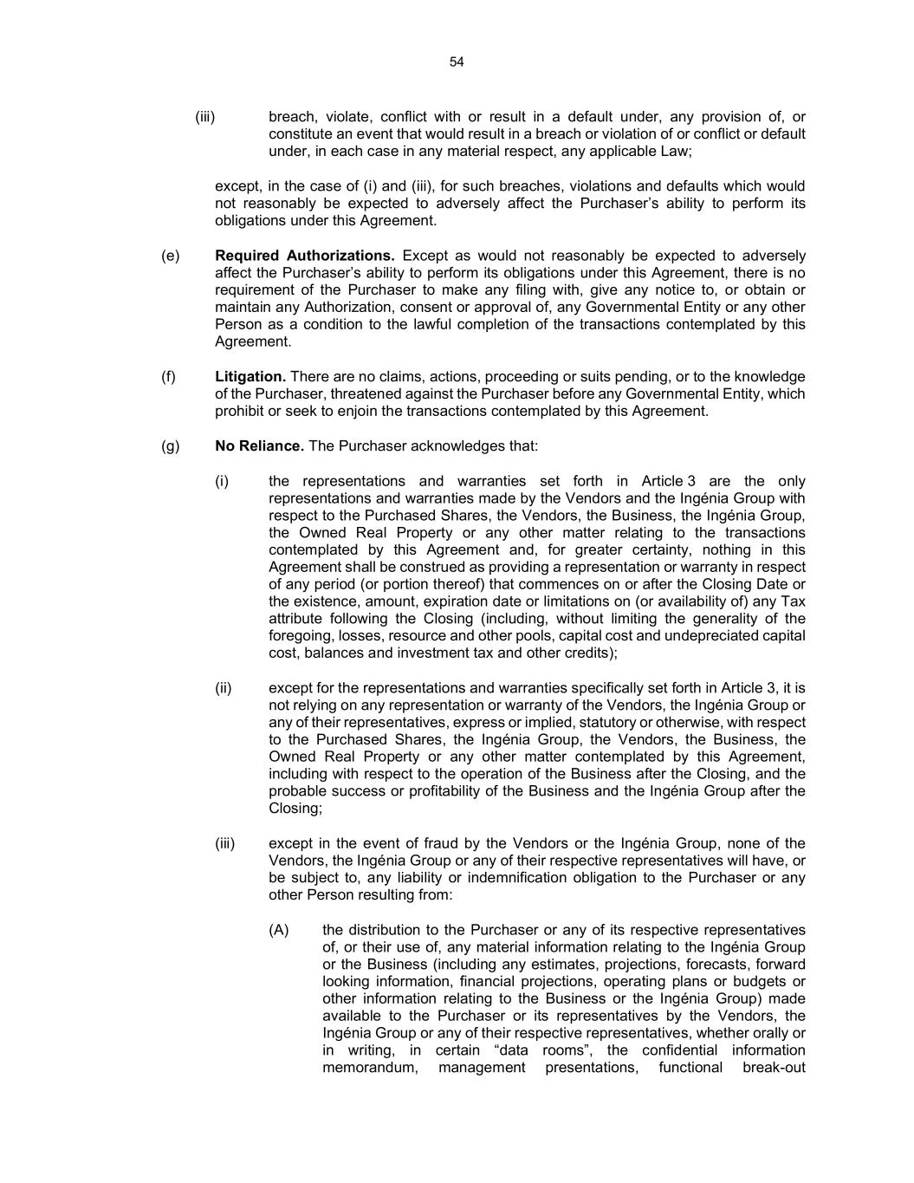
54 (iii) breach, violate, conflict with or result in a default under, any provision of, or constitute an event that would result in a breach or violation of or conflict or default under, in each case in any material respect, any applicable Law; except, in the case of (i) and (iii), for such breaches, violations and defaults which would not reasonably be expected to adversely affect the Purchaser’s ability to perform its obligations under this Agreement. (e) Required Authorizations. Except as would not reasonably be expected to adversely affect the Purchaser’s ability to perform its obligations under this Agreement, there is no requirement of the Purchaser to make any filing with, give any notice to, or obtain or maintain any Authorization, consent or approval of, any Governmental Entity or any other Person as a condition to the lawful completion of the transactions contemplated by this Agreement. (f) Litigation. There are no claims, actions, proceeding or suits pending, or to the knowledge of the Purchaser, threatened against the Purchaser before any Governmental Entity, which prohibit or seek to enjoin the transactions contemplated by this Agreement. (g) No Reliance. The Purchaser acknowledges that: (i) the representations and warranties set forth in Article 3 are the only representations and warranties made by the Vendors and the Ingénia Group with respect to the Purchased Shares, the Vendors, the Business, the Ingénia Group, the Owned Real Property or any other matter relating to the transactions contemplated by this Agreement and, for greater certainty, nothing in this Agreement shall be construed as providing a representation or warranty in respect of any period (or portion thereof) that commences on or after the Closing Date or the existence, amount, expiration date or limitations on (or availability of) any Tax attribute following the Closing (including, without limiting the generality of the foregoing, losses, resource and other pools, capital cost and undepreciated capital cost, balances and investment tax and other credits); (ii) except for the representations and warranties specifically set forth in Article 3, it is not relying on any representation or warranty of the Vendors, the Ingénia Group or any of their representatives, express or implied, statutory or otherwise, with respect to the Purchased Shares, the Ingénia Group, the Vendors, the Business, the Owned Real Property or any other matter contemplated by this Agreement, including with respect to the operation of the Business after the Closing, and the probable success or profitability of the Business and the Ingénia Group after the Closing; (iii) except in the event of fraud by the Vendors or the Ingénia Group, none of the Vendors, the Ingénia Group or any of their respective representatives will have, or be subject to, any liability or indemnification obligation to the Purchaser or any other Person resulting from: (A) the distribution to the Purchaser or any of its respective representatives of, or their use of, any material information relating to the Ingénia Group or the Business (including any estimates, projections, forecasts, forward looking information, financial projections, operating plans or budgets or other information relating to the Business or the Ingénia Group) made available to the Purchaser or its representatives by the Vendors, the Ingénia Group or any of their respective representatives, whether orally or in writing, in certain “data rooms”, the confidential information memorandum, management presentations, functional break-out

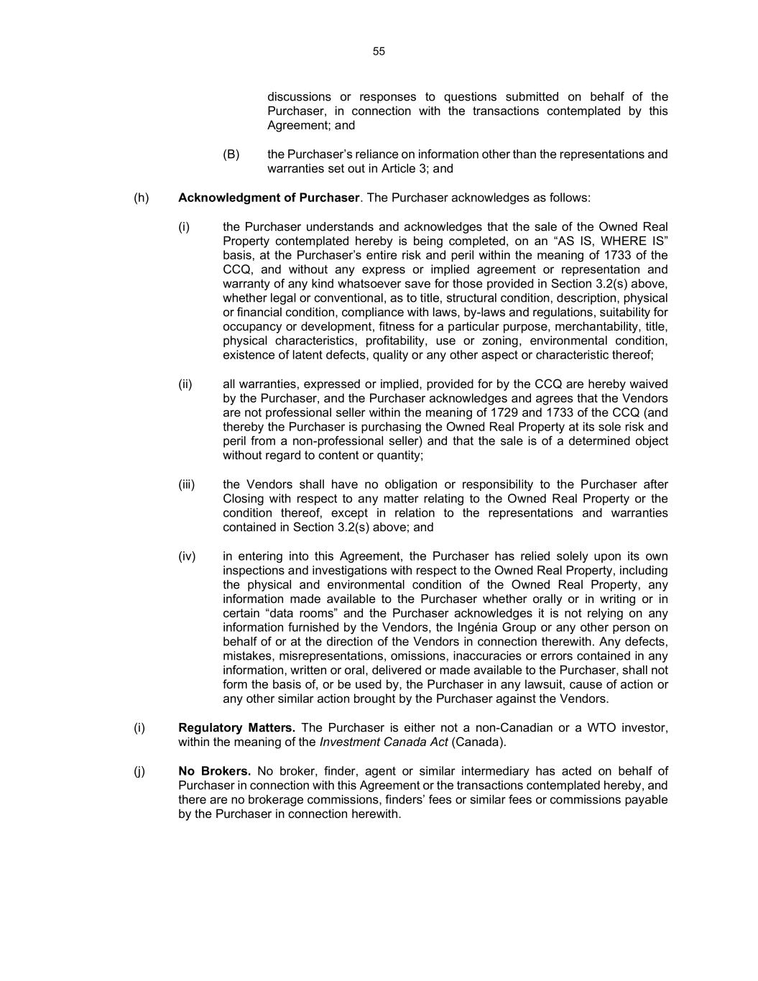
55 discussions or responses to questions submitted on behalf of the Purchaser, in connection with the transactions contemplated by this Agreement; and (B) the Purchaser’s reliance on information other than the representations and warranties set out in Article 3; and (h) Acknowledgment of Purchaser. The Purchaser acknowledges as follows: (i) the Purchaser understands and acknowledges that the sale of the Owned Real Property contemplated hereby is being completed, on an “AS IS, WHERE IS” basis, at the Purchaser’s entire risk and peril within the meaning of 1733 of the CCQ, and without any express or implied agreement or representation and warranty of any kind whatsoever save for those provided in Section 3.2(s) above, whether legal or conventional, as to title, structural condition, description, physical or financial condition, compliance with laws, by-laws and regulations, suitability for occupancy or development, fitness for a particular purpose, merchantability, title, physical characteristics, profitability, use or zoning, environmental condition, existence of latent defects, quality or any other aspect or characteristic thereof; (ii) all warranties, expressed or implied, provided for by the CCQ are hereby waived by the Purchaser, and the Purchaser acknowledges and agrees that the Vendors are not professional seller within the meaning of 1729 and 1733 of the CCQ (and thereby the Purchaser is purchasing the Owned Real Property at its sole risk and peril from a non-professional seller) and that the sale is of a determined object without regard to content or quantity; (iii) the Vendors shall have no obligation or responsibility to the Purchaser after Closing with respect to any matter relating to the Owned Real Property or the condition thereof, except in relation to the representations and warranties contained in Section 3.2(s) above; and (iv) in entering into this Agreement, the Purchaser has relied solely upon its own inspections and investigations with respect to the Owned Real Property, including the physical and environmental condition of the Owned Real Property, any information made available to the Purchaser whether orally or in writing or in certain “data rooms” and the Purchaser acknowledges it is not relying on any information furnished by the Vendors, the Ingénia Group or any other person on behalf of or at the direction of the Vendors in connection therewith. Any defects, mistakes, misrepresentations, omissions, inaccuracies or errors contained in any information, written or oral, delivered or made available to the Purchaser, shall not form the basis of, or be used by, the Purchaser in any lawsuit, cause of action or any other similar action brought by the Purchaser against the Vendors. (i) Regulatory Matters. The Purchaser is either not a non-Canadian or a WTO investor, within the meaning of the Investment Canada Act (Canada). (j) No Brokers. No broker, finder, agent or similar intermediary has acted on behalf of Purchaser in connection with this Agreement or the transactions contemplated hereby, and there are no brokerage commissions, finders’ fees or similar fees or commissions payable by the Purchaser in connection herewith.

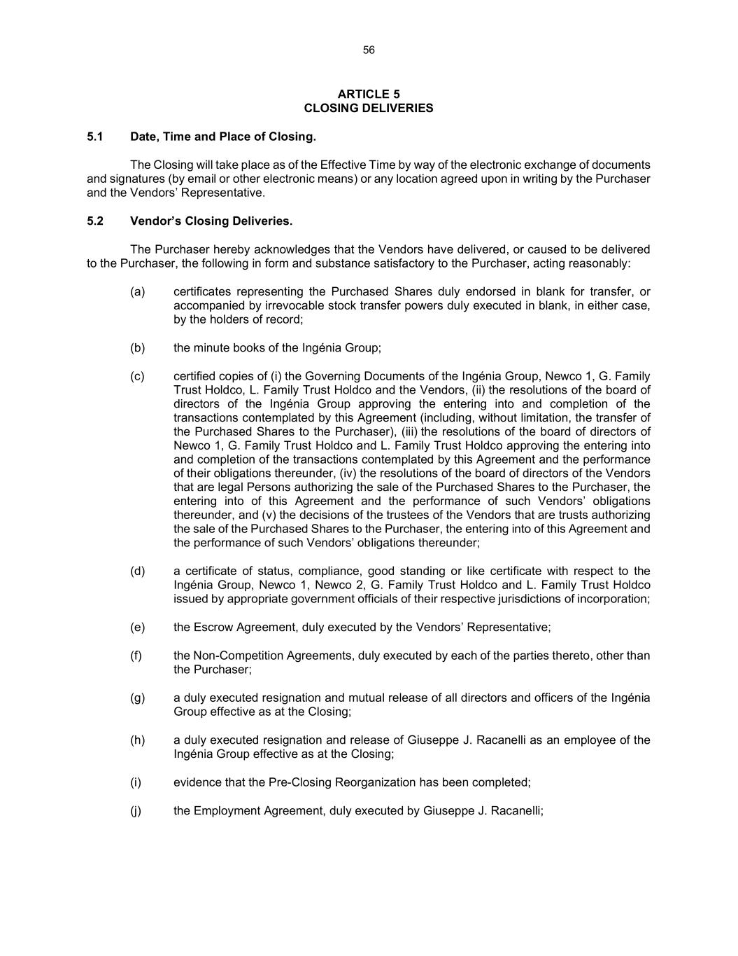
56 ARTICLE 5 CLOSING DELIVERIES 5.1 Date, Time and Place of Closing. The Closing will take place as of the Effective Time by way of the electronic exchange of documents and signatures (by email or other electronic means) or any location agreed upon in writing by the Purchaser and the Vendors’ Representative. 5.2 Vendor’s Closing Deliveries. The Purchaser hereby acknowledges that the Vendors have delivered, or caused to be delivered to the Purchaser, the following in form and substance satisfactory to the Purchaser, acting reasonably: (a) certificates representing the Purchased Shares duly endorsed in blank for transfer, or accompanied by irrevocable stock transfer powers duly executed in blank, in either case, by the holders of record; (b) the minute books of the Ingénia Group; (c) certified copies of (i) the Governing Documents of the Ingénia Group, Newco 1, G. Family Trust Holdco, L. Family Trust Holdco and the Vendors, (ii) the resolutions of the board of directors of the Ingénia Group approving the entering into and completion of the transactions contemplated by this Agreement (including, without limitation, the transfer of the Purchased Shares to the Purchaser), (iii) the resolutions of the board of directors of Newco 1, G. Family Trust Holdco and L. Family Trust Holdco approving the entering into and completion of the transactions contemplated by this Agreement and the performance of their obligations thereunder, (iv) the resolutions of the board of directors of the Vendors that are legal Persons authorizing the sale of the Purchased Shares to the Purchaser, the entering into of this Agreement and the performance of such Vendors’ obligations thereunder, and (v) the decisions of the trustees of the Vendors that are trusts authorizing the sale of the Purchased Shares to the Purchaser, the entering into of this Agreement and the performance of such Vendors’ obligations thereunder; (d) a certificate of status, compliance, good standing or like certificate with respect to the Ingénia Group, Newco 1, Newco 2, G. Family Trust Holdco and L. Family Trust Holdco issued by appropriate government officials of their respective jurisdictions of incorporation; (e) the Escrow Agreement, duly executed by the Vendors’ Representative; (f) the Non-Competition Agreements, duly executed by each of the parties thereto, other than the Purchaser; (g) a duly executed resignation and mutual release of all directors and officers of the Ingénia Group effective as at the Closing; (h) a duly executed resignation and release of Giuseppe J. Racanelli as an employee of the Ingénia Group effective as at the Closing; (i) evidence that the Pre-Closing Reorganization has been completed; (j) the Employment Agreement, duly executed by Giuseppe J. Racanelli;

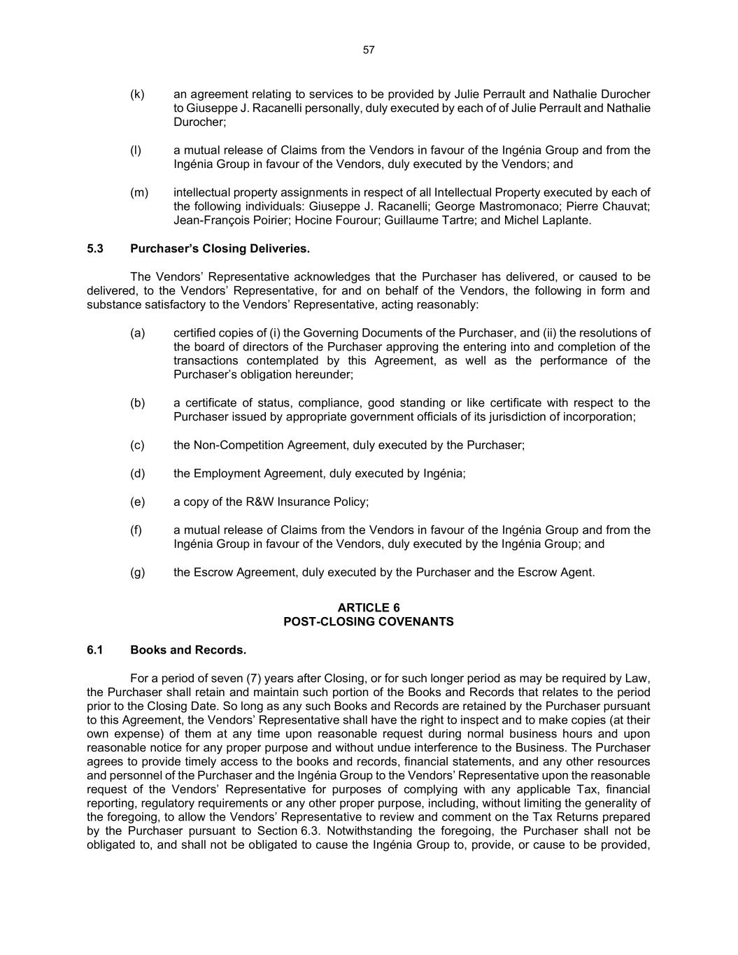
57 (k) an agreement relating to services to be provided by Julie Perrault and Nathalie Durocher to Giuseppe J. Racanelli personally, duly executed by each of of Julie Perrault and Nathalie Durocher; (l) a mutual release of Claims from the Vendors in favour of the Ingénia Group and from the Ingénia Group in favour of the Vendors, duly executed by the Vendors; and (m) intellectual property assignments in respect of all Intellectual Property executed by each of the following individuals: Giuseppe J. Racanelli; George Mastromonaco; Pierre Chauvat; Jean-François Poirier; Hocine Fourour; Guillaume Tartre; and Michel Laplante. 5.3 Purchaser’s Closing Deliveries. The Vendors’ Representative acknowledges that the Purchaser has delivered, or caused to be delivered, to the Vendors’ Representative, for and on behalf of the Vendors, the following in form and substance satisfactory to the Vendors’ Representative, acting reasonably: (a) certified copies of (i) the Governing Documents of the Purchaser, and (ii) the resolutions of the board of directors of the Purchaser approving the entering into and completion of the transactions contemplated by this Agreement, as well as the performance of the Purchaser’s obligation hereunder; (b) a certificate of status, compliance, good standing or like certificate with respect to the Purchaser issued by appropriate government officials of its jurisdiction of incorporation; (c) the Non-Competition Agreement, duly executed by the Purchaser; (d) the Employment Agreement, duly executed by Ingénia; (e) a copy of the R&W Insurance Policy; (f) a mutual release of Claims from the Vendors in favour of the Ingénia Group and from the Ingénia Group in favour of the Vendors, duly executed by the Ingénia Group; and (g) the Escrow Agreement, duly executed by the Purchaser and the Escrow Agent. ARTICLE 6 POST-CLOSING COVENANTS 6.1 Books and Records. For a period of seven (7) years after Closing, or for such longer period as may be required by Law, the Purchaser shall retain and maintain such portion of the Books and Records that relates to the period prior to the Closing Date. So long as any such Books and Records are retained by the Purchaser pursuant to this Agreement, the Vendors’ Representative shall have the right to inspect and to make copies (at their own expense) of them at any time upon reasonable request during normal business hours and upon reasonable notice for any proper purpose and without undue interference to the Business. The Purchaser agrees to provide timely access to the books and records, financial statements, and any other resources and personnel of the Purchaser and the Ingénia Group to the Vendors’ Representative upon the reasonable request of the Vendors’ Representative for purposes of complying with any applicable Tax, financial reporting, regulatory requirements or any other proper purpose, including, without limiting the generality of the foregoing, to allow the Vendors’ Representative to review and comment on the Tax Returns prepared by the Purchaser pursuant to Section 6.3. Notwithstanding the foregoing, the Purchaser shall not be obligated to, and shall not be obligated to cause the Ingénia Group to, provide, or cause to be provided,

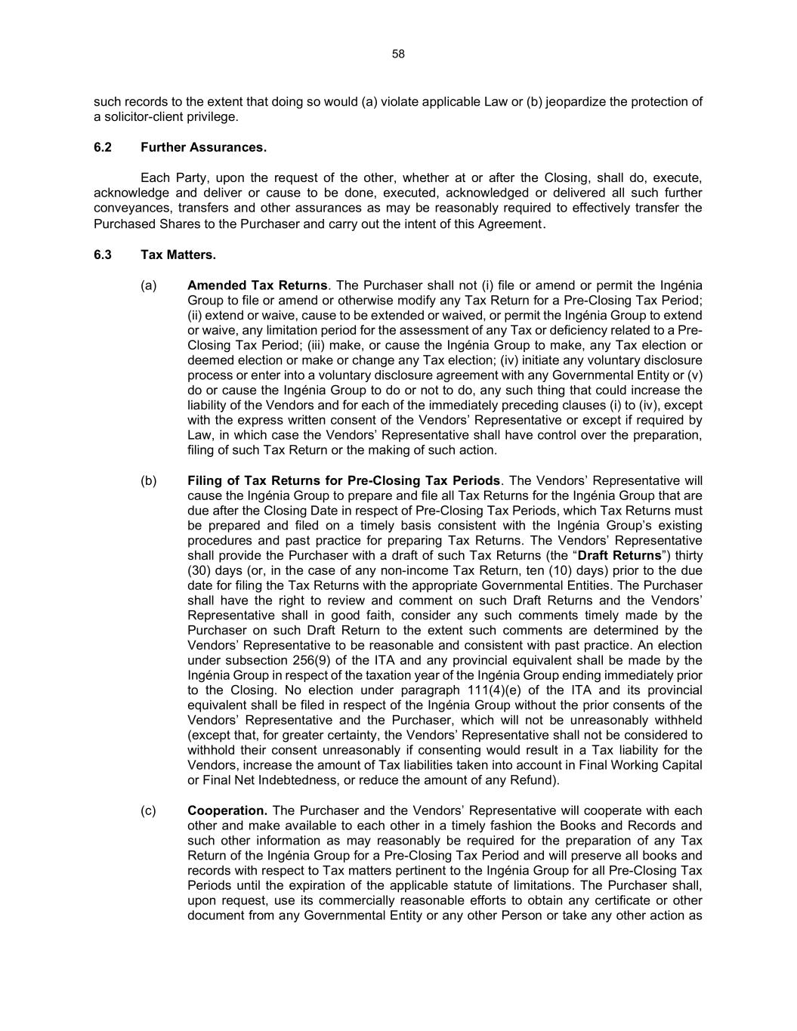
58 such records to the extent that doing so would (a) violate applicable Law or (b) jeopardize the protection of a solicitor-client privilege. 6.2 Further Assurances. Each Party, upon the request of the other, whether at or after the Closing, shall do, execute, acknowledge and deliver or cause to be done, executed, acknowledged or delivered all such further conveyances, transfers and other assurances as may be reasonably required to effectively transfer the Purchased Shares to the Purchaser and carry out the intent of this Agreement. 6.3 Tax Matters. (a) Amended Tax Returns. The Purchaser shall not (i) file or amend or permit the Ingénia Group to file or amend or otherwise modify any Tax Return for a Pre-Closing Tax Period; (ii) extend or waive, cause to be extended or waived, or permit the Ingénia Group to extend or waive, any limitation period for the assessment of any Tax or deficiency related to a Pre- Closing Tax Period; (iii) make, or cause the Ingénia Group to make, any Tax election or deemed election or make or change any Tax election; (iv) initiate any voluntary disclosure process or enter into a voluntary disclosure agreement with any Governmental Entity or (v) do or cause the Ingénia Group to do or not to do, any such thing that could increase the liability of the Vendors and for each of the immediately preceding clauses (i) to (iv), except with the express written consent of the Vendors’ Representative or except if required by Law, in which case the Vendors’ Representative shall have control over the preparation, filing of such Tax Return or the making of such action. (b) Filing of Tax Returns for Pre-Closing Tax Periods. The Vendors’ Representative will cause the Ingénia Group to prepare and file all Tax Returns for the Ingénia Group that are due after the Closing Date in respect of Pre-Closing Tax Periods, which Tax Returns must be prepared and filed on a timely basis consistent with the Ingénia Group’s existing procedures and past practice for preparing Tax Returns. The Vendors’ Representative shall provide the Purchaser with a draft of such Tax Returns (the “Draft Returns”) thirty (30) days (or, in the case of any non-income Tax Return, ten (10) days) prior to the due date for filing the Tax Returns with the appropriate Governmental Entities. The Purchaser shall have the right to review and comment on such Draft Returns and the Vendors’ Representative shall in good faith, consider any such comments timely made by the Purchaser on such Draft Return to the extent such comments are determined by the Vendors’ Representative to be reasonable and consistent with past practice. An election under subsection 256(9) of the ITA and any provincial equivalent shall be made by the Ingénia Group in respect of the taxation year of the Ingénia Group ending immediately prior to the Closing. No election under paragraph 111(4)(e) of the ITA and its provincial equivalent shall be filed in respect of the Ingénia Group without the prior consents of the Vendors’ Representative and the Purchaser, which will not be unreasonably withheld (except that, for greater certainty, the Vendors’ Representative shall not be considered to withhold their consent unreasonably if consenting would result in a Tax liability for the Vendors, increase the amount of Tax liabilities taken into account in Final Working Capital or Final Net Indebtedness, or reduce the amount of any Refund). (c) Cooperation. The Purchaser and the Vendors’ Representative will cooperate with each other and make available to each other in a timely fashion the Books and Records and such other information as may reasonably be required for the preparation of any Tax Return of the Ingénia Group for a Pre-Closing Tax Period and will preserve all books and records with respect to Tax matters pertinent to the Ingénia Group for all Pre-Closing Tax Periods until the expiration of the applicable statute of limitations. The Purchaser shall, upon request, use its commercially reasonable efforts to obtain any certificate or other document from any Governmental Entity or any other Person or take any other action as

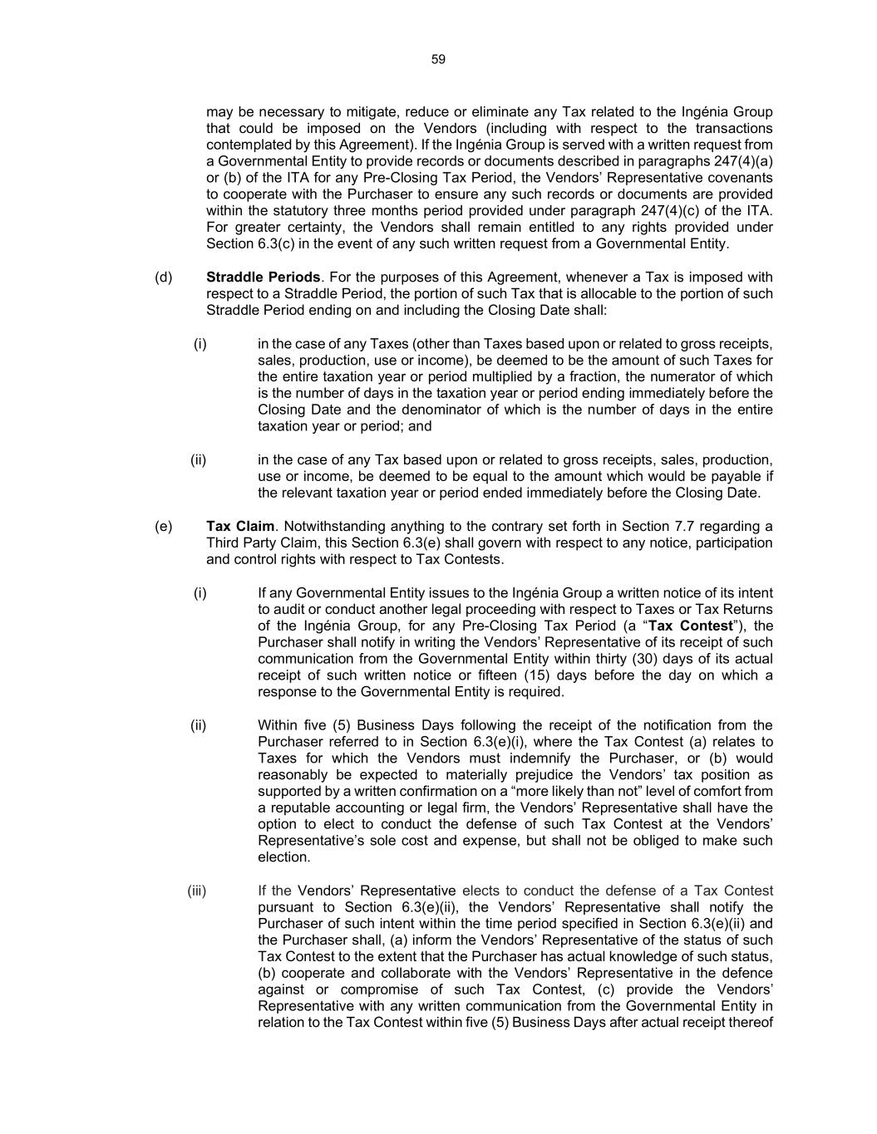
59 may be necessary to mitigate, reduce or eliminate any Tax related to the Ingénia Group that could be imposed on the Vendors (including with respect to the transactions contemplated by this Agreement). If the Ingénia Group is served with a written request from a Governmental Entity to provide records or documents described in paragraphs 247(4)(a) or (b) of the ITA for any Pre-Closing Tax Period, the Vendors’ Representative covenants to cooperate with the Purchaser to ensure any such records or documents are provided within the statutory three months period provided under paragraph 247(4)(c) of the ITA. For greater certainty, the Vendors shall remain entitled to any rights provided under Section 6.3(c) in the event of any such written request from a Governmental Entity. (d) Straddle Periods. For the purposes of this Agreement, whenever a Tax is imposed with respect to a Straddle Period, the portion of such Tax that is allocable to the portion of such Straddle Period ending on and including the Closing Date shall: (i) in the case of any Taxes (other than Taxes based upon or related to gross receipts, sales, production, use or income), be deemed to be the amount of such Taxes for the entire taxation year or period multiplied by a fraction, the numerator of which is the number of days in the taxation year or period ending immediately before the Closing Date and the denominator of which is the number of days in the entire taxation year or period; and (ii) in the case of any Tax based upon or related to gross receipts, sales, production, use or income, be deemed to be equal to the amount which would be payable if the relevant taxation year or period ended immediately before the Closing Date. (e) Tax Claim. Notwithstanding anything to the contrary set forth in Section 7.7 regarding a Third Party Claim, this Section 6.3(e) shall govern with respect to any notice, participation and control rights with respect to Tax Contests. (i) If any Governmental Entity issues to the Ingénia Group a written notice of its intent to audit or conduct another legal proceeding with respect to Taxes or Tax Returns of the Ingénia Group, for any Pre-Closing Tax Period (a “Tax Contest”), the Purchaser shall notify in writing the Vendors’ Representative of its receipt of such communication from the Governmental Entity within thirty (30) days of its actual receipt of such written notice or fifteen (15) days before the day on which a response to the Governmental Entity is required. (ii) Within five (5) Business Days following the receipt of the notification from the Purchaser referred to in Section 6.3(e)(i), where the Tax Contest (a) relates to Taxes for which the Vendors must indemnify the Purchaser, or (b) would reasonably be expected to materially prejudice the Vendors’ tax position as supported by a written confirmation on a “more likely than not” level of comfort from a reputable accounting or legal firm, the Vendors’ Representative shall have the option to elect to conduct the defense of such Tax Contest at the Vendors’ Representative’s sole cost and expense, but shall not be obliged to make such election. (iii) If the Vendors’ Representative elects to conduct the defense of a Tax Contest pursuant to Section 6.3(e)(ii), the Vendors’ Representative shall notify the Purchaser of such intent within the time period specified in Section 6.3(e)(ii) and the Purchaser shall, (a) inform the Vendors’ Representative of the status of such Tax Contest to the extent that the Purchaser has actual knowledge of such status, (b) cooperate and collaborate with the Vendors’ Representative in the defence against or compromise of such Tax Contest, (c) provide the Vendors’ Representative with any written communication from the Governmental Entity in relation to the Tax Contest within five (5) Business Days after actual receipt thereof

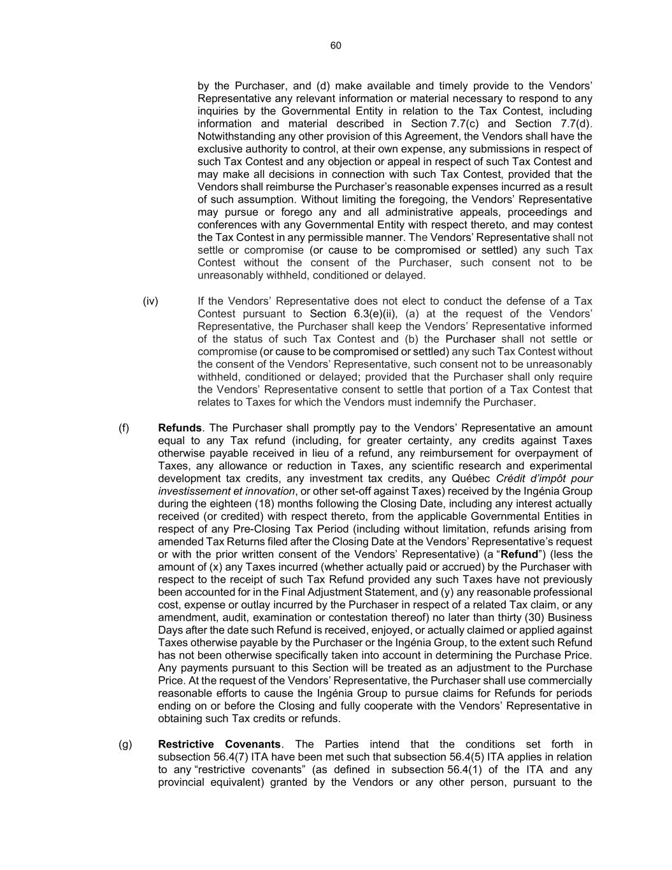
60 by the Purchaser, and (d) make available and timely provide to the Vendors’ Representative any relevant information or material necessary to respond to any inquiries by the Governmental Entity in relation to the Tax Contest, including information and material described in Section 7.7(c) and Section 7.7(d). Notwithstanding any other provision of this Agreement, the Vendors shall have the exclusive authority to control, at their own expense, any submissions in respect of such Tax Contest and any objection or appeal in respect of such Tax Contest and may make all decisions in connection with such Tax Contest, provided that the Vendors shall reimburse the Purchaser’s reasonable expenses incurred as a result of such assumption. Without limiting the foregoing, the Vendors’ Representative may pursue or forego any and all administrative appeals, proceedings and conferences with any Governmental Entity with respect thereto, and may contest the Tax Contest in any permissible manner. The Vendors’ Representative shall not settle or compromise (or cause to be compromised or settled) any such Tax Contest without the consent of the Purchaser, such consent not to be unreasonably withheld, conditioned or delayed. (iv) If the Vendors’ Representative does not elect to conduct the defense of a Tax Contest pursuant to Section 6.3(e)(ii), (a) at the request of the Vendors’ Representative, the Purchaser shall keep the Vendors’ Representative informed of the status of such Tax Contest and (b) the Purchaser shall not settle or compromise (or cause to be compromised or settled) any such Tax Contest without the consent of the Vendors’ Representative, such consent not to be unreasonably withheld, conditioned or delayed; provided that the Purchaser shall only require the Vendors’ Representative consent to settle that portion of a Tax Contest that relates to Taxes for which the Vendors must indemnify the Purchaser. (f) Refunds. The Purchaser shall promptly pay to the Vendors’ Representative an amount equal to any Tax refund (including, for greater certainty, any credits against Taxes otherwise payable received in lieu of a refund, any reimbursement for overpayment of Taxes, any allowance or reduction in Taxes, any scientific research and experimental development tax credits, any investment tax credits, any Québec Crédit d’impôt pour investissement et innovation, or other set-off against Taxes) received by the Ingénia Group during the eighteen (18) months following the Closing Date, including any interest actually received (or credited) with respect thereto, from the applicable Governmental Entities in respect of any Pre-Closing Tax Period (including without limitation, refunds arising from amended Tax Returns filed after the Closing Date at the Vendors’ Representative’s request or with the prior written consent of the Vendors’ Representative) (a “Refund”) (less the amount of (x) any Taxes incurred (whether actually paid or accrued) by the Purchaser with respect to the receipt of such Tax Refund provided any such Taxes have not previously been accounted for in the Final Adjustment Statement, and (y) any reasonable professional cost, expense or outlay incurred by the Purchaser in respect of a related Tax claim, or any amendment, audit, examination or contestation thereof) no later than thirty (30) Business Days after the date such Refund is received, enjoyed, or actually claimed or applied against Taxes otherwise payable by the Purchaser or the Ingénia Group, to the extent such Refund has not been otherwise specifically taken into account in determining the Purchase Price. Any payments pursuant to this Section will be treated as an adjustment to the Purchase Price. At the request of the Vendors’ Representative, the Purchaser shall use commercially reasonable efforts to cause the Ingénia Group to pursue claims for Refunds for periods ending on or before the Closing and fully cooperate with the Vendors’ Representative in obtaining such Tax credits or refunds. (g) Restrictive Covenants. The Parties intend that the conditions set forth in subsection 56.4(7) ITA have been met such that subsection 56.4(5) ITA applies in relation to any “restrictive covenants” (as defined in subsection 56.4(1) of the ITA and any provincial equivalent) granted by the Vendors or any other person, pursuant to the

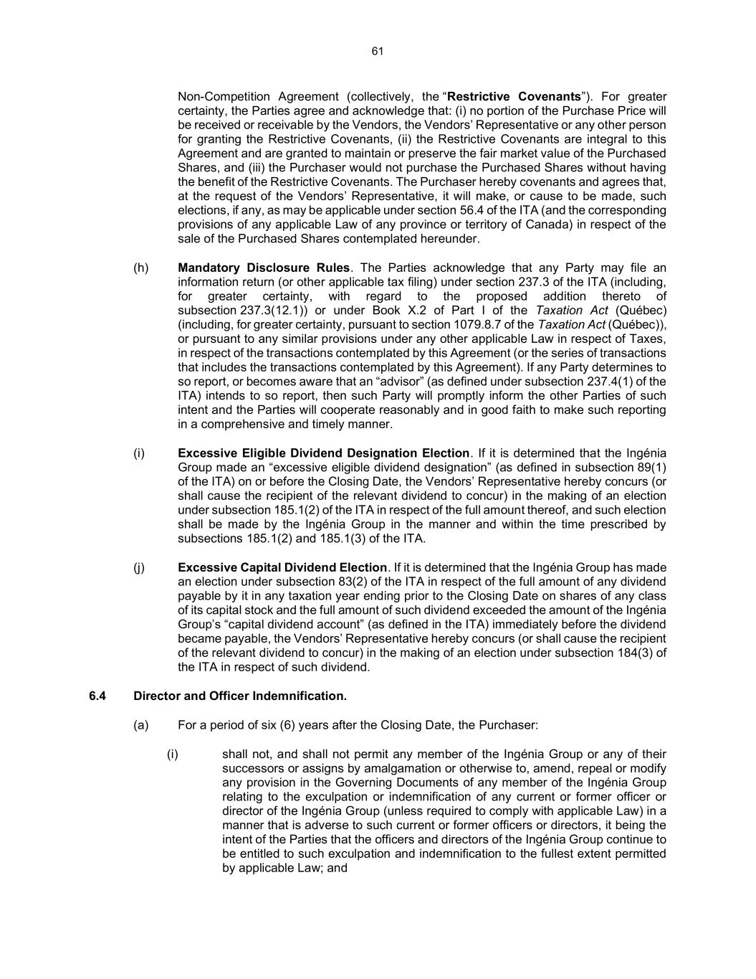
61 Non-Competition Agreement (collectively, the “Restrictive Covenants”). For greater certainty, the Parties agree and acknowledge that: (i) no portion of the Purchase Price will be received or receivable by the Vendors, the Vendors’ Representative or any other person for granting the Restrictive Covenants, (ii) the Restrictive Covenants are integral to this Agreement and are granted to maintain or preserve the fair market value of the Purchased Shares, and (iii) the Purchaser would not purchase the Purchased Shares without having the benefit of the Restrictive Covenants. The Purchaser hereby covenants and agrees that, at the request of the Vendors’ Representative, it will make, or cause to be made, such elections, if any, as may be applicable under section 56.4 of the ITA (and the corresponding provisions of any applicable Law of any province or territory of Canada) in respect of the sale of the Purchased Shares contemplated hereunder. (h) Mandatory Disclosure Rules. The Parties acknowledge that any Party may file an information return (or other applicable tax filing) under section 237.3 of the ITA (including, for greater certainty, with regard to the proposed addition thereto of subsection 237.3(12.1)) or under Book X.2 of Part I of the Taxation Act (Québec) (including, for greater certainty, pursuant to section 1079.8.7 of the Taxation Act (Québec)), or pursuant to any similar provisions under any other applicable Law in respect of Taxes, in respect of the transactions contemplated by this Agreement (or the series of transactions that includes the transactions contemplated by this Agreement). If any Party determines to so report, or becomes aware that an “advisor” (as defined under subsection 237.4(1) of the ITA) intends to so report, then such Party will promptly inform the other Parties of such intent and the Parties will cooperate reasonably and in good faith to make such reporting in a comprehensive and timely manner. (i) Excessive Eligible Dividend Designation Election. If it is determined that the Ingénia Group made an “excessive eligible dividend designation” (as defined in subsection 89(1) of the ITA) on or before the Closing Date, the Vendors’ Representative hereby concurs (or shall cause the recipient of the relevant dividend to concur) in the making of an election under subsection 185.1(2) of the ITA in respect of the full amount thereof, and such election shall be made by the Ingénia Group in the manner and within the time prescribed by subsections 185.1(2) and 185.1(3) of the ITA. (j) Excessive Capital Dividend Election. If it is determined that the Ingénia Group has made an election under subsection 83(2) of the ITA in respect of the full amount of any dividend payable by it in any taxation year ending prior to the Closing Date on shares of any class of its capital stock and the full amount of such dividend exceeded the amount of the Ingénia Group’s “capital dividend account” (as defined in the ITA) immediately before the dividend became payable, the Vendors’ Representative hereby concurs (or shall cause the recipient of the relevant dividend to concur) in the making of an election under subsection 184(3) of the ITA in respect of such dividend. 6.4 Director and Officer Indemnification. (a) For a period of six (6) years after the Closing Date, the Purchaser: (i) shall not, and shall not permit any member of the Ingénia Group or any of their successors or assigns by amalgamation or otherwise to, amend, repeal or modify any provision in the Governing Documents of any member of the Ingénia Group relating to the exculpation or indemnification of any current or former officer or director of the Ingénia Group (unless required to comply with applicable Law) in a manner that is adverse to such current or former officers or directors, it being the intent of the Parties that the officers and directors of the Ingénia Group continue to be entitled to such exculpation and indemnification to the fullest extent permitted by applicable Law; and

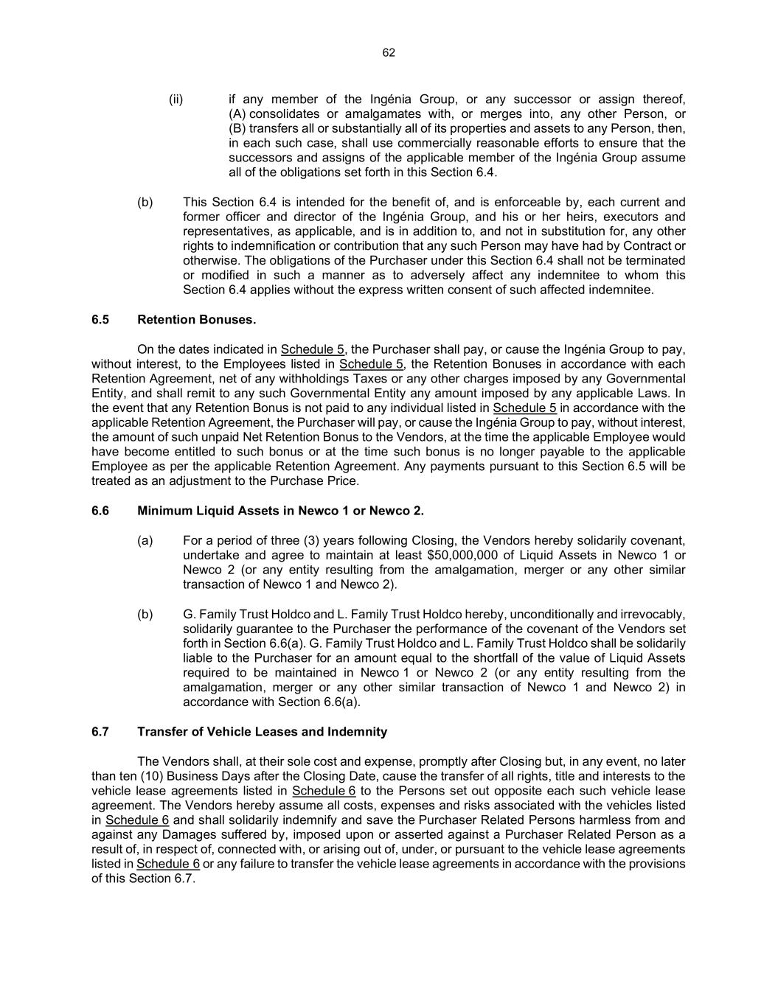
62 (ii) if any member of the Ingénia Group, or any successor or assign thereof, (A) consolidates or amalgamates with, or merges into, any other Person, or (B) transfers all or substantially all of its properties and assets to any Person, then, in each such case, shall use commercially reasonable efforts to ensure that the successors and assigns of the applicable member of the Ingénia Group assume all of the obligations set forth in this Section 6.4. (b) This Section 6.4 is intended for the benefit of, and is enforceable by, each current and former officer and director of the Ingénia Group, and his or her heirs, executors and representatives, as applicable, and is in addition to, and not in substitution for, any other rights to indemnification or contribution that any such Person may have had by Contract or otherwise. The obligations of the Purchaser under this Section 6.4 shall not be terminated or modified in such a manner as to adversely affect any indemnitee to whom this Section 6.4 applies without the express written consent of such affected indemnitee. 6.5 Retention Bonuses. On the dates indicated in Schedule 5, the Purchaser shall pay, or cause the Ingénia Group to pay, without interest, to the Employees listed in Schedule 5, the Retention Bonuses in accordance with each Retention Agreement, net of any withholdings Taxes or any other charges imposed by any Governmental Entity, and shall remit to any such Governmental Entity any amount imposed by any applicable Laws. In the event that any Retention Bonus is not paid to any individual listed in Schedule 5 in accordance with the applicable Retention Agreement, the Purchaser will pay, or cause the Ingénia Group to pay, without interest, the amount of such unpaid Net Retention Bonus to the Vendors, at the time the applicable Employee would have become entitled to such bonus or at the time such bonus is no longer payable to the applicable Employee as per the applicable Retention Agreement. Any payments pursuant to this Section 6.5 will be treated as an adjustment to the Purchase Price. 6.6 Minimum Liquid Assets in Newco 1 or Newco 2. (a) For a period of three (3) years following Closing, the Vendors hereby solidarily covenant, undertake and agree to maintain at least $50,000,000 of Liquid Assets in Newco 1 or Newco 2 (or any entity resulting from the amalgamation, merger or any other similar transaction of Newco 1 and Newco 2). (b) G. Family Trust Holdco and L. Family Trust Holdco hereby, unconditionally and irrevocably, solidarily guarantee to the Purchaser the performance of the covenant of the Vendors set forth in Section 6.6(a). G. Family Trust Holdco and L. Family Trust Holdco shall be solidarily liable to the Purchaser for an amount equal to the shortfall of the value of Liquid Assets required to be maintained in Newco 1 or Newco 2 (or any entity resulting from the amalgamation, merger or any other similar transaction of Newco 1 and Newco 2) in accordance with Section 6.6(a). 6.7 Transfer of Vehicle Leases and Indemnity The Vendors shall, at their sole cost and expense, promptly after Closing but, in any event, no later than ten (10) Business Days after the Closing Date, cause the transfer of all rights, title and interests to the vehicle lease agreements listed in Schedule 6 to the Persons set out opposite each such vehicle lease agreement. The Vendors hereby assume all costs, expenses and risks associated with the vehicles listed in Schedule 6 and shall solidarily indemnify and save the Purchaser Related Persons harmless from and against any Damages suffered by, imposed upon or asserted against a Purchaser Related Person as a result of, in respect of, connected with, or arising out of, under, or pursuant to the vehicle lease agreements listed in Schedule 6 or any failure to transfer the vehicle lease agreements in accordance with the provisions of this Section 6.7.

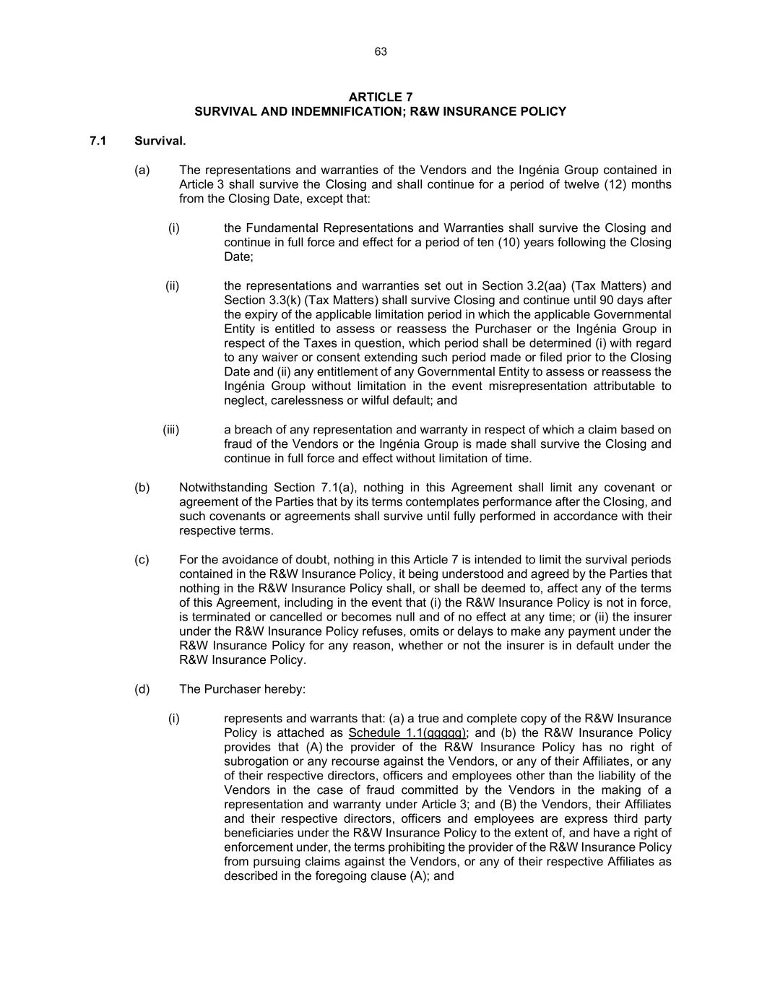
63 ARTICLE 7 SURVIVAL AND INDEMNIFICATION; R&W INSURANCE POLICY 7.1 Survival. (a) The representations and warranties of the Vendors and the Ingénia Group contained in Article 3 shall survive the Closing and shall continue for a period of twelve (12) months from the Closing Date, except that: (i) the Fundamental Representations and Warranties shall survive the Closing and continue in full force and effect for a period of ten (10) years following the Closing Date; (ii) the representations and warranties set out in Section 3.2(aa) (Tax Matters) and Section 3.3(k) (Tax Matters) shall survive Closing and continue until 90 days after the expiry of the applicable limitation period in which the applicable Governmental Entity is entitled to assess or reassess the Purchaser or the Ingénia Group in respect of the Taxes in question, which period shall be determined (i) with regard to any waiver or consent extending such period made or filed prior to the Closing Date and (ii) any entitlement of any Governmental Entity to assess or reassess the Ingénia Group without limitation in the event misrepresentation attributable to neglect, carelessness or wilful default; and (iii) a breach of any representation and warranty in respect of which a claim based on fraud of the Vendors or the Ingénia Group is made shall survive the Closing and continue in full force and effect without limitation of time. (b) Notwithstanding Section 7.1(a), nothing in this Agreement shall limit any covenant or agreement of the Parties that by its terms contemplates performance after the Closing, and such covenants or agreements shall survive until fully performed in accordance with their respective terms. (c) For the avoidance of doubt, nothing in this Article 7 is intended to limit the survival periods contained in the R&W Insurance Policy, it being understood and agreed by the Parties that nothing in the R&W Insurance Policy shall, or shall be deemed to, affect any of the terms of this Agreement, including in the event that (i) the R&W Insurance Policy is not in force, is terminated or cancelled or becomes null and of no effect at any time; or (ii) the insurer under the R&W Insurance Policy refuses, omits or delays to make any payment under the R&W Insurance Policy for any reason, whether or not the insurer is in default under the R&W Insurance Policy. (d) The Purchaser hereby: (i) represents and warrants that: (a) a true and complete copy of the R&W Insurance Policy is attached as Schedule 1.1(ggggg); and (b) the R&W Insurance Policy provides that (A) the provider of the R&W Insurance Policy has no right of subrogation or any recourse against the Vendors, or any of their Affiliates, or any of their respective directors, officers and employees other than the liability of the Vendors in the case of fraud committed by the Vendors in the making of a representation and warranty under Article 3; and (B) the Vendors, their Affiliates and their respective directors, officers and employees are express third party beneficiaries under the R&W Insurance Policy to the extent of, and have a right of enforcement under, the terms prohibiting the provider of the R&W Insurance Policy from pursuing claims against the Vendors, or any of their respective Affiliates as described in the foregoing clause (A); and

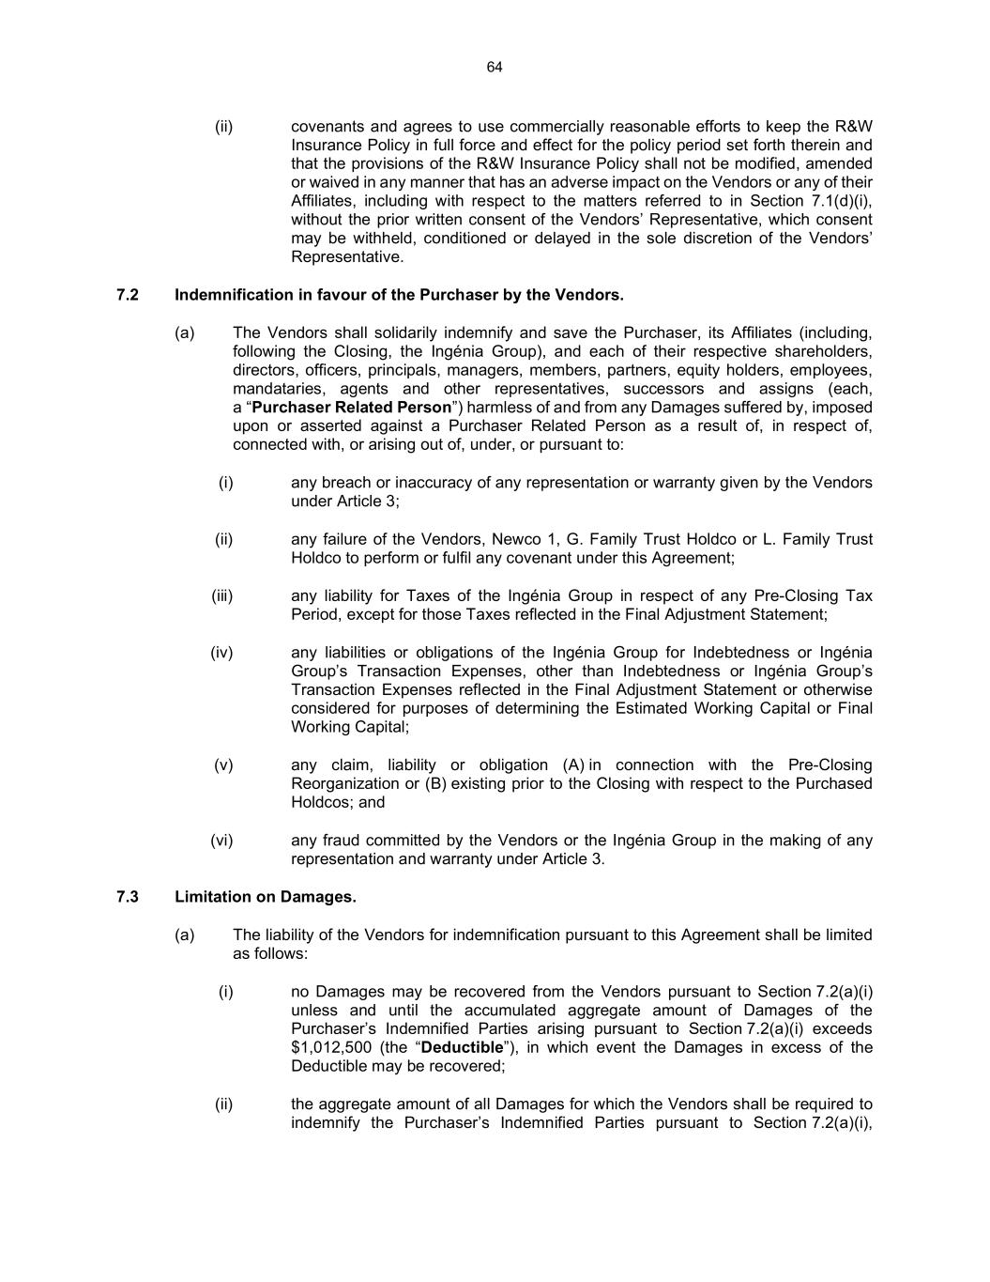
64 (ii) covenants and agrees to use commercially reasonable efforts to keep the R&W Insurance Policy in full force and effect for the policy period set forth therein and that the provisions of the R&W Insurance Policy shall not be modified, amended or waived in any manner that has an adverse impact on the Vendors or any of their Affiliates, including with respect to the matters referred to in Section 7.1(d)(i), without the prior written consent of the Vendors’ Representative, which consent may be withheld, conditioned or delayed in the sole discretion of the Vendors’ Representative. 7.2 Indemnification in favour of the Purchaser by the Vendors. (a) The Vendors shall solidarily indemnify and save the Purchaser, its Affiliates (including, following the Closing, the Ingénia Group), and each of their respective shareholders, directors, officers, principals, managers, members, partners, equity holders, employees, mandataries, agents and other representatives, successors and assigns (each, a “Purchaser Related Person”) harmless of and from any Damages suffered by, imposed upon or asserted against a Purchaser Related Person as a result of, in respect of, connected with, or arising out of, under, or pursuant to: (i) any breach or inaccuracy of any representation or warranty given by the Vendors under Article 3; (ii) any failure of the Vendors, Newco 1, G. Family Trust Holdco or L. Family Trust Holdco to perform or fulfil any covenant under this Agreement; (iii) any liability for Taxes of the Ingénia Group in respect of any Pre-Closing Tax Period, except for those Taxes reflected in the Final Adjustment Statement; (iv) any liabilities or obligations of the Ingénia Group for Indebtedness or Ingénia Group’s Transaction Expenses, other than Indebtedness or Ingénia Group’s Transaction Expenses reflected in the Final Adjustment Statement or otherwise considered for purposes of determining the Estimated Working Capital or Final Working Capital; (v) any claim, liability or obligation (A) in connection with the Pre-Closing Reorganization or (B) existing prior to the Closing with respect to the Purchased Holdcos; and (vi) any fraud committed by the Vendors or the Ingénia Group in the making of any representation and warranty under Article 3. 7.3 Limitation on Damages. (a) The liability of the Vendors for indemnification pursuant to this Agreement shall be limited as follows: (i) no Damages may be recovered from the Vendors pursuant to Section 7.2(a)(i) unless and until the accumulated aggregate amount of Damages of the Purchaser’s Indemnified Parties arising pursuant to Section 7.2(a)(i) exceeds $1,012,500 (the “Deductible”), in which event the Damages in excess of the Deductible may be recovered; (ii) the aggregate amount of all Damages for which the Vendors shall be required to indemnify the Purchaser’s Indemnified Parties pursuant to Section 7.2(a)(i),

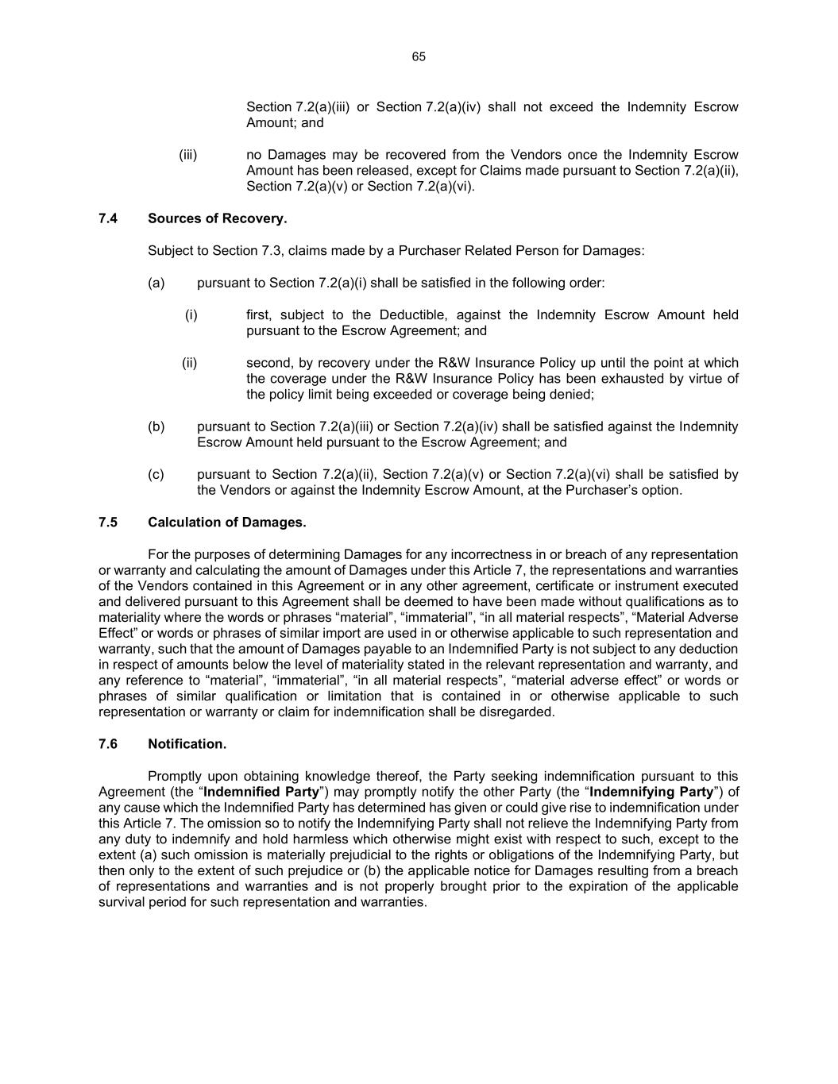
65 Section 7.2(a)(iii) or Section 7.2(a)(iv) shall not exceed the Indemnity Escrow Amount; and (iii) no Damages may be recovered from the Vendors once the Indemnity Escrow Amount has been released, except for Claims made pursuant to Section 7.2(a)(ii), Section 7.2(a)(v) or Section 7.2(a)(vi). 7.4 Sources of Recovery. Subject to Section 7.3, claims made by a Purchaser Related Person for Damages: (a) pursuant to Section 7.2(a)(i) shall be satisfied in the following order: (i) first, subject to the Deductible, against the Indemnity Escrow Amount held pursuant to the Escrow Agreement; and (ii) second, by recovery under the R&W Insurance Policy up until the point at which the coverage under the R&W Insurance Policy has been exhausted by virtue of the policy limit being exceeded or coverage being denied; (b) pursuant to Section 7.2(a)(iii) or Section 7.2(a)(iv) shall be satisfied against the Indemnity Escrow Amount held pursuant to the Escrow Agreement; and (c) pursuant to Section 7.2(a)(ii), Section 7.2(a)(v) or Section 7.2(a)(vi) shall be satisfied by the Vendors or against the Indemnity Escrow Amount, at the Purchaser’s option. 7.5 Calculation of Damages. For the purposes of determining Damages for any incorrectness in or breach of any representation or warranty and calculating the amount of Damages under this Article 7, the representations and warranties of the Vendors contained in this Agreement or in any other agreement, certificate or instrument executed and delivered pursuant to this Agreement shall be deemed to have been made without qualifications as to materiality where the words or phrases “material”, “immaterial”, “in all material respects”, “Material Adverse Effect” or words or phrases of similar import are used in or otherwise applicable to such representation and warranty, such that the amount of Damages payable to an Indemnified Party is not subject to any deduction in respect of amounts below the level of materiality stated in the relevant representation and warranty, and any reference to “material”, “immaterial”, “in all material respects”, “material adverse effect” or words or phrases of similar qualification or limitation that is contained in or otherwise applicable to such representation or warranty or claim for indemnification shall be disregarded. 7.6 Notification. Promptly upon obtaining knowledge thereof, the Party seeking indemnification pursuant to this Agreement (the “Indemnified Party”) may promptly notify the other Party (the “Indemnifying Party”) of any cause which the Indemnified Party has determined has given or could give rise to indemnification under this Article 7. The omission so to notify the Indemnifying Party shall not relieve the Indemnifying Party from any duty to indemnify and hold harmless which otherwise might exist with respect to such, except to the extent (a) such omission is materially prejudicial to the rights or obligations of the Indemnifying Party, but then only to the extent of such prejudice or (b) the applicable notice for Damages resulting from a breach of representations and warranties and is not properly brought prior to the expiration of the applicable survival period for such representation and warranties.

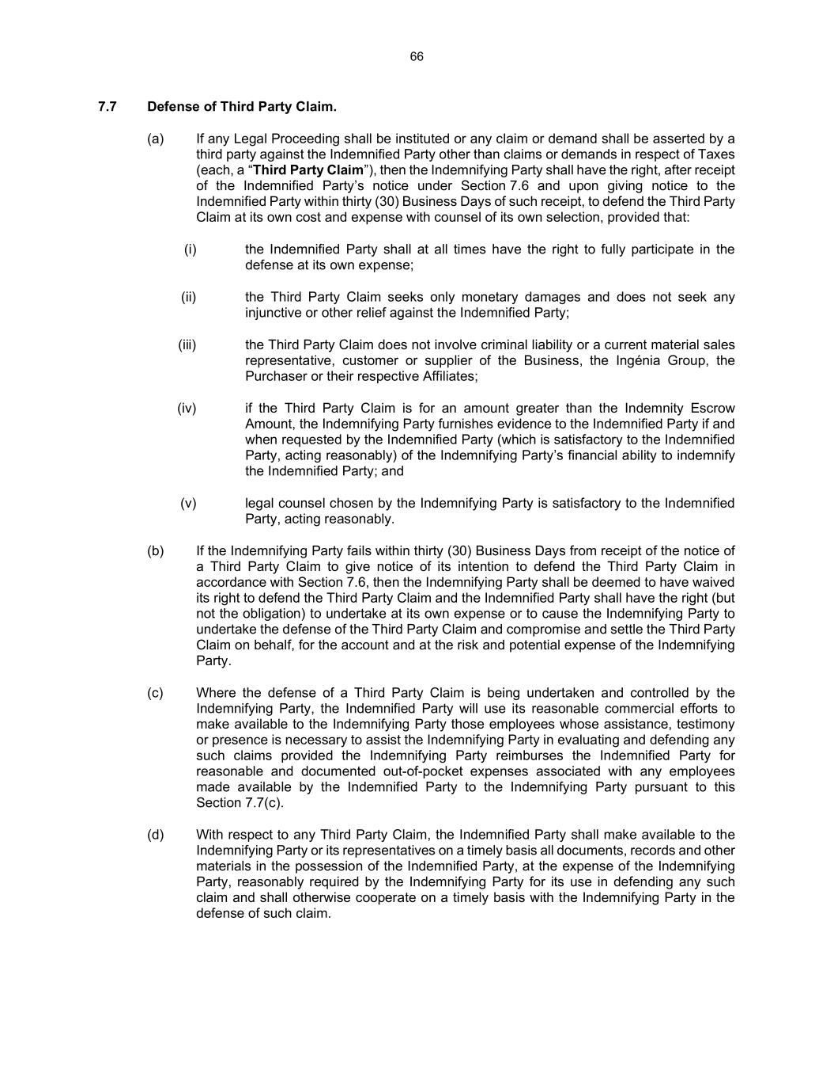
66 7.7 Defense of Third Party Claim. (a) If any Legal Proceeding shall be instituted or any claim or demand shall be asserted by a third party against the Indemnified Party other than claims or demands in respect of Taxes (each, a “Third Party Claim”), then the Indemnifying Party shall have the right, after receipt of the Indemnified Party’s notice under Section 7.6 and upon giving notice to the Indemnified Party within thirty (30) Business Days of such receipt, to defend the Third Party Claim at its own cost and expense with counsel of its own selection, provided that: (i) the Indemnified Party shall at all times have the right to fully participate in the defense at its own expense; (ii) the Third Party Claim seeks only monetary damages and does not seek any injunctive or other relief against the Indemnified Party; (iii) the Third Party Claim does not involve criminal liability or a current material sales representative, customer or supplier of the Business, the Ingénia Group, the Purchaser or their respective Affiliates; (iv) if the Third Party Claim is for an amount greater than the Indemnity Escrow Amount, the Indemnifying Party furnishes evidence to the Indemnified Party if and when requested by the Indemnified Party (which is satisfactory to the Indemnified Party, acting reasonably) of the Indemnifying Party’s financial ability to indemnify the Indemnified Party; and (v) legal counsel chosen by the Indemnifying Party is satisfactory to the Indemnified Party, acting reasonably. (b) If the Indemnifying Party fails within thirty (30) Business Days from receipt of the notice of a Third Party Claim to give notice of its intention to defend the Third Party Claim in accordance with Section 7.6, then the Indemnifying Party shall be deemed to have waived its right to defend the Third Party Claim and the Indemnified Party shall have the right (but not the obligation) to undertake at its own expense or to cause the Indemnifying Party to undertake the defense of the Third Party Claim and compromise and settle the Third Party Claim on behalf, for the account and at the risk and potential expense of the Indemnifying Party. (c) Where the defense of a Third Party Claim is being undertaken and controlled by the Indemnifying Party, the Indemnified Party will use its reasonable commercial efforts to make available to the Indemnifying Party those employees whose assistance, testimony or presence is necessary to assist the Indemnifying Party in evaluating and defending any such claims provided the Indemnifying Party reimburses the Indemnified Party for reasonable and documented out-of-pocket expenses associated with any employees made available by the Indemnified Party to the Indemnifying Party pursuant to this Section 7.7(c). (d) With respect to any Third Party Claim, the Indemnified Party shall make available to the Indemnifying Party or its representatives on a timely basis all documents, records and other materials in the possession of the Indemnified Party, at the expense of the Indemnifying Party, reasonably required by the Indemnifying Party for its use in defending any such claim and shall otherwise cooperate on a timely basis with the Indemnifying Party in the defense of such claim.

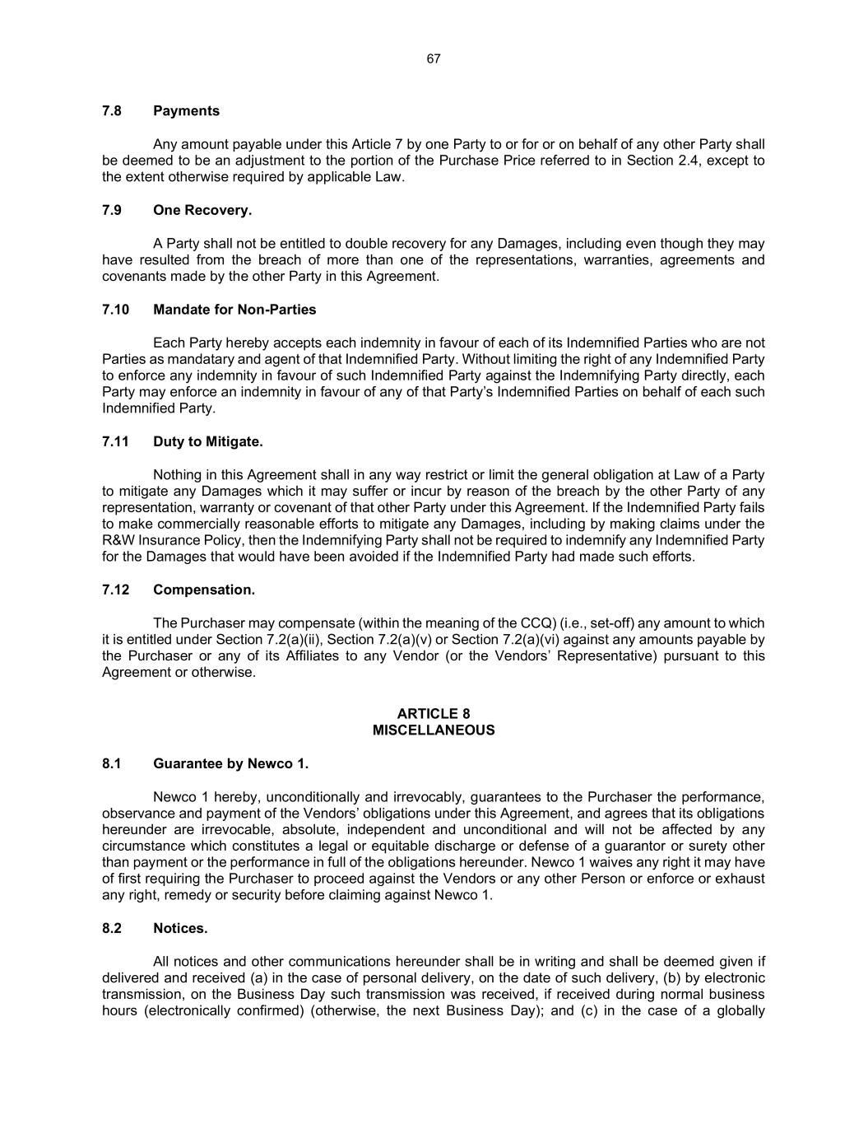
67 7.8 Payments Any amount payable under this Article 7 by one Party to or for or on behalf of any other Party shall be deemed to be an adjustment to the portion of the Purchase Price referred to in Section 2.4, except to the extent otherwise required by applicable Law. 7.9 One Recovery. A Party shall not be entitled to double recovery for any Damages, including even though they may have resulted from the breach of more than one of the representations, warranties, agreements and covenants made by the other Party in this Agreement. 7.10 Mandate for Non-Parties Each Party hereby accepts each indemnity in favour of each of its Indemnified Parties who are not Parties as mandatary and agent of that Indemnified Party. Without limiting the right of any Indemnified Party to enforce any indemnity in favour of such Indemnified Party against the Indemnifying Party directly, each Party may enforce an indemnity in favour of any of that Party’s Indemnified Parties on behalf of each such Indemnified Party. 7.11 Duty to Mitigate. Nothing in this Agreement shall in any way restrict or limit the general obligation at Law of a Party to mitigate any Damages which it may suffer or incur by reason of the breach by the other Party of any representation, warranty or covenant of that other Party under this Agreement. If the Indemnified Party fails to make commercially reasonable efforts to mitigate any Damages, including by making claims under the R&W Insurance Policy, then the Indemnifying Party shall not be required to indemnify any Indemnified Party for the Damages that would have been avoided if the Indemnified Party had made such efforts. 7.12 Compensation. The Purchaser may compensate (within the meaning of the CCQ) (i.e., set-off) any amount to which it is entitled under Section 7.2(a)(ii), Section 7.2(a)(v) or Section 7.2(a)(vi) against any amounts payable by the Purchaser or any of its Affiliates to any Vendor (or the Vendors’ Representative) pursuant to this Agreement or otherwise. ARTICLE 8 MISCELLANEOUS 8.1 Guarantee by Newco 1. Newco 1 hereby, unconditionally and irrevocably, guarantees to the Purchaser the performance, observance and payment of the Vendors’ obligations under this Agreement, and agrees that its obligations hereunder are irrevocable, absolute, independent and unconditional and will not be affected by any circumstance which constitutes a legal or equitable discharge or defense of a guarantor or surety other than payment or the performance in full of the obligations hereunder. Newco 1 waives any right it may have of first requiring the Purchaser to proceed against the Vendors or any other Person or enforce or exhaust any right, remedy or security before claiming against Newco 1. 8.2 Notices. All notices and other communications hereunder shall be in writing and shall be deemed given if delivered and received (a) in the case of personal delivery, on the date of such delivery, (b) by electronic transmission, on the Business Day such transmission was received, if received during normal business hours (electronically confirmed) (otherwise, the next Business Day); and (c) in the case of a globally

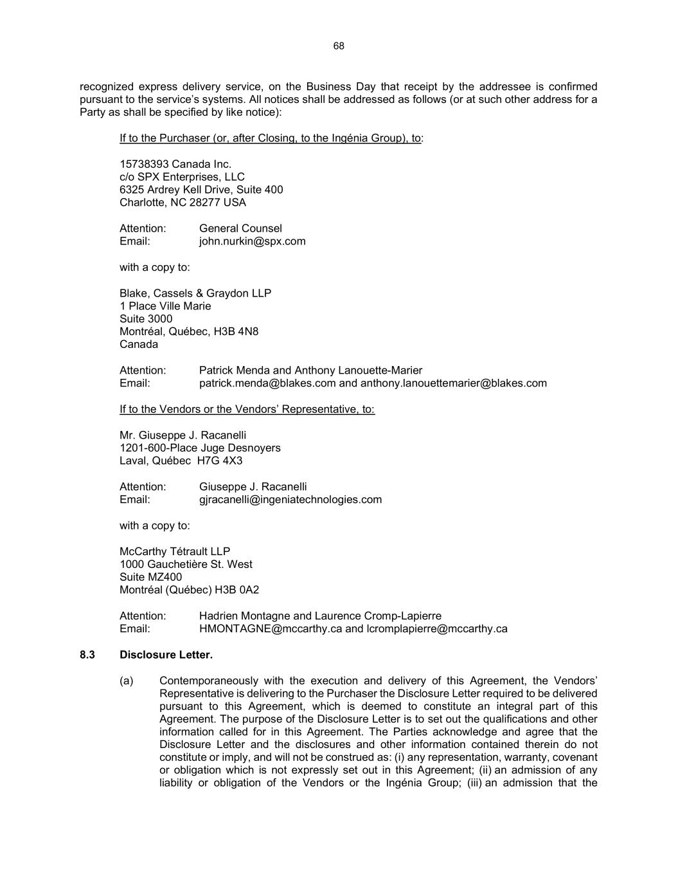
68 recognized express delivery service, on the Business Day that receipt by the addressee is confirmed pursuant to the service’s systems. All notices shall be addressed as follows (or at such other address for a Party as shall be specified by like notice): If to the Purchaser (or, after Closing, to the Ingénia Group), to: 15738393 Canada Inc. c/o SPX Enterprises, LLC 6325 Ardrey Kell Drive, Suite 400 Charlotte, NC 28277 USA Attention: General Counsel Email: john.nurkin@spx.com with a copy to: Blake, Cassels & Graydon LLP 1 Place Ville Marie Suite 3000 Montréal, Québec, H3B 4N8 Canada Attention: Patrick Menda and Anthony Lanouette-Marier Email: patrick.menda@blakes.com and anthony.lanouettemarier@blakes.com If to the Vendors or the Vendors’ Representative, to: Mr. Giuseppe J. Racanelli 1201-600-Place Juge Desnoyers Laval, Québec H7G 4X3 Attention: Giuseppe J. Racanelli Email: gjracanelli@ingeniatechnologies.com with a copy to: McCarthy Tétrault LLP 1000 Gauchetière St. West Suite MZ400 Montréal (Québec) H3B 0A2 Attention: Hadrien Montagne and Laurence Cromp-Lapierre Email: HMONTAGNE@mccarthy.ca and lcromplapierre@mccarthy.ca 8.3 Disclosure Letter. (a) Contemporaneously with the execution and delivery of this Agreement, the Vendors’ Representative is delivering to the Purchaser the Disclosure Letter required to be delivered pursuant to this Agreement, which is deemed to constitute an integral part of this Agreement. The purpose of the Disclosure Letter is to set out the qualifications and other information called for in this Agreement. The Parties acknowledge and agree that the Disclosure Letter and the disclosures and other information contained therein do not constitute or imply, and will not be construed as: (i) any representation, warranty, covenant or obligation which is not expressly set out in this Agreement; (ii) an admission of any liability or obligation of the Vendors or the Ingénia Group; (iii) an admission that the

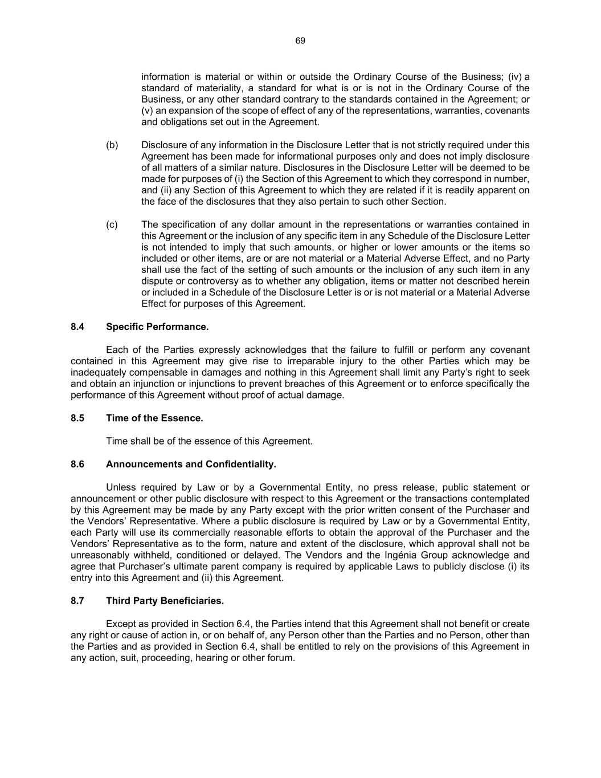
69 information is material or within or outside the Ordinary Course of the Business; (iv) a standard of materiality, a standard for what is or is not in the Ordinary Course of the Business, or any other standard contrary to the standards contained in the Agreement; or (v) an expansion of the scope of effect of any of the representations, warranties, covenants and obligations set out in the Agreement. (b) Disclosure of any information in the Disclosure Letter that is not strictly required under this Agreement has been made for informational purposes only and does not imply disclosure of all matters of a similar nature. Disclosures in the Disclosure Letter will be deemed to be made for purposes of (i) the Section of this Agreement to which they correspond in number, and (ii) any Section of this Agreement to which they are related if it is readily apparent on the face of the disclosures that they also pertain to such other Section. (c) The specification of any dollar amount in the representations or warranties contained in this Agreement or the inclusion of any specific item in any Schedule of the Disclosure Letter is not intended to imply that such amounts, or higher or lower amounts or the items so included or other items, are or are not material or a Material Adverse Effect, and no Party shall use the fact of the setting of such amounts or the inclusion of any such item in any dispute or controversy as to whether any obligation, items or matter not described herein or included in a Schedule of the Disclosure Letter is or is not material or a Material Adverse Effect for purposes of this Agreement. 8.4 Specific Performance. Each of the Parties expressly acknowledges that the failure to fulfill or perform any covenant contained in this Agreement may give rise to irreparable injury to the other Parties which may be inadequately compensable in damages and nothing in this Agreement shall limit any Party’s right to seek and obtain an injunction or injunctions to prevent breaches of this Agreement or to enforce specifically the performance of this Agreement without proof of actual damage. 8.5 Time of the Essence. Time shall be of the essence of this Agreement. 8.6 Announcements and Confidentiality. Unless required by Law or by a Governmental Entity, no press release, public statement or announcement or other public disclosure with respect to this Agreement or the transactions contemplated by this Agreement may be made by any Party except with the prior written consent of the Purchaser and the Vendors’ Representative. Where a public disclosure is required by Law or by a Governmental Entity, each Party will use its commercially reasonable efforts to obtain the approval of the Purchaser and the Vendors’ Representative as to the form, nature and extent of the disclosure, which approval shall not be unreasonably withheld, conditioned or delayed. The Vendors and the Ingénia Group acknowledge and agree that Purchaser’s ultimate parent company is required by applicable Laws to publicly disclose (i) its entry into this Agreement and (ii) this Agreement. 8.7 Third Party Beneficiaries. Except as provided in Section 6.4, the Parties intend that this Agreement shall not benefit or create any right or cause of action in, or on behalf of, any Person other than the Parties and no Person, other than the Parties and as provided in Section 6.4, shall be entitled to rely on the provisions of this Agreement in any action, suit, proceeding, hearing or other forum.

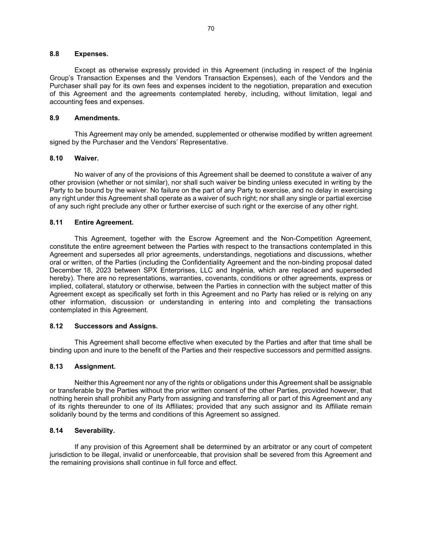
70 8.8 Expenses. Except as otherwise expressly provided in this Agreement (including in respect of the Ingénia Group’s Transaction Expenses and the Vendors Transaction Expenses), each of the Vendors and the Purchaser shall pay for its own fees and expenses incident to the negotiation, preparation and execution of this Agreement and the agreements contemplated hereby, including, without limitation, legal and accounting fees and expenses. 8.9 Amendments. This Agreement may only be amended, supplemented or otherwise modified by written agreement signed by the Purchaser and the Vendors’ Representative. 8.10 Waiver. No waiver of any of the provisions of this Agreement shall be deemed to constitute a waiver of any other provision (whether or not similar), nor shall such waiver be binding unless executed in writing by the Party to be bound by the waiver. No failure on the part of any Party to exercise, and no delay in exercising any right under this Agreement shall operate as a waiver of such right; nor shall any single or partial exercise of any such right preclude any other or further exercise of such right or the exercise of any other right. 8.11 Entire Agreement. This Agreement, together with the Escrow Agreement and the Non-Competition Agreement, constitute the entire agreement between the Parties with respect to the transactions contemplated in this Agreement and supersedes all prior agreements, understandings, negotiations and discussions, whether oral or written, of the Parties (including the Confidentiality Agreement and the non-binding proposal dated December 18, 2023 between SPX Enterprises, LLC and Ingénia, which are replaced and superseded hereby). There are no representations, warranties, covenants, conditions or other agreements, express or implied, collateral, statutory or otherwise, between the Parties in connection with the subject matter of this Agreement except as specifically set forth in this Agreement and no Party has relied or is relying on any other information, discussion or understanding in entering into and completing the transactions contemplated in this Agreement. 8.12 Successors and Assigns. This Agreement shall become effective when executed by the Parties and after that time shall be binding upon and inure to the benefit of the Parties and their respective successors and permitted assigns. 8.13 Assignment. Neither this Agreement nor any of the rights or obligations under this Agreement shall be assignable or transferable by the Parties without the prior written consent of the other Parties, provided however, that nothing herein shall prohibit any Party from assigning and transferring all or part of this Agreement and any of its rights thereunder to one of its Affiliates; provided that any such assignor and its Affiliate remain solidarily bound by the terms and conditions of this Agreement so assigned. 8.14 Severability. If any provision of this Agreement shall be determined by an arbitrator or any court of competent jurisdiction to be illegal, invalid or unenforceable, that provision shall be severed from this Agreement and the remaining provisions shall continue in full force and effect.

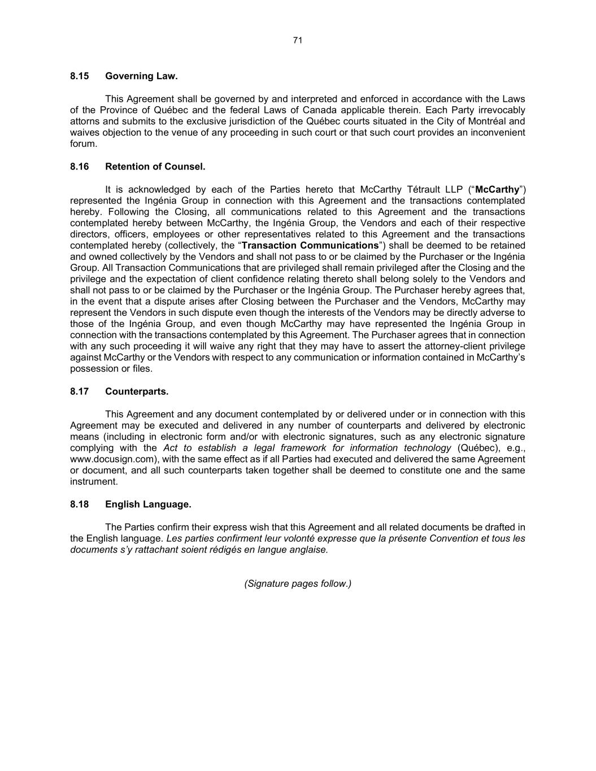
71 8.15 Governing Law. This Agreement shall be governed by and interpreted and enforced in accordance with the Laws of the Province of Québec and the federal Laws of Canada applicable therein. Each Party irrevocably attorns and submits to the exclusive jurisdiction of the Québec courts situated in the City of Montréal and waives objection to the venue of any proceeding in such court or that such court provides an inconvenient forum. 8.16 Retention of Counsel. It is acknowledged by each of the Parties hereto that McCarthy Tétrault LLP (“McCarthy”) represented the Ingénia Group in connection with this Agreement and the transactions contemplated hereby. Following the Closing, all communications related to this Agreement and the transactions contemplated hereby between McCarthy, the Ingénia Group, the Vendors and each of their respective directors, officers, employees or other representatives related to this Agreement and the transactions contemplated hereby (collectively, the “Transaction Communications”) shall be deemed to be retained and owned collectively by the Vendors and shall not pass to or be claimed by the Purchaser or the Ingénia Group. All Transaction Communications that are privileged shall remain privileged after the Closing and the privilege and the expectation of client confidence relating thereto shall belong solely to the Vendors and shall not pass to or be claimed by the Purchaser or the Ingénia Group. The Purchaser hereby agrees that, in the event that a dispute arises after Closing between the Purchaser and the Vendors, McCarthy may represent the Vendors in such dispute even though the interests of the Vendors may be directly adverse to those of the Ingénia Group, and even though McCarthy may have represented the Ingénia Group in connection with the transactions contemplated by this Agreement. The Purchaser agrees that in connection with any such proceeding it will waive any right that they may have to assert the attorney-client privilege against McCarthy or the Vendors with respect to any communication or information contained in McCarthy’s possession or files. 8.17 Counterparts. This Agreement and any document contemplated by or delivered under or in connection with this Agreement may be executed and delivered in any number of counterparts and delivered by electronic means (including in electronic form and/or with electronic signatures, such as any electronic signature complying with the Act to establish a legal framework for information technology (Québec), e.g., www.docusign.com), with the same effect as if all Parties had executed and delivered the same Agreement or document, and all such counterparts taken together shall be deemed to constitute one and the same instrument. 8.18 English Language. The Parties confirm their express wish that this Agreement and all related documents be drafted in the English language. Les parties confirment leur volonté expresse que la présente Convention et tous les documents s’y rattachant soient rédigés en langue anglaise. (Signature pages follow.)

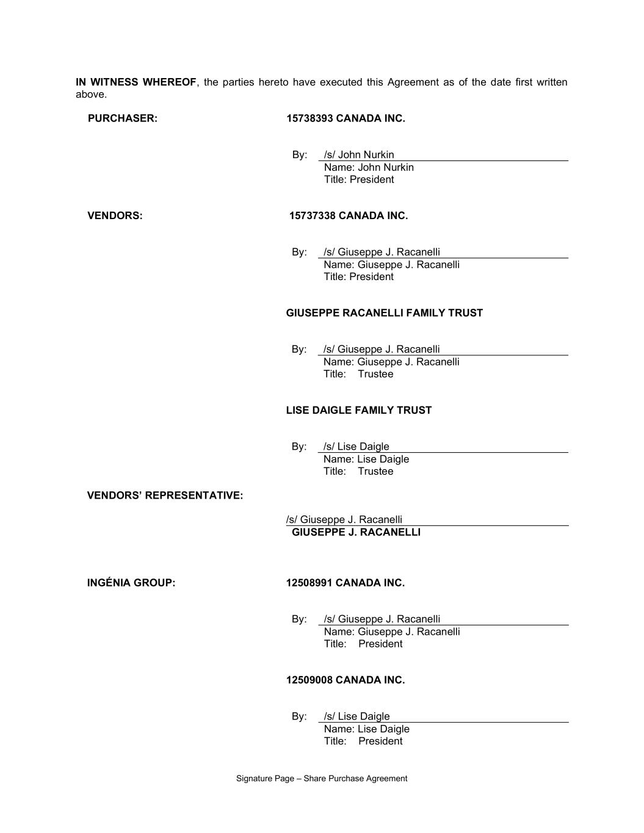
Signature Page – Share Purchase Agreement IN WITNESS WHEREOF, the parties hereto have executed this Agreement as of the date first written above. PURCHASER: 15738393 CANADA INC. By: /s/ John Nurkin Name: John Nurkin Title: President VENDORS: 15737338 CANADA INC. By: /s/ Giuseppe J. Racanelli Name: Giuseppe J. Racanelli Title: President GIUSEPPE RACANELLI FAMILY TRUST By: /s/ Giuseppe J. Racanelli Name: Giuseppe J. Racanelli Title: Trustee LISE DAIGLE FAMILY TRUST By: /s/ Lise Daigle Name: Lise Daigle Title: Trustee VENDORS’ REPRESENTATIVE: /s/ Giuseppe J. Racanelli GIUSEPPE J. RACANELLI INGÉNIA GROUP: 12508991 CANADA INC. By: /s/ Giuseppe J. Racanelli Name: Giuseppe J. Racanelli Title: President 12509008 CANADA INC. By: /s/ Lise Daigle Name: Lise Daigle Title: President

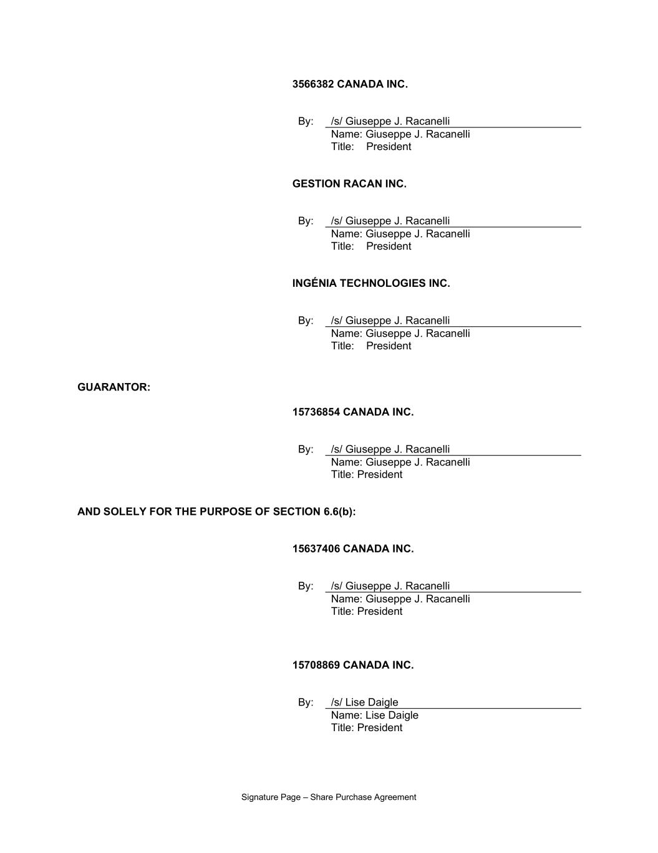
Signature Page – Share Purchase Agreement 3566382 CANADA INC. By: /s/ Giuseppe J. Racanelli Name: Giuseppe J. Racanelli Title: President GESTION RACAN INC. By: /s/ Giuseppe J. Racanelli Name: Giuseppe J. Racanelli Title: President INGÉNIA TECHNOLOGIES INC. By: /s/ Giuseppe J. Racanelli Name: Giuseppe J. Racanelli Title: President GUARANTOR: 15736854 CANADA INC. By: /s/ Giuseppe J. Racanelli Name: Giuseppe J. Racanelli Title: President AND SOLELY FOR THE PURPOSE OF SECTION 6.6(b): 15637406 CANADA INC. By: /s/ Giuseppe J. Racanelli Name: Giuseppe J. Racanelli Title: President 15708869 CANADA INC. By: /s/ Lise Daigle Name: Lise Daigle Title: President

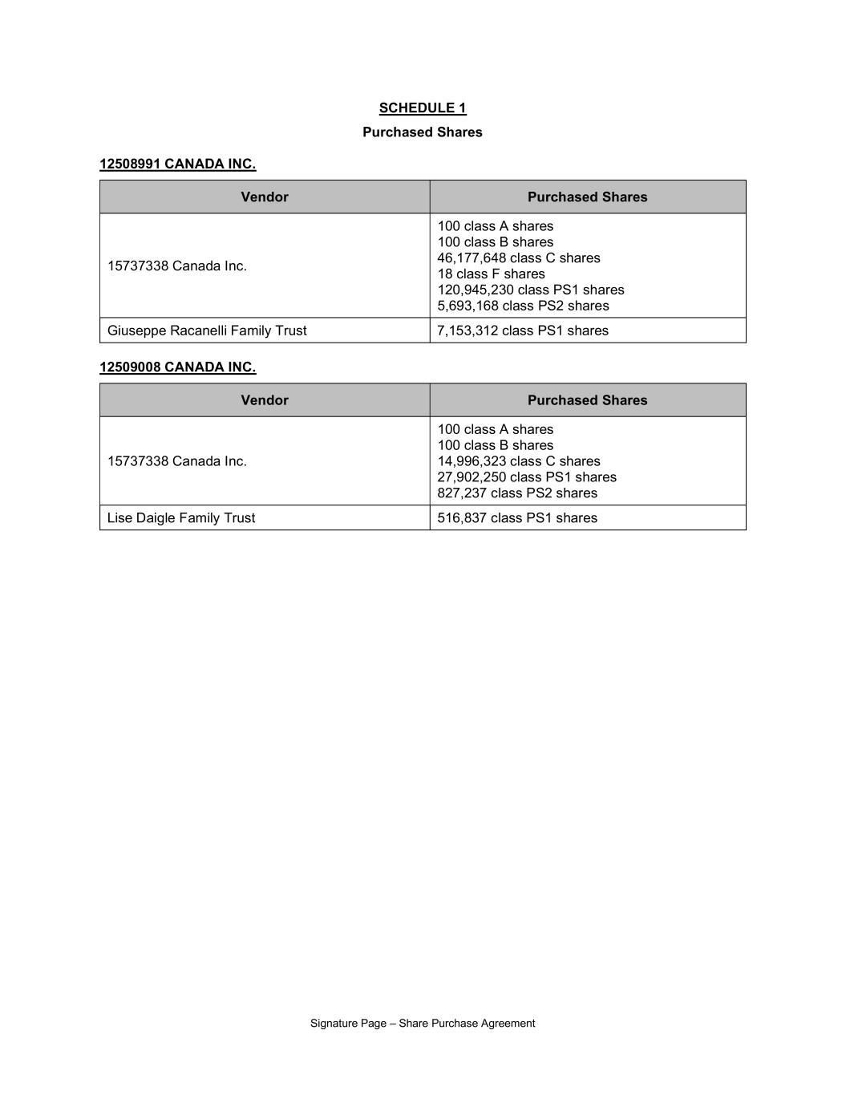
Signature Page – Share Purchase Agreement SCHEDULE 1 Purchased Shares 12508991 CANADA INC. Vendor Purchased Shares 15737338 Canada Inc. 100 class A shares 100 class B shares 46,177,648 class C shares 18 class F shares 120,945,230 class PS1 shares 5,693,168 class PS2 shares Giuseppe Racanelli Family Trust 7,153,312 class PS1 shares 12509008 CANADA INC. Vendor Purchased Shares 15737338 Canada Inc. 100 class A shares 100 class B shares 14,996,323 class C shares 27,902,250 class PS1 shares 827,237 class PS2 shares Lise Daigle Family Trust 516,837 class PS1 shares

EXHIBIT 31.1

CERTIFICATION PURSUANT TO RULE 13a-14(a) AND 15d-14(a),
AS ADOPTED PURSUANT TO SECTION 302 OF THE SARBANES-OXLEY ACT OF 2002
I, Eugene J. Lowe, III, certify that:
1. I have reviewed this quarterly report on Form 10-Q of SPX Technologies, Inc.;
2. Based on my knowledge, this report does not contain any untrue statement of a material fact or omit to state a material fact necessary to make the statements made, in light of the circumstances under which such statements were made, not misleading with respect to the period covered by this report;
3. Based on my knowledge, the financial statements, and other financial information included in this report, fairly present in all material respects the financial condition, results of operations and cash flows of the registrant as of, and for, the periods presented in this report;
4. The registrant's other certifying officer and I are responsible for establishing and maintaining disclosure controls and procedures (as defined in Exchange Act Rules 13a-15(e) and 15d-15(e)) and internal control over financial reporting (as defined in Exchange Act Rules 13a-15(f) and 15d-15(f)), for the registrant and have:
a. designed such disclosure controls and procedures, or caused such disclosure controls and procedures to be designed under our supervision, to ensure that material information relating to the registrant, including its consolidated subsidiaries, is made known to us by others within those entities, particularly during the period in which this report is being prepared;
b. designed such internal control over financial reporting, or caused such internal control over financial reporting to be designed under our supervision, to provide reasonable assurance regarding the reliability of financial reporting and the preparation of financial statements for external purposes in accordance with generally accepted accounting principles;
c. evaluated the effectiveness of the registrant's disclosure controls and procedures and presented in this report our conclusions about the effectiveness of the disclosure controls and procedures, as of the end of the period covered by this report based on such evaluation; and
d. disclosed in this report any change in the registrant's internal control over financial reporting that occurred during the registrant's most recent fiscal quarter (the registrant's fourth fiscal quarter in the case of an annual report) that has materially affected, or is reasonably likely to materially affect, the registrant's internal control over financial reporting; and
5. The registrant's other certifying officer and I have disclosed, based on our most recent evaluation of internal control over financial reporting, to the registrant's auditors and the audit committee of the registrant's board of directors (or persons performing the equivalent functions):
a. all significant deficiencies and material weaknesses in the design or operation of internal control over financial reporting which are reasonably likely to adversely affect the registrant's ability to record, process, summarize and report financial information; and
b. any fraud, whether or not material, that involves management or other employees who have a significant role in the registrant's internal control over financial reporting.

Date: May 2, 2024 |  |  | /s/ EUGENE J. LOWE, III
Eugene J. Lowe, III
President and Chief Executive Officer

EXHIBIT 31.2

CERTIFICATION PURSUANT TO RULE 13a-14(a) AND 15d-14(a),
AS ADOPTED PURSUANT TO SECTION 302 OF THE SARBANES-OXLEY ACT OF 2002
I, Mark A. Carano, certify that:
1. I have reviewed this quarterly report on Form 10-Q of SPX Technologies, Inc.;
2. Based on my knowledge, this report does not contain any untrue statement of a material fact or omit to state a material fact necessary to make the statements made, in light of the circumstances under which such statements were made, not misleading with respect to the period covered by this report;
3. Based on my knowledge, the financial statements, and other financial information included in this report, fairly present in all material respects the financial condition, results of operations and cash flows of the registrant as of, and for, the periods presented in this report;
4. The registrant's other certifying officer and I are responsible for establishing and maintaining disclosure controls and procedures (as defined in Exchange Act Rules 13a-15(e) and 15d-15(e)) and internal control over financial reporting (as defined in Exchange Act Rules 13a-15(f) and 15d-15(f)), for the registrant and have:
a. designed such disclosure controls and procedures, or caused such disclosure controls and procedures to be designed under our supervision, to ensure that material information relating to the registrant, including its consolidated subsidiaries, is made known to us by others within those entities, particularly during the period in which this report is being prepared;
b. designed such internal control over financial reporting, or caused such internal control over financial reporting to be designed under our supervision, to provide reasonable assurance regarding the reliability of financial reporting and the preparation of financial statements for external purposes in accordance with generally accepted accounting principles;
c. evaluated the effectiveness of the registrant's disclosure controls and procedures and presented in this report our conclusions about the effectiveness of the disclosure controls and procedures, as of the end of the period covered by this report based on such evaluation; and
d. disclosed in this report any change in the registrant's internal control over financial reporting that occurred during the registrant's most recent fiscal quarter (the registrant's fourth fiscal quarter in the case of an annual report) that has materially affected, or is reasonably likely to materially affect, the registrant's internal control over financial reporting; and
5. The registrant's other certifying officer and I have disclosed, based on our most recent evaluation of internal control over financial reporting, to the registrant's auditors and the audit committee of the registrant's board of directors (or persons performing the equivalent functions):
a. all significant deficiencies and material weaknesses in the design or operation of internal control over financial reporting which are reasonably likely to adversely affect the registrant's ability to record, process, summarize and report financial information; and
b. any fraud, whether or not material, that involves management or other employees who have a significant role in the registrant's internal control over financial reporting.

Date: May 2, 2024 |  |  | /s/ MARK A. CARANO
Mark A. Carano
Vice President, Chief Financial Officer and Treasurer

EXHIBIT 32.1

CERTIFICATIONS PURSUANT TO 18 U.S.C. SECTION 1350,
AS ADOPTED PURSUANT TO SECTION 906 OF THE SARBANES-OXLEY ACT OF 2002

In connection with the Quarterly Report of SPX Technologies, Inc. on Form 10-Q for the period ended March 30, 2024, as filed with the Securities and Exchange Commission on the date hereof (the “Report”), we certify, pursuant to 18 U.S.C. Section 1350, as adopted pursuant to Section 906 of the Sarbanes-Oxley Act of 2002, that, to the best of our knowledge:

(1)the Report fully complies with the requirements of Section 13(a) or 15(d) of the Securities Exchange Act of 1934; and
(2)the information contained in the Report fairly presents, in all material respects, the financial condition and results of operations of SPX Technologies, Inc.

Date: May 2, 2024
/s/ EUGENE J. LOWE, III |  |  |  |  |  | /s/ MARK A. CARANO
Eugene J. Lowe, III  President and Chief Executive Officer |  |  |  |  |  | Mark A. Carano  Vice President, Chief Financial Officer and Treasurer
A signed original of this written statement required by Section 906 has been provided to SPX Technologies, Inc. and will be retained by SPX Technologies, Inc. and furnished to the Securities and Exchange Commission or its staff upon request.

